*Mountain Spirit Metropolitan Community Church*

*A spiritual community born out of LGBTQIA+ Appalachia*

*“I praise you for I am fearsomely and wonderfully made.”*

*Ps. 139.14*

**Pentecost Sunday 2**

**June 15, 2025**

**Prelude** Paul W., musician

**Welcome and Protocol Honoring Home** Rev. Pressley Sutherland, liturgist

**All: We bless these mountains in which we gather, and all the animals, plants, and elements for whom this is home;**

**We bless all who have walked this land and called this place home long before us;**

**We bless and honor Congregation Beth Israel for sharing their home with us;**

**And we pray that we will be a blessing in this place.**

**May peace be among us. Amen.**

**Invocation Veni Sancte Spiritu**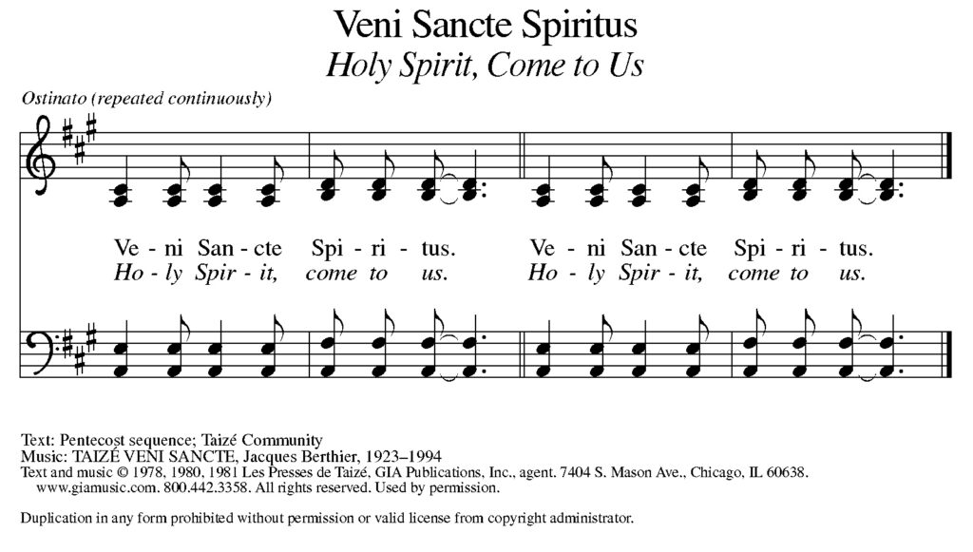

**Come Holy Spirit. Come any way you want. Just come. Amen**

**Community Prayer A Prayer for Peace** Christine W., liturgist

Creator God, in whom all peace is grounded,

kindle in our hearts the presence of love and healing,

and guide us with pure and peaceful wisdom.

We pray peace:

In places of war

And for people displaced;

For those who are victims of violence

And those who foment violence;

For the suffering voiceless

And those who make decisions for many;

For all of Nature

and those who would destroy the harmony of creation;

For all who work for peace

And all whose awareness does not contain peace.

We pray also for ourselves

That we will learn the ways of peace,

Within and without,

And become a blessing in this world. Amen

**Reading Proverbios/Proverbs 8:1-4, 22-31** Angel P. and Sharilyn S., M.Div., lectors

*(Español) Llamado de la sabiduría*

¿Acaso no está llamando la sabiduría?  
    ¿No está elevando su voz la inteligencia?

Toma su puesto en las alturas,  
    a la vera del camino y en las encrucijadas.

Junto a las puertas que dan a la ciudad,  
    a la entrada misma, grita con fuerza:

«A ustedes los hombres, los estoy llamando;  
    dirijo mi voz a toda la humanidad.

»El Señor me dio la vida[a] como primicia de sus obras,[b]  
    mucho antes de sus obras de antaño.

Fui establecida desde la eternidad,  
    desde antes de que existiera el mundo.

No existían los grandes mares cuando yo nací;  
    no había entonces manantiales de abundantes aguas.

Nací antes de que se cimentaran las montañas,  
    antes de que fueran formadas las colinas,

antes de que él creara la tierra y sus paisajes  
    y el polvo primordial con que hizo el mundo.

Cuando Dios cimentó la bóveda celeste  
    y trazó el horizonte sobre el abismo,  
    allí estaba yo presente.

Cuando estableció las nubes en los cielos  
    y reforzó las fuentes del abismo;

cuando señaló los límites del mar,  
    para que las aguas no desobedecieran su orden;  
cuando estableció los cimientos de la tierra,

    allí estaba yo a su lado, afirmando su obra.  
Día tras día me llenaba yo de alegría,  
    siempre disfrutaba de estar en su presencia;

me regocijaba en el mundo que él creó;  
    ¡en el género humano me deleitaba!

La palabra de Dios. **Te alabamos Dios.**

*(English) Wisdom rejoices in the creation*

Does not Wisdom call and Understanding raise her voice?

On the heights, beside the way, at the crossroads she takes her stand; beside the gates in front of the town, at the entrance of the portals she cries out:

"To you, O people, I call, and my cry is to all who live.

The Creator created me at the beginning of Their work, the first of God’s acts of long ago.

Ages ago I was set up, at the first, before the beginning of the earth.

When there were no depths I was brought forth,

When there were no springs abounding with water.

Before the mountains had been shaped, before the hills, I was brought forth,

When God had not yet made earth and fields or the world's first bits of soil,

When God established the heavens, I was there;

When God drew a circle on the face of the deep,

When They made firm the skies above,

When They established the fountains of the deep,

When They assigned to the sea its limit, so that the waters might not transgress Their command,

When They marked out the foundations of the earth, then I was beside Them, like a master worker, and I was daily God’s delight, playing before God always, playing in God’s inhabited world and delighting in the human race.”

Let us hear Living Words. **Thanks be to God.**

**Response Every Time I Feel the Spirit Paul W. And Christine W., Musicians**

(Chorus)

Every time I feel the Spirit

Moving in my heart, I will pray,

Oh, every time I feel the Spirit

Moving in my heart, I will pray.

V1. Upon the mountain when my God spoke

Out of God’s mouth came fire and smoke

Looked all around me, it looked so fine,

’Til I asked my God if it were mine (to chorus)

V2. Oh, I have sorrows and I have woe,

And I have heartaches here below

But my God leads me, Im in God’s care,

And I can feel God everywhere (to chorus)

V3. Oh there’s a new land, for which we’re bound,

Where there is freedom all around!

Will you come with me, to that new land?

We will walk bravely hand in hand (to chorus)

**Poem**   **I Wish My Heart Was as Wide as The Ocean** Erik W, Lector

I wish my heart was as wide as the ocean

But it will never be; and yet, when Your love comes

Into the rooms of my inner chamber, the walls dissolve

As if made of sugar or salt or magic paper,

And I become sea-ish for a liquid moment.

I want to be this for You, a broad expanse that somehow is both

Element and lover, otherwise I could not bear another

Day with this self-knowledge that is growing tiresome.

The truest prayer I know is, “Please, let me be an ocean.”

And if this cannot be during my years as I am,

When I am released, receive me as a stream

That made its way home from the clouds and mountains

Through the dams, cities, power plants, sprinklers and waste pipes,

Good for very little anymore, save the hope of adding

My love to yours, and therein may they swim,

All the precious others.

**Response Spirit of the Living God** Paul W And Christine W, musicians

Spirit of the living God, fall fresh on me

Spirit of the living God, fall fresh on me

Melt me, mold me, fill me, use me

Spirit of the living God, fall fresh on me

Soul of heaven, heart of God, wash over me

Soul of heaven, heart of God, wash over me

Cleanse me, teach me, hold me, reach me

Soul of heaven, heart of God, wash over me

Holy presence, Love Divine, cast out my fear

Holy presence, Love Divine, cast out my fear

Shield me, free me, call me, lead me

Holy presence, Love Divine, cast out my fear

**Sermon “I Was/Am There”** Rev. Pressley Sutherland, Pastor

I know who I am, I know whose I am, I am what I am by the power of Love

I’ll pick up the scattered, broken and shattered, pieces that mattered by the power of Love

**Offertory** **Remember God Cherishes You**  Paul W and Christine W, musicians

1. There are those who would say we must all be the same,

And that differences must be denied;

But we know that each soul is belov’d in God’s eyes

And we claim all God’s blessings with pride!

*(Chorus)*

*So remember God cherishes you;*

*You are precious, and worthy, and loved.*

*When you live out the truth that is yours,*

*There’s rejoicing in heaven above!*

2. There are voices of fear that deny what we know:

That all of God’s people are blessed.

So we sing loud and clear, with our words and our lives,

And we share the good news we confess: *(to chorus)*

3. When hate threatens to harm, may we speak out as one

And declare that love conquers all fear.

No one shall stand alone; we will walk side by side,

And proclaim that God’s kin_dom is near! *(to chorus)*

**Communion** Rev. Dr. Joan S., celebrant Cari M., acolyte

C: God is with you. **All: And also with you**

C: Let us open our hearts. **All: We open them to God**

C: Let us give God thanks and praise **All: It is a good and joyful thing to do**

**Santo, santo, santo**

**Mi corazón te adora**

**Mi corazón sabe decir**

**Santo eres tú**

**Holy, Holy, Holy**

**My heart, my heart adores you**

**My heart knows how to say to you**

**You are holy, God**

**Announcements** Rev. Pressley S, liturgist

* **Founding Committee Meeting**, Monday, June 16, 6:30 @ Haywood Famous, 508 Haywood Rd., Asheville
* **New Book Group - “Jesus in Love: A Novel” by Kittredge Cherry, Intro-ch.4** Tuesday, June 17, 7:30pm on Zoom.
* **ReSister Bingo!** Saturday, June 21st, 6pm @ Haywood Famous, $20 Entry, Cash or Zelle
* **New Mountain Spirit Video Series** being created by David R. Based on three questions:

1. What makes Mountain Spirit MCC different than other churches?

2. What brought you to Mountain Spirit?

3. Do you have an experience testimonial about something important/good that has

happened with you while at Mountain Spirit?

+**Congratulations to UFMCC Moderator, Rev. Elder Cecilia Eggleston**, on her election to serve another term.

**Benediction** Rev. Pressley S., liturgist

**All will be well; and all will be well;**

**And all manner of thing will be well;**

**All will be well, be well.**

**Go out with peace. Go out with kindness. Go out with Love,**

**In the name of the Creator, Christ, Comforter, and All that are Wise and Good. Amén/Amen**