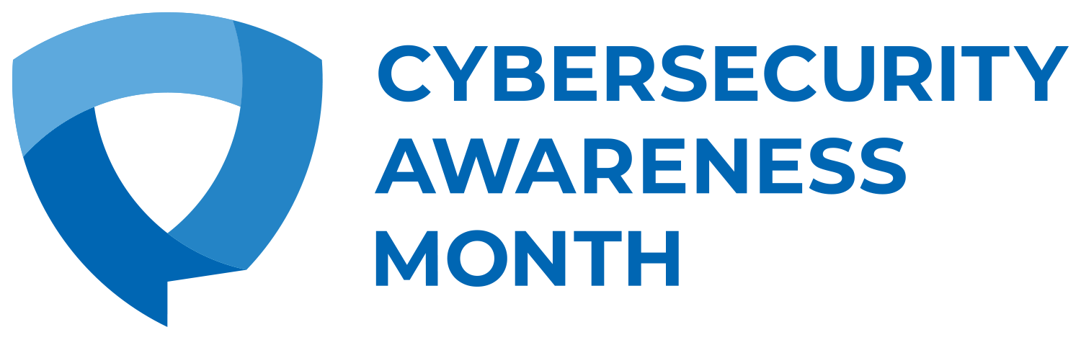

Cyber Defense West Announces Commitment to Global Efforts Advocating for Cybersecurity and Online Behavior Change during Cybersecurity Awareness Month
This year’s initiative highlights the growing importance of cybersecurity and encouraging individuals and organizations to take necessary measures to stay safe and secure in an increasingly connected world

Media Contact:
Contact@CyberDefenseWest.com
Www.CyberDefenseWest.com

August 01, 2021 — Cyber Defense West today announced its commitment to Cybersecurity Awareness Month, held annually in October, by signing up as a 2021 Champion and joining a growing global effort to promote the awareness of online safety and privacy. The Cybersecurity Awareness Month Champions Program is a collaborative effort among businesses, government agencies, colleges and universities, associations, nonprofit organizations and individuals committed to the Cybersecurity Awareness Month theme of ‘Do Your Part. #BeCyberSmart.’

More than ever before, technology plays a part in almost everything we do. Connected devices have been woven into society as an integral part of how people communicate and access services essential to their well being. Despite these great advances in technology and the conveniences this provides, recent events have shown us how quickly our lives and businesses can be disrupted when cyber criminals and adversaries use technology to do harm. Cybersecurity Awareness Month aims to shed light on these security vulnerabilities, while offering actionable guidance surrounding behaviors anyone can take to protect themselves and their organizations. Everyone has a responsibility to do their part in securing our interconnected world.

“With the exceptional growth of cybercrime, and the targeting of any and everything of perceived value no one is safe, home or commercial. There is a false belief that smaller businesses are safe!” Said Ty Moore, Founder of CDW. “Reality is smaller businesses are more likely to get attacked and are the easiest of targets to penetrate!”. CDW is excited to help improve business defenses and their employees understanding of how to operate with a #BeCyberSmart mindset.

This year, the Cybersecurity Awareness Month’s main weekly focus areas will revolve around:
- Understanding and implementing basic cyber hygiene, including the importance of strong passphrases, using multi-factor authentication, performing software updates and backing up data.
- Recognizing and reporting phishing attempts whether it’s through email, text messages, or chat boxes.
- Empowering individuals to not only practice safe online behavior but consider joining the mission of securing our online world by considering a career in cybersecurity!
- Making cybersecurity a priority in business by making products and processes “secure by design” and considering cybersecurity when purchasing new internet-connected devices.

If everyone does their part – implementing stronger security practices, raising community awareness, educating vulnerable audiences, or training employees – our interconnected world will be safer and more resilient for everyone.

Now in its 18th year, Cybersecurity Awareness Month continues to build momentum and impact with the goal of providing everyone with the information they need to stay safer and more secure online. Cyber Defense West is proud to support this far-reaching online safety awareness and education initiative which is co-led by the National Cyber Security Alliance and the Cybersecurity and Infrastructure Agency (CISA) of the U.S. Department of Homeland Security.

For more information about Cybersecurity Awareness Month 2021 and how to participate in a wide variety of activities, visit staysafeonline.org/cybersecurity-awareness-month/. You can also follow and use the official hashtag #BeCyberSmart on social media throughout the month.

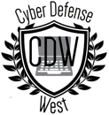
About Cyber Defense West (CDW)
CDW is a local team of business and technical professionals united to support non-profit organizations, home based & small businesses in Washington State and Oregon in matters of Cybersecurity. Our mission is simple! We take our decades of experience in computing, business, and security along with insights from some of the top institutions (NCSA/CIST, Microsoft, ISSA, MIT, Cornell, Stanford University Engineering…) and assist the community around us by partnering with the Chamber of Commerce(s) and local CyberSecurity organizations.

About Cybersecurity Awareness Month
Cybersecurity Awareness Month is designed to engage and educate public- and private-sector partners through events and initiatives with the goal of raising awareness about cybersecurity to increase the resiliency of the nation in the event of a cyber incident. Since the Presidential proclamation establishing Cybersecurity Awareness Month in 2004, the initiative has been formally recognized by Congress, federal, state, and local governments and leaders from industry and academia. This united effort is necessary to maintain a cyberspace that is safer and more resilient and remains a source of tremendous opportunity and growth for years to come. For more information, visit staysafeonline.org/cybersecurity-awareness-month/

About National Cyber Security Alliance
The National Cyber Security Alliance is a nonprofit alliance on a mission to create a more secure connected world. We enable powerful, public-private partnerships in our mission to educate and inspire individuals to protect themselves, their families, and their organizations for the collective good. Our primary partners are the Department of Homeland Security’s Cybersecurity and Infrastructure Security Agency (CISA) and our Board of Directors, which includes representatives from ADP; AIG; Bank of America; Cofense; Discover; Eli Lilly and Company; ESET North America; Facebook; KnowBe4; La-Z-Boy; Lenovo; Marriott International; Mastercard; Microsoft; Mimecast; NortonLifeLock; Paubox; Proofpoint; Raytheon; Terranova Security; US Bank; VISA; Wells Fargo. The National Cyber Security Alliance’s core efforts include Cybersecurity Awareness Month (October); Data Privacy Day (Jan. 28); Identity Management Day; and CyberSecure My Business™. For more information on the National Cyber Security Alliance, please visit https://staysafeonline.org.

V0728FD1836

