LINGLE FORT LARAMIE CONSERVATION DISTRICT
1441 East M Street, Suite B
Torrington, Wy 82240
307-534-5768

ANNUAL REPORT FY 2020-2021

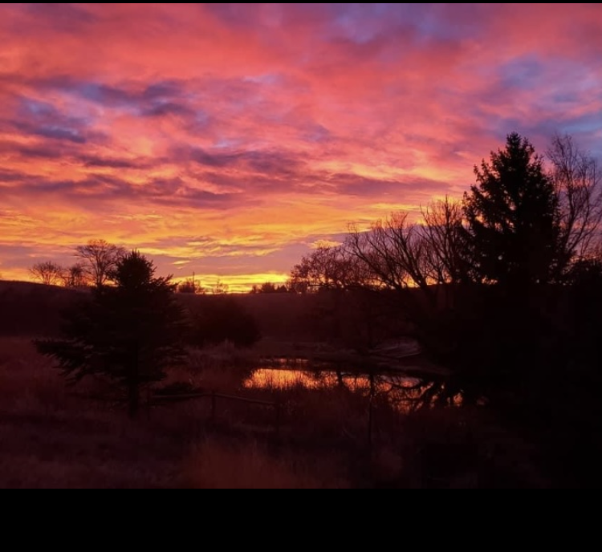

The Lingle Fort Laramie Conservation District was organized by local farmers and ranchers on May 2nd, 1943. This District, compromising an area of 474,620 acres, is a legal subdivision of the State of Wyoming. Land use consists of 25,0000 acres of irrigated cropland, 43,000 acres of dry cropland, 400,000 acres of rangeland, 5,000 acres of dryland pasture and hayland, and about 1,600 acres of forest and woodland.

LINGLE FORT LARAMIE CONSERVATION DISTRICT
BOARD OF SUPERVISORS

Don McDowell Chair Rural 2022
11836 County Line Road
Fort Laramie, Wy 82212
307-334-0178 or 307-532-1932

Linda Nichol Vice-Chair Urban 2024
PO Box 56
Lingle, Wy 82223
307-837-2432 or 307-899-2500

Dave Johnson Treasurer Rural 2024
6696 Road 23
Lingle, Wy 82223
307-837-2946 or 307- 534-5395

Tim Bartel Rural 2022
2967 Wyncote Road
Lingle, Wy 82223
307-534-5119

Jenna Meeks At Large 2024
PO Box 331
Lingle, Wy 82223
970-556-3533

Karen Johnson District Manager
307-534-5768 or 307-532-4880

W.S. 11-16-122. Powers and duties of districts and supervisors thereof generally. (v) Conduct surveys, investigations, and research and disseminate information relating to range management, the character of soil erosion, flood prevention or the conservation, development, utilization and disposal of water, and the preventive and control measures and works of improvement needed, but in order to avoid duplication of research activities, no district shall initiate any research program except in cooperation with the government of this state or its agencies, or with the United States or its agencies.

OUR DISTRICT MANAGER
Our District Manager, Karen Johnson began working for the district September 14, 2020. Karen’s responsibility is to care for overall functions of the district programs and projects. She is responsible to the district board for budgets, annual plan of work, annual reports, audits, grant proposals letters, payroll, tax forms, meeting agendas, minutes, websites, and many other functions. Karen previously spent 17 years working with the United States Department of Agriculture. Karen moved from Tennessee to Wyoming in December 2014. We are excited to have Karen working for the LFLCD.

Karen attended the Area II meeting held in Wheatland in September 2020. She completed the Water Quality Training Course in January 2021. She also attended Employee Training in Cheyenne February 2021.

Website and Facebook Pages

We have created a website and Facebook page for informational use. Both sites contain board supervisors’ emails, contact numbers, and addresses of all board members. As well as posting regular monthly board meeting dates, time, and location of meeting, and past approved minutes. Our website contains information of rental equipment, rates, and contracts.

DISTRICT ACTIVITIES: GOSHEN COUNTY FAIR AUG-SEPT 2021
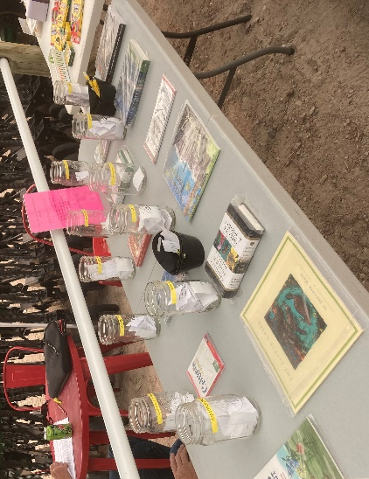
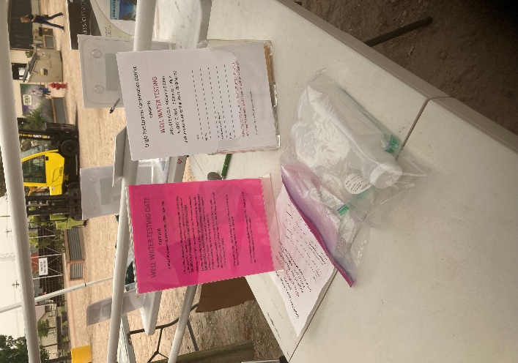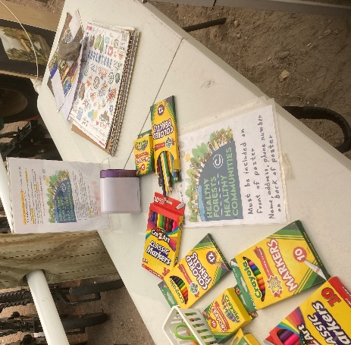
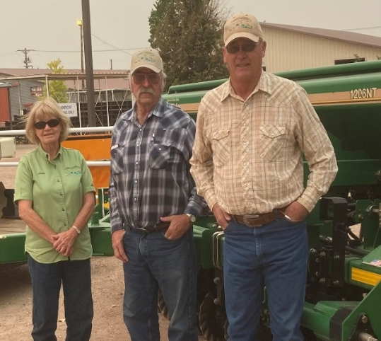NACD Poster Contest “Healthy Forests, Healthy Forests” was one of 4 booths sponsored by LFLCD. Book Drawing, Water Testing information, & equipment rental information. LFLCD brought both the No-Till Drills, Broadcaster/seeder, and the Patriot Pivot Tract Closer.
EQUIPMENT RENTAL PROGRAMS
SPONSORED BY THE
LINGLE FORT LARAMIE CONSERVAION DISTRICT

OPEN TO ALL CONSTITUENTS IN GOSHEN COUNTY
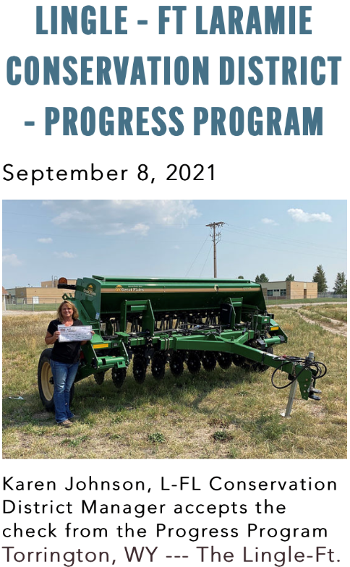
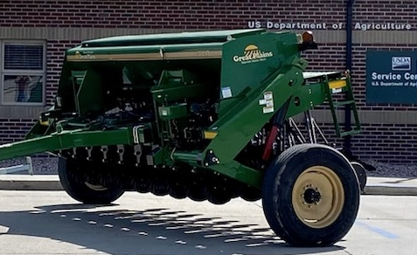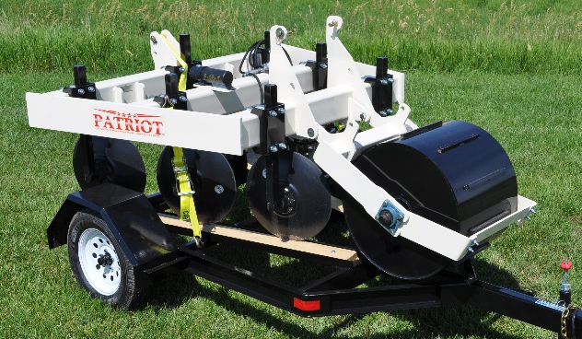

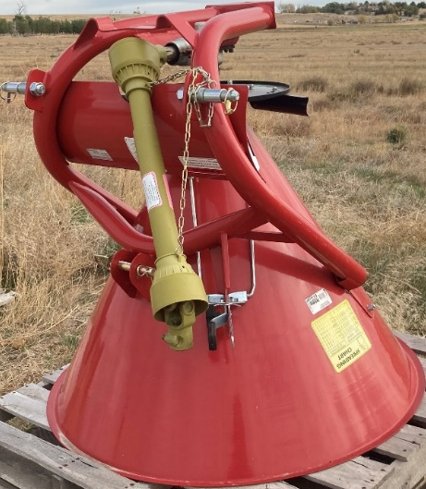
All information pertaining to equipment rentals can be obtained in the office, on the LFLCD website, LFLCD facebook page, or by calling Karen.

CALENDAR OF EVENTS
July
- Budget Hearing/Submission of Final Budget
- Goshen County Fair sponsored No-Till Drill
August
- Submitted State Funding Financial Requirements (WDA & WACD)
- Conduct interviews for District Manager position/Hired District Manager
September
- Annual Census Report
- Hazardous Waste Collection Day (in conjunction with the NPVCD and SGCD)
- Area II Meeting in Wheatland, Wy
October
- Annual Report Summary and Proof of Cash
- Created new website and facebook page
November
- WACD Annual Convention (Cancelled)
- Election of board members
December
- Submitted Annual Plan, Annual Report, and Summary
- Procurement Accounts
- Swearing in of newly elected board members
January
- Administrative Duties/Budget Review/Programs Review
- District Reorganization Forms to WDA and WACD
- Replacement of board member with new member
February
- Supervisors and District manager attended Employee Training held in Cheyenne
March
- District Manager took over bookkeeping responsibilities
April
- Arrival of new No-Till Drill
- Purchased a Patriot Pivot Track Closer
May
- Preparation for preliminary budget
June
- Purchase of Trailer for Pivot Track Closer
Several Subdivision reviews were submitted for review throughout the year
Held 12 regular monthly board meetings, and held 3 special meetings throughout the year

FINANCIAL REPORTS

