LINGLE FORT LARAMIE CONSERVATION DISTRICT
PO Box 461, 224 Main Street
Lingle, Wy 82223
307-534-5768

ANNUAL REPORT FY 2021-2022

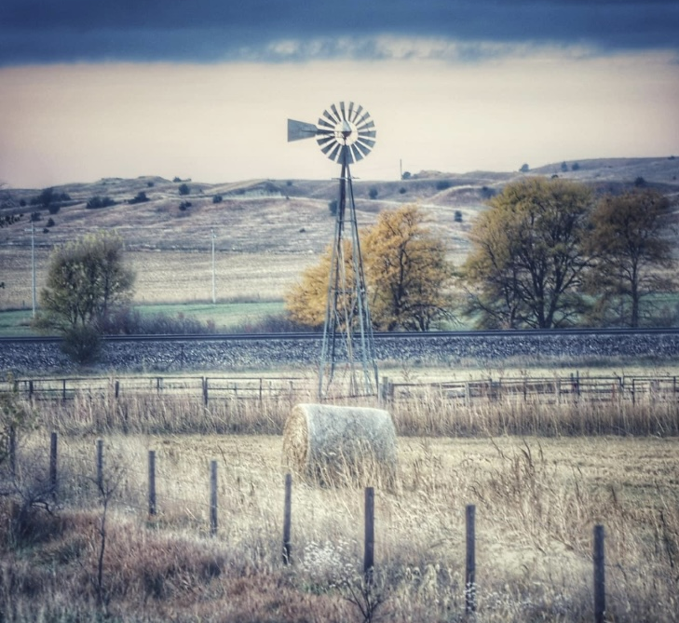

The Lingle Fort Laramie Conservation District was organized by local farmers and ranchers on May 2nd, 1943. This District, compromising an area of 474,620 acres, is a legal subdivision of the State of Wyoming. Land use consists of 25,0000 acres of irrigated cropland, 43,000 acres of dry cropland, 400,000 acres of rangeland, 5,000 acres of dryland pasture and hay land, and about 1,600 acres of forest and woodland.

LINGLE FORT LARAMIE CONSERVATION DISTRICT
BOARD OF SUPERVISORS

Don McDowell Chair Rural 2022
11836 County Line Road
Fort Laramie, Wy 82212
307-334-0178 or 307-715-0033

Linda Nichol Vice-Chair At-Large 2024
PO Box 56
Lingle, Wy 82223
307-837-2432 or 307-899-2500

Dave Johnson Treasurer Rural 2024
6696 Road 23
Lingle, Wy 82223
307-837-2946 or 307- 534-5395

Tim Bartel Member Rural 2022
2967 Wyncote Road
Lingle, Wy 82223
307-534-5119

Jenna Meeks Secretary Urban 2024
PO Box 331
Lingle, Wy 82223
970-556-3533

Karen Johnson District Manager
307-534-5768

W.S. 11-16-122. Powers and duties of districts and supervisors thereof generally. (v) Conduct surveys, investigations, and research and disseminate information relating to range management, the character of soil erosion, flood prevention or the conservation, development, utilization and disposal of water, and the preventive and control measures and works of improvement needed, but in order to avoid duplication of research activities, no district shall initiate any research program except in cooperation with the government of this state or its agencies, or with the United States or its agencies.
Website and Facebook Pages
We continue to manage a District Website and Facebook page for informational use. Both sites contain board supervisors’ emails, contact numbers, and addresses of all board members. As well as posting regular monthly board meeting dates, time, and location of meeting, and past approved minutes. Our website contains information of rental equipment, rates, and contracts.
EQUIPMENT RENTALS
DISTRICT COST SHARE PROGRAMS
Seed Cost Share
Solar Pump Cost Share
TREE SALES
WELL WATER TESTING
QUARTERLY NEWSLETTERS
SAREC BOOTH
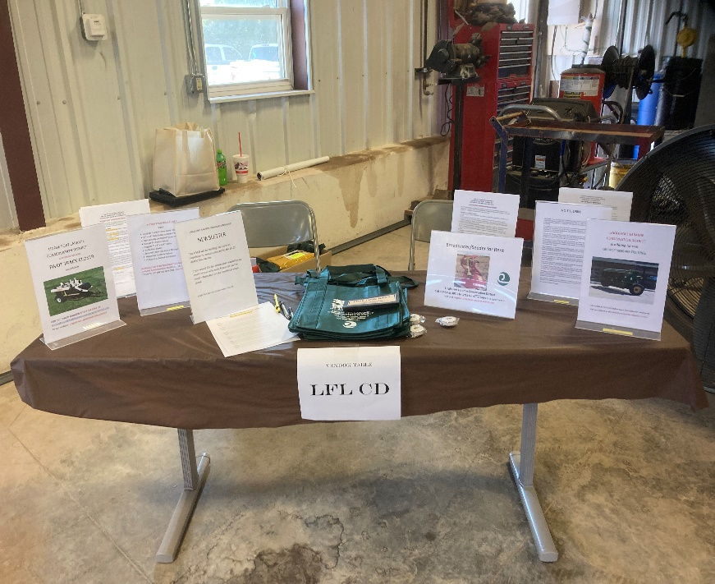

DISTRICT ACTIVITIES: GOSHEN COUNTY FAIR AUG-SEPT 2021
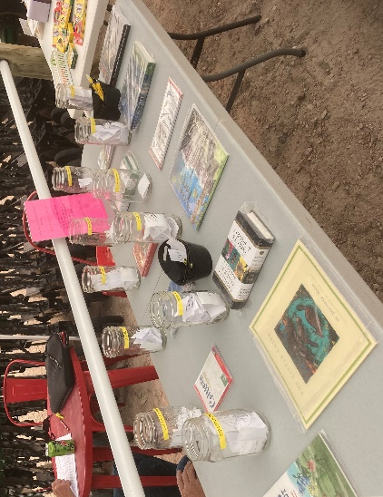
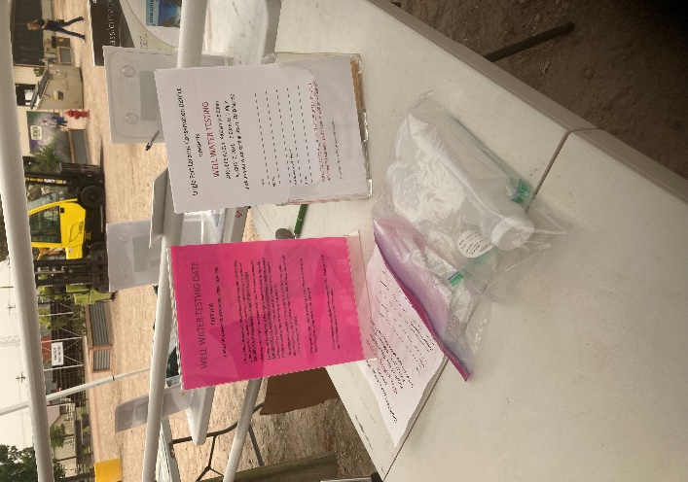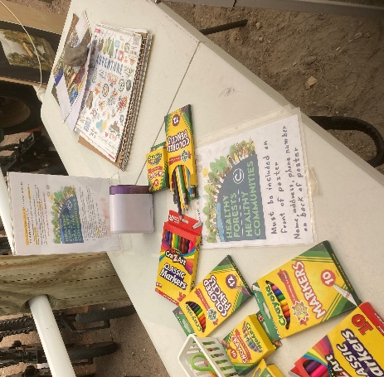
NACD Poster Contest “Healthy Forests, Healthy Communities” was one of 4 booths sponsored by LFLCD. Book Drawing, Water Testing information, & equipment rental information. LFLCD brought both the No-Till Drills, Broadcaster/seeder, and the Patriot Pivot Tract Closer.

EQUIPMENT RENTAL PROGRAMS
SPONSORED BY THE
LINGLE FORT LARAMIE CONSERVAION DISTRICT

OPEN TO ALL CONSTITUENTS IN GOSHEN COUNTY
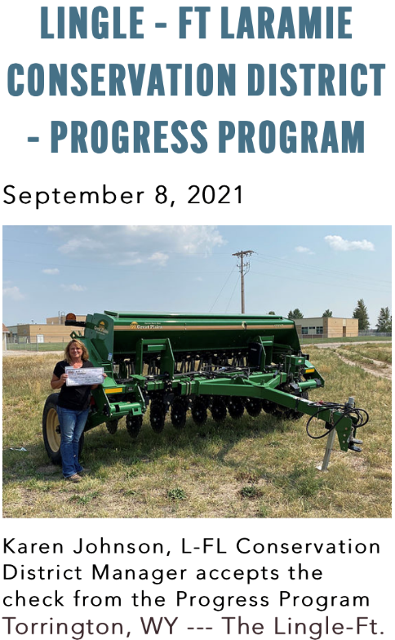
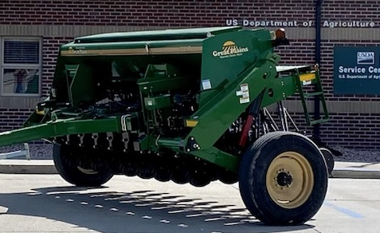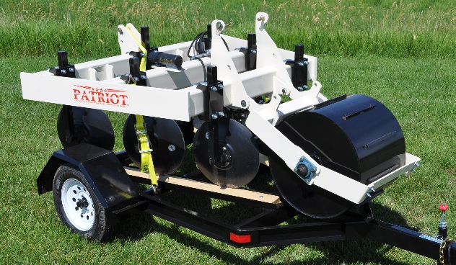

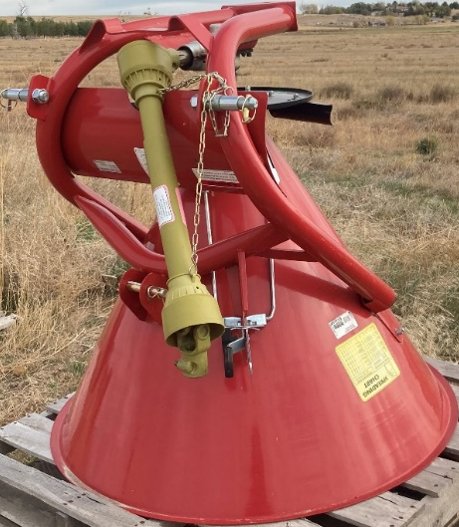
All information pertaining to equipment rentals can be obtained in the office, on the LFLCD website, LFLCD Facebook page, or by calling Karen.

CALENDAR OF EVENTS
July
- Budget Hearing/Submission of Final Budget
August
- Goshen County Fair featuring the No-Till Drills, Pivot Track Closer
- Well Water Testing in conjunction with the Goshen County Fair.
- Book drawings and Poster Contest “Healthy Forests, Healthy Communities”
- Submitted State Funding and Financial Requirements (WDA & WACD)
September
- Annual Census Report, Annual Report Summary, Proof of Cash to Dept of Audit
- Attended the Area II Meeting in Torrington, Wy
- Received grant funding from Goshen Economic Development towards the second No-Till Drill
October
- Attended meeting with the South Goshen Conservation District at their request
November
- WACD Annual Convention held in Cody Wy
December
- Submitted Annual Plan of Work, Annual Report, and One Page Summary
- Met all WDA/WACD funding requirements
January
- Administrative Duties/Budget Review/Programs Review
- District Reorganization Forms to WDA and WACD
- Attended meetings in Lusk pertaining to the Clean Water Hydrogen Center.
- Implemented the Seed Cost Share Program/ Solar Pump Cost Share Program
February
- The District sent out Quarterly Newsletters
- Began Annual Tree Sales
March
- Some board members attended the WDA meeting in Cheyenne at their request.
- Well Water Testing.
- Board Member Linda Nichol assisted the Lingle Lions Club and LFL High School Student Council to clean Lingle City Park.
April
- The District purchased a Pickup for delivery of Drills, Pivot Closer, and use of official business.
- Attended WDA meeting in Cheyenne.
May
- The District sold and delivered 4200 trees to constituents within the district boundaries.
- The District began the process to purchase a new office building in Lingle.
June
- The District submitted preliminary budget to Dept of Audit
- The District reached agreements with the other districts for shared programs and signed MOU’s.
Several Subdivision reviews were submitted for review throughout the year.
The District held 12 regular monthly board meetings, and held 2 special meetings throughout the year.

FINANCIAL REPORT
(GRAPHS)

JULY 1ST, 2021 THRU JUNE 30, 2022

