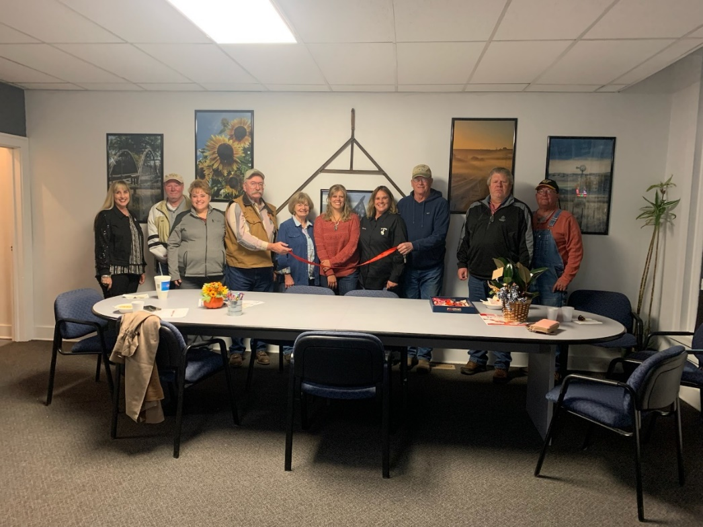Con

|  |  |  |
| --- | --- | --- |
|  | LFLCD NEWS | WINTER 2023 |
|  | The District’s Quarterly Newsletter | |
| MONTHLY BOARD MEETINGS  Held the second Tuesday of each month at 224 Main Street, Lingle, WY at 1:00pm.  WELL WATER TESTING  LFLCD will be offering free well water testing on Tuesday, April 18, 2023. Contact the Office to pick up kit @ 307-534-5768  SEED COST SHARE  50% cost of seed purchased up to $500 per constituent with no-till drill rental. Preapproval required. |  | |
| **LFLCD BOARD**  *Welcome to our newly elected Board Member, Matt Teeters!*  Don McDowell  Linda Nichol  Dave Johnson  Jenna Meeks  Matt Teeters  DISTRICT EVENTS  The NRCS, in conjunction with LFLCD, performed dam inspections in 2022 on the Case Bier, Pine Ridge, Spring Canyon, London Flats, and Angell Draw watersheds.  The WACD Area II meeting was held in Douglas, WY on September 21, 2022. Area II consists of 8 nearby Conservation Districts.  LFLCD donated use of the no-till drill to Goshen Irrigation District for reclamation of the area above the 2019 tunnel collapse (image above).    A lawnmower on the grass  Description automatically generated with medium confidence | NEW OLD HOME Goshen Economic Development and LFLCD celebrated the move to a new location with a ribbon cutting ceremony on Tuesday, November 8, 2022.  It was a homecoming for the LFLCD office located at 224 Main Street, Lingle, WY. This is the location where the organization previously resided until 1984. Now 38 years later and with a renovation to accommodate the public, we are excited to be within the District. Programs provided include trees for residents to plant, machine rental, and educational resources. Collaboration with other districts within the county community services, tree plantings, and equipment rental.  LFLCD continues in pursuit of its mission to provide leadership in the wise and sustainable use of natural resources.  **NOW TAKING TREE ORDERS**  Trees make excellent windbreaks and offer wildlife habitat.  Due to CSU’s tree nursery going through a restructuring phase, they have limited tree availability. This has resulted in difficulty finding nurseries to fulfill orders. Don’t fret…LFLCD has pre-ordered limited quantities of various species of trees to be sold on a first come first sold basis. We have a variety of conifers, hardwood trees, trees for windbreaks, and habitats. A tree order form has been included in this newsletter.  Call Karen before sending in payment to ensure trees are available.  **HAZARDOUS HOUSEHOLD WASTE DAY**  The Conservation Districts were thrilled to offer a waste collection day in November 2022. Thanks to all who braved the cold to protect our natural resources!  After a couple year hiatus, the North Platte Valley CD, South Goshen CD, and Lingle Fort Laramie CD jointly coordinated the annual hazardous household waste collection day. We filled four roll-off containers with TV’s, microwaves, refrigerators, etc. Hundreds of gallons of pesticide, paint, motor oil, and other hazardous wastes were properly disposed of and kept out of our precious soil and water resources. We look forward to providing this service to constituents in the future!  Many thanks to our donors! City of Torrington, City of Torrington Water Department, Butler’s Auto Salvage, First State Bank, Goshen County Clerk, Simplot, Panhandle Coop, Town of Yoder, and the Town of LaGrange  **WACD ANNUAL CONVENTION**  LFLCD Board Members and staff attended the Wyoming Association of Conservation Districts (WACD) annual convention December 5-8, 2022, held at the Ramkota Hotel & Conference Center in Casper. This year’s event was held in conjunction with the Wyoming Stock Growers Association (WSGA) and Wyoming Wool Growers Association (WWGA). The WY Natural Resource Foundation held a fundraiser drawing for a 2022 John Deere Gator and Stihl chainsaw. Timothy Dittmer of Fort Laramie won the Stihl chainsaw.  Governor Mark Gordon and First Lady Jennie Gordon were also in attendance. The First Lady educated the group on the Wyoming Hunger Initiative which is a program that allows for increased collaboration and community participation in the fight against childhood hunger.  The District was able to obtain some knowledge and informational materials on several topics by attending Progressive Resource Manager Forums.  **AVAILABLE EQUIPMENT RENTALS**  The Lingle Fort Laramie Conservation District offers no-till drills, a broadcast seeder, and pivot track closer to all Goshen County residents. The North Platte Valley CD offers LFLCD constituents the opportunity to rent a five-foot no till drill. The South Goshen CD offers LFLCD constituents the opportunity to rent a gopher machine. | |