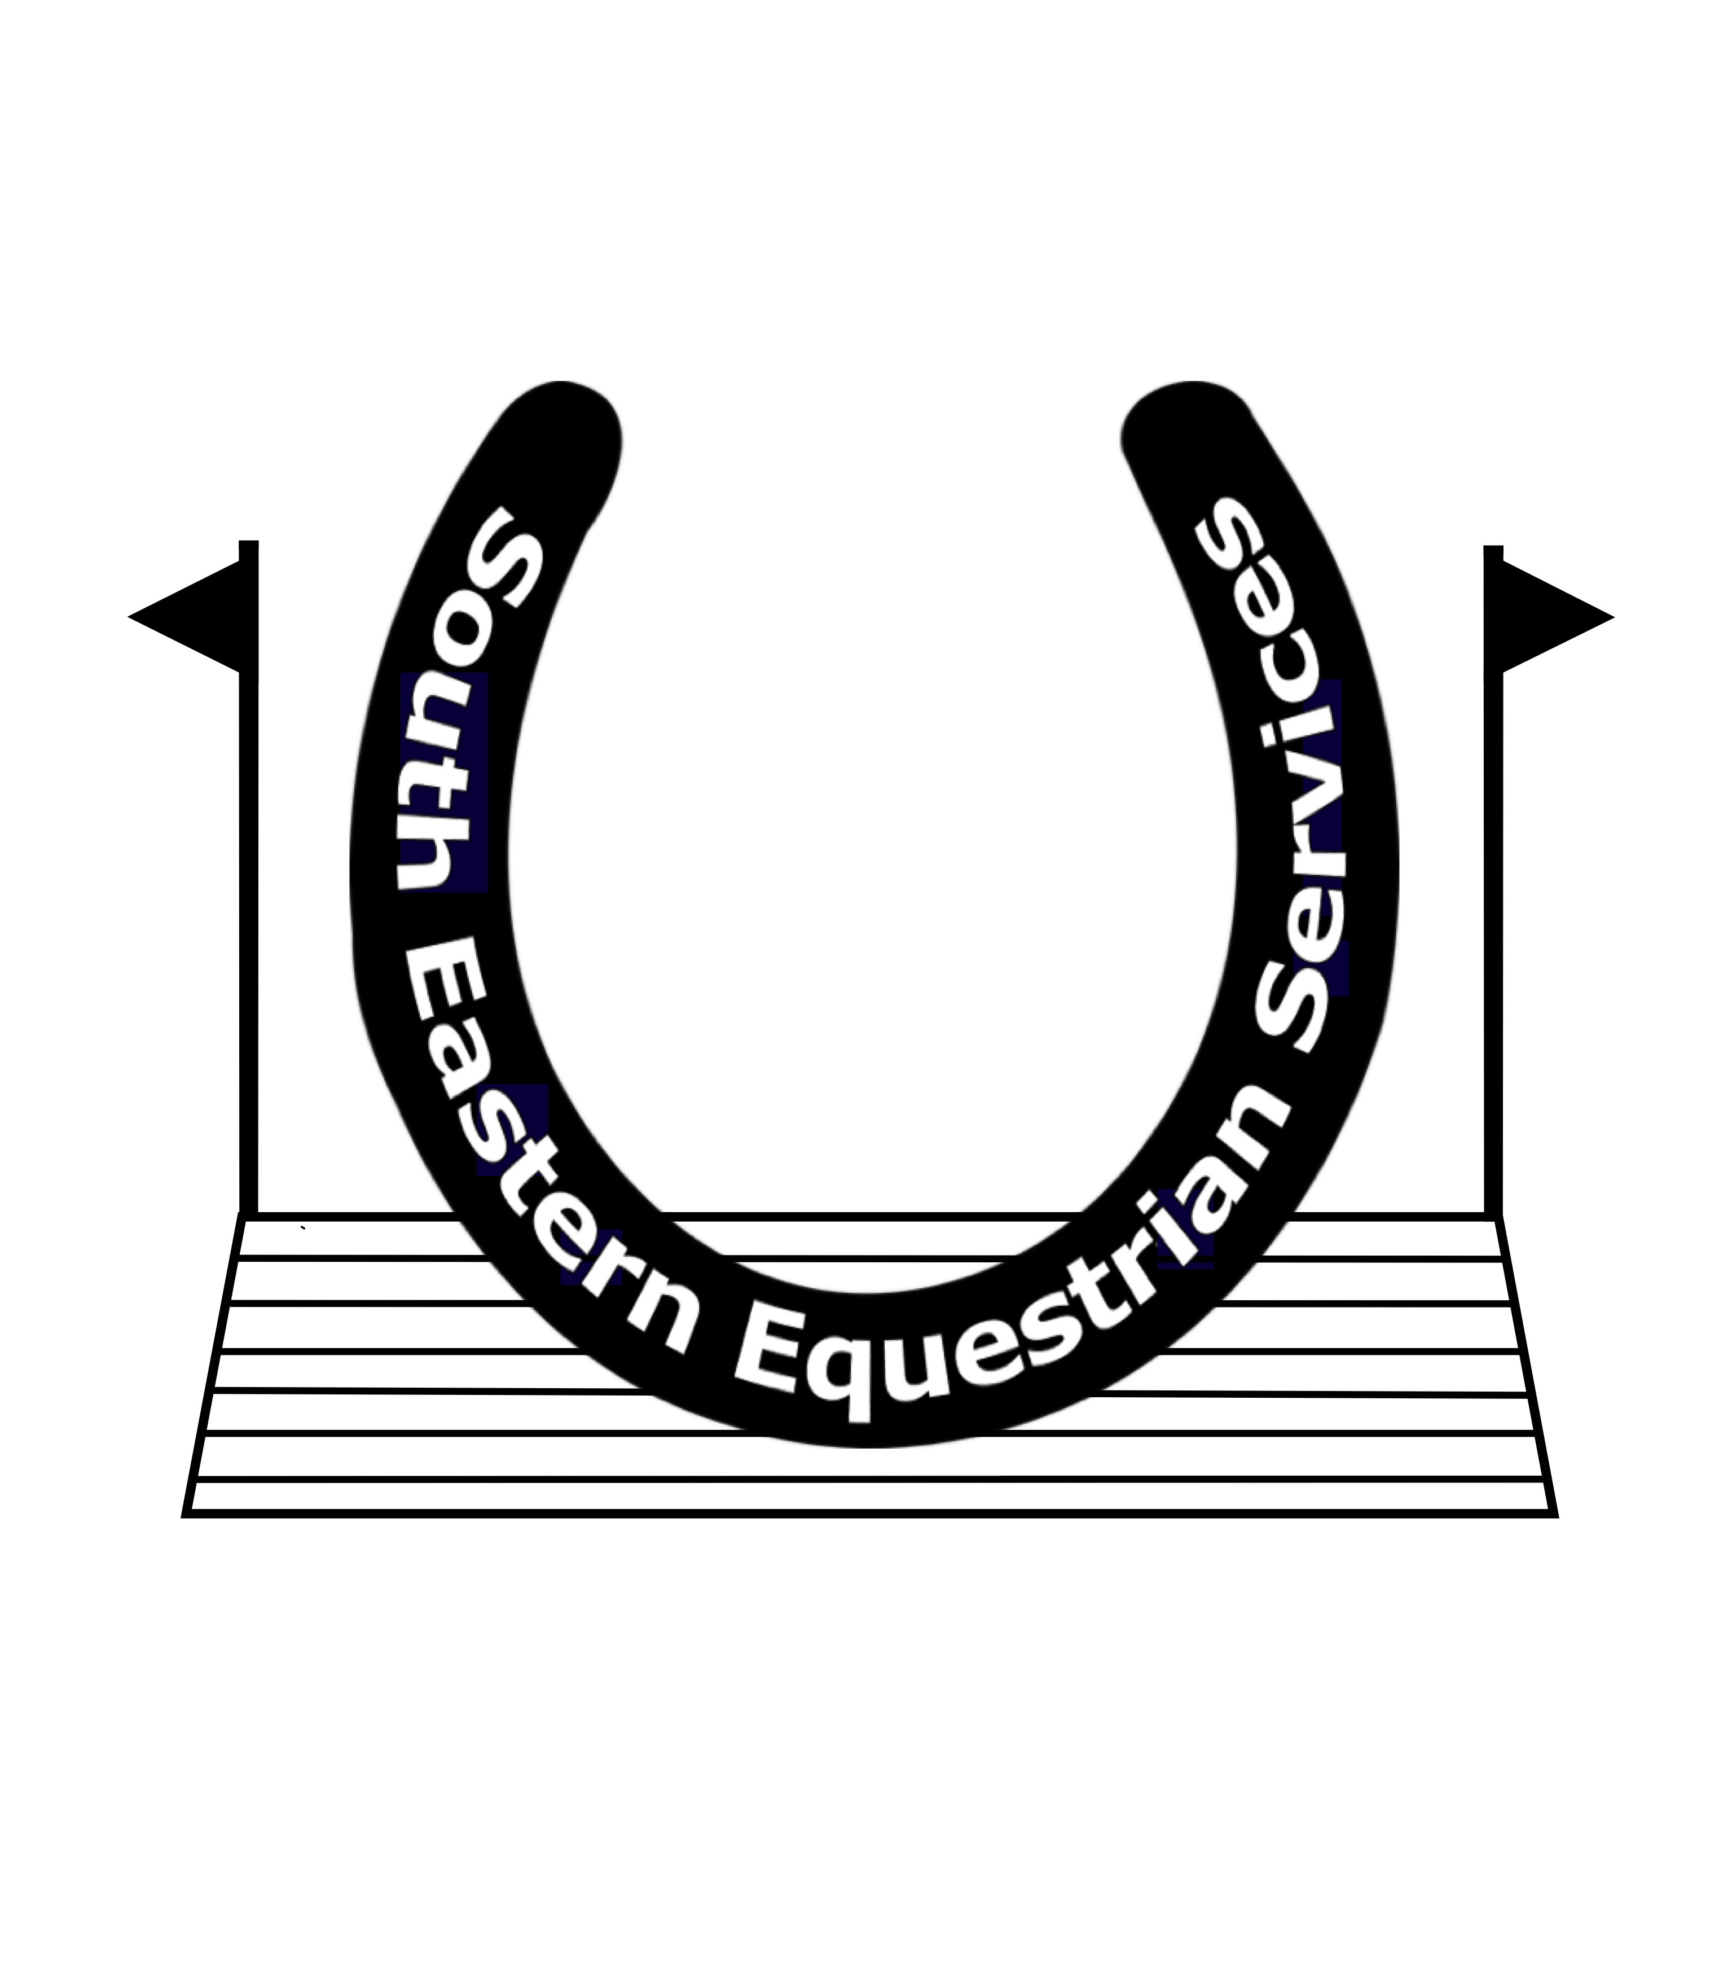
Mobile: 07767 444684
Website: www.southofenglandhorsetrials.co.uk
Email: timnolan06@yahoo.co.uk

THE
SOUTH OF ENGLAND INTERNATIONAL HORSE TRIALS

South of England International Horse Trials 26th & 27th September 2026

CONGRATULATIONS

CLAIMING YOUR PRIZE MONEY

To claim your Prize money please could you fill out this form and email it back to timnolan06@yahoo.co.uk by Monday 19th October. There will be no way of claiming after then, as unclaimed money will be donated to The Kent Sussex & Surrey Air Ambulance Service.

Riders Name:

Horses Name:

Placed ………………… in Section…………………

Bank Account name

Bank account number

Sort Code

Well done and we look forward to seeing you at South of England Horse Trials in 2027

