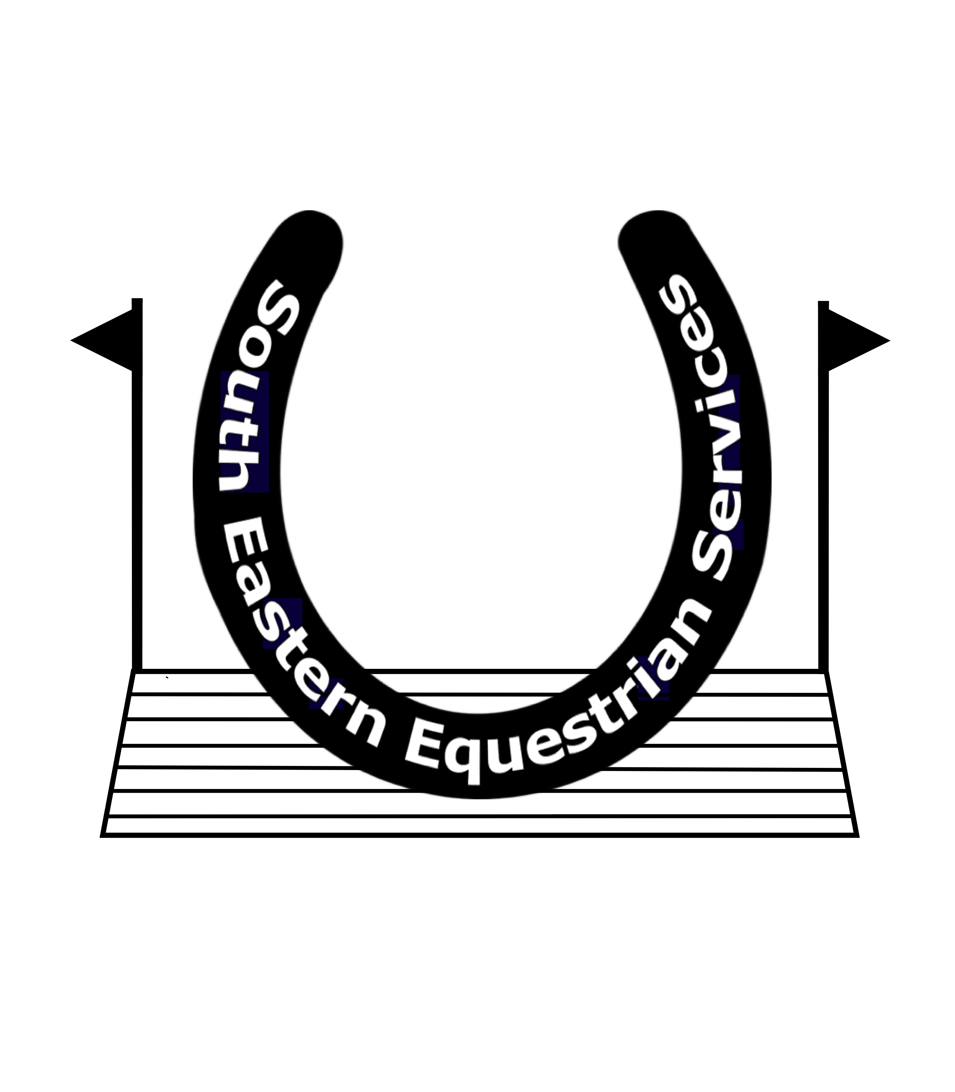
Mobile: 07767 444684
Website: www.southofenglandhorsetrials.co.uk
Email: info@southofenglandhorsetrials.co.uk

THE
SOUTH OF ENGLAND (1) HORSE TRIALS

South of England Horse Trials 10th & 11th April 2021

CONGRATULATIONS

CLAIMING YOUR PRIZE MONEY

We apologise but due to Covid-19 protocols we are paying all prize money 1st – 4th place only by BACS directly into your bank accounts as we were unable to pay you as normal at the event.

To claim your Prize money please could you fill out this form and email it back to timnolan06@yahoo.co.ukby Monday 26th April. There will be no way of claiming after then, as unclaimed money will be donated to Riding For Disabled Charity.

Riders Name:

Horses Name:

Placed ………………… in Section…………………

Bank Account name

Bank account number

Sort Code

Rosettes

If you wish to get your rosette please send a A4 stamped address envelope (with the right stamps on for size) Rider, Horses Name and Section on the back please to

SEES Ltd, Oatridges, Beech Hill, Wadhurst East Sussex. TN5 6JL

Well done and we look forward to seeing you at South of England International in September

