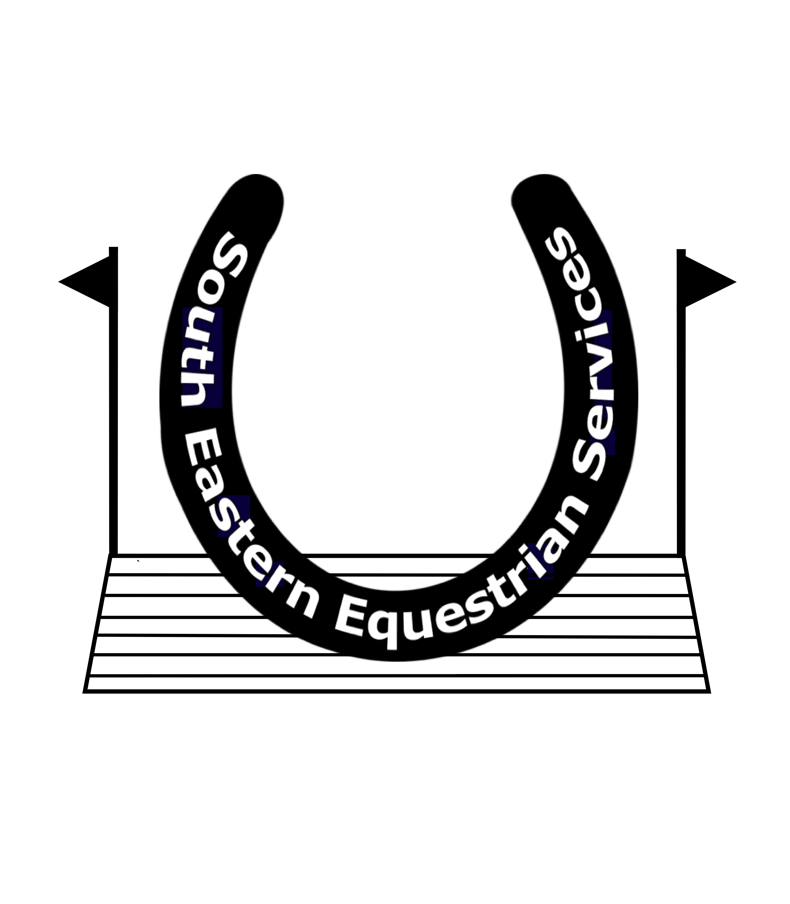
Mobile: 07767 444684
Website: www.southofenglandhorsetrials.co.uk
Email: info@southofenglandhorsetrials.co.uk

THE SOUTH OF ENGLAND HORSE TRIALS

South of England Horse Trials 9th & 10^{h} April 2022

CONGRATULATIONS

CLAIMING YOUR PRIZE MONEY

To claim your Prize money please could you fill out this form and email it back to timnolan06@yahoo.co.uk by Tuesday 26th April. There will be no way of claiming after then, as unclaimed money will be donated to British Equestrians for Ukraine.

Riders Name:

Horses Name:

Placed ………………… in Section…………………

Bank Account name

Bank account number

Sort Code

Well done and we look forward to seeing you at South of England International Horse Trials and New Autumn Show in September 2022

