Congratulations!
You have been selected by the Board Members of the Sicilian Cultural Association as a recipient of our Scholarship Program award of $1,000.00.
This check will be sent to the Financial Aid Office of the university/college/trade school you will be attending before your first semester commences. Once you have received The Scholarship Award, secure a Confirmation/Verification form from your chosen institution and please promptly send a copy to Scholarship Program Director*.
We invite you and your parent(s) and/or sponsor to attend our June Sicilian Cultural Association meeting to officially accept and receive your accolades.
Attendance is required. However, if circumstances prevent in-person
attendance, some form of acceptance must be submitted i.e., a student video.
Your presentation will take place at the beginning of the meeting and you and your guest(s) can choose whether to stay and participate in the entire meeting or not. You will be notified of the date, time and location of the meeting in advance.
Again, congratulations to you! Your hard work and dedication will provide opportunities for your future endeavors and we hope your Sicilian heritage and this award will aid in achieving your goals.
Sincerely,
Joe Tortorici/ All Board Members of the Sicilian Cultural Association
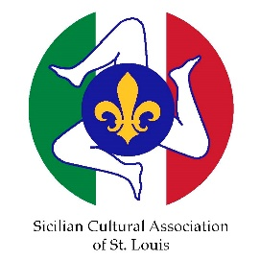
*Scholarship Program Director
Joe Tortorici
37 Misty Ridge Ct.
Saint Charles, Mo. 63304
jatortorici@msn.com

Rev 2.2 2/27/2023
/jat

