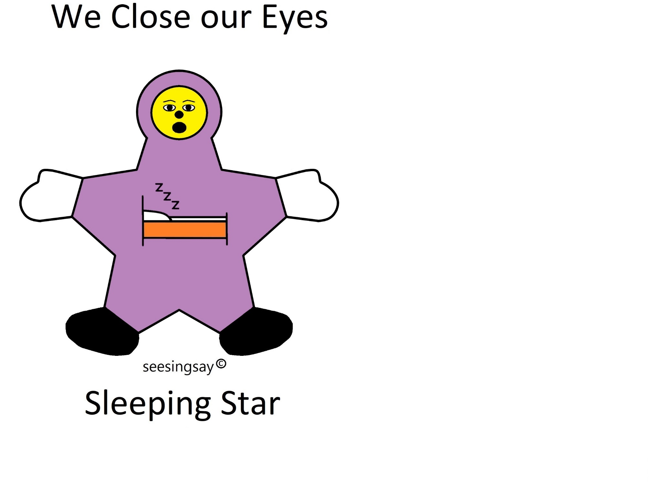
We close our eyes we stop moving
We close our eyes and we go to sleep

We close our eyes we hush our noise
We close our eyes and we go to sleep

We close our eyes we listen with our ears
We close our eyes and we go to sleep

We close our eyes we breathe with our nose
We close our eyes and we go to sleep

We close our eyes we rest our minds
We close our eyes and we go to sleep

We close our eyes we stop thinking
We close our eyes and we go to sleep

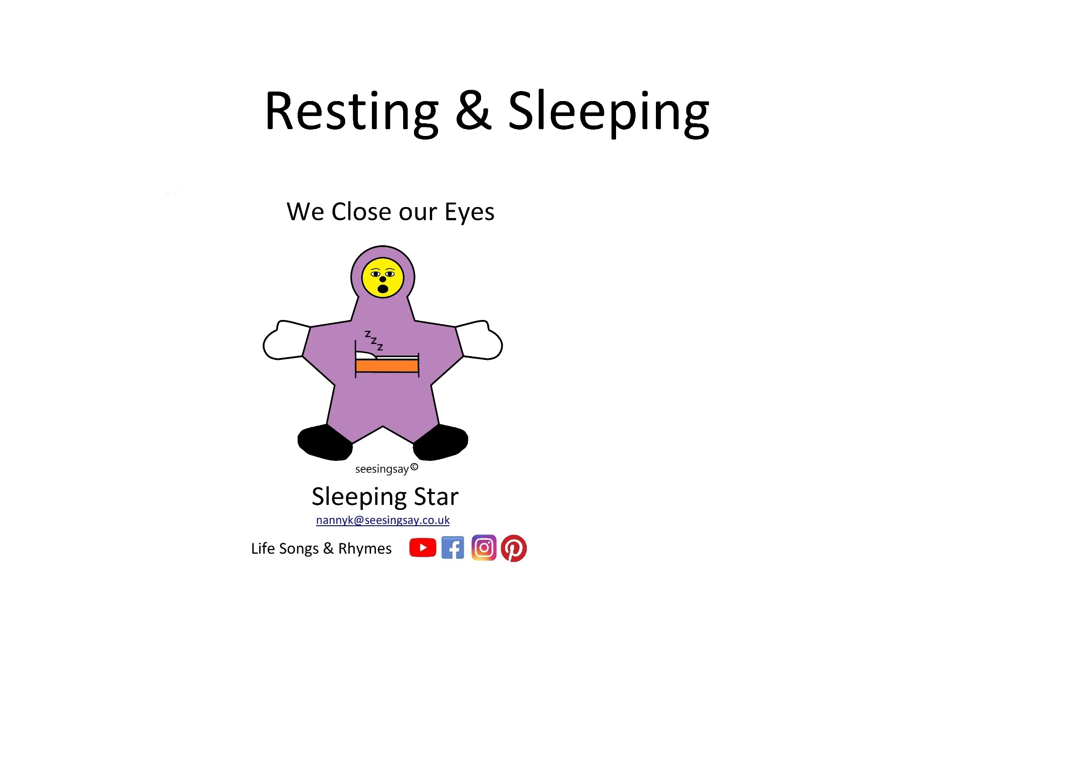

We close our eyes we stop moving
We close our eyes and we go to sleep

We close our eyes we rest our minds
We close our eyes and we go to sleep

We close our eyes we listen with our ears
We close our eyes and we go to sleep

We close our eyes we breathe with our nose
We close our eyes and we go to sleep

We close our eyes we rest our minds
We close our eyes and we go to sleep

We close our eyes we stop thinking
We close our eyes and we go to sleep

We close our eyes we stop moving
We close our eyes and we go to sleep

We close our eyes we hush our noise
We close our eyes and we go to sleep

We close our eyes we listen with our ears
We close our eyes and we go to sleep

We close our eyes we breathe with our nose
We close our eyes and we go to sleep

We close our eyes we rest our minds
We close our eyes and we go to sleep

We close our eyes we stop thinking
We close our eyes and we go to sleep

