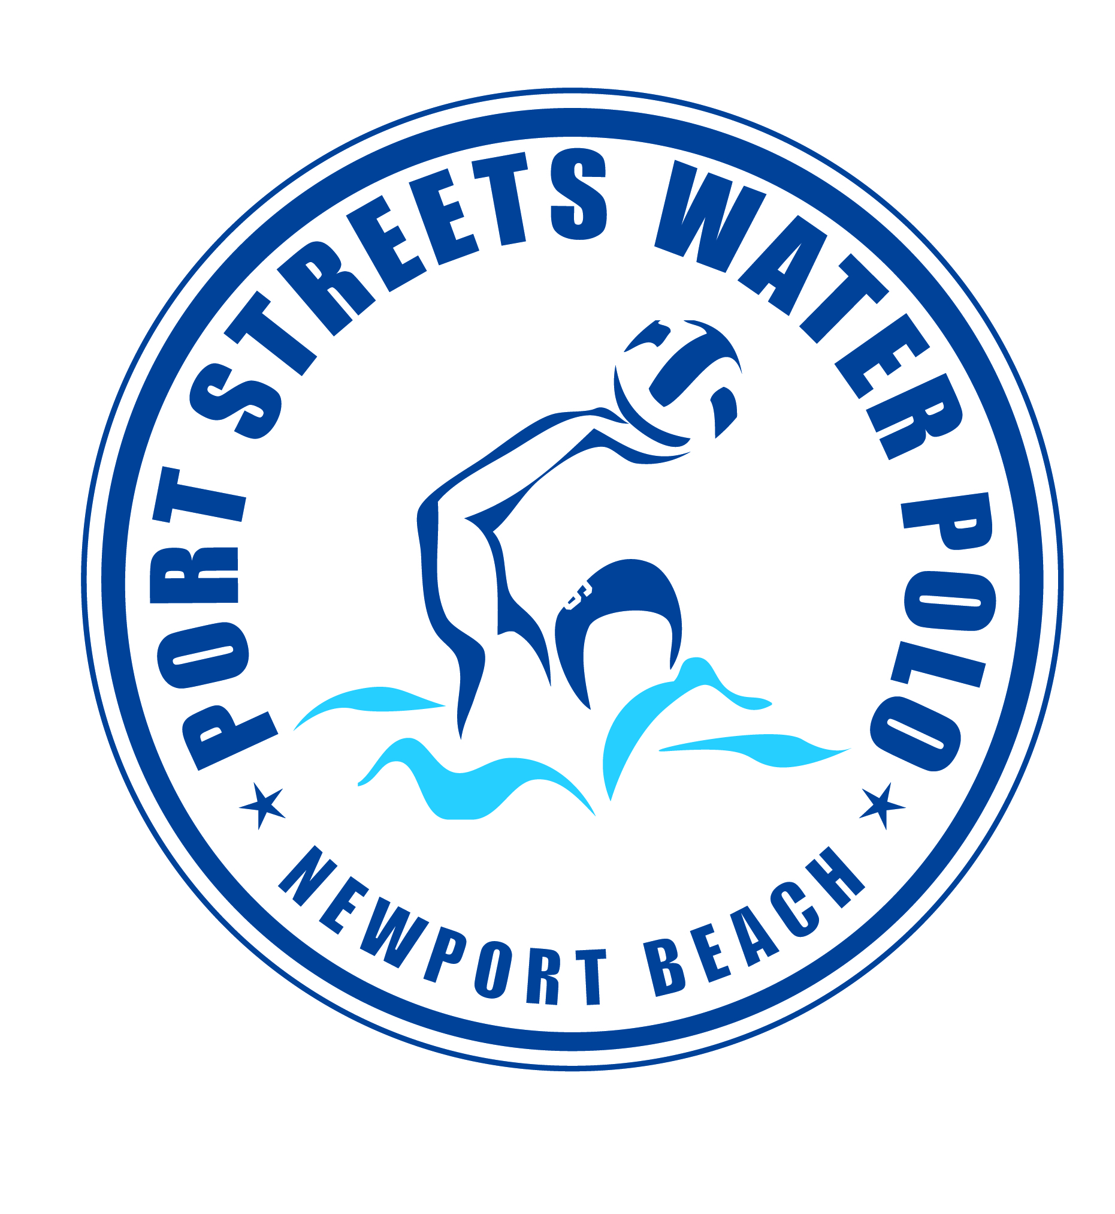
“PORT STREETS POLO” FALL 2025
with Coach Tom Norton @ Phase 1 Pool

September 2nd to November 20th

PRACTICE TIMES:
MONDAY-THURSDAY 5:30pm to 6:30pm

Tournaments: “K7 Evan Cousineau Cup” 10/4 & 10/5
SPA League Championships 11/1 & 11/2

ALL BOYS AND GIRLS Ages 8-11 years old are welcome to join!

This is a great water polo program for beginners and returning water polo players! Practices will focus on “balance in the water”, rules of the game, advancing ball handling skills and learning how to play as a team.

Fee: $495. VENMO: PortStreetsPolo
Questions? Please email waternorton@hotmail.com or call Tom Norton at (949) 584-6462.
FEES MUST BE PAID AND WAIVER SIGNED PRIOR TO PARTICIPATION
Parent or Guardian Name(s)_____________________________________
Phone Number________________________________________________
Email Address________________________________________________
Participants Name | Age | Date of Birth | Swim/Polo Experience
Emergency Medical Authorization: (Agent: Authorized agent of Harbor View Community Association)
I/We, parent(s)/person(s) having legal custody/ legal guardianship of the above listed minor do hereby authorize medical, dental or surgical diagnosis or treatment, and hospital care which is deemed advisable by, and is to be rendered under the general or on the medical staff of any hospital, whether such diagnosis or treatment is rendered at the office or said physician, dentist or at said hospital. It is understood that this authorization is given in advance of any special diagnosis, treatment, or hospital care being required but is given to provide authority to the aforesaid Agent to give specific consent to any; and all such diagnosis, treatment, or hospital care which a physician or dentist meeting the requirements of this authorization may in the exercise of his/her best judgment deem advisable.

Release of Liability: In consideration of your accepting this registration, I hereby agree to indemnify and hold harmless the Harbor View Community Association and any of the Port Streets Polo officers, agents, or employees from any liability or claim or action for damages resulting from or in any way arising out of participation in the program by the person.

Parents Signature (Required) Date:
_______________________ ______________

