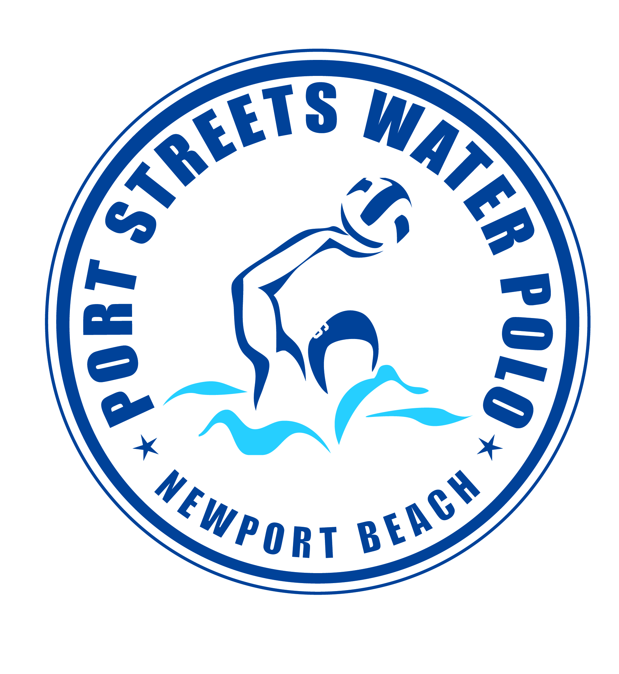
PORT STREETS POLO SPRING SESSION 2026
March 2nd to May 28th
Coach Norton @ Phase 1 Pool

PRACTICES MONDAY-THURSDAY 5:45pm to 6:45pm

ALL BOYS & GIRLS AGES 8-11 YEARS OLD!

This is a great water polo program for beginners and returning water polo players!

Practices will focus on strategies, rules of the game, advancing individual ball handling skills and learning how to play as a team. Practice is offered 4 days a week and daily attendance is encouraged but not mandatory.

Tournament: KAP7 CUP April 18th & 19th (fees apply)

Fee: $495 VENMO: PORTSTREETSPOLO
Questions? Email waternorton@hotmail.com or call Tom Norton at (949) 584-6462.
FEES MUST BE PAID AND WAIVER SIGNED PRIOR TO PARTICIPATION
Parents Name(s)________________________________________________
Email Address__________________________________________________
Phone Number _________________________________________________
Emergency Contact______________________________________________
Athletes Name | Age | Date of Birth | Polo/Swim Experience

Release of Liability: In consideration of your accepting this registration, I hereby agree to indemnify and hold harmless the Harbor View Community Association, Port Streets Polo and any of its officers, agents, or employees from any liability or claim or action for damages resulting from or in any way arising out of participation in the program by the person.

Parents Signature (Required)__________________________ Date: _________

