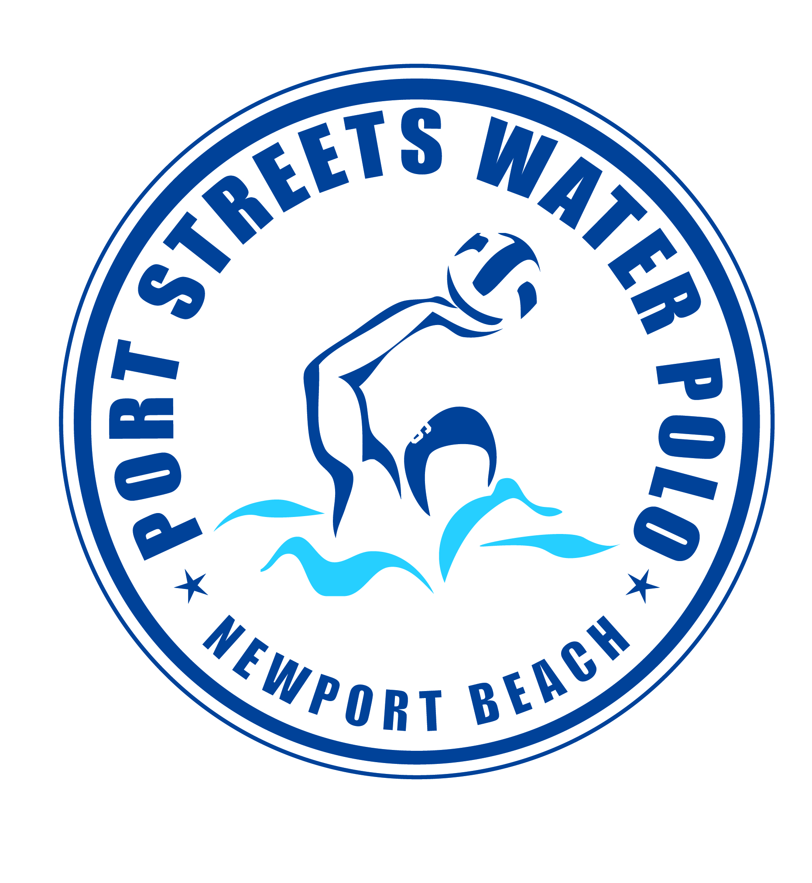
“SPLASH BALL” SPRING 2025
with Coach Tom Norton @ Phase 1 Pool

SESSION 1: March 11th to April 3rd
Practice TUESDAYS, WEDNESDAYS & THURSDAYS
5:45pm to 6:30pm

SESSION 2: April 15th to May 8th
Practice TUESDAYS, WEDNESDAYS & THURSDAYS
5:45pm to 6:30pm

SESSION 3: May 13th to June 5th
Practice TUESDAYS, WEDNESDAYS & THURSDAYS
5:45pm to 6:30pm

ALL BOYS AND GIRLS Ages 7, 8 years old welcome to join!

Splash Ball is the little kid’s version of water polo where the athletes can touch the bottom of the pool. Come and join the fun!!!

Fee: EACH SESSION $225. VENMO: PortStreetsPolo
Questions? Please email waternorton@hotmail.com or call Tom Norton at (949) 584-6462.
FEES MUST BE PAID AND WAIVER SIGNED PRIOR TO PARTICIPATION
Parent or Guardian Name(s)____________________________
Phone Number_______________________________________
Email Address_______________________________________
Participants Name | Age | Date of Birth | Swim/Polo Experience

Release of Liability: In consideration of your accepting this registration, I hereby agree to indemnify and hold harmless the Harbor View Community Association and any of the Port Streets Polo officers, agents, or employees from any liability or claim or action for damages resulting from or in any way arising out of participation in the program by the person.

Parents Signature (Required) Date:
_______________________ ______________

