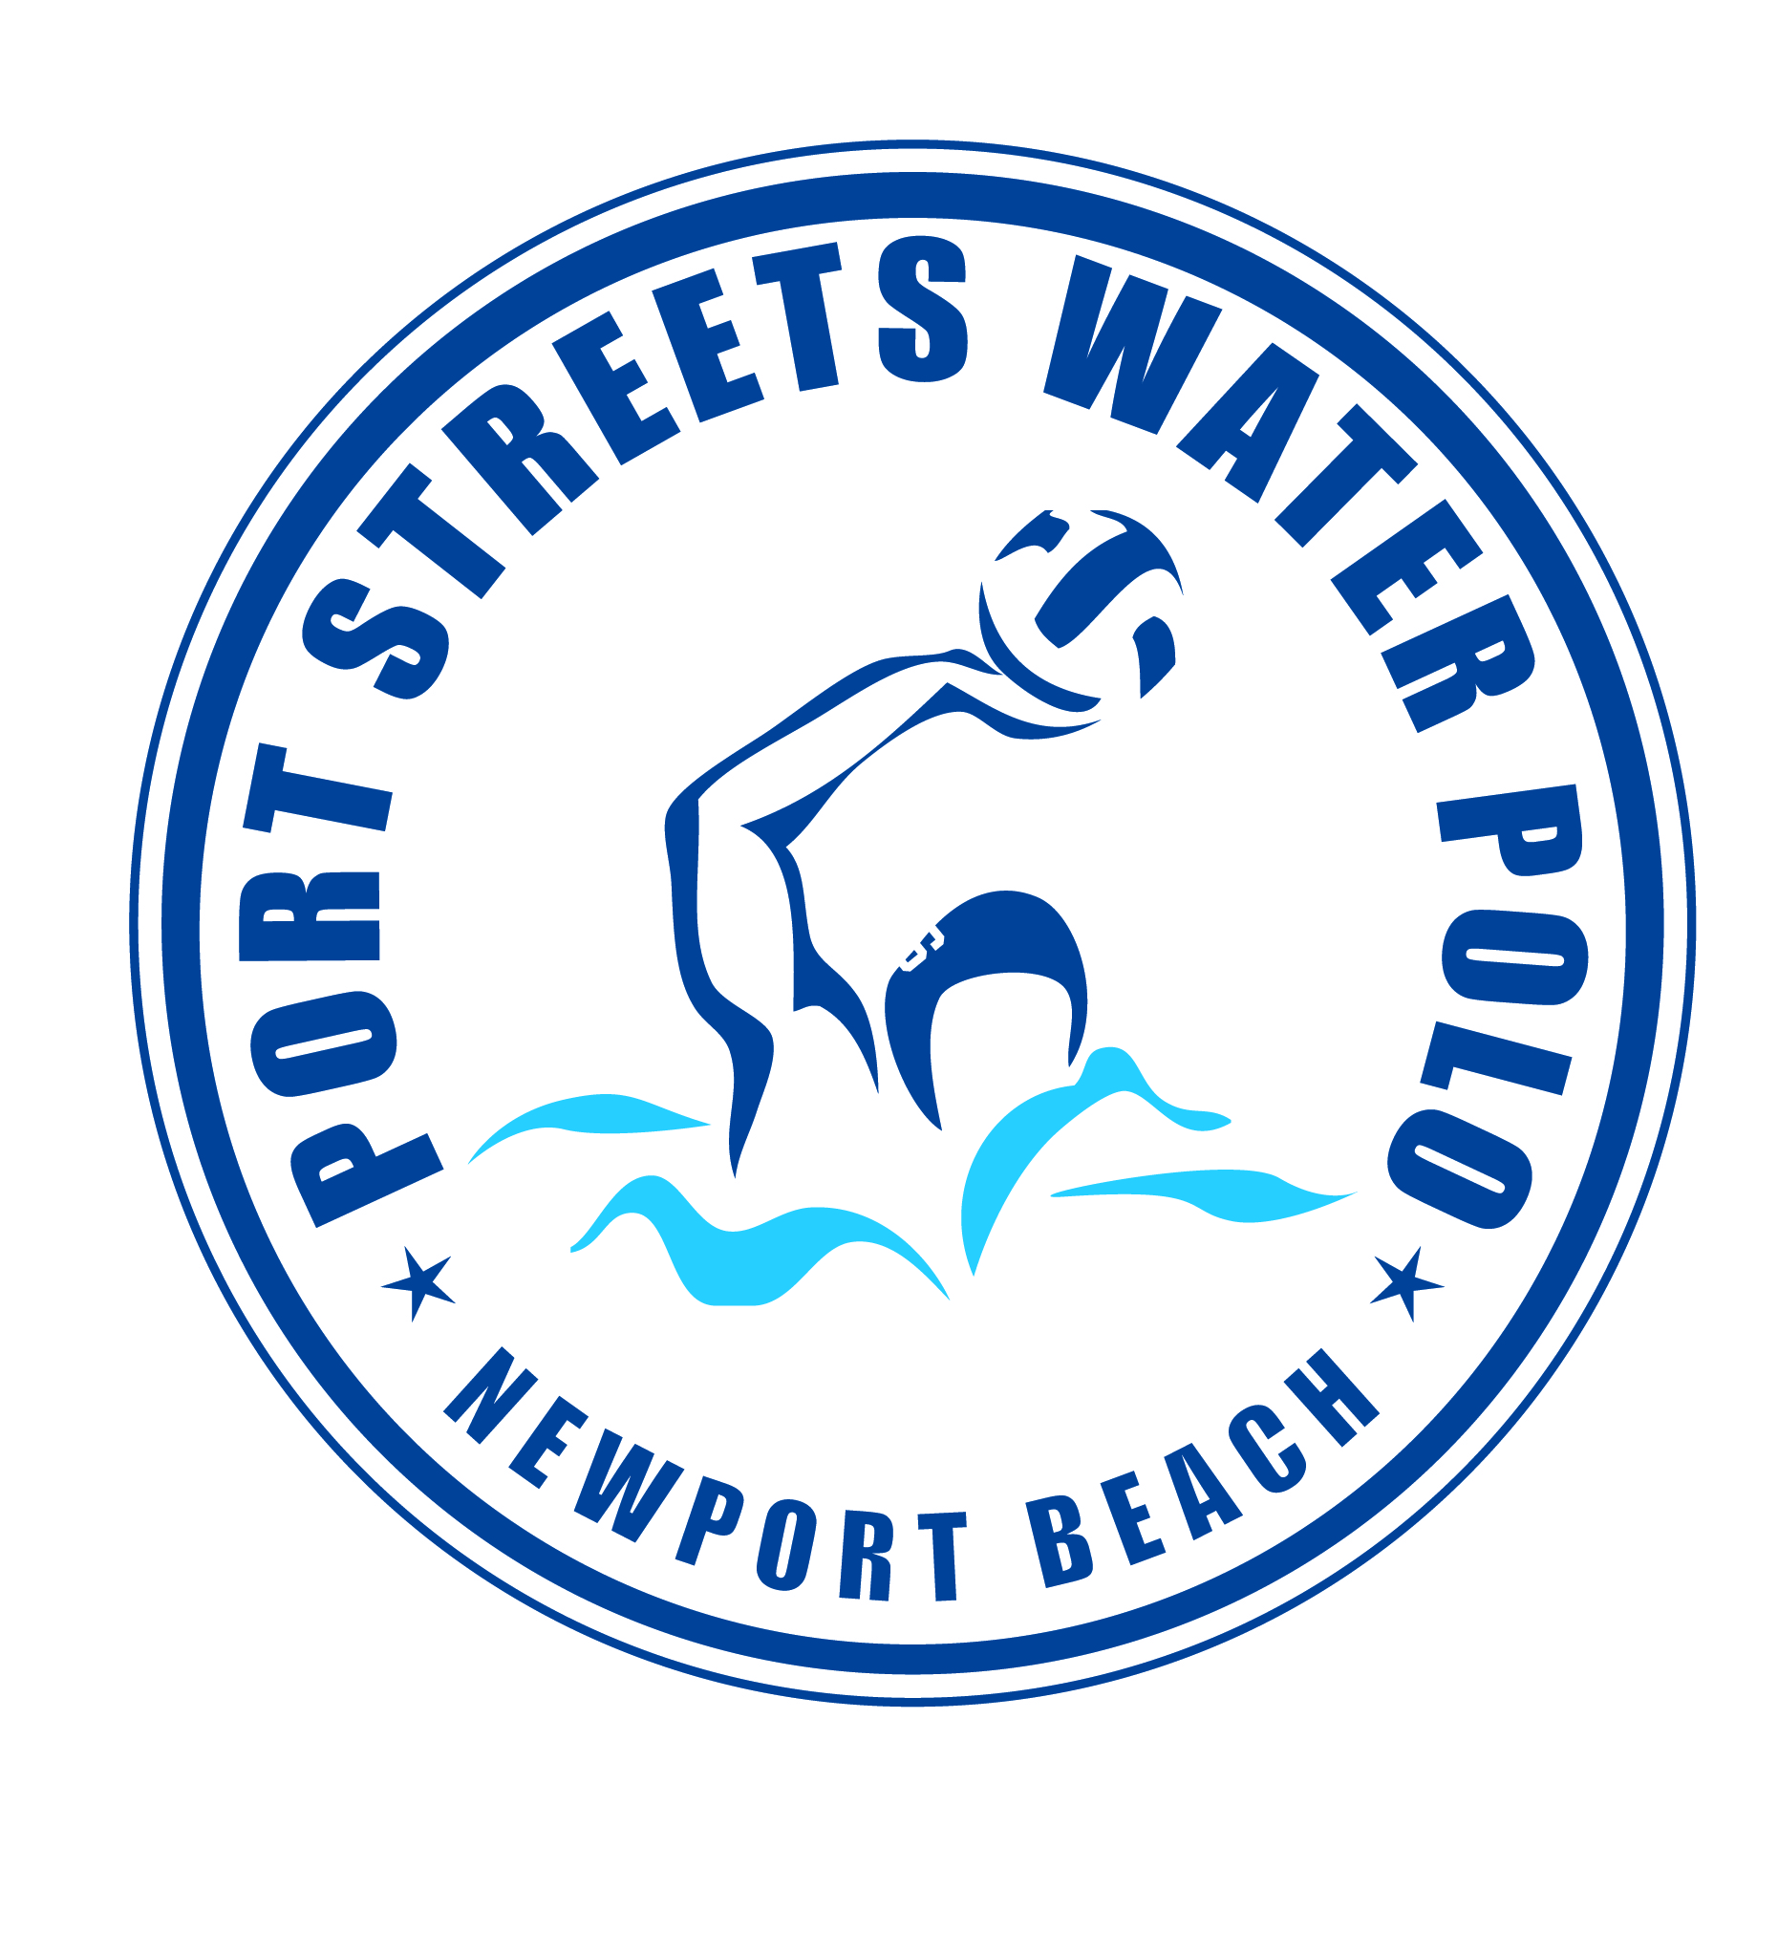

PORT STREETS POLO SPRING SESSION 2025

March 3rd to May 29th

*Coach Norton @ Phase 1 Pool*

PRACTICES MONDAY-THURSDAY 5:45pm to 6:45pm

###### *ALL BOYS & GIRLS AGES 8-11 YEARS OLD*

###### *This is a great water polo program for beginners and returning water polo players!*

###### *Practices will focus on strategies, rules of the game, advancing individual ball handling skills and learning how to play as a team.*

###### Tournament: KAP7 CUP April 12th & 13th (fees apply)



**Fee: $495 VENMO: PORTSTREETSPOLO**

**Questions? Email** [**waternorton@hotmail.com**](mailto:waternorton@hotmail.com) **or call Tom Norton at (949) 584-6462.**

**FEES MUST BE PAID AND WAIVER SIGNED PRIOR TO PARTICIPATION**

Parents Name(s)________________________________________________

Email Address__________________________________________________

Phone Number _________________________________________________

Emergency Contact______________________________________________

|  |  |  |  |
| --- | --- | --- | --- |
| Athletes Name | Age | Date of Birth | **Polo/Swim Experience** |
|  |  |  |  |
|  |  |  |  |

Release of Liability: In consideration of your accepting this registration, I hereby agree to indemnify and hold harmless the Harbor View Community Association, Port Streets Polo and any of its officers, agents, or employees from any liability or claim or action for damages resulting from or in any way arising out of participation in the program by the person.

Parents Signature (Required)__________________________ Date: _________