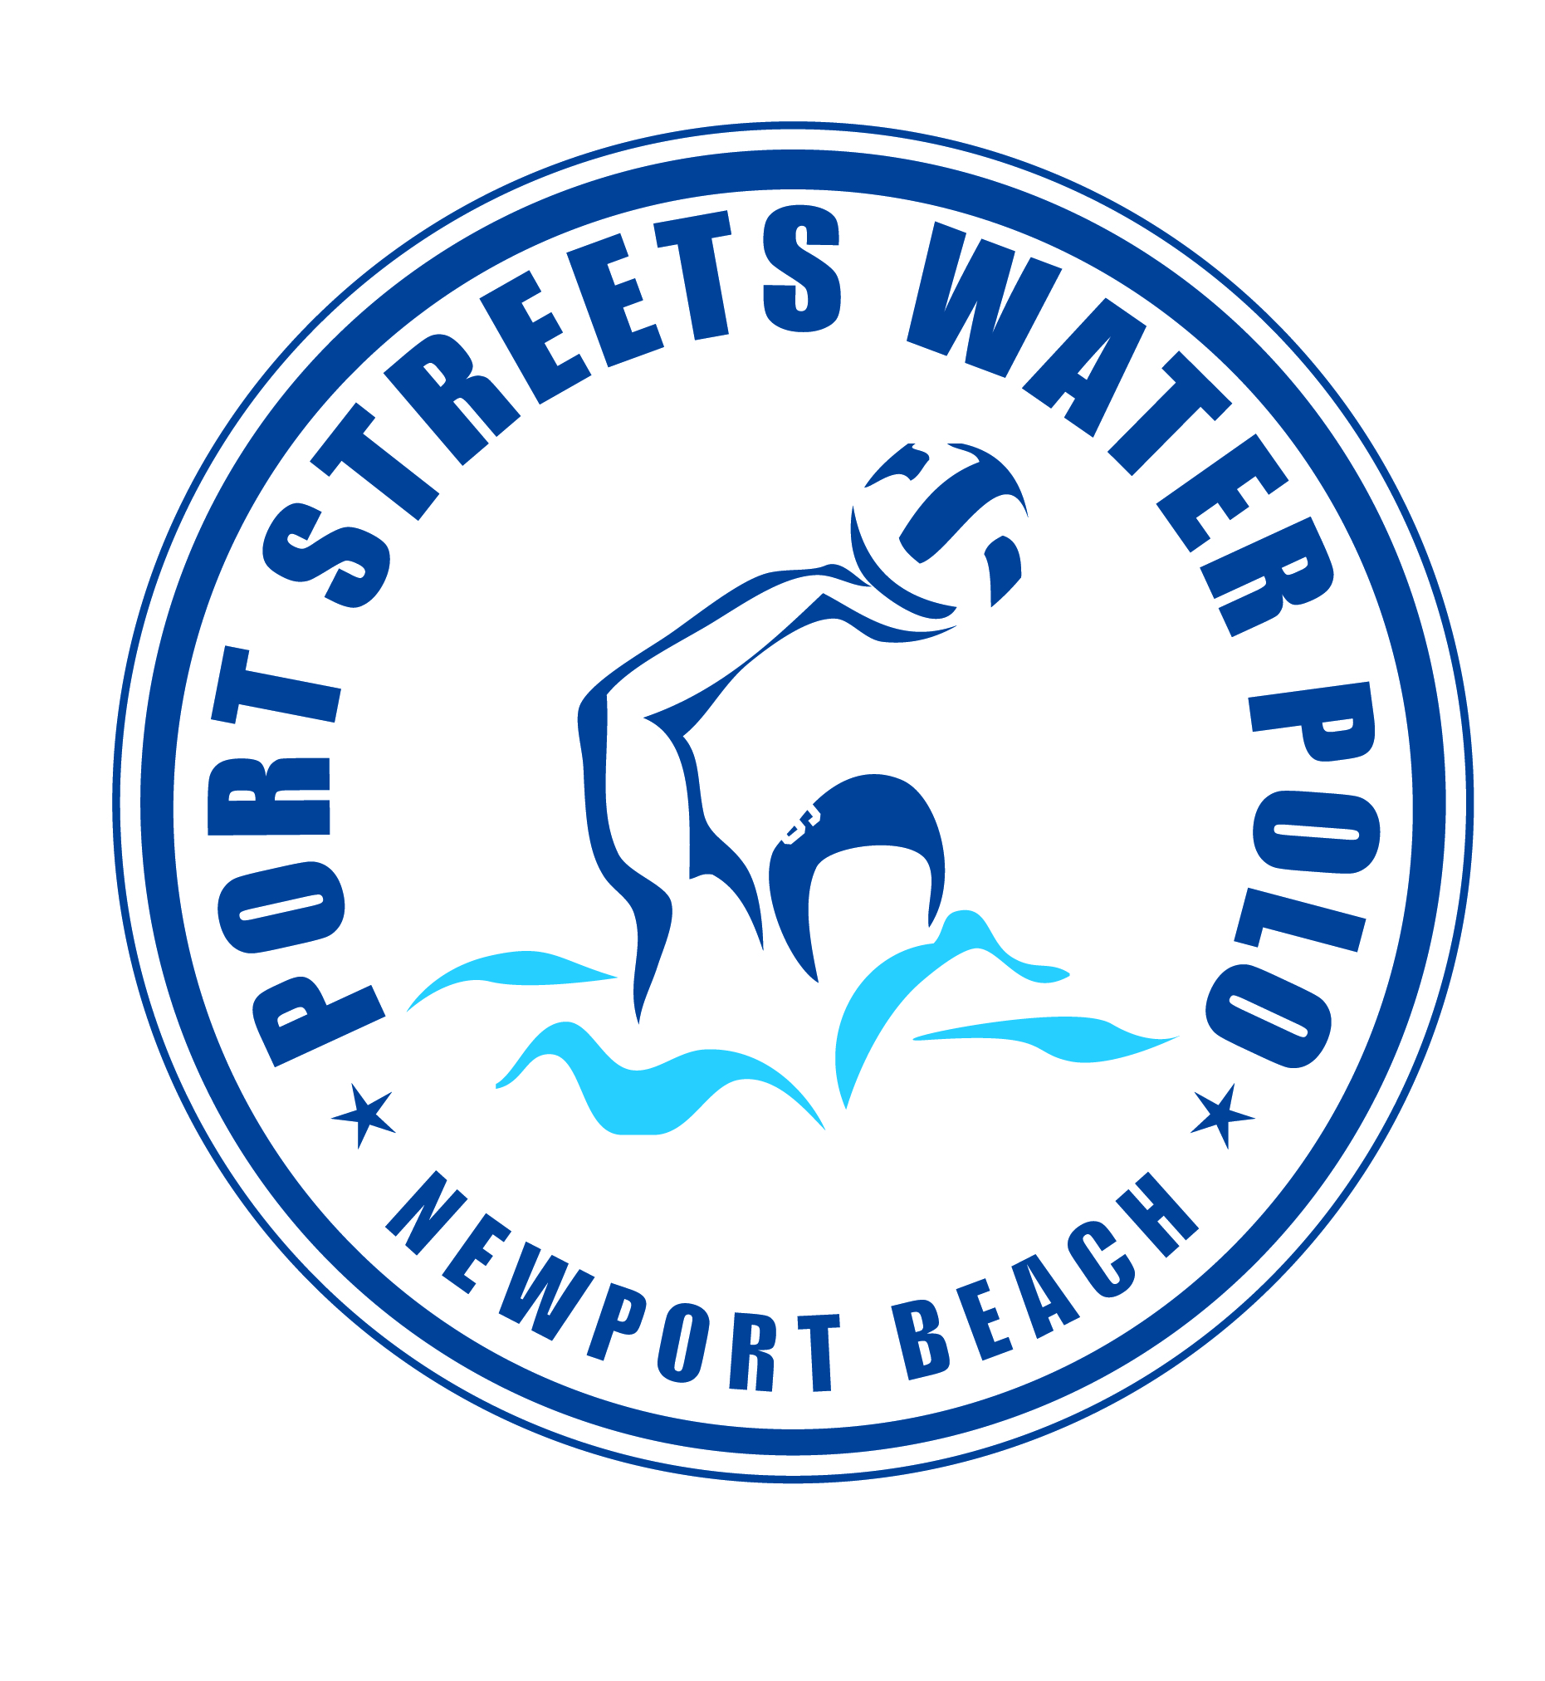
PORT STREETS POLO WINTER SESSION 2025-26
Coach Tom Norton @ Phase 1 Pool

December 1st to February 27th

PRACTICES: MONDAYS, TUESDAYS & WEDNESDAYS 5:30pm-6:30pm
& FRIDAYS 3:30pm-5pm

TOURNAMENT: Holiday Cup December 13th & 14th (fees apply)

ALL BOYS AND GIRLS Ages 8-11years old are welcome to join!

This is a great water polo program for beginners and returning water polo players!

Practices will focus on strategies, rules of the game, advancing individual ball handling skills and learning how to play as a team.

Fee: $495 VENMO: PORTSTREETSPOLO
Questions? Email waternorton@hotmail.com or call Tom Norton at (949) 584-6462.
FEES MUST BE PAID AND WAIVER SIGNED PRIOR TO PARTICIPATION
Parents Name(s)________________________________________________
Email Address__________________________________________________
Phone Number _________________________________________________
Emergency Contact______________________________________________
Athletes Name | Age | Date of Birth | Polo/Swim Experience

List allergies or medical concerns if any ________________________
Release of Liability: In consideration of your accepting this registration, I hereby agree to indemnify and hold harmless the Harbor View Community Association, Port Streets Polo and any of its officers, agents, or employees from any liability or claim or action for damages resulting from or in any way arising out of participation in the program by the person.

Parents Signature (Required)___________________________________ Date: _________

