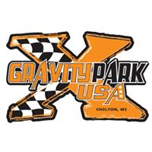
W.2571 HICKORY HILLS RD, CHILTON, WI 53014

GATES OPEN 4PM, RACING 7PM

FRIDAY, MAY 10TH SEASON OPENER - DIRTGRINDER
SATURDAY, MAY 11TH AMA/DISTRICT 16 MX AND SHORT TRACK
FRIDAY, MAY 17TH – DIRTGRINDER
FRIDAY, JUNE 14TH – DIRTGRINDER
FRIDAY, JUNE 21ST
STADIUMCROSS
SATURDAY, JUNE 29TH (NIGHT RACE)
SUNDAY, JUNE 30TH (MORNING RACE)
THIS RACE WILL BE A COMBINED OVERALL OF THE TWO DAYS FOR THE BIG TROPHIES
FRIDAY, JULY 12TH DIRTGRINDERS
FRIDAY, JULY 26TH DIRTGRINDERS
FRIDAY, AUGUST 9TH DIRTGRINDERS
SATURDAY, AUGUST 10TH AMA/DISTRICT 16 MX AND SHORT TRACK. STATE CHAMPIONSHIP ON THE SHORT TRACK
FRIDAY, AUGUST 23RD DIRTGRINDERS
SATURDAY, AUGUST 24TH AMA/DISTRICT 16 – MX TRACK

SCHEDULE SUBJECT TO CHANGE!
Contact: Bob 920.378.3864 or Kelly 920.418.0438

