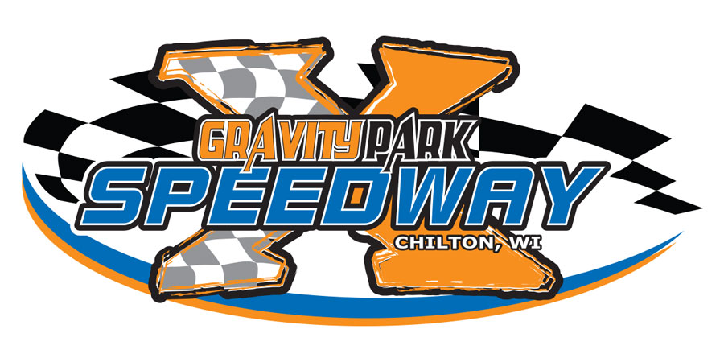

W.2571 HICKORY HILLS RD, CHILTON, WI 53014

GATES OPEN 4PM, RACING 7PM

FRIDAY, APRIL 19TH SEASON OPENER
APRIL 26th
MAY 3rd
MAY 10th
MAY 17th
MAY 24TH - VINTAGE MOD
MAY 26th ENDURO RACE 6PM - SUNDAY
MAY 31st
JUNE 7th
JUNE 14th
JUNE 21ST – VINTAGE MOD
JUNE 28TH – WISCONSIN LEGENDS
JULY 5th
JULY 12th
JULY 19th – STOCK CARS CLASS OFF
JULY 26th – VINTAGE MOD
AUGUST 2nd
AUGUST 9th – WISCONSIN LEGENDS
AUGUST 16th – VINTAGE MOD
AUGUST 23rd
AUGUST 30th – CHAMPIONSHIP NIGHT
**FALL CLASSIC SEPTEMBER 20th AND 21st **
CHECK FACEBOOK FOR UDATES!! www.gravityparkusa.com
SCHEDULE SUBJECT TO CHANGE!
Contact: Bob 920.378.3864 or Kelly 920.418.0438

