Social Emotional Learning (SEL) and DDAAT-App

Curriculum Synthesis

**Synthesis Objective**: This synthesis aligns the resources provided by the Digi-dad Advice Anytime Application (DDAAT-APP) with the core competencies in the Social Emotional Learning (SEL) framework outlined in the Collaborative for Academic, Social, and Emotional Learning research center (CASEL).

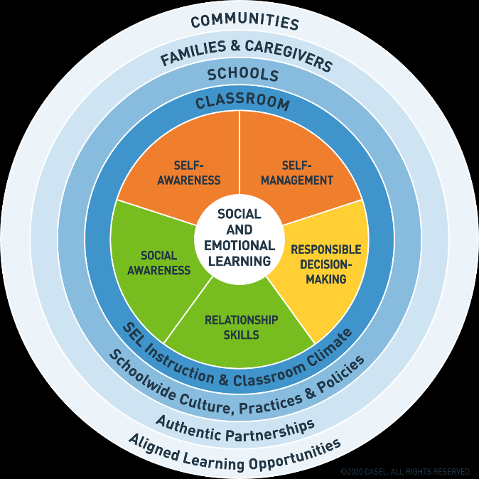

**What is SEL?**

According to Collaborative for Academic, Social, and Emotional Learning (CASEL) website, “social and emotional learning (SEL) is an integral part of education and human development. SEL is the process through which all young people and adults acquire and apply the knowledge, skills, and attitudes to develop healthy identities, manage emotions and achieve personal and collective goals, feel and show empathy for others, establish and maintain supportive relationships, and make responsible and caring decisions”.

**What is DDAAT-APP?** DDAAT-APP is a student support resource that provides male mentorship in the form of advice on a number of topics related to the core competencies of SEL for students. This application provides a database of digital resources such as videos from fathers, male community leaders, and male stakeholders to address the needs of at-risk student populations who may be impacted by absentee fathers and/or inconsistent interaction with positive male role models.

Due to the ease of accessibility, DDAAT-APP provides a convenient resource that can be used by districts, schools, parents, communities and other educational stakeholders to meet the social/emotional needs of at-risk populations.

The following document provides a resource that demonstrates the ways schools can utilize the DDAAT-APP as an instructional tool to address SEL.

|  |  |
| --- | --- |
| **Social and Emotional Learning (SEL) Competency** | **DDAAT-APP Resources** |
| Social Awareness | Male virtual video library on topics outlined in this competency; automated interactive real-time responses; routing to Telehealth virtual counseling resources from professional counseling agencies. |
| Responsible Decision Making | Male virtual video library on topics outlined in this competency; automated interactive real-time responses; routing to Telehealth virtual counseling resources from professional counseling agencies. |
| Self-management | Male virtual video library on topics outlined in this competency; automated interactive real-time responses; routing to Telehealth virtual counseling resources from professional counseling agencies. |
| Relationship Skills | Male virtual video library on topics outlined in this competency; automated interactive real-time responses; routing to Telehealth virtual counseling resources from professional counseling agencies. |
| Self-Awareness | Male virtual video library on topics outlined in this competency; automated interactive real-time responses; routing to Telehealth virtual counseling resources from professional counseling agencies. |

**Sample SEL/DDAAT-APP Lesson Plan**

|  |  |
| --- | --- |
| **Grade Level: 7th Grade** | **SEL Standard:** Identifying One’s Emotions; Demonstrating empathy and awareness; showing concern for the feelings of others |
| **SEL Competency:** Self-Awareness; Social Awareness | **Lesson Topic:** Coping With Divorced/Single Parents Dating and Changes in Parent Relationships |

|  |
| --- |
| **Objectives:** SWBAT- understand how coping with parental relationship changes can be difficult and identify psychological reasons why; understand parents’ perspectives and concerns during these changes; identify appropriate responses and healthy ways students can cope with these changes;  **Materials:** Journals, computer for access to DDAAT-APP, different relationship scenarios, emotion reaction sheets.  **Introduction: (10 mins)**Students will watch the video on the DDAAT-APP resource library on “Dealing with Parents Dating”  Afterwards, students will reflect on the video with the following prompts:   1. What emotions do you think a child experiences when one of their parents becomes involved in a relationship with another adult?   **Presentation of General Information**: **(15 mins)** In a powerpoint presentation, teacher will present statistics on marriage, divorce and relationships in the U.S. to illustrate to students that relationships can change in a variety of ways and discuss with students. Teacher will also present information in a powerpoint presentation about common psychological reactions to changes in parent relationships and healthy ways parents and students can deal with these changes.  **Guided Practice**: **(20 mins)** Students will be split into groups and be provided with different relationship scenarios. They will rotate to different stations around the classroom that have appropriate and inappropriate reactions to the scenarios they have in their own groups. At each station, students will be required to fill in their reaction sheets. These sheets require students to read the reactions and answer the following questions: Based on your scenario, would this reaction be appropriate? If so, why? If not, what alternative way could someone respond?  **Independent Practice**: Independently, students will complete an exercise where they are asked to imagine the perspective of the parents in the scenarios of the groups they participated in. Students will identify emotions they think parents experience in these scenarios and write a letter to children to advise them on how to respond appropriately to these scenarios based on the information they learned in class.  **Closing Activity/Review of Skill**:  3-2-1 Exit Ticket in bullet form students will share 3 ways they can appropriately respond to changes in the relationships of their parents, 2 ways parents can help children, 1 concern or question they may still have. |

|  |
| --- |
| **Accommodations/Modifications:** Guided notes can be provided for students who require instructional support during note taking |