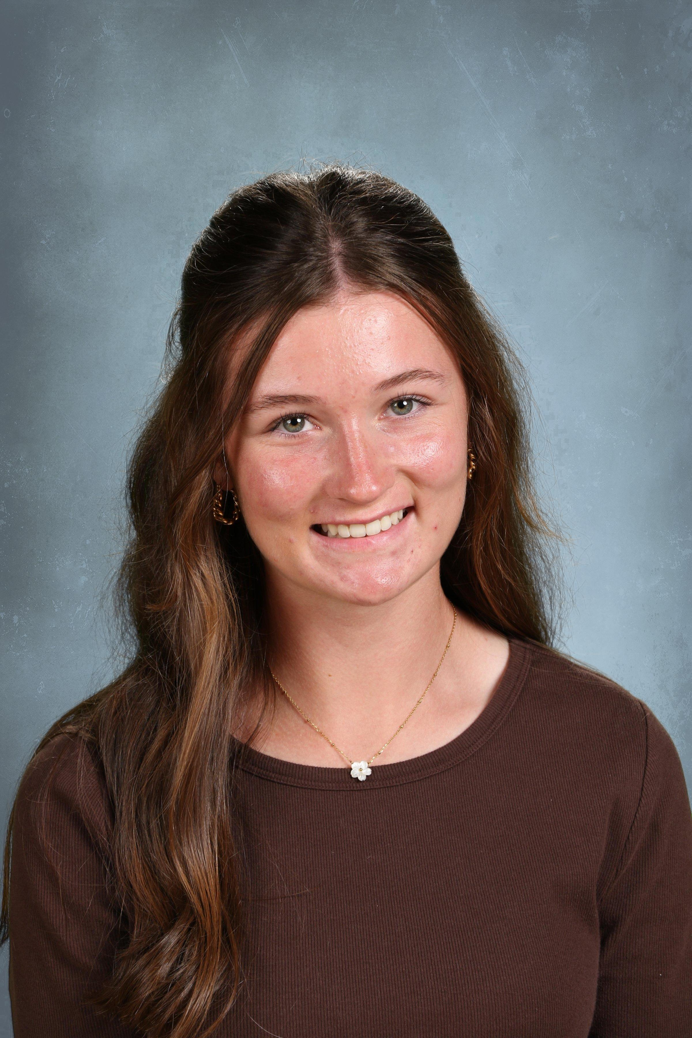
Golf & Academic Resume

Ellie Sticha
Alexandria Area High School - Class of 2026
D.O.B. 10/28/08 (Age:16)

Personal Information

Website: elliesticha.com Email: esticha@icloud.com
Height: 5’ 6” Weight: 115 lbs.

Personal Statement: My love for golf started at an early age. Growing up in a family who enjoyed taking golf vacations gave me an opportunity to play courses varying in difficulty and location. Starting school a year ahead of my peers, I have grown accustomed to interacting and competing with people who are older than me; an asset that has been beneficial to my golf game. Contrary to what most people think, being a year or more younger than my competitors gives me confidence that has been important throughout my life. I was involved with the Minnesota Junior PGA and Minnesota Golf Association at a very early age and strive to participate in tournaments on a national level. Possessing a true passion for the game, I take my golf game seriously and hope to play competitive collegiate golf while studying for a career in medicine.
I focus my tournament selection on difficulty and strength of field rather than trying to achieve and maintain a certain ranking. I participate in as many 6,000+ yd tournaments as possible. Additionally, I follow a number of women’s college golf teams on Instagram and the one thing I love to see is how much fun they are having. Whether they are practicing, working out or spending free time together, they really seem to care about one another and enjoy each others company. I can’t wait to be part of such a group.

______________________________________________________________________________

Parent Information

Father: Russell Sticha Mother: Maureen Sticha
College Attended: University of Minnesota College Attended: Washburn University
Post Graduate: Des Moines University Post Graduate: Des Moines University

Academic Information

Name of High School: Alexandria Area High School
Graduation Date: June 2026 Cumulative GPA: 3.96 Class Rank: 22/344
ACT: N/A Academic Advisor: Carrie Urness (curness@alexschools.org)

Registered with NCAA Eligibility Center: Yes
Registration Number: 2209657766

______________________________________________________________________________

Academic Awards

Nominated to National Youth Leadership Forum: Explore STEM 2022 (Loyola University)
Advanced Placement Courses: Honors Physical Science, AP Human Geography, AP Biology

______________________________________________________________________________

Other Extracurricular Activities

Competitive Dance (performed at local and regional competitions many times per year) 2011-2017
Performs in Plays/Musicals (ongoing)
Concert Band (Percussion-Section Leader) 2019 - current
Jazz Band (Drum Kit) 2019 - current
Pit Orchestra (Percussion) 2022 - current
MSHSL Section Visual Arts Festival (Original Drawing Superior Rating - 2024)

______________________________________________________________________________

Service Organizations/Volunteer Work

Legacy of the Lakes Museum & Gardens (Clean up, Greeter, Boat Show etc.) 2018 - current
V.I.B.E. Service Organization (Voice, Influence, Build, Educate) 2021 - 2023
Key Club (Community Volunteer) 2022 - current
Leadership Council (Student Council, Community Volunteer) 2022 - current
Freshman Advisory Board (Nominated by teachers, Orientation for 8th grade students to High School) 2023

______________________________________________________________________________

Employment

Scott Dirck Golf Academy April 2023 - current
(Scheduling Lessons, Simulator Instruction, Selling Merchandise, Help Teaching Junior Golf, etc.)

______________________________________________________________________________

Home Course, Trainers & Coaches

Home Courses: Geneva Golf Club and Alexandria Golf Club
Club Pro: Grant Hanson Phone: (320) 762-7089 Email: granthanson@genvagolfclub.com
Swing Coach: Scott Dirck Phone: (320) 219-7677 Email: scottd@scottdirckgolf.com
Club Fitting: Sam Christiansen Phone: (320) 219-7677 Email: info@scottdirckgolf.com
High School Coach: Tim Zupfer Phone: (320) 763-5254 Email: timothyzupfer@gmail.com
Assistant Coach: Lauren Stockmoe Phone: (320) 491-5188 Email: laurenstockmoe@gmail.com

*Year-Round Member Scott Dirck Golf Academy in Alexandria, MN

______________________________________________________________________________

High School Golf Experience: Team

Minnesota Central Lakes Conference Championship
2022 8th Grade (R1:291 R2:315 1st Place Pebble Lake GC/Eagle Creek GC, Fergus Falls/Willmar)
2023 Freshman (R1:326 R2:312 1st Place Rich Spring GC/Territory GC, Cold Spring/St. Cloud)
2024 Sophomore (R1:342 R2:321 2nd Place Maddens East GC/Wapicada GC, Baxter/St. Cloud)
Minnesota Section 8AAA Championship
2022 8th Grade (R1:338 R2:311 1st Place Rich Spring GC, Cold Spring)
2023 Freshman (R1:320 R2:325 2nd Place Headwaters GC, Park Rapids)
2024 Sophomore (R1:330 R2:344 1st Place, Greystone Golf Club, Sauk Centre)
Minnesota Class AAA State Tournament
2022 8th Grade (R1:318 R2:310 1st Place Bunker Hills GC, Coon Rapids)
2024 Sophomore (R1:346 R2:336 4th Place Bunker Hills Golf Club, Coon Rapids)

______________________________________________________________________________

High School Golf Experience: Individual (Complete Tournament File Available Upon Request)

Minnesota Central Lakes Conference Championship
2022 8th Grade (R1:82 R2:86, 13th/44, Pebble Lake GC/Eagle Creek GC, Fergus Falls/Willmar)
2023 Freshman (R1:79 R2:82, 5th/47, Rich Spring GC/Territory GC, Cold Spring/St. Cloud)
2024 Sophomore (R1:83 R2:82, 7th/47, Madden’s Pine Beach East GC/Wapicada GC, Baxter/St. Cloud)
Minnesota Section 8AAA Championship
2022 8th Grade (R1:102 R2:86, T31st/48, Rich Spring GC, Cold Spring, MN)
2023 Freshman (R1:87 R2:88, T16th/47, Headwaters GC, Park Rapids, MN)
2024 Sophomore (R1:78 R2:92, 6th/66, Greystone GC, Sauk Centre, MN)
Minnesota Class AAA State Tournament
2022 8th Grade (R1:92 R2:92, T70th/88, Bunker Hills GC, Coon Rapids, MN)
2024 Sophomore (R1:81 R2:78, T20th/87, Bunker Hills GC, Coon Rapids, MN)

______________________________________________________________________________

Minnesota All-State Ranking

Minnesota State High School League Class 3A All-State Ranking (iWanamaker App)
(top 20 considered All-State golfers)
Year iWR Differential Place
2022 (8th Grade) 5.443 47/769
2023 (Freshman) 5.159 80/769
2024 (Sophomore) 1.885 25/853

______________________________________________________________________________

High School Golf Honors & Achievements

Central Lakes Conference Performer of the Week
*4/21/22 Shot 38 (Eighth Grade-Varsity) Took 2nd Place (9-hole tourn.) Braemar GC Edina, MN
*5/20/24 Shot 80/74 for 4th/118 Tri-State Preview Invitational, Bunker Hills GC Coon Rapids, MN
Most Improved Varsity Player 2022 (Lowered Varsity scoring average by 10 strokes from previous year)
Lowered Gross Scoring Average by 7.5 Strokes from Freshman to Sophomore Seasons Cardinal
Athlete Profile Radio Station KXRA-FM 100.3
*6/22/24 Recognized with teammate for outstanding high school season and State Tournament
MVP Alexandria Girls Golf Team (2024)
High School Varsity Letter in Golf (2021, 2022, 2023, 2024)
First Team All-Conference Player (2022, 2023, 2024)
Spotlight on Scholarship Award (2022, 2023, 2024)
MSHSL 3A State Qualifier (2022, 2024)
Top 10 Central Lakes Conference Championship (2023, 2024)
Top 10 Class 3A Section 8 Championship (2024)
Top 20 Class 3A State Championship (2024)

______________________________________________________________________________

High School Golf Notable Finishes

Central Lakes Conference Championship,Territory/Rich Spring GC (R1:79, R2:82, 5th/44) May 22, 2023
Alexandria Invitational, Alexandria GC, Alexandria, MN (77, T5/94) April 24, 2024
Tri-State Preview Invitational, Bunker Hills GC, Coon Rapids, MN (R1:80, R2:74, T4/118) May 17-18, 2024
MSHSL 3A State Tournament, Bunker Hills GC, Coon Rapids, MN (R1:81, R2:78, T20/87) June 11-12, 2024

______________________________________________________________________________

Golf Camps

Share My Passion Girls Golf Clinic-Annika Foundation
3M Open TPC Twin Cities Blaine, MN July 19, 2021
Northland Fellowship of Christian Athletes Golf Camp
Pebble Creek Golf Course Becker, MN June 26-28, 2022

______________________________________________________________________________

Drive, Chip & Putt

Local Qualifier Girls 14-15 Alexandria GC, Alexandria, MN July 5, 2023
Drive: 41 Chip: 31 Putt: 45 Total: 117 Place: 1st Overall, 1st Drive, 1st Chip, 1st Putt
Sub-Regional Qualifier Girls 14-15 Braemar GC, Edina, MN August 6, 2023
Drive: 40 Chip: 30 Putt: 60 Total: 130 Place: 1st Overall, 1st Drive, 1st Putt
Regional Qualifier Girls 14-15 Castle Pines GC, Castle Rock, CO September 24, 2023
Drive: 38 Chip: 26 Putt: 40 Total: 104 Place: 6th Overall, 3rd Drive (missed 1st overall by 1 drive OB)

______________________________________________________________________________

Stroke Play Tournaments Junior (Complete Tournament File Available Upon Request)

Geneva GC Club Championship
Co-Ed Junior Championship 13-18, Geneva GC Islands/Ponds, Alexandria, MN, September 2022
5,633 yds. Rating/Slope: 72.8/127 Par 72 (R1:83, 5th/14)

Minnesota Section Junior PGA (9/18-Hole Events)
*MNPGA, Junior Tour/Players Tour, 9-hole and 18-hole tournaments, 2019 - current (22 tournaments on file)

MNPGA Junior Tour - Thumper Pond Golf Course, Ottertail, MN August 9, 2022
5,342 yds. Rating/Slope: 71.5/127 Par 72 (R1:81, 2nd/7)
MNPGA Junior Tour - Lake Miltona GC, Alexandria, MN July 14, 2023
5,127 yds. Rating/Slope: 69.2/116 Par 72 (R1:81, 2nd/8)

Minnesota Section Junior PGA (36-Hole Events)
*MN Section Junior PGA, 36-hole tournaments, 2022 - current (11 tournaments on file)

MNPGA Players Tour - Edinburgh USA/Rush Creek GC, Maple Grove, MN July 26-27, 2022
5,709 yds. Rating/Slope: 75.6/144 Par 72 (R1:77 R2:91, 5th/20)
MNPGA Players Tour Fall Event at Detroit CC, Detroit Lakes, MN Sept 17-18, 2022
5,577 yds. Rating/Slope: 74/128 Par 72 (R1:92 R2:90, 7th/8)
MN Section Girls Junior PGA Championship, Legacy Golf, Faribault, MN June 19-20, 2023
5,779 yds. Rating/Slope: 73.8/126 Par 72 (R1:90 R2:89, T51/62)
MNPGA Players Tour - The Classic at Maddens, The Classic at Maddens, Baxter, MN June 27-28, 2023
5,438 yds. Rating/Slope: 72.9/133 Par 72 (R1:100 R2:85, 15th /21) *significant bad weather
MNPGA Players Tour - Minnewaska/Geneva, Minnewaska/Geneva, Alexandria, MN July 26-27, 2023
5,633 yds. Rating/Slope: 73.3/129 Par 72 (R1:85 R2:81, T11th/19)
MNPGA Players Tour - Bunker Hills GC, Coon Rapids, MN July 1-2, 2024
5,615 yds. Rating/Slope: 72.1/124 Par 72 (R1:85 R2:78, T9/27)
MNPGA Players Tour - Minnewaska/Geneva, Minnewaska/Geneva, Alexandria, MN July 17-18, 2024
5,335yds./5,630 yds. Rating/Slope: 71.4/128/73.3/129 Par 72 (R1:87 R2:75, T8/22)
MNPGA Players Tour Fall Event at Detroit CC, Detroit Lakes, MN Sept 28-29, 2024
5,580 yds. Rating/Slope: 72.5/125 Par 71 (R1:88 R2:87, T4/6)

Stroke Play Tournaments Junior (cont’)

Minnesota Golf Association
Twin Cities Junior Championship, Victory Links GC, Blaine, MN June 23, 2022
5,560 yds. Rating/Slope: 72.1/126 Par 72 (R1:85, 5th/9)
Minnesota State Junior Girls Championship, Fox Hollow GC, St. Michael, MN July 11-12, 2022
5,743 yds. Rating/Slope: 74.8/135 Par 72 (R1:93 R2:92, 51st/65)
Minnesota State Junior Girls Championship, Emerald Greens GC, Hastings, MN July 11-12, 2023
6,024 yds. Rating/Slope: 72.0/120 Par 72 (R1:87 R2:83, MC, T44/61)
Minnesota State Junior Girls Championship, Victory Links GC, Blaine, MN June 25-27, 2024
5,734 yds. Rating/Slope: 72.9/128 Par 71 (R1:80 R2:83, MC, 32/66)

Tim Herron Prep Tour Invitational
Tim Herron Prep Tour - Geneva Golf Club Islands/Marsh, Alexandria, MN Sept. 30 - Oct. 1, 2023
5,893 yds. Rating/Slope: 74.9/130 Par 73 (R1:86 R2:79, 1st/2)
Tim Herron Prep Tour Championship, Windsong Farm, Independence, MN Oct. 14-15, 2023
6,231 yds. Rating/Slope: 75.8/137 Par 71 (R1:86 R2:90, 5/6)
Tim Herron Prep Tour - Hudson, Troy Burne GC/White Eagle GC, Hudson, WI August 19-20, 2024
6,032/6,112 yds. Rating/Slope: 75.2/135, 76.7/139 Par 71/72 (R1:86 R2:84, 4/7)
Tim Herron Prep Tour - Becker, Pebble Creek Golf Club, Becker, MN August 24-25, 2024
6,019 yds. Rating/Slope: 73.2/129 Par 72 (R1:85 R2:82, 2/3 (won playoff putting))
Tim Herron Prep Tour - Alexandria, Geneva Golf Club, Alexandria, MN October 5-6, 2024
6,012 yds. Rating/Slope: 74.9/130 Par 71 (R1:85 R2:79, 2/3)
Tim Herron Prep Tour Championship, Windsong Farm Golf Course, Independence, MN
6,231 yds. Rating/Slope: 75.8/137 Par 71 (R1:83 R2:88, 4/5) Led tournament through hole 32.

United States Golf Association
US Girls Junior Championship Qualifying, Oak Glen GC, Stillwater, MN June 6, 2023
5,934 yds. Rating/Slope: 72.7/130 Par 72 (R1:85, 23rd/27)

American Junior Golf Association
AJGA Austin Minnesota Junior Championship Qual, Austin Country Club, Austin, MN July 18, 2023
5,977 yds. Rating/Slope: 73.8/131 Par 72 (R1:89, Qualified)
AJGA Austin Minnesota Junior Championship, Austin Country Club, Austin, MN July 19-20, 2023
5,977 yds. Rating/Slope: 73.8/131 Par 72 (R1:94 R2:89 MC)
AJGA Austin Minnesota Junior Championship, Austin Country Club, Austin, MN July 18-20, 2024
5,914 yds. Rating/Slope: 73.8/131 Par 72 (R1:89 R2:82 MC)

Other 36-Hole Tournaments
Chaska Junior Invitational, Chaska Town Course & Hazeltine National GC, July 8-9, 2024
5,458/5,570 yds. Rating/Slope: 73/127, 73.6/132 Par 72 (R1:86 R2:92, 19/21)

_____________________________________________________________________________________

Stroke Play Tournaments Women

Minnesota Section PGA
MN Women’s State Open Championship, StoneRidge GC, Stillwater, MN August 8-9, 2023
6,052 yds. Rating/Slope: 74.9/130 Par 72 (R1:92 R2:92, 75th/78)

Stroke Play Tournaments Women (con’t)

Minnesota Golf Association
Women’s Amateur Championship, Minnewaska Golf Club, Glenwood, MN July 22-25, 2024
6,232 yds. Rating/Slope: 76.0/138 Par 72 (R1:88 R2:87 R3:93, 60/76)

______________________________________________________________________________

Match Play Tournaments

Resorters Tournament Alexandria Golf Club
2021 Co-Ed Age 10-12 Players: 28, Qualified for Champ Bracket: 16, Matches won: 2, Finish: Semi-Finals
2022 Co-Ed Age 13-15 Players: 24, Qualified for Champ Bracket: 16, Matches won: 1, Finish: Quarter-Finals
2023 Co-Ed Age 13-15 Players: 32, Qualified for Champ Bracket: 16, Matches won: 1, Finish: Quarter-Finals
2024 Co-Ed Age 13-15 Players entered: 48, Qualified for 1st Flight: 16, Matches won: 4, Finish: 1st Place

______________________________________________________________________________

Club Golf Honors & Achievements

Warrior Cup Invitation as a 12 y.o. Seventh Grader
Invitation to the MN Section Junior PGA Player’s Tour as a 13 y.o. Eighth Grader
Numerous Medalist Finishes Minny/Prep/Junior Tour Events MN Junior PGA
Qualified for Regional Drive, Chip & Putt Competition 2023
Tim Herron College Prep Tour Tied for 2nd in Point Totals 2024

______________________________________________________________________________

USGA Golf Handicap Information Network (updated 11/28/24)

GHIN #: 10862958 USGA Handicap Index: 4.5
Gross Scoring Average: 81.3 Tournament Scoring Average: 82.8
______________________________________________________________________________

Junior Golf Scoreboard Ranking (updated 11/28/24)

Overall Rank: 2768 Class 2026 Rank: 705 State Overall Rank: 24

State Class 2026 Rank: 10 Scoring Differential: 9.11 Strength of Tourn.: 98.14

______________________________________________________________________________

Rolex AJGA Ranking (updated 11/28/24)

Overall Rank: 1212 Total Points: 1.333 Average Points: 0.222
Junior Golf Hub Rankings (updated 11/28/24)

Overall Rank: 2478 Class 2026 Rank: 469 State Overall Rank: 8

_____________________________________________________________________________________

Trackman (updated 11/28/24)

Combine 74-76

______________________________________________________________________________

Upcoming Tournaments

TBD

______________________________________________________________________________

elliesticha.com

“Golf is deceptively simple and endlessly complicated. It satisfies the soul and frustrates the intellect. It is at the same time rewarding and maddening and is without a doubt the greatest game mankind has ever invented.”
Arnold Palmer


