Spears Dispute Resolution LLC

Judge Ron Spears (Retired)

3501 Lake Drive, Taylorville, IL 62568 spearsdisputeresolution@gmail.com
Cell Phone 217-820-4878
Home Phone 217-824-9449

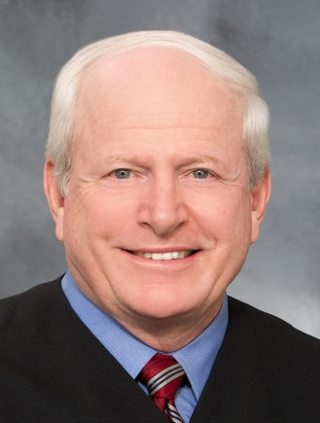

Professional Experience
- 2016-Present: Spears Dispute Resolution LLC; Mediator, Arbitrator, Alternate Dispute Resolution Processes.
- 1993-2015: Circuit Court Judge, State of Illinois, Fourth Judicial Circuit; General Jurisdiction Trial Court Judge in nine county circuit handling all types of bench and jury trials. Excellent evaluations in all areas including legal knowledge, integrity, and temperament. Conducted numerous successful settlement conferences.
- 1979-1993: Attorney with Miley, Meyer, Austin, Spears & Romano, P.C.; general practice with emphasis on litigation in state and federal courts; represented plaintiffs and defendants, businesses and individuals, in civil and criminal cases. Recognized with AV rating for legal ability and ethics.
- 1977-1979: Law Clerk for U.S. District Judge J. Waldo Ackerman; prepared draft opinions and assisted federal judge in preparation for hearings and trials. Admitted to Bar of the state of Illinois and federal courts.
- 1972-2006: Illinois Army National Guard; citizen-soldier began as an enlisted Private and retired as a Colonel in the Judge Advocate General’s Corps and certified military judge. Held a variety of staff positions, including Staff Judge Advocate, Equal Opportunity Advisor, Program Manager and Director of Human Resources.
Education
- Juris Doctorate, Southern Illinois University School of Law, Carbondale, Illinois, 1977: Graduated Summa cum Laude; Editor-in-Chief of Law Journal.
- Bachelor of Arts, University of Illinois, Champaign-Urbana, Illinois, 1974: Graduated with high honors.
- Taylorville High School, Taylorville, Illinois: Class of 1969, Member of Sports Hall of Fame.
- Specialized ADR Training, Mediation Training at the National Judicial College and at the Lane & Calkins ISBA Mediation Practice Course; Arbitration CLE through the American Bar Association. Member of Dispute Resolution Section of ABA and Alternate Dispute Resolution Committee of ISBA.
Leadership Positions Held
- Illinois Institute for Continuing Legal Education (IICLE): Member of Board of Directors since 2013.
- Army Educational Advisory Committee: Member of Federal Advisory Committee 2011-2018; provided Army Senior Leaders advice and recommendations pertaining to educational programs.
- Abraham Lincoln Association: Member of Board of Directors since 2009.
- Taylorville Memorial Hospital: Member of Board of Directors since 2016.
- Lincoln-Douglas American Inn of Court: Master of the Bench; Past Member of Board of Directors; Past-President 2006-2007.
- Lincoln Academy of Illinois: Regent; Vice-Chancellor since 2016; Order of Lincoln is Highest Civilian Award presented by the State of Illinois.
- Illinois Judges Association: Member of Board of Directors from 2003-2013; Officer from 2006 to 2010, including President in 2010.
- Illinois State Bar Association: Member of Assembly from 1988-1994 and Board of Governors from 1997-2002; continue to serve on Military Affairs Committee (Past Chair from 2001-2008) and Alternate Dispute Resolution Committee. Member of Illinois Bar Foundation. Author of numerous columns and articles in Bar publications, including the Judge Justice columns and Lincoln The Lawyer series.
- Illinois Supreme Court Committees and Commissions: Current Member of Committee on Character and Fitness for the Fifth District of Illinois; Past Member of Committee on Education from 2006-2015, served as planner and faculty for numerous judicial education events; Past Certified New Judge Mentor and Peer Judge Mentor; Judicial Performance Evaluation Facilitator; Past Member of Illinois Supreme Court Committee on Judicial Conduct, 1997-2005 (Chair 1998-2000).
- Leader in Community Organizations: Christian County Bar Association (Member since 1977, Past-President 1987); Christian County YMCA (Member since 1982, past Member of Board of Directors, Past-President and Drive Fund Chair); United Fund of Taylorville (past Member of Board of Directors, Past President and Drive Fund Chair); Taylorville Optimist Club (Member since 1983, past Member of Board of Directors, Past-President, Past-Lieutenant Governor); Christian County Crime Stoppers Board (2016 to Present).

