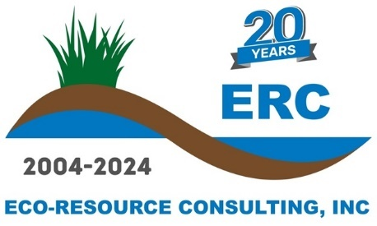
February 2025
Eco-Resource Consulting, Inc. Job Description - Ecological Restoration Assistant Project Manager
Location: Stoughton & Butler, Wisconsin (Full-time)
Essential Job Duties:
- Direct and conduct ecological field work with minimal supervision, such as project evaluation, ecological assessment and inventory, and floral and faunal monitoring.
- Compose accurate proposals and cost estimates that define the scope of project and relevant tasks.
- Developing schedules for project completion that effectively allocate resources to the tasks.
- Execute projects according to the project plan while documenting progress during project timeline.
- Monitor progress of projects and incorporate adaptive management to ensure successful completion.
- Communicate effectively with ERC Senior Staff, field staff, clients, stakeholders, and subcontractors.
- Manage budget and invoicing of projects consistently.
- Ensure quality of deliverables, communication, and implementation on every project.
- Meet deadlines of project deliverables.
- Read, review, interpret, and create bid packages for desired new projects.
- Write reports summarizing the agreed goals and the results of projects.
- Assist Senior Ecologists with client objectives, staff management, and workload as needed.
- Assist with field work on an as needed basis, anticipated 20-40% per week.

Job Qualifications:
- Bachelor’s degree in Natural Resources, Ecology, Biology, or relevant natural sciences degree.
- 3 to 5 years working in natural resources management.
- Experience working with herbicides and a Wisconsin Commercial Pesticide Applicators License or willingness and ability to attain said license within 60 days.
- Ability to manage budgets and schedules.
- A working knowledge of business development, marketing, and client acquisition.
- Excellent customer service skills.
- Strong written, communication, and technical skills
- Ability to effectively communicate with clients, agency staff, and contractors.
- Demonstrated ecological expertise and botany skills.
- Must be proficient with MS Word, Excel, and Outlook.
- Valid driver’s license with the ability to pass a motor vehicle record check.
- Travel throughout Wisconsin and surrounding states may be required depending on project site locations. This includes overnight stays as well as long workdays required to adhere to project schedules and objectives.

Desirable Skills and Experience:
- 2-3 years of field work experience in ecological restoration.
- 1-2 years of experience managing ecological restoration projects.
- Ability to identify native and non-native plant species common to Wisconsin.
- Chainsaw safety training certification.
- Experience with stormwater management and erosion control.
- CDL holder and experience with heavy equipment operation and maintenance.

Benefits:
- Paid Vacation – Two weeks pro-rated as lump sum following 60-day probationary period.
- Paid Sick Leave and Bereavement – Five days pro-rated as lump sum following 60-day probationary period.
- Paid Holidays – Seven paid Holidays.
- Health, Dental, and Vision insurance is offered following 60-day probationary period.
- Simple IRA with 3% company match offered following three months of employment.

