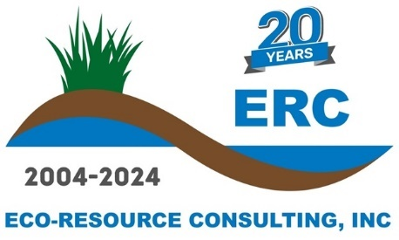
February 2025
Eco-Resource Consulting, Inc. Job Description – Restoration Technician
Location: Stoughton & Butler, Wisconsin (Full-time)
Eco-Resource Consulting, Inc. is seeking to fill a Restoration Technician position. Job duties will primarily involve conducting field work on ecological restoration project sites. Additional duties will include collection of ecological field data and assisting Project Managers and Senior Biologists/Ecologists with vegetation monitoring and report drafting. Data collection may be in support of: wetland determination/delineation, wildlife habitat/land resource assessments, endangered resources review, vegetation monitoring, GPS data collection, permit applications, and environmental reports. This position will be full-time seasonal with the option of permanent employment after a 60-day probation period.

Job Duties:
Job duties will include carrying out tasks related to prairie, wetland, woodland, and other natural community restoration and land management. Specific job tasks will include application of herbicides, mowing, installation of erosion control products, native seed and plant installation, and invasive shrub/tree removal and treatment. Equipment operations may include chainsaws, brush-cutters, backpack herbicide sprayers, ATV, UTV, skid-steer, and tractor with various implements. Applicants must be proficient in the operation of mid-duty to heavy duty trucks and trailers.

Job Qualifications:
- Experience observing field operations and reporting project details to Senior Staff.
- Two or more years of experience operating and maintaining various types of implements and power equipment, including trucks, large trailers, ATVs, UTVs, skid-steers, tractors (and attachments), pumps, chainsaws, brush-cutters, backpack herbicide sprayers, small engines/pumps, etc.
- Must be able to lift 50 lbs. and be able to perform physical work in a wide range of outdoor weather and environments including walking 2-4 miles in rough terrain.
- Willingness to travel and conduct field work in remote areas for extended periods.
- Experience working with herbicides and a Wisconsin Commercial Pesticide Applicators License or willingness and ability to attain said license within 60 days.
- Strong written, communication, and technical skills.
- Ability to effectively communicate with ERC Staff, and sometimes clients.
- Experience writing summary reports throughout and at completion of projects.
- Ability to identify native and non-native plant species common to Wisconsin.
- Must be proficient with MS Word, Excel, and Outlook.
- Valid driver’s license with the ability to pass a motor vehicle record check.
- Travel throughout Wisconsin and surrounding states may be required depending on project site locations. This includes overnight stays as well as long workdays required to adhere to project schedules and objectives.

Desirable Skills and Experience:
- 2-3 years of field work experience in ecological restoration.
- Chainsaw safety training certification.
- Experience with stormwater management and erosion control.
- CDL holder and experience with heavy equipment operation and maintenance.

Benefits:
- Paid Vacation – Two weeks pro-rated as lump sum following 60-day probationary period.
- Paid Sick Leave and Bereavement – Five days pro-rated as lump sum following 60-day probationary period.
- Paid Holidays – Seven paid Holidays.
- Health, Dental, and Vision insurance is offered following 60-day probationary period.
- Simple IRA with 3% company match offered following three months of employment.

