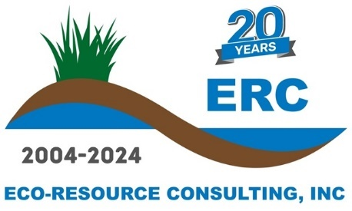
February 2025
Eco-Resource Consulting, Inc. - Summer Internship Program

Location: Stoughton & Butler, Wisconsin (Full-time)
Eco-Resource Consulting, Inc. (ERC) seeks well-qualified natural resource career-track students or recent graduates to participate in a summer internship program. The goal of the ERC internship program is to provide field experience and knowledge building for students wishing to enter the natural resource management industry and may provide a pathway for the offer of a permanent full-time position at ERC. Internships correspond with the academic calendar and cover the summer period from May 2024 through August 2024. ERC considers interns as short team seasonal employees.

Primary Responsibilities:
Interns are responsible for assisting restoration technicians in all daily operations. Restoration activities may include planting native species, watering, installing erosion control products, herbicide applications, mechanical removal of invasive species, operating small equipment, and recording data and entering the data in excel and word. Occasionally overnighting near a project site is a requirement, depending on location and duration of the project.

Educational Opportunities:
In addition to receiving hands on training from restoration technicians, ERC will provide several days of plant and tree identification throughout the internship. Each day will be led by an ERC Ecologist and will be spent identifying both native and non-native species at different locations near Madison, Wisconsin.

Please contact Kyle Duquaine with inquires at kduquaine@eco-resource.net or call 608-316-5071.

