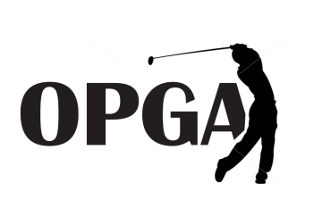
OHIO PUBLIC GOLF ASSOCIATION
2019 SCHEDULE OF EVENTS

ORGANIZED 1928 CELEBRATING OUR 91st YEAR
Adam Fluty
Secretary/Treasurer
Westerville, Ohio
614-893-1012
Ken Hyland
President
Louisville, Ohio
330-875-4196
Rob Schustrich
Vice President
Windham, Ohio
216-789-3325

OPGA Mid-Amateur Championship
Apple Valley Golf Club
Howard, OH
Saturday June 8th – Sunday June 9th
36 Hole Stroke Play Tournament – Ages 25+


OPGA Publinx State Amateur Championship


Cumberland Trail Golf Club
Pataskala, OH
Saturday July 27th – Monday July 29th
54 Hole Stroke Play Tournament

OPGA Memorial Senior Championship
Hiawatha Golf Club
Mt. Vernon, OH
Friday September 6th – Sunday September 8th
36 Holes – Ages 50+ - 6 Age Brackets (Friday Practice Round)


Additional details and information can be found on the entry forms, on our website at www.opga.us, or on our Facebook Page. You may also email us at ohiopublicgolfassociation@gmail.com or contact an OPGA director with questions.

