Northwestern University
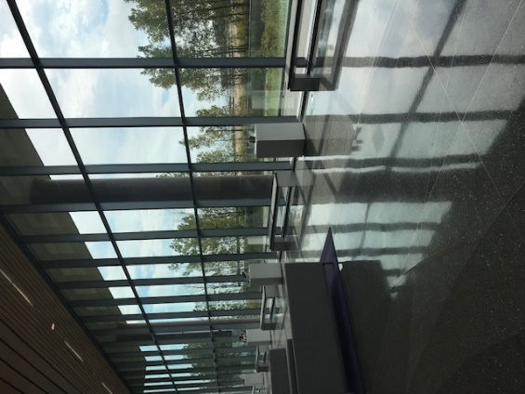
Overview
Northwestern University is situated on Lake Michigan and is nestled in small town of Evansville, Chicago with an amazing view of city of Chicago. Northwestern has the college town vibe with big-city access. It is a beautiful sprawling university with 9 colleges and schools offering classes for undergraduates. The close-knit community of students are intellectually curious. Northwestern is also member of the Big Ten Conference.

What we loved about the school
Northwestern University is very interdisciplinary school as it is on the quarter system, which allows students to take 48 classes making it easier to double major, minor or gain a certificate in addition to an undergraduate degree. This system is great for students who thrive in a fast past learning environment. Northwestern is a research institution that supports approximately 1500 research laboratories.
Northwestern fosters creative environments for students. "The Garage" allows students to collaborate across disciplines to create startups. Cutting-edge resources such as 3-D printers are in excess and easily available for students!
Popular undergraduate majors include: Economics, Journalism, Psychology, Political Science, and Government, and Biology/Biological Sciences
The campus is large and even has two beaches where students can take sailing lessons on the lake.

The type of students we think would thrive here:
Students should consider this school if:
- You want a very competitive international experience - at a 9% acceptance rate Northwestern is very selective.
- You want to attend a Big Ten School with Division 1 athletes.
- You want a university that offers many majors and research opportunities.
- You want to be an in an environment of intellectual curiosity and you thrive in an environment of academic excellence.
- You want a racially and geographically diverse student body.

Let's talk numbers (entering Class of 2017):
Avg SAT scores of 1490
Avg ACT scores of 33

Northwestern University is a very selective school with a 9% acceptance rate. In 2017, almost 50% of the class was accepted via ED.

Northwestern Website: https://www.northwestern.edu/

