
Annual Report



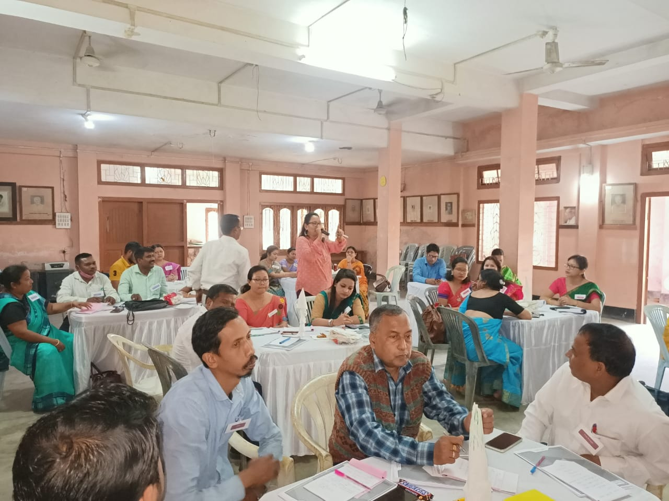
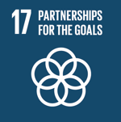
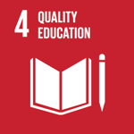
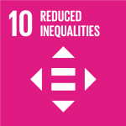

Prepared by Nandita Nag

AEF
B/139, Block B, Sector 8
Dwarka, Newe Delhi - 110077
Principals’ Training Assam
Agragati Education Foundation
Contents
Director Message 3
Leadership & Governance 4
Legal Status 10
Empanelment 11
About Agragati Education Foundation 12
Who we work with @ a glance 14
Our Approach 14
Our Expertise 15
Resource Team 16
Project Details 17
Trainings at Kamrup 18
Trainings at Majuli 19
Trainings at Jorhat 20
Trainings at Biswanath Charali 21
Workshop on the Needs and Rights of Senior Citizens 22
Teacher Training Series 23
Content Development & Review 25
Training Module Development 25
Impact Evaluation & Research 26
Guidelines 28
Comparative report for LLF 28
Assessment Content Review & Development 28
Our Partners 29
Our Clients 30


Director Message

Greetings Friends!

I am delighted to present the first Annual Report of Agragati Education Foundation!

AEF is a dream for its founders! A dream for an equal society with a fair chance for everyone irrespective of cast creed colour ethnicity class or division and every kid in the world getting its fair chance to develop into a beautiful human being. We believe that goodness out there in the world, is far more prevalent and every individual wants to do a good turn!

You will agree that human values are universal and critical for the continuity of human life and civilisation! We intend to live by them. I am proud to be working with people, who are dedicated, passionate and each a proven specialist in their field of work. Together we have the knowledge and capacity for any initiative required to deal with new and existing challenges!

We have had a great start! We have done assignments and interventions that are meaningful! Those which will have far reaching impact on society! We had just started as philanthropy and the COVID 19 Pandemic broke out. Needless to say, an experience unlike any other! Human interaction arrested mid action! For the first time in life pervasive stillness settled in unimaginable places. Nature seemed to have healed from the bruises of civilisation but hunger stood out harsh raw and angry! Millions plodded back home with an empty stomach! A daunting task feeding millions! But the unexpected happened again…. Numerous groups individuals and government came together to feed the hungry!

The universe laid it bare who and what works! Our public servants, particularly the police, our medicos, our ‘safaiwalas’ essential service providers showed their true mettle “Service!” We did out small bit in all this – We organised food distribution in the back waters of Assam… The battle goes on.

I see the shimmer of a breaking dawn! A beautiful sympathetic world! As people realize the consequences of human action! The world will be different! Better!

Wishing the Very Best

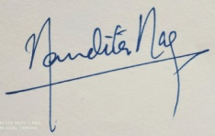

Nandita Nag
Director

"True peace is not merely the absence of tension; it is the presence of justice." —Stride Toward Freedom, 1958

Leadership & Governance
Director
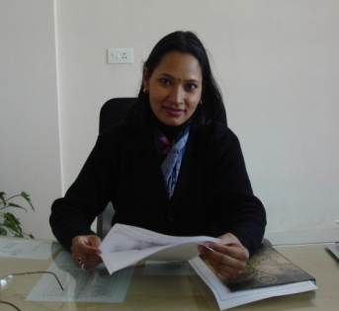

Ms. Nandita Nag

Nandita is an Educational Professional with twenty four years of experience in Education & Social Development sector, having worked across geographies: Punjab, Rajasthan, Haryana, Uttar Pradesh, West-Bengal & Tamil Nadu, Assam, Meghalaya, Jammu & Kashmir, Telengana, Andhra Pradesh, Karnataka, Maharashtra, Delhi, Karnataka, Goa, and Jharkhand.

Awards Received:
- ‘Prof. K. Subramanian Endowment Award 2019’ by English & Foreign Languages University Hyderabad
- ‘Guru Draunacharya Samman’ by AVANTIKA

She was born to Mrs. Shanti & Mr. Boloram Nag on 1 February 1972. In 2019 she topped the PGDTE programme in the School of Distance Education of English & Foreign Languages University Hyderabad. She received her Master’s Degree from University of Pune in 1994 and her bachelor’s degree in Education from Guwahati University in 1995. She graduated with major in English from Sir Henry Cotton Memorial College, Guwahati in 1992. Her Alma Mater is St. Joseph’s Convent, Tezpur, Assam.

Formerly she has headed the department of Training & Curriculum in Bharti Foundation, Been Education Officer in Darshan Education Foundation, Head of School in Delhi Public School Civil Lines and Iqra Public School, Aligarh; had been HOD English Department and Controller of Examinations in Delhi Public School Guwahati.

Her teaching experience with students from Pre-primary to University level, in institutions like Army School Narangi, Kendriya Vidyalaya, Delhi Public School Guwahati, Tezpur Central University and Arya Vidyapeeth College, Guwahati has given her both a micro and macro perspective in education.

Director
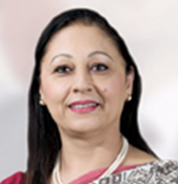

Ms. Ikwinder Kaur

Ikwinder has 26 years of rich experience as an Educator in the School Education sector. Before joining us as an honorary Director she has been Additional Director, Lingaya’s Group of Schools and also headed the Lingaya’s Public School Faridabad. She had been member of the Edu Excellence & Academic Excellence teams.
Prior to which she had been part of the Teachers Training Course Designing team of Manav Rachna International University for framing the curriculum for Early Childhood Care and Education Program. She has also implemented the Paragon Programme; part of the Mosaica Education of U.S.A. and the IPC in the Early Years.
She has been founder principal of Delhi Public School, Ferozepur and DPS World School Gurgaon. Other DPSes that she has headed are DPS Bahrain, DPS Dehradun, DPS Civil lines - Aligarh, and DPS Bahadurgarh. Other prestigious schools, she had groomed as an education leader are Dutse International School - Nigeria; Amity International School, Pushp Vihar New Delhi Manav Rachna International School, Faridabad.
She has a long teaching stint of 18 years at Delhi Public School Vasantkunj Delhi, before which she started her journey as a teacher in Carman School, Dehradun, Uttrakhand.
She is married to Col. Sarabjit Singh, Army Officer (Retd.) and is the proud mother of Ms. Hasleen Kaur, Winner Femina Miss India Earth 2011, who has endorsed for many leading fashion brands; and Harsimran Singh, an entrepreneur.
She has seen the world with travel to places like Nepal, Bhutan, Philippines, and Bangkok etc. to name a few.
She is an alumnus of Convent of Jesus & Mary, M.K.P. College and D.W.T. College Dehradun, Uttrakhand.

"The ultimate measure of a man is not where he stands in moments of comfort and convenience, but where he stands at times of challenge and controversy." —Strength to Love, 1963
Director
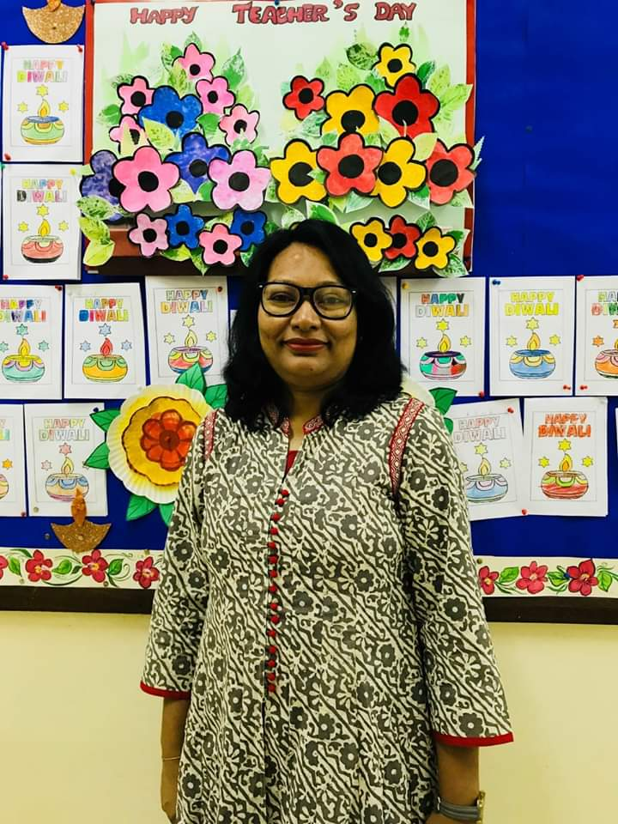

Ms. Kavita Nag

Kavita has 20+ years of rich experience as an Educator in the School Education sector. A very talented individual and teacher, has guided students for the last so many years. She has developed curriculum and assessment for classes 1 through X in science and technology. She has taught Life Sciences to innumerable students in the Senior and Senior Secondary Level.
She has been in charge of examination and HOD Science. Her long stint as an academic has taken her far and wide from Guwahati in Assam to Aligarh, Uttar Pradesh, Pilani Rajasthan to Sohar in Oman.
She has been associated with Delhi Public School, Disneyland School and Police Public School in Guwahati, Delhi Public School Aligarh, BITS Pilani Public School and Sohar Indian School in Oman.
She has been instrumental in bringing innovative teaching learning practices wherever she has work with approaches and teaching methods such as flip classroom, project based learning, technology in classroom, Interactive notebook, digital learning assessment and many more.
She has guided students for many science Olympiads, organised learning fares and project presentation while in school. She has authored the books ‘Planning Effective Science Lessons’ and ‘ Simple Activities for teaching Science’ and has to her credit a collection of digital teaching –learning material, which are easy for young learners to view and learn from.
Her connect with her students and young learners has been legendary. She has made invaluable contribution to many lives through her nurturing and caring attitude towards them and their learning abilities.

"Injustice anywhere is a threat to justice everywhere. We are caught in an inescapable network of mutuality, tied in a single garment of destiny. Whatever affects one directly, affects all indirectly." —"Letter from Birmingham Jail," April 16, 1963

Our Advisory Board
Advisor
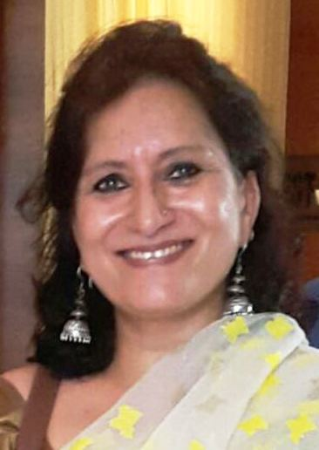

Geetika Bahuguna
COO, Millennium Group of Schools
Geetika is an ‘accomplishments’ driven leader, is a Delhi University Alumni, has studied Psychology, Education and Management in Entrepreneurship from DSSC, Wellington. She comes with over 27 years of rich experience and expertise in the management of educational projects and programs for establishment of new chain of schools, quality interventions in both commercial as well as CSR projects with time bound results at large scale , impacting more than 700 schools, over 2 lakh students and more than 6000 educators over the years.
She has excelled in organizational development backed by practical actions and programs that have been a vanguard for change management, development and recognition within the education sector.
A thorough Professional with expertise and experience in Conceptualization, Planning, Execution and Management of Projects that involved curriculum formulation, quality management, school processes, school audits and trainings for all stakeholders and creation of SOPs for program scale up. Possess strong networking skills & ability to maintain diplomatic and productive relations with diverse stakeholders, leading NGOs /Institutions/Foundations for continuous learning and growth
She has developed and managed high performing teams of school leaders, trainers, leadership coaches, and program managers to lead various program operations and schools effectively through her enriching last 2 decades of experience in education programs as Vice President Training & Implementation in Educomp, as General Manager Programs in Bharti Foundation and now Chief Operating Officer (Services) in Millennium Education Management . In her current profile as COO, she plays a critical role in the establishment of K-12 Millennium Group of Schools pan India and ensures quality standards of education being provided by them.
"Darkness cannot drive out darkness, only light can do that. Hate cannot drive out hate, only love can do that." —Strength to Love, 1963
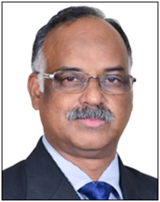
Advisor

Victor Paul, Ph. D.
Head, Department of Social Work and Sociology
Team leader, CSA
CHRIST (Deemed to be University), Bangalore

Dr. Victor Paul is the Head, Department of Sociology and Social Work and team leader for Centre for Social Action at CHRIST (Deemed to be University). Prior to his joining CHRIST he was working with Education Development Centre (EDC) as Chief of Party and Country Director of US AID sponsored Education project that focused on improving quality of education in various states in India, reaching out to more than 300,000 schools and 42 million students.
Other than the Education Sector, he has worked with other development sectors like Community Development, Labour Welfare, capacity building of NGOs, Training, Disaster Relief & Reconstruction and managed integrated development projects in urban, rural and tribal areas in organizations like CARE, TaTa Tea Ltd and UNICEF.
He also worked with Government of Madhya Pradesh in the Education Dept, as Project Director of “Rajiv Gandhi Initiative for Elementary Education”, and provided his services as task force team member of Government of Inida Programmes like ‘District Primary Education Programme’ (DPEP), ‘Janshala Programme’ and ‘Sarva Shiksha Abhiyan’ (SSA) . He is also the founder member of national level NGOs like “Nitya Seva” and “Prerana Service Society”.
Dr. Paul is a graduate in Economics and Law. He holds a master’s degree in Social Work and a Ph.D in Sociology. He brings 33 years of experience in academic management, teaching, research and development programmes implemented by national and international organizations.
"I believe that unarmed truth and unconditional love will have the final word in reality. This is why right, temporarily defeated, is stronger than evil triumphant." —Nobel Peace Prize acceptance speech, Oslo, Norway, 1964

Advisor
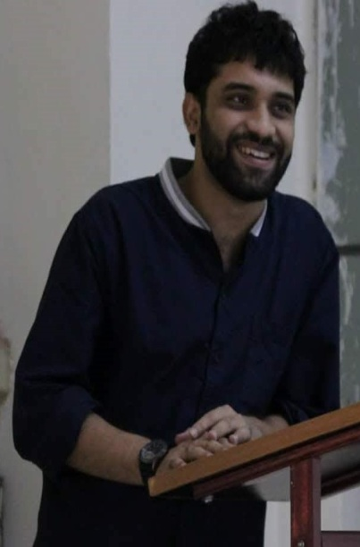

Sanjay Raghav, Director Arc Math
Director at Add Math Research Centre Pvt. Ltd. New Delhi

Sanjay Raghav, Director Arc Math is a Practitioner, Innovator and thought leader in the Math domain. He is also Director at Add Math Research Centre Pvt. Ltd. New Delhi; He has done path breaking research and development work in foundational and practical Mathematics teaching for learners at beginners’ level to higher education. He is also an Adjunct Faculty at B.R. Ambedkar University, Delhi and consulting with Blue Bells International School New Delhi presently.
He started his career in with Naz Foundation working in HIV prevention and support to positive persons in India. Since then he has come a long way and hence been associated with Tara Homes working with abandoned children from low socio-economic background; Government School, Lancer Road, Naini Kakkar Study Centre in Delhi; Mothers International School, Sri Aurobindo Marg New Delhi and Learning Links Foundation. He has been a meritorious scholar with merit scholarships from CBSE in 2008, Ambedkar University Delhi in 2015 and qualified the National Eligibility Test by CBSE (India) for Assistant Professor from CBSE, Delhi, India.
His life’s work are: “Gaps in Mathematics Competence in Early Years Mathematics Teaching at National Math Conference organised by NCERT in 2017; Curriculum for Early years and primary year’s math & and mentor teachers; Concept booklets and videos for concepts in K-8 numbers; Continuous Professional Program on Algebra and geometry in the Middle Years School; Teacher Resource Manual in Math; Constructive Mathematics; After-school math teaching programs for K-; Math Remediation Programme and Assessment Tools for Math. He has collaborated for Math Programs for abandoned children from low socio-economic background
He is a M. Sc. Mathematics Education from Cluster Innovation Centre University of Delhi and M. A. Education from SES, Ambedkar University
"I believe that unarmed truth and unconditional love will have the final word in reality. This is why right, temporarily defeated, is stronger than evil triumphant." —Nobel Peace Prize acceptance speech, Oslo, Norway, 1964
Advisor


Ms. Mamta Godiyal
Founder and Director MaGpie Warriors

Ms. Mamta Godiyal is a dynamic & versatile personality, holds a Post Graduate degree in Business Administration from Symbiosis College Pune with specialization in HR & a Graduate in Biology. She comes over with 17 years of rich experience in Banking and Finance. Her core competence is in the area of Audit & Compliance and Banking where her strategic planning, designing & execution of blended training programmes for employees has been appreciated in HDFC BANK Ltd. (Country’ s Largest private sector bank). She is presently running her own training and Coaching firm with the name "MaGpie. She is result oriented professional, believes in team work & people management.
Ms Mamta Godiyal is ambitious and avid learner. She keeps herself updated with new skills and technologies. She is also Certified NLP Practitioner and a Coach, specialized in Brain based coaching from Neuro Leadership Institute. She has dealt and motivated more than 5500 people with her coaching/mentoring skills. Naturally a great listener, enabler is also a health healer with Certification in Yoga & Meditation from MDNIY, Delhi. She conducts virtual mind healing sessions. Her passion for social work has helped her to found MaGpie and she leads with grace her own team of Warriors called "MG Warriors" in various projects of social awareness and work.
“If then a practical end must be assigned to a University course, I say it is that of training good members of society... It is the education which gives a man a clear, conscious view of their own opinions and judgements, a truth in developing them, an eloquence in expressing them, and a force in urging them. It teaches him to see things as they are, to go right to the point, to disentangle a skein of thought to detect what is sophistical and to discard what is irrelevant.”― Cardinal John Henry Newman, The Idea of a University

Legal Status

Sl. No. | Ministry Details | Registration |   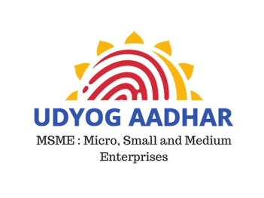
1 | Niti Aayog (NGO DARPAN) | DL/2020/0254239
2 | UDYOG AADHAR | DL10D0015306
3 | Income Tax, India – 12 A | AASCA7051QE20219
4 | Income Tax, India – 80 G | AASCA7051QF2022501

Empanelment
5 | CSR Registration | CSR00017196
6 | Ministry of Women & Child Development | DL/2020/0254239
7 | Ministry of Tribal Affairs | DL/2020/0254239
8 | Ministry of Forest, Environment and Climate Change | DL/2020/0254239
9 | Ministry of Development of North Eastern Region | DL/2020/0254239
10 | Ministry of Information & Broadcasting | DL/2020/0254239
11 | Ministry of Social Justice and Empowerment | Agrgati0254239
12 | Department of Economic Affair | DL/2020/0254239
13 | Ministry of Food Processing Industries | DL/2020/0254239
14 | Ministry of Housing and Urban Affairs | DL/2020/0254239
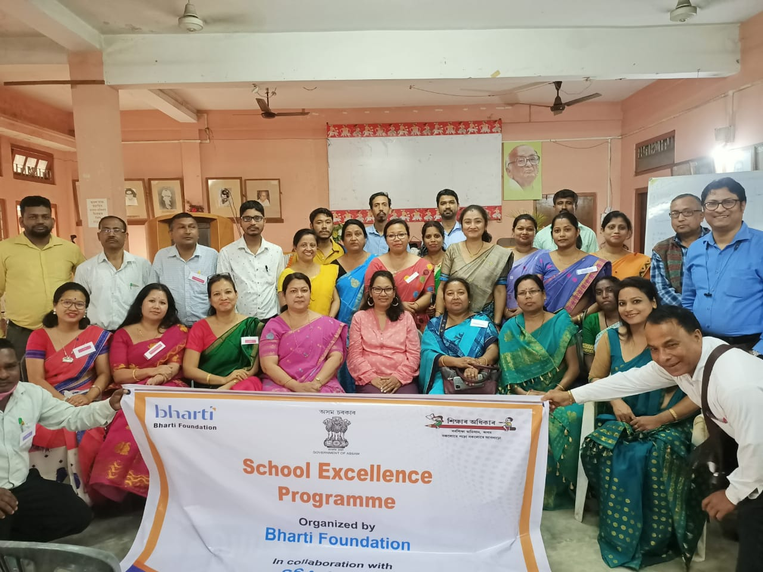

About Agragati Education Foundation
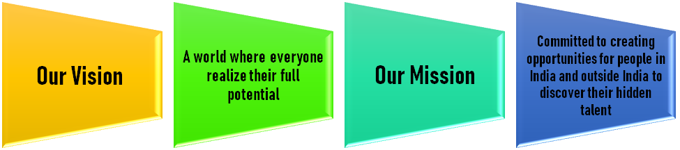

Our Motto
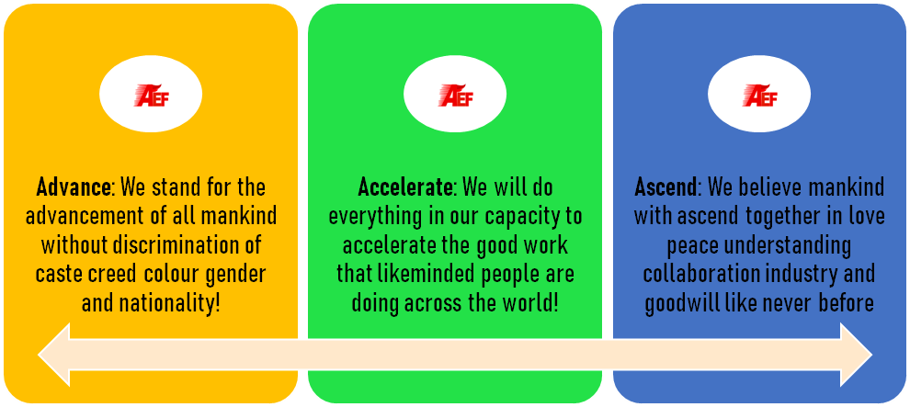

Our Values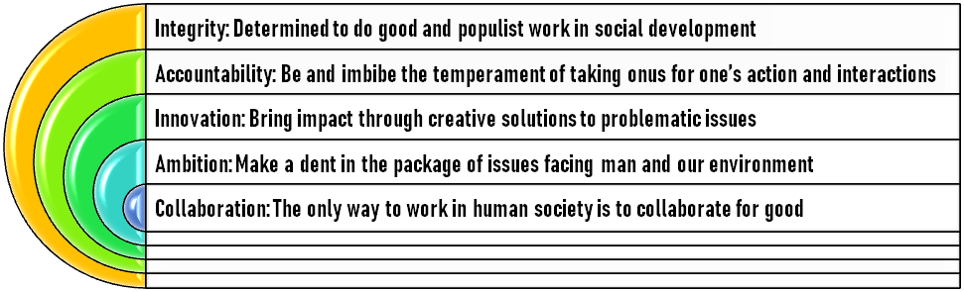
AGRAGATI stands “A Global Reach for Ascent, Growth, Achievement & Timeless Impact”
We are a philanthropic initiative having a vision in consonance with the sustainable development goals adopted in the G-Summit……
Agragati Education Foundation, a registered NGO, is a development advisory and think tank delivering transformational solutions in the social development space through sustainable initiatives. We are a group of education and social development professionals who are passionate about sustainable social development. An Alliance of like-minded people who work in the area of Health, Education, Agriculture, Livelihood, Environment and Research, we are committed to the achievement of United Nation’s Sustainable Development Goals.
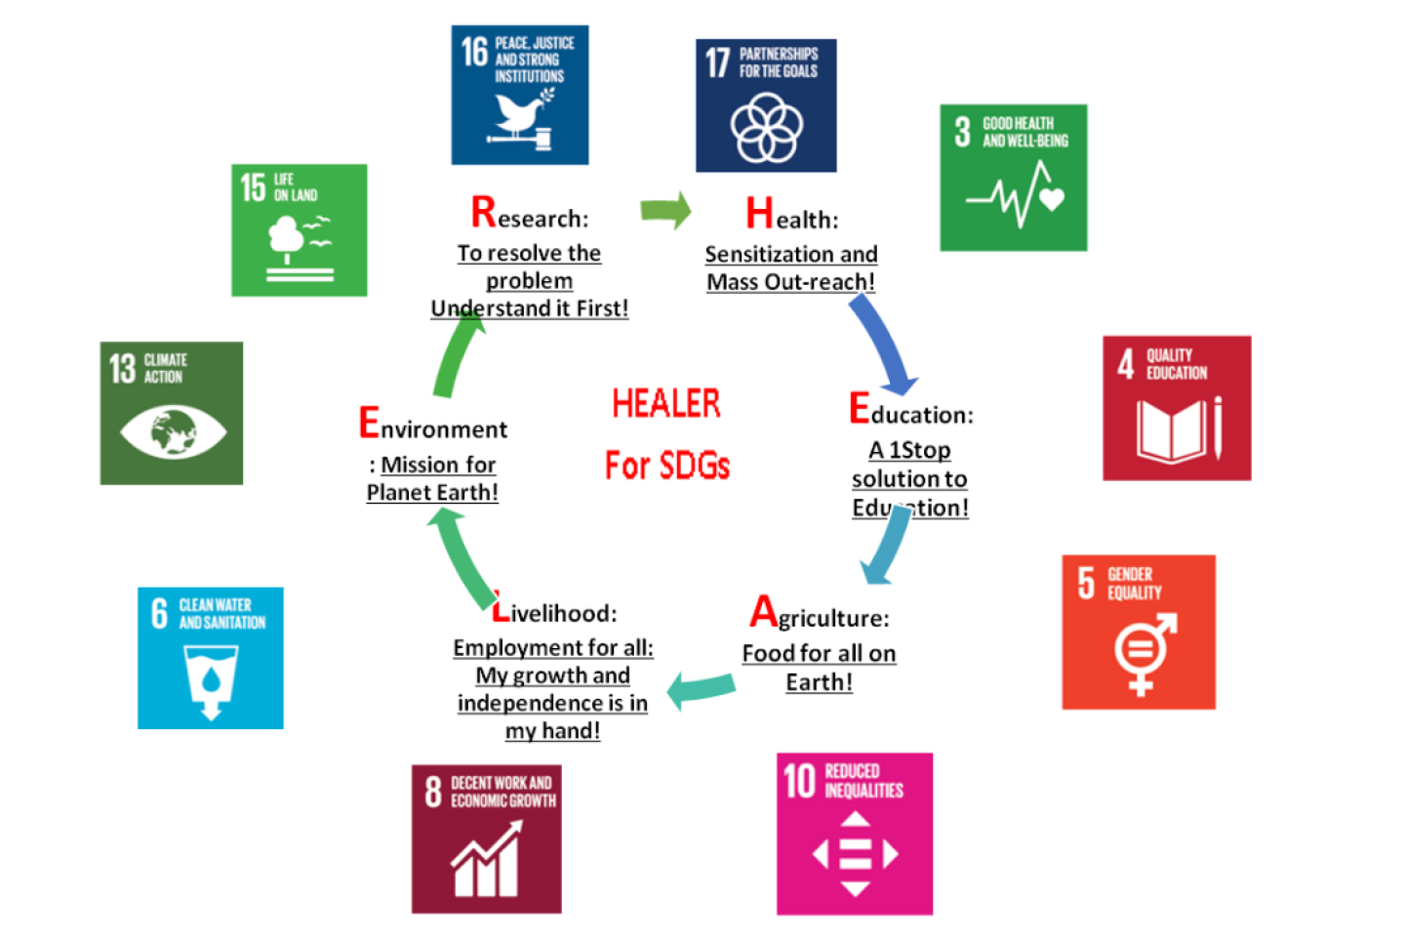
We are also involved in directly implementing programmes and projects to provide solutions and products to enhance education, health, and employment. Capable of delivering complex projects to inspire our stakeholders for being more effective and efficient, we also work in other areas like energy, rural development, culture, sports and tourism-related activities to improve the quality of life of people in India and outside India.
We undertake research and render technical assistance for baseline, survey, impact assessment, evaluations, process monitoring, and socio-economic conditions across various sectors and regions for a range of stakeholders. These vary from multi-state reviews to focused strategic and thematic assessments with the purpose of learning and constructive engagement. We are equipped to act as technical services body for promoting efforts to be part of the institution-building process of the Government and non-government institutions, educational institutions, civil society organisations and corporate for strengthening their strategies for achieving their goals.

Who we work with @ a glance
- Governmental Agencies – Help implement/assess/ all initiatives
- Head of School – Teachers – Parents – Capacity building, personal & professional development
- Students – Counselling, Life Skills and career guidance
- Non-Governmental Agencies – Help implement/assess/ all initiatives
- Educational Institutions – Capacity building, system strengthening and assessment
- Corporate – Help implement/assess/ all initiatives
- Working Professionals – Capacity building, personal & professional development
- Women – Capacity building, personal & professional development
Our Approach: We believe you have it in you to achieve your goals and dreams. Hence our approach focuses on empowering the stakeholders, based on the following principles

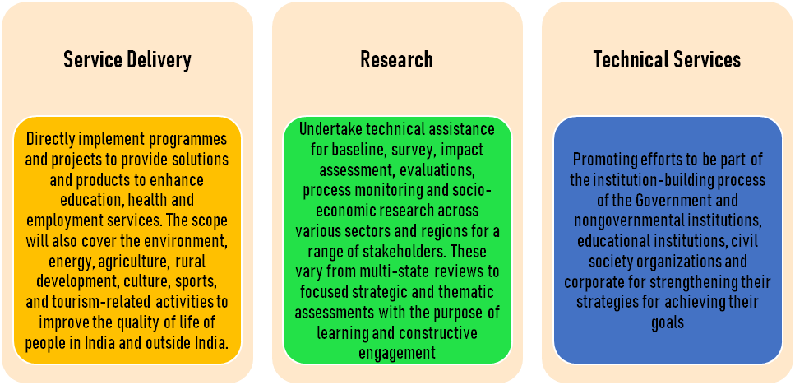
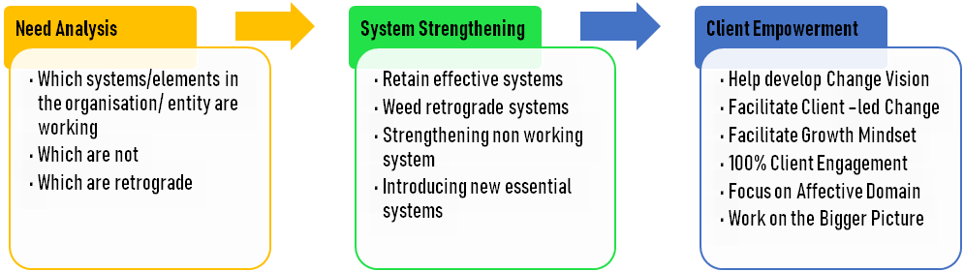
Our Expertise
PROJECT PLANNING & IMPLEMENTATION

Early Childhood experiences determine the kind of life an individual have in the future. Whether they will have a house, cope with stress, practise values etc. We recommend a positive environment for your child.
EARLY CHILDHOOD CARE & EDUCATION (ECCE)

Early Childhood experiences determine the kind of life an individual have in the future. Whether they will have a house, cope with stress, practise values etc. We recommend a positive environment for your child.

POLICY
WRITING
A to Z
School Establishment
EVALUATION
RESEARCH
PARENT EDUCATION
SUBJECT DOMAIN

Developing Course Content, Curriculum, Remedial Material, Library Resource material, Training Material for all educational and Training subject domains
CONTENT DEVELOPMENT

Developing a range of content including educational and Information Education Communication (IEC) content, Question Items/Bank, Assessment Tools, Analysis and Reports, proposals, Policy and Guidelines
TRANSFORMATIVE TRAINING

Transformative training leading to behavioural changes including Mentoring, Coaching, Happitude and other therapeutic trainings leading to self empowerment, stress management, positive and proactive attitude and outlook etc.

PEDAGOGY AND ANDRAGOGY

Training on pedagogy for Educators, Training on Andragogy for HR personnel, Team Leaders, CEOs, Managers, Educators, Community Members, Community Based Organisations, Research Teams, Local Self Government personnel, Trainers, Master Trainers etc.
.
CAPACITY BUILDING

Capacity Building & Empowerment of Organisational Heads, Team Leaders, CEOs, Managers, Educators, Students, Women, Community Members, Community Based Organisations, Research Teams, Local Self Government personnel, Trainers, Master Trainers etc.

LEADERSHIP TRAINING

Developing Leadership in Organisational Heads including Team Leaders, CEOs, Managers, Educators, Students
Community Members, Community Based Organisations, Research Teams, Local Self Government personnel, Trainers, Master Trainers etc.

Resource Team
Our Resource team is a highly talented group with a wide repertoire of skills. They have had long professional careers and hence chiseled them well. We are mentioning only a couple of areas from their vast repertoire of knowledge and expertise.
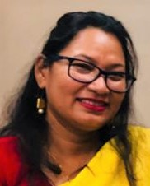  Nandita Nag  School Management-Leadership, ELT | Ikwinder Kaur  Primary School Specialist  Learning in Early Years |   Vandana Banga  Dale Carnegie Certified  Innovative Teacher Training |   Jaswinder Grewal  Author, Life Coach & Counselling
  Dr. Sujata Chaudhary  Curriculum Development  Teaching Innovation | 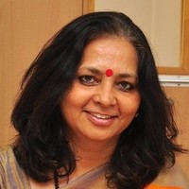  Indu Malhotra  Teacher Training  Educational Psychology | Kavita Nag  Teaching Innovation  Life Sciences | 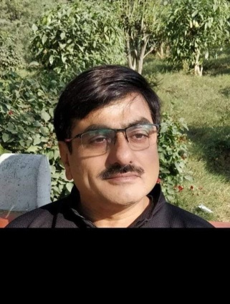  Dr. Ganesh Dutt Sharma  Mathematic  Teaching Innovation
Satish Kumar Kaushik  Founder Trustee Rajbala Foundation  Counselling Psychologist  Certified Happiness Coach | SP Verma  School Leadership  Pedagogy, Hindi and Science | Upasana Kataki  Law & Social Development | Birendra Soni  Community Development, IT ,  Communication, Social Development, Public Administration
Haren Nayak  Social Media Management  Marketing  Office Management | Pranita N Hazarika  Law and Justice, Publishing & Printing | Yachna Thakur  Counselling Psychologist  Certified Happiness Coach | Gitima Sharma  Assamese & Library Science

“Nothing would be done at all if one waited until one could do it so well that no one could find fault with it.”― Cardinal John Henry Newman

Project Details
School Leadership Training for School Excellence Programme (SEP) Location - Assam (Kamrup, Jorhat, Majuli, Biswanath Charali)
A capacity development program conducted on ‘SCHOOL EXCELLENCE’ for all the Head Teachers and 1 Sr. teacher from the government schools under the quality support programme (QSP) of Bharti Foundation. The programme is expected to enable head of the school to be a “Visionary leader capable of empowering and inspiring the team, to lead the change to ensure all stakeholders share the vision of the school and strive to attain their potential”.
Areas of Training the school excellence training:
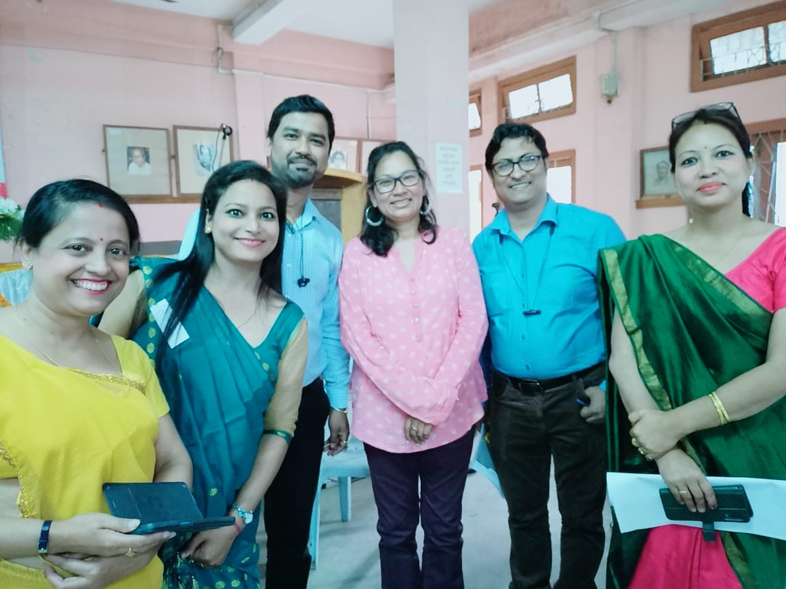
The School Principal / Head Teacher as a Leader; Shaping a vision of academic success for all students; Creating a climate hospitable, happy and engaging to education;
Cultivating leadership in others and developing leaders; Leading schools to better teaching and learning: Improving instruction and transaction; Managing people, data and processes to foster school improvement. Implemented in all Govt School Projects of Bharti Foundation (Meghalaya, Assam, Delhi supporting govt. schools for Quality Education)
Glimpses of School Excellence Programme Training for Govt. School Principals and Block Resource Persons in Kamrup, Bishwanath Charali, Jorhat and Majuli in Assam

Trainings at Kamrup

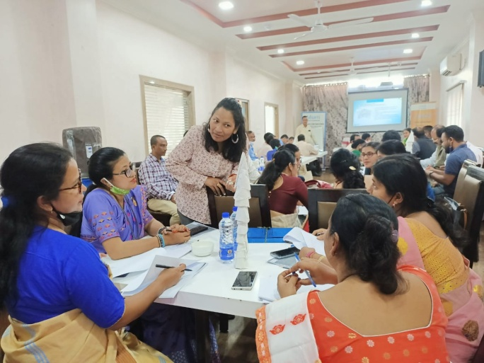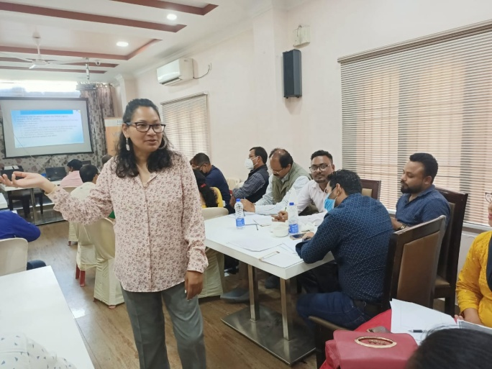
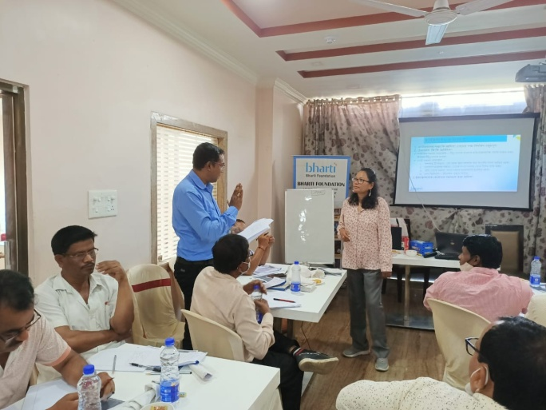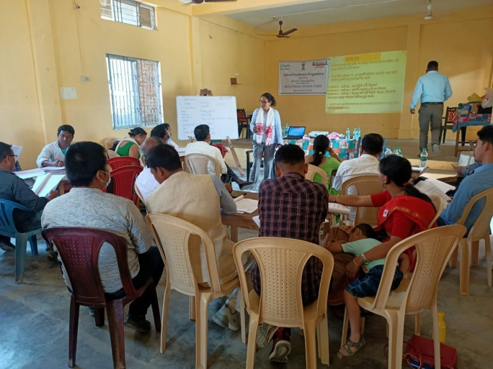
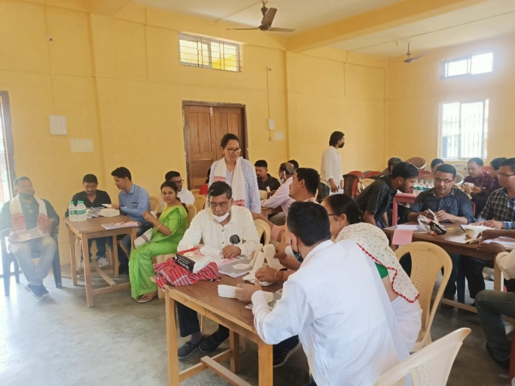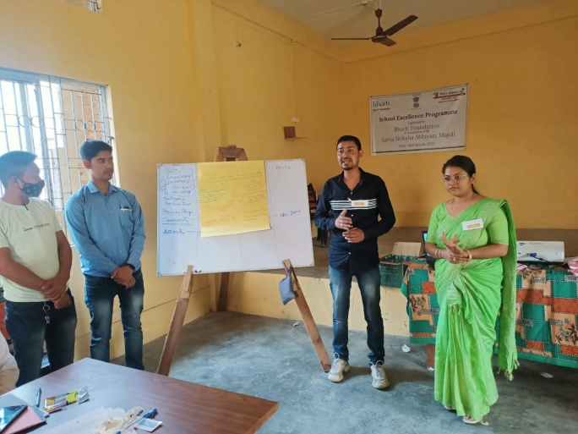

Trainings at Majuli

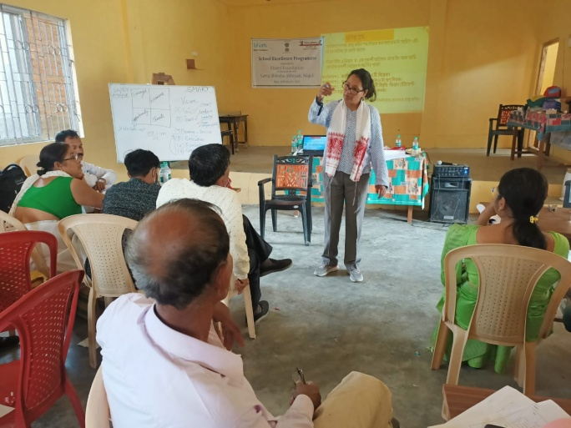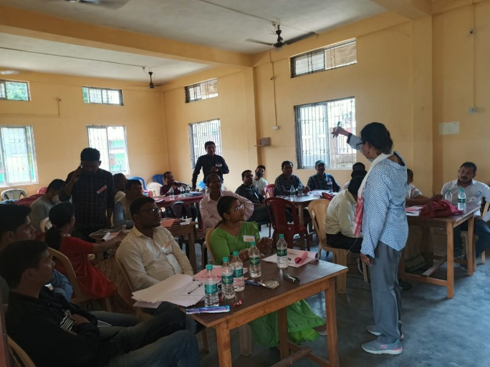

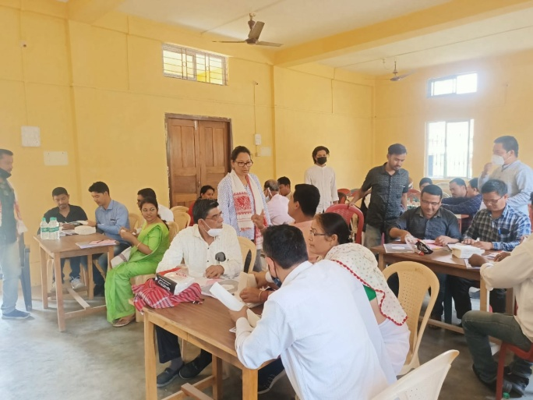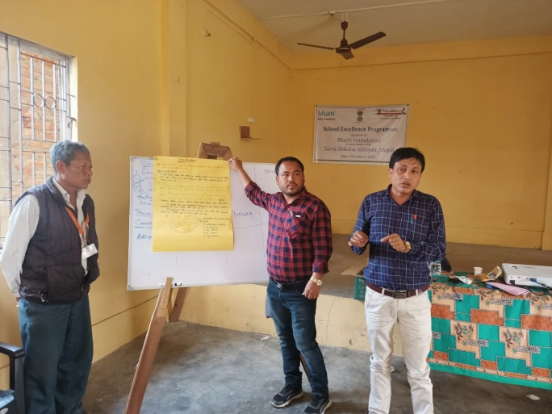

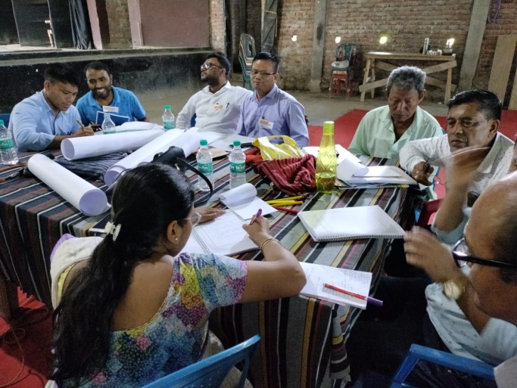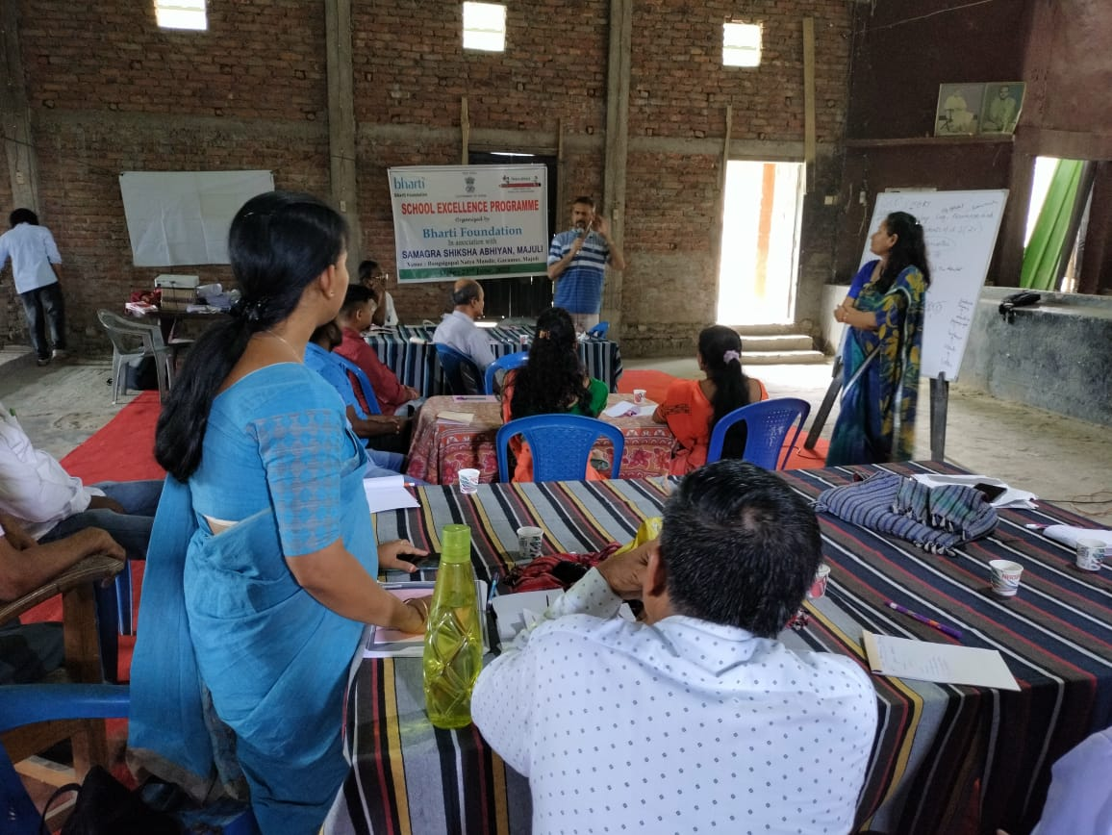

Trainings at Jorhat

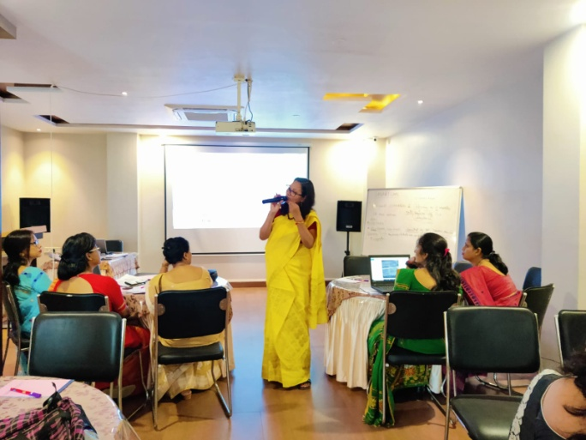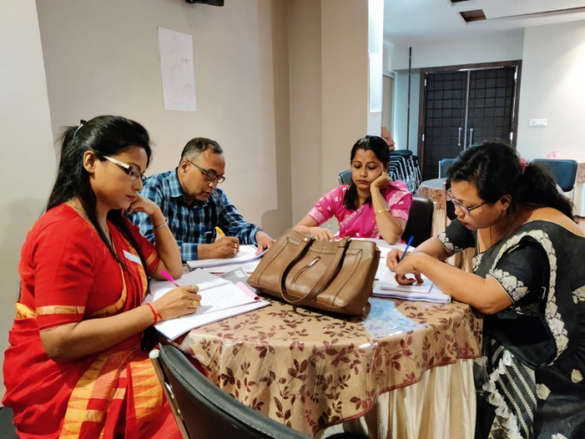

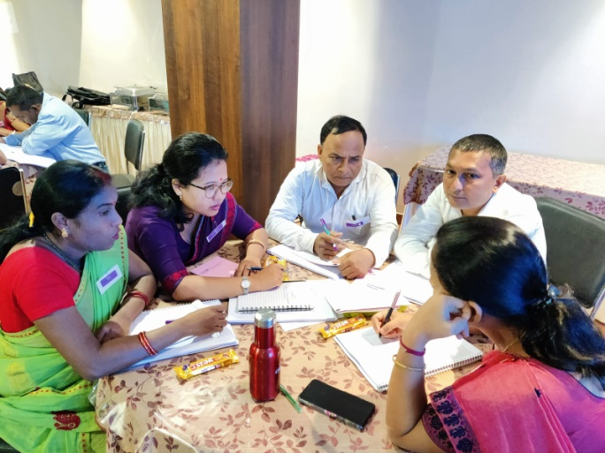

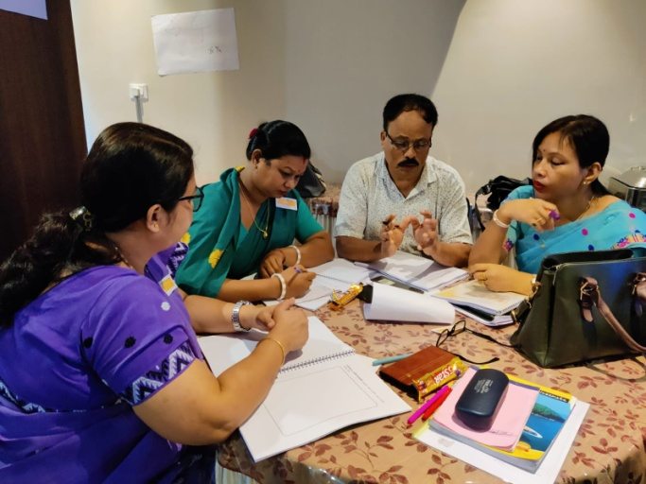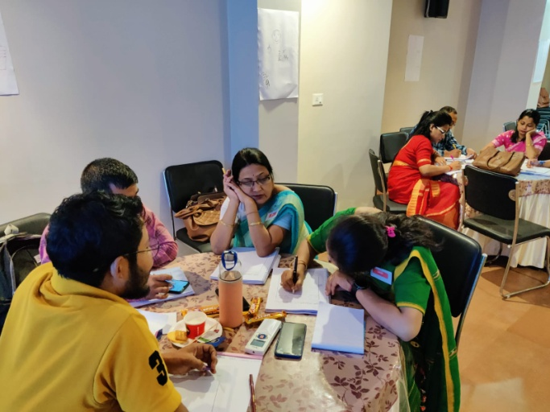

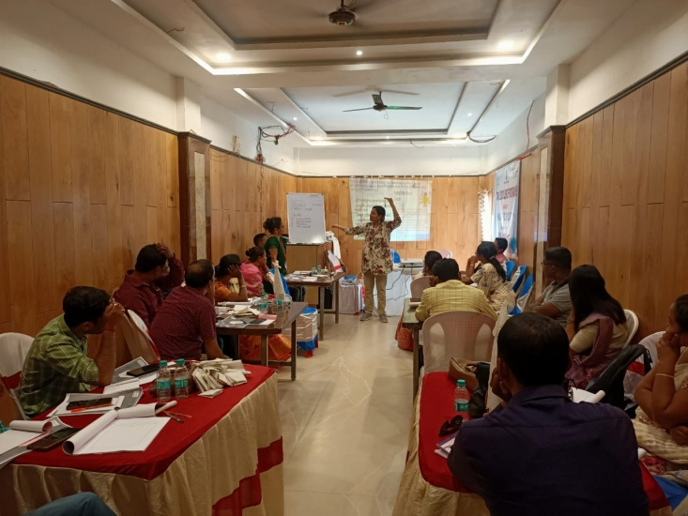
Trainings at Biswanath Charali
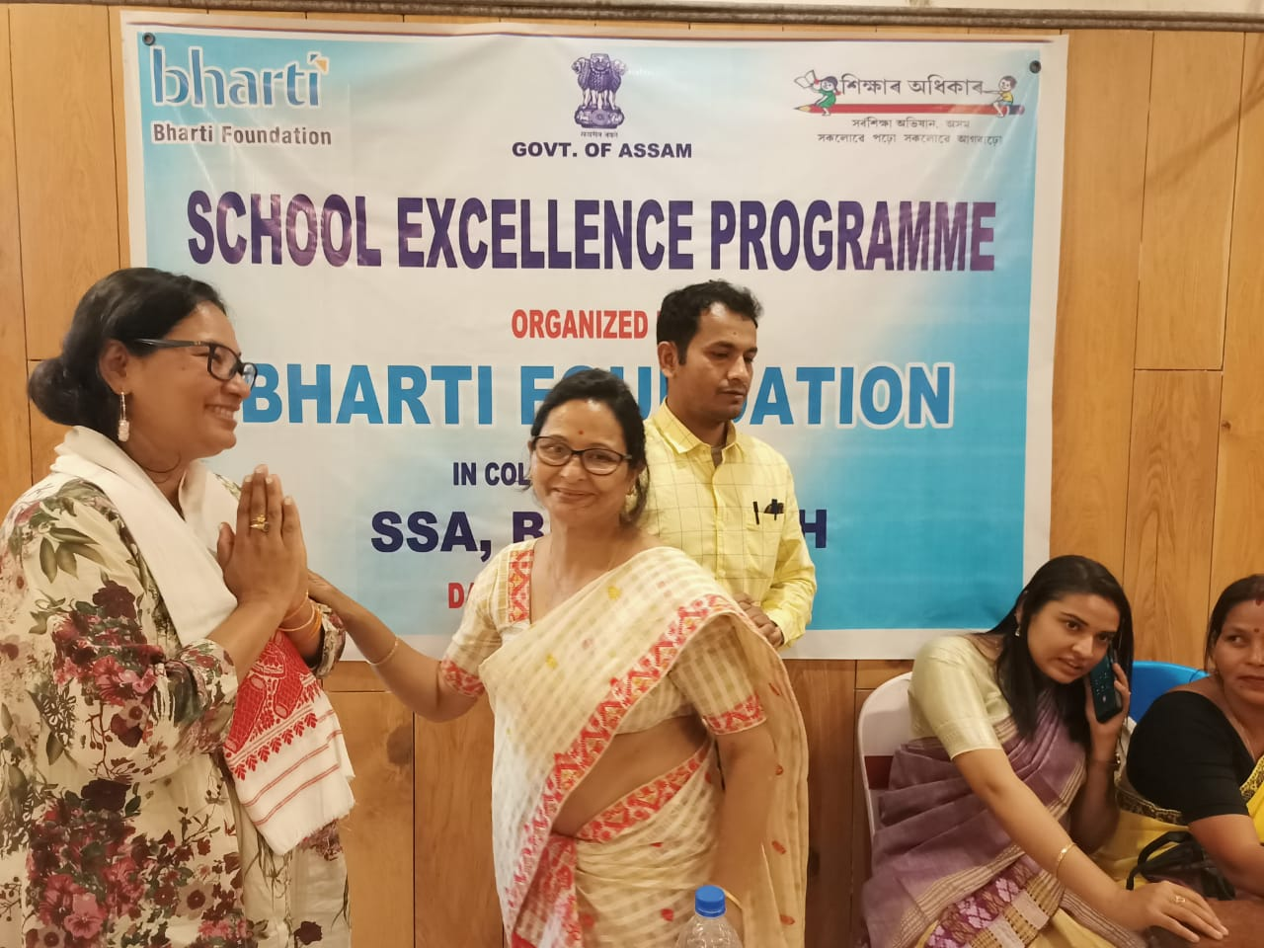

Workshop on the Needs and Rights of Senior Citizens

Glimpses of Training on Rights of Senior Citizens and Elderly Care in collaboration with Abhinav Samaj and Non Violence and Peace Foundation
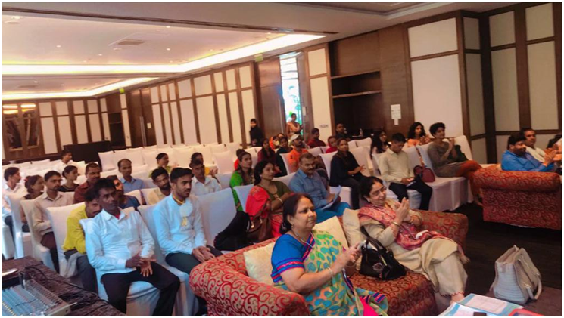
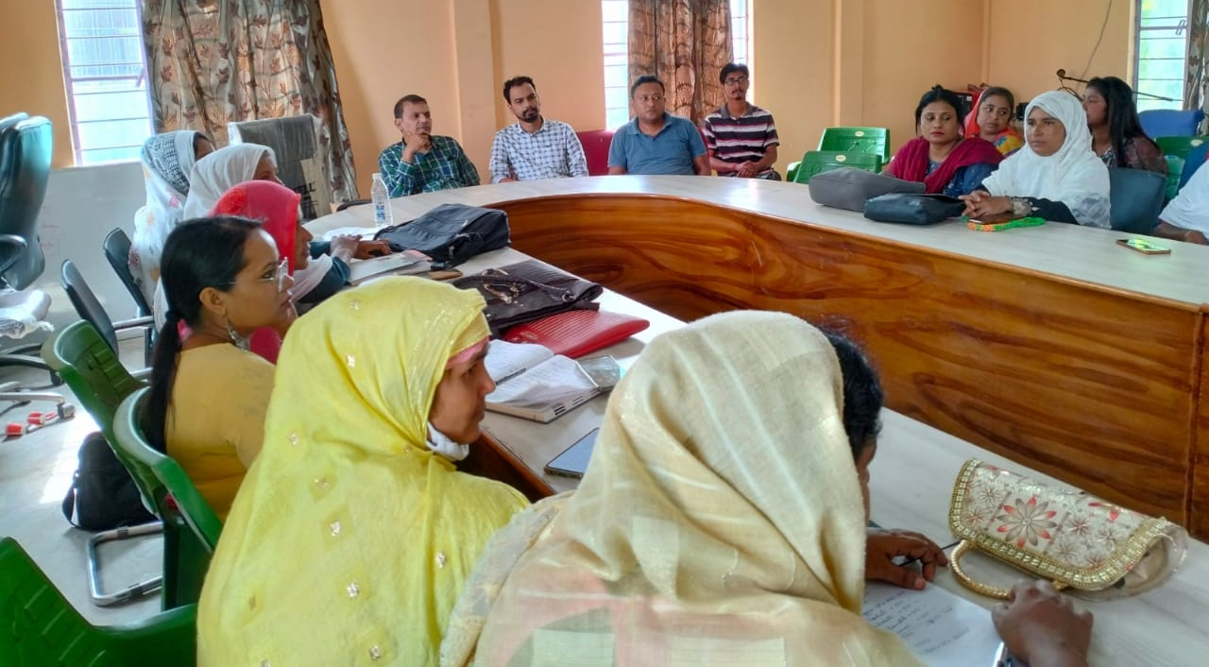
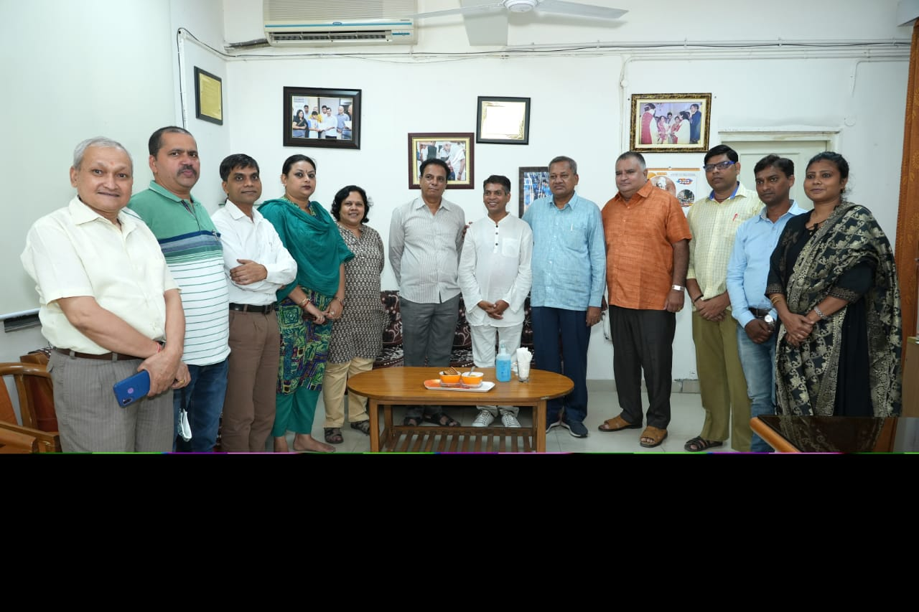
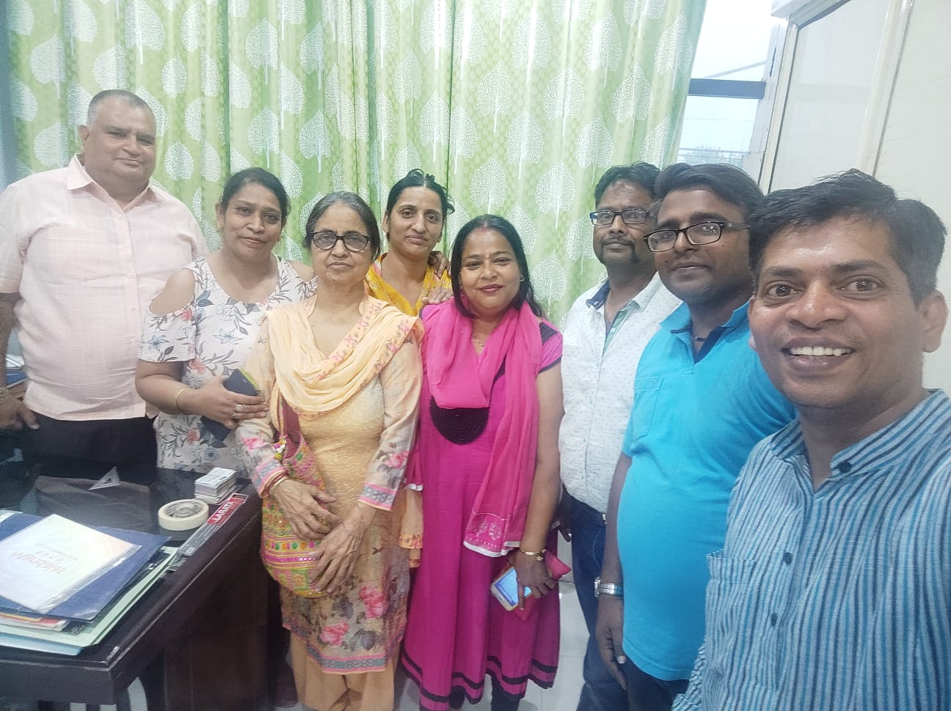

Teacher Training Series

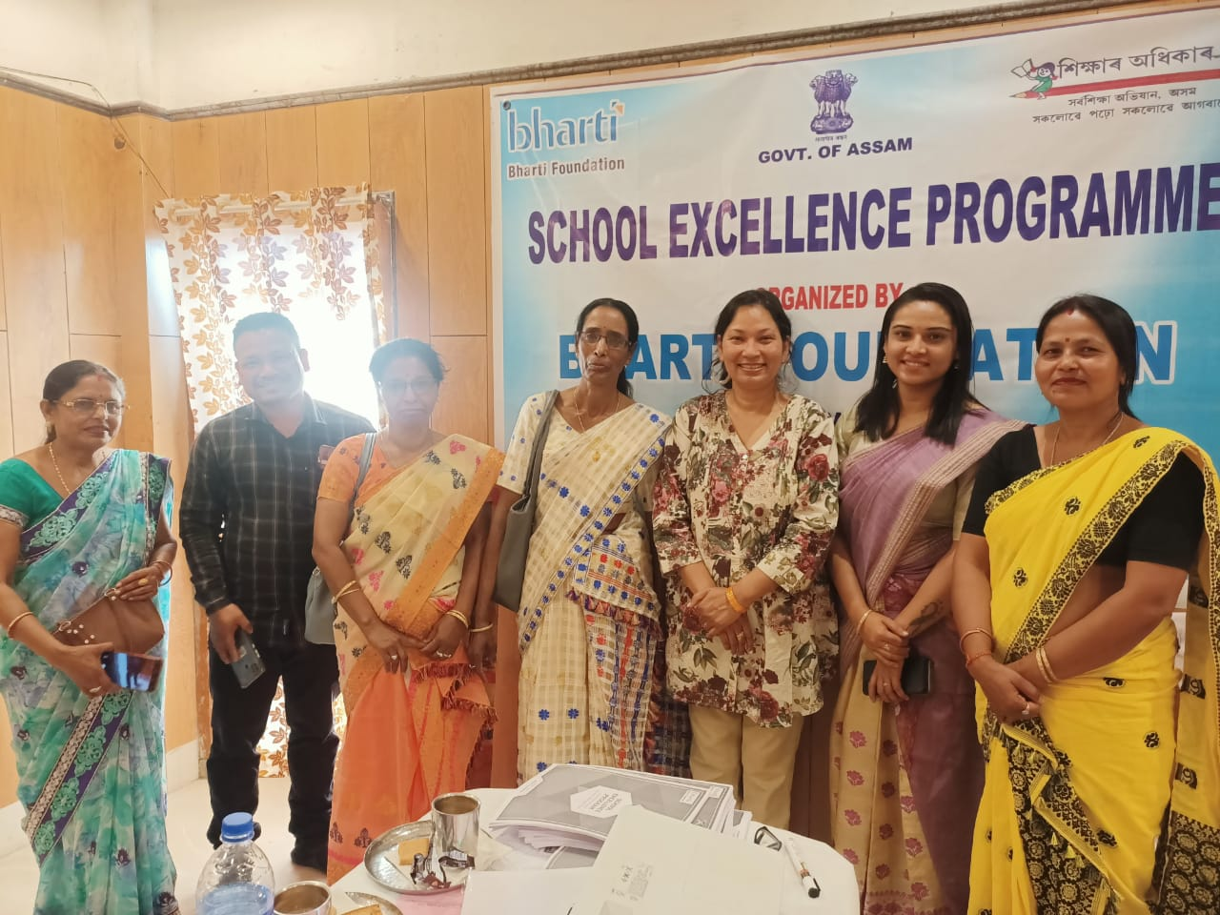
Teacher Training Series
Teacher Training for teachers of Samarth Jyoti School synchronous online – A special online training was organised on General Pedagogy attended by Samarth Jyoti School Teachers of all three location
Teacher Training for teachers of Samarth Jyoti School: synchronous offline - General Pedagogy training including Early Childhood Education – ERAC/David Kolb’s Cycle of Experience, Multiple Intelligence & Learning Styles, Brain-based Approach to Learning, Activity –Based Learning
Mode of Training - activity based, with and hands-on activities. A lot of simple easy to do activities were done with them and various methods of active learning strategies were shared.
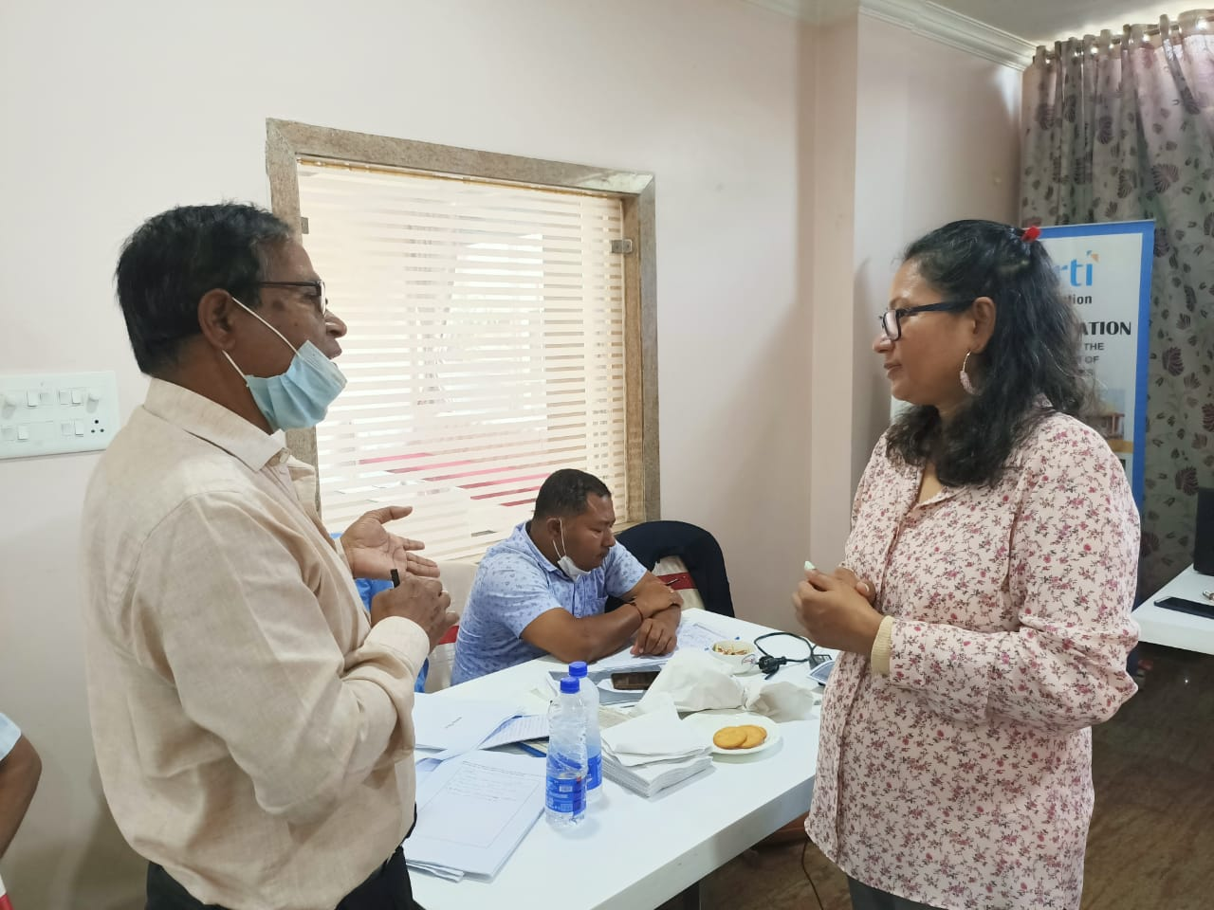
The training was attended by Haryana based Samarth Jyoti School Teachers and the same trainings were attended online by teachers from Pune, Ahmadabad and Tamil Nadu.

Content Development & Review

Language Framework in Hindi for Class VIII & Language Framework in Hindi for Class V for CAF Foundation
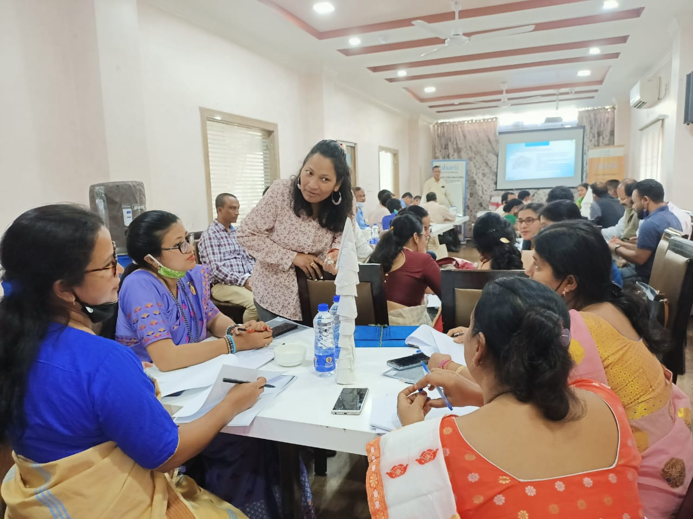
CBSE Item Review and Content Development for CSF based on standard Language framework defining competency level to be achieved by language learners in classes 3 to 5 and classes 6 to 8 in Hindi as well as English. Task required review of items created by CBSE item creators for alignment with intended learning outcome(LO) item structure, justification, language accuracy, level fitment and as per intended level of difficulty.

Training Module Development

A series of training modules on Module 1 – Academic Leadership, Module 2 – Student Leadership, Module 3 – Resource Management
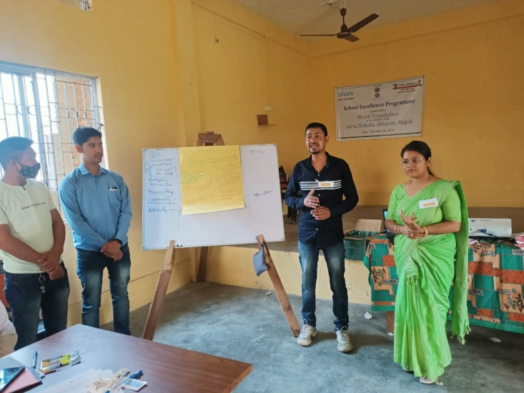
Each Training Module included Pre-Test: to test the previous knowledge of the Trainees on the topic of training prior to the first session / module for a particular topic / subject of training, Outlining the Learning Objectives as shared by T&C for the particular topic / subject of training. Beginning with an interactive Opening activity / Video to introduce the topic for Session / Module1. Power point presentation (with pointers and minimum written text) to achieve the learning outcomes of each Session / Module. Interactive Training materials (Poll, Quiz, Break-through activities like discussions / debates, etc., Videos or Audios) to be included to support the presentation in each Session / Module. Overnight Tasks at the end of each Session / Module (like to do activities based on the session presentation / transaction or pre- / post- reading materials or videos or audios based either on the session transacted or the session to follow). Recapitulation Activity of the previous Session / Module for every subsequent session. Detailed training guidelines to support and transact all the above. Post-Test same as Pre-Test for evaluation of the training delivery at the end of all sessions. Consolidated Assessment of the Subject / Topic of transaction at the end of the entire training.
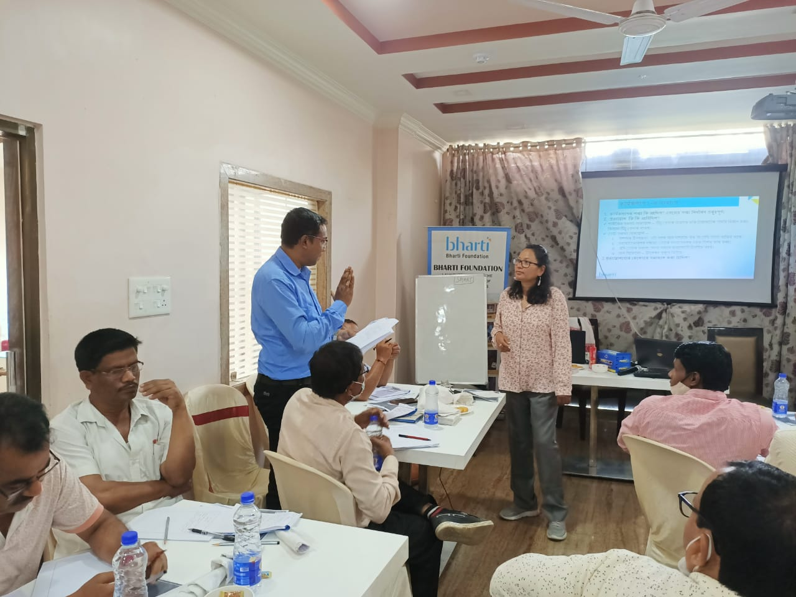
Power Point Presentation included Ice breaker Activity/Recap Activity : Hands on/ online activity; Covering of Learning objectives and outcomes as described in the trajectory; (Can be revisited and finalized after discussion with T&C team, if required) Well explained and elaborated with relevant examples. Learning Outcomes shared by Bharti Foundation in synchrony with NEP 2020, MoE, Pragyata document. Handout/ online materials/ Activities: Individual/ pair/ group activities that can be conducted online (off-boarding) or offline, Questions & Interactive Materials: Pre Test and Post Test comprising of the same set of questions based on the key learning outcomes; Poll question, Quiz, Points of discussion, etc.; Interesting relevant videos or audios and reading material Videos: Downloadable videos relevant to the subject for better understanding. (To be downloaded and embedded in PPT / shared before or after the module.) Check Copy right issues! (Give credit for video references) Reading materials: Pre and Post Training materials Supporting Materials: Pre- test: and Post- test : 10 questions after every 4 modules (Mapped as per Bloom’s Taxonomy / Cognitive Levels) Consolidated Module Assessment 1 : 20 question (Mapped as per Bloom’s Taxonomy / Cognitive Levels) Consolidated Module Assessment 2 : 20 questions (Mapped as per Bloom’s Taxonomy / Cognitive Levels) Suitable links (downloadable Material for the free online course)Flow of the module: (As per the actual flow of the Module) and Trainer’s guidelines: Detailed guidelines for the trainer for each module

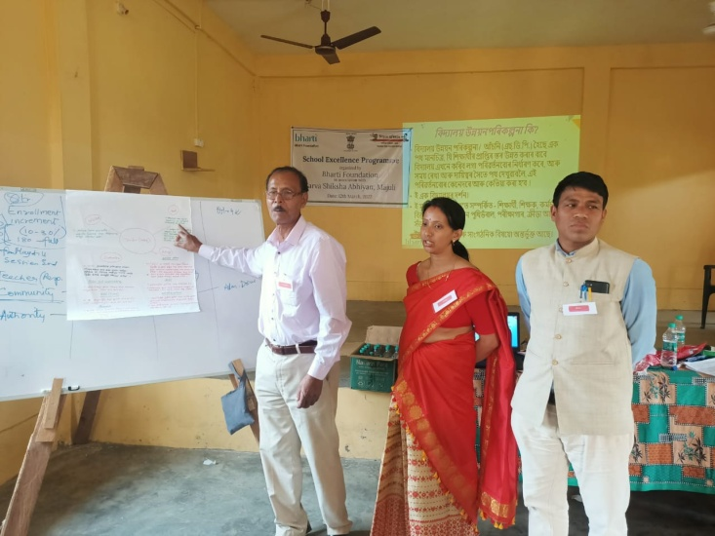
Impact Evaluation & Research

- Sarv Shiksha Abhiyan Impact Evaluation Report 2021 Review and finalization of the report for Datamation International
- End to End Impact Assessment and Monitoring of six (6) NSDC - RPL 2.0, PMKVY – GOI projects for Datamation
- Impact Evaluation & Report of PMKVY - RPL Training & Certification of SPEFL, NSDC
- Impact Evaluation & Report of PMKVY - RPL Training & Certification of DWSSC, NSDC – Nagaland
- Impact Evaluation & Report of Media & Entertainment Schedule Beneficiaries_ Impact Assessment of PMKVY - RPL Projects under NSDC.
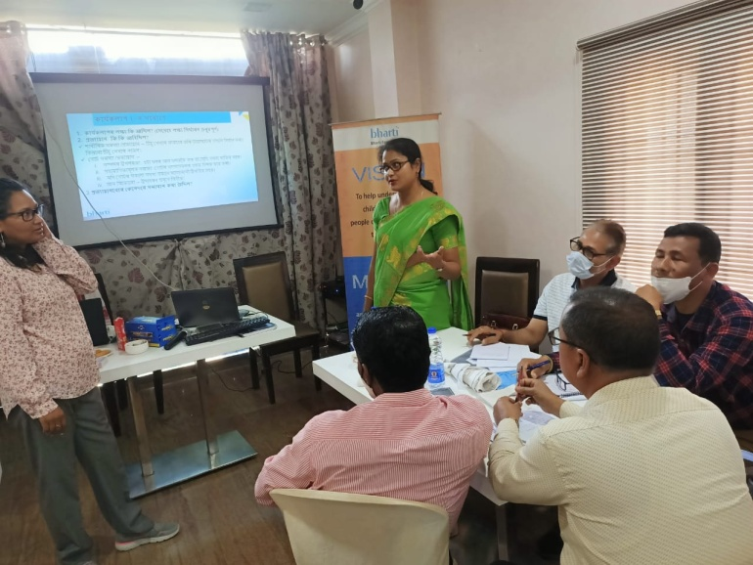
- Assessment Tools and Survey Coordination of 210525_Schedules_RPL_Beauty & Wellness English_ 24 June
- Assessment Tools and Survey Coordination of Media & Entertainment Schedule Beneficiaries_ Impact Assessment of PMKVY - RPL Projects under NSDC.
- Survey Coordination of Construction Skill Development Council of India (CSDCI)
- End to End Impact Assessment and Monitoring of three (3) CSR Project Impact Evaluation – Mazagaon Docks and Shipbuilders
- Impact Evaluation & Report of Cancer Counselling Project at 9 RCC with Sanjeevani Life Beyond Cancer for the FY 2019-20
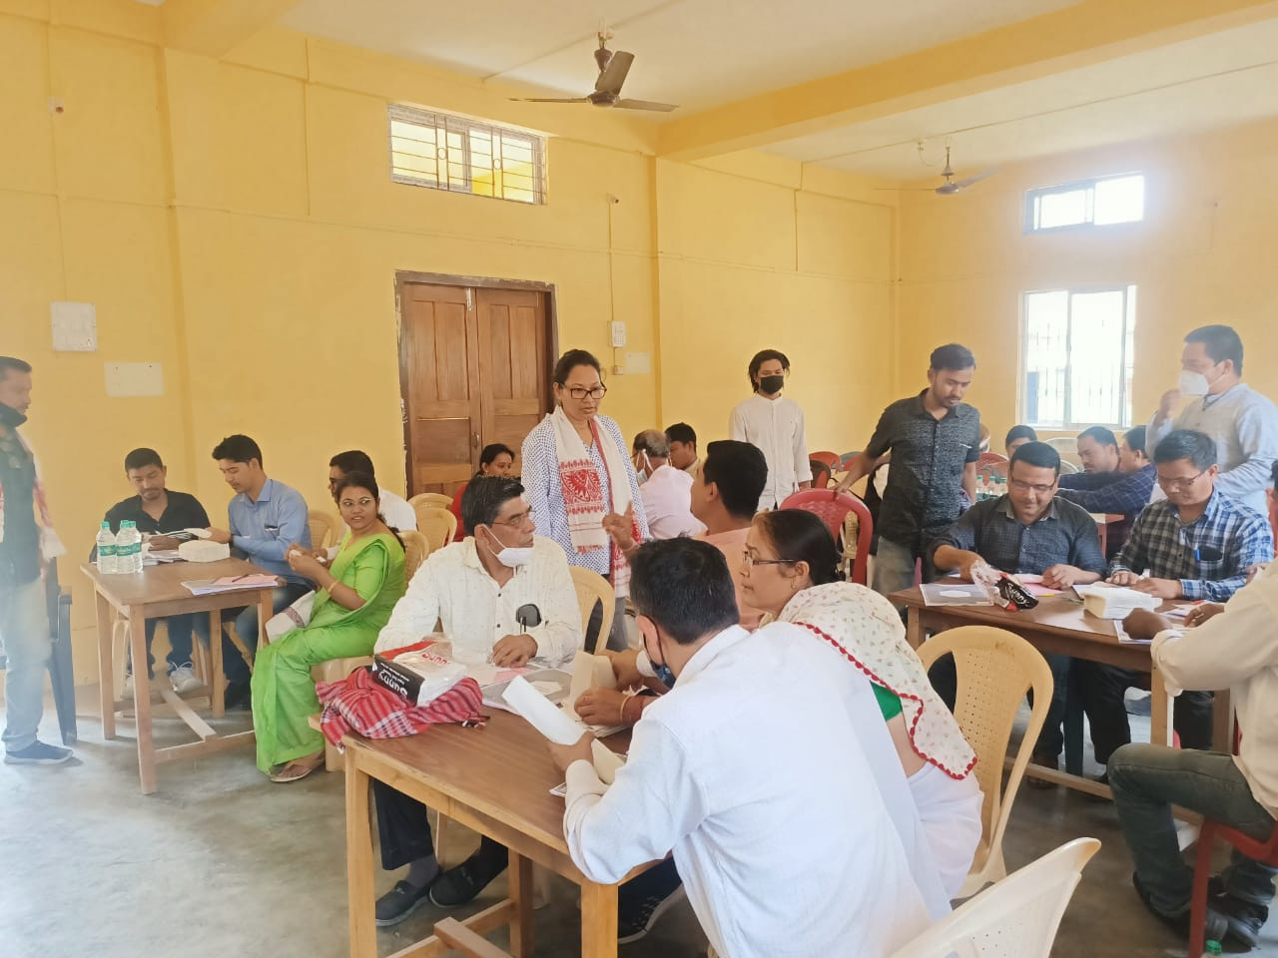
- Impact Evaluation & Report of MDL Impact Study of 7 Jeevanshala and 1 hostel in Nandurbar
- Impact Evaluation & Report of MDL-ABM CSR Project for Primitive Tribe Residential School - Impact Study – Analysis
- Mazagaon Ship Builder's CSR Intervention - Bon Bosco Tech Society
- End to End Impact Assessment and Monitoring of four (4) Swargiya Annasaheb Tatha Sudhir Baburao Pethkar Shikshan Prasarak Sanstha (SATSBPSPS)
- Impact Evaluation & Report of PMKVY by SATSBPSPS – Apparel
- Impact Evaluation & Report of PMKVY by SATSBPSPS – Food
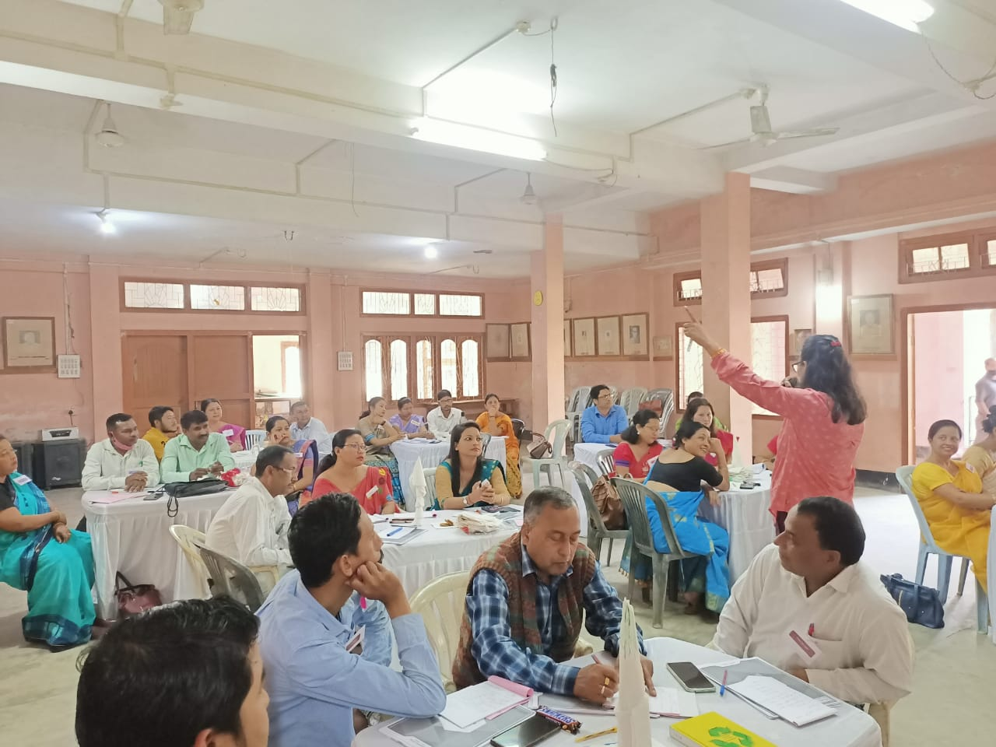
Impact Evaluation & Report of PMKVY by SATSBPSPS - Textile & DWSSC

Guidelines

We developed the “NCERT Guidelines for bridging the Learning Loss in Language & Mathematics due to school closure as a result of COVID 19 Pandemic” for Language & Learning Foundation, the guideline will be part of Post COVID Learning Recovery strategy guideline for schools to be released by NCERT/CBSE
Analysis of Post COVID Learning Strategy Across the Globe

Comparative report for LLF

Titled - UNICEF – Summarizing Global Strategies for Learning Recovery post Crisis Situations in various countries.

Assessment Content Review & Development

We created and reviewed assessment content for CSF to be used for National Achievement Survey (NAS), which provides an overview of students’ academic performance in the state. The NAS surveys a sample of all schools in each state to measure students’ performance on 5 subjects Math, Science, Social Science, English and Modern-Indian Languages (MIL) – Reading Comprehension. We created more than hundred items for classes 8 and 5

Our Partners
Towards achieving UN SDG Goals No
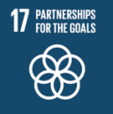  - NEXUS OF GOOD   | - COMMUNITY OF GOOD  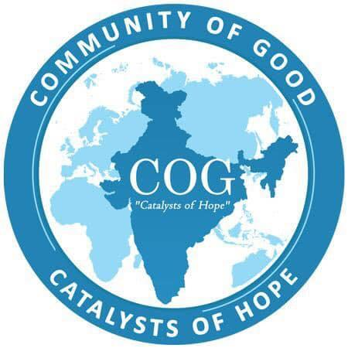
- RAJBALA FOUNDATION  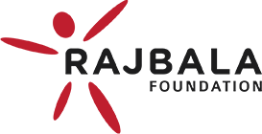 | - RADIO MEWAT  
- COVID ACTION COLLABORATION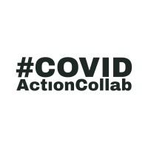 | - RADIO BRAHMAPUTRA  
- AASRA   | - GALGOTIAS UNIVERSIT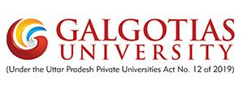
- NON VIOLENCE AND PEACE FOUNDATION   | - GURGAON KI AWAZ  

Our Clients
Towards achieving UN SDG Goals No
- BHARTI FOUNDATION  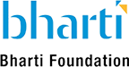 | - SAVE THE CHILDREN  
- CENTRAL SQUARE FOUNDATION   | - UNO MINDA  
- DATAMATION   | - ABHNAV SAMAJ  