**Holistic Healing Reiki, Reflexology, Massage and More!!**

**CLIENT INTAKE FORM**

Date: _________________

Name: ____________________________________________________ Date of Birth: ______________

Address: ____________________________________ City: ____________ State: _____ Zip: _________

I consent to email? Y: ___ No: ­___ Email: __________________________________________________

Home/Cell Phone: _____________________________________________________________________

How did you find Holistic Healing: ________________________________________________________

Emergency contact & phone: ____________________________________________________________

Are you sensitive to fragrances or touch? Yes____ No____

**LATE CANCELLATION/MISSED APPOINTMENT AGREEMENT**

Due to High Demand, please provide 24 hours advance notice of any changes or cancellations so the therapist can try to fill the spot. Appointments that are missed or cancelled with less than 24 hours’ notice may be charged $45.

Signature: ______________________________________________ Date: __________________

Please list any allergies and check any medical conditions below: ______________________________________________________________________

____ High/Low Blood Pressure ____ Varicose Veins ____ Heart Attack / Stroke / Cardiovascular issues

____ Low Back Pain ____ TMJ ____ Arthritis or Bursitis

____ Allergy to Nut Oils ____ Skin Infections ____ Headaches

____ Osteoporosis ____ Thyroid Conditions ____ Blood Clots

____ Diabetes ____ Sciatica ____ Seizure/Epilepsy

____ Pregnant currently ____ Bleeding conditions ____ Ulcer

Are you currently under the care of your Primary Care Doctor Physician? (Y/N) ______________________

For what medical conditions? _______________________________________________________________

List any goals, concerns, or questions here:

______________________________________________________________________________________

Do you have any specific areas of focus? ________________________________________________

What Services are you interested in today:

Reiki ________ Reflexology ________ Manual Lymph Drainage Massage _________ Cupping ___­­­____

If you selected Reiki, have you ever received it Y/N ________ When was last time? ____________________

All conversations are included as part of the session. For example, if you selected 1 hour session (50 minutes hands on) it will be included during the 50 minutes _________ (Initials)

**PLEASE INITIAL ALL THE TDLR and HIPPA REQUIRED STATEMENTS BELOW IN ACKNOWLEDGEMENT:**

Massage therapy is not a substitute for a medical examination or diagnosis. It is recommended that I see a physician for any mental or physical ailment. I understand the massage therapist does not prescribe medical treatments or pharmaceuticals or perform any spinal adjustments. I am aware that if I have any serious medical diagnosis, I must provide a physician’s written consent to receive services prior to receiving services. I affirm that I have stated all my known medical conditions and answered all questions honestly. I agree to keep the massage therapist updated on any changes to my medical profile. If I fail to do so, I understand there will be no liability on the massage therapist’s part. _______ (Initials)

The licensed massage therapist shall drape the breasts of all clients and not engage in breast massage of female clients unless the client gives written consent before each session involving breast massage. ______

If undressing, draping of the genital area and gluteal cleavage will be used at all times during the session for all clients. The licensee must immediately end the massage session if a client initiates any verbal or physical contact that is sexual in nature. The client will be liable for full payment of the session. ______ (initials)

If the client is uncomfortable for any reason, the client may ask the licensee to end the massage, and the licensee will end the session. The licensee also has a right to end the session if uncomfortable for any reason. _____(Initials)

If I experience any pain or discomfort during this session, I will immediately inform the therapist so that the pressure and/or techniques may be adjusted to my level of comfort. ______ (initials)

Printed Name: ____________________________________________________

Signature: _______________________________________________________ Date: __________________

Therapist’s Signature: ______________________________________________ Date: _________________­­_

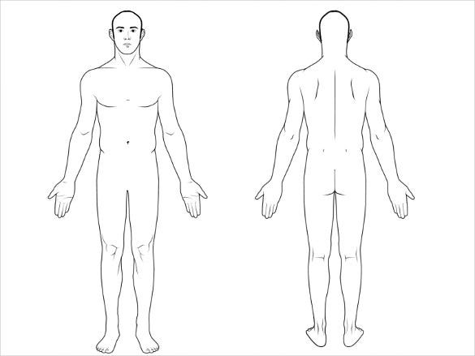Please circle areas to be addressed: