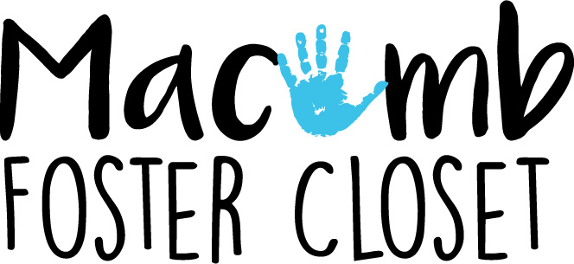

WHAT SHOULD I KEEP??
- Keep only EXCELLENT condition new or nearly new items that would currently be sold at Target.
- We keep current season sizes Preemie to Adult L
- Off season we keep 2T/24m through child size 14-16 (we do not keep off season adult clothes no matter how nice, or smaller than 2T child clothes no matter how nice. There is no room to store them and we have a surplus, pay these items forward)
- Underwear and Socks must be New With Tags
  - only exception is infant socks, used OK if still excellent condition
  - Long underwear can be put in the pajama bins
PAY IT FORWARD (PIF) or TRASH
- Any item that has a specific; School, classroom, child sports team, RARA, vacation, club team, company logo, Date, Concert, Run/Walk events, vacation destination, any personalized items…. our children did not personally experience the event so they won’t need the T-Shirt. (exception is U of M, MSU and professional local sports teams our kids follow local sports)-trash
- Alcohol/Drug/Cigarette references-PIF
- Any shirt without a positive message i.e. “I suck”-trash
- Prom-Type Formal dresses and purses these are better suited for other organizations, we keep church dresses but not Prom. -PIF
- Holiday themed items of any sort-PIF
- Family reference: Aunt, Papa, Big Sis our kids don’t live with their natural families right now these can be offensive to biological parents-PIF
- Household items: toasters, rugs, TV, coffee pots…PIF
- Robes our families never shop for them-PIF
- ANY Used Bedding except-excellent crib sheets-PIF
- USED Comforters or blankets-PIF
- Maternity, breast pumps, pregnancy related items-PIF
- Baby bassinets (they kill babies)-trash
- Positioning sleep wedges for babies (they kill babies)-trash
- Off season shoes-PIF
- Crib bumpers, crib quilts (they kill babies)-trash
- Adult XL clothing-PIF
- Room décor, wall hangings-PIF
- Cribs with drop side (they kill babies)-trash
- Stained, ripped, offensive, missing buttons, broken zipper, holes in knees, tattered cuffs, size unreadable, yellowed, not current style, “trashy”, not conservative, see through, spiked platform heels……. Trash!
- Offensive smelling – if you open a donation and think “wow they are smokers” or “ewe smells gross” throw the entire bag away, don’t sort it at all-trash
- Animal hair covered throw the entire bag away, we don’t need that dander in the closet-trash
- If First ½ of the bag is very poor quality/dirty – we can assume the entire bag is, throw it out, save everyone’s time-trash
- PJ parts -size 0 to kids 6 we only keep PJ sets in like new condition, size 7 and larger PJ bottoms alone are ok to keep and place in bin -trash
- Single shoe/sock-trash
- Underwear without tags-trash

OTHER ITEMS
- Belts, Hats, ties, purses- top right most corner of shoe bins one boy, one girl there is a bin for these items, only current styles, new looking current season go there.
- We have a general items shelf -located to left of infant items. This shelf has bins marked for diaper bags, twin sheets, crib sheets, burp cloths, infant socks (used OK), Back packs, lunch boxes, pillow cases. and a variety of other items. Same standards apply, excellent condition and if there is not a bin already marked for a donation, you need to pay it forward. Our shoppers probably don’t shop for it.
- Diapers/wipes/diaper cream- We have diapers NB-school age. We accept new diapers from open packages, keep them together and place them with like size diapers. There are overflow diaper boxes in the closet of the bathroom.
- Toys Books- excellent, clean condition, current trend, with all their pieces (and we have room for them) we keep them if not -PIF
- Baby Equipment closet- items must be clean and current with all their pieces. If broken or dirty PIF, if not stack it with like items in a safe manner and keep the pieces together. When in doubt “throw it out”
- Used Car seats- Check for manufacture date or expiration date, IF YOU FEEL CONFIDENT fill out a green tag and mark it with expiration date, you can use 7 years as your benchmark or google the expiration date of the exact seat. If it is already expired, looks dirty, or damaged, cut the straps and throw it out. We don’t mess around with “maybe” in care seats.

