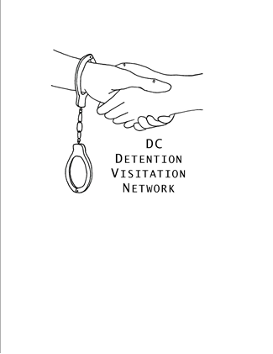
DC Detention Visitation Network (DC DVN)

Our Mission is to provide friendship and support to people in immigration detention.

We are members of DC, Maryland, and Virginia communities who are concerned about the welfare of people affected by immigration detention. We make social visits to people who are detained by US Immigration and Customs Enforcement (ICE) in Maryland and Virginia. On any given night, when the system is operating at typical capacity, as many as 1,000 or more people may be held in ICE custody in at least four detention facilities in these two states.

Why? Many immigrants in detention do not have family or friends who can visit them. It is common for people in immigration custody to be held in a location distant from where they lived or worked. Boredom, tension, trauma, and anxiety frequently affect immigration detainees, who face the severe stress of potential deportation and indefinite confinement. Visits from community members give detainees a “break,” boost their morale, and help individuals refocus their emotions on positive relationships while in detention.

We invite you to join us. There are many opportunities to volunteer with DC DVN, including as a detention visitor, pen pal, or as a voice for the voiceless, by speaking with others in our community about the immigration detention system and the experiences of people being held in ICE custody. We ask those who are interested in writing to detainees or visiting in person to attend a 2 hour training session that we hold approximately every other month; in addition, in order to visit a detention center in person, you must have a valid government-issued photo ID and be capable of passing a background check. A criminal record is not necessarily disqualifying, but we cannot guarantee that detention facilities will permit your entry. Undocumented residents generally cannot visit detention centers but can perform any other volunteer role with DC DVN.

Visit logistics: We conduct regular in-person visits to detainees at Worcester County Jail in Snow Hill, MD. We are also able to connect volunteers with people detained in Farmville Detention Center in Farmville, VA and Caroline Detention Facility in Bowling Green, VA for ad hoc visits.
- We go to Worcester County on the fourth Friday of each month. Worcester County Jail is located on the Eastern Shore of Maryland, approximately a three-hour drive from central Washington, DC. We typically leave our area at 7am and return at 4pm on visit days.
- We can visit people in Farmville during the facility’s regular visiting hours: 9am to 9pm, seven days a week (though individuals may have more limited options depending on their security classification). Farmville is about 65 miles west of Richmond, VA.
- We will begin visiting Caroline Detention Facility for the first time when visits resume post-pandemic.

Please let us know you’re interested in hearing more.
We’re at http://www.dcdetentionvisitation.org/
https://www.facebook.com/DCVistationNetwork
@DC_Visitation * https://twitter.com/DC_Visitation
washingtonareadvn@gmail.com
443-620-3380

Visitation Do’s and Don’ts

- DO be a friend, not a social worker, counselor, lawyer, reporter, or minister.
- DO be open, non-judgmental, and sympathetic.
- DO recognize your position of privilege, and give your friend in detention the power to lead your conversation.
- DO be predictable and consistent, insofar as possible, to counter the uncertainty that permeates detained life.
- DO maintain your friends’ confidentiality, and do not disclose that any particular person told you any particular thing without first getting an okay from your friend to do so.
- DO bring a government-issued ID with you to detention facilities.
- DO follow instructions from detention facility staff.
- DO share your experiences (while safeguarding confidentiality) with and tell your friends and acquaintances about the immigration detention system.

- DON’T create or encourage unrealistic expectations, but do cultivate hope and realistic optimism.
- DON’T feel obligated to solve all of the concerns and problems your friends in detention might share. Showing that you care is enough, and it helps.
- DON’T feel obligated to give money or do anything outside of visiting that any person may ask of you.
- DON’T proselytize.
- DON’T disclose your friends’ names or other identifying personal information to anyone outside our organization.
- DON’T bring any items other than identification (and car keys if you have driven) into a detention center.
- DON’T provoke or participate in conflict with detention center staff. Don’t conduct any investigation or protest of detention facilities while serving as a DC DVN volunteer.

