Sunday 17th November 2019
10am start from Radnage Village Hall (HP14 4DF)

Dear Runner

We hope you will find the following information useful. Please contact us if you have any questions: Jim Whittington jimwit1@yahoo.co.uk or grgh@yahoo.com Race registration enquiries to info@evententry.co.uk.

Race numbers are picked up on race day at Radnage Village Hall. Please write on the back: your name, emergency contact number and any allergies or relevant medical conditions. Don’t forget to bring 4 safety pins to attach your number to the front of your running vest. Your race number will be marked to show if you are running the 10K or 5K. UK athletics rules state that ear phones/pieces are prohibited.

Photographs will be taken along the 10K route and later published. If you (or your parent/carer if you are under 18) do not wish to have your photo published on the web, please put a large thick red cross across your race number. Red markers will be provided at the Village Hall for this purpose.

Parking
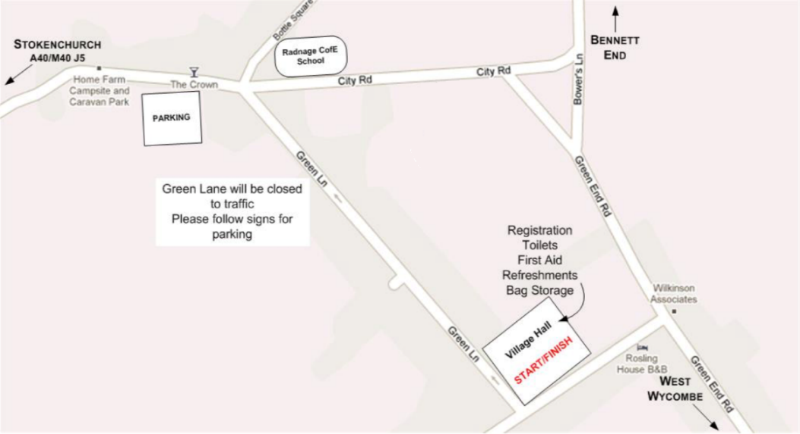

Dedicated race parking is on City Road, Radnage HP14 4DW. Follow the signs as you come into the village and listen for advice from the parking marshals. Some of the parking is in a field, which may be muddy. There are no parking facilities for coaches. Parking is at your own risk and Radnage Primary School & PTA accept no liability for any loss or damage. Please note that to reduce road traffic during the race, there will be no access to/from the car park from 9.55 until 10.40am.

From A40/Stokenchurch/M40: turn into Mudds Bank off A40 and follow the road into Radnage where you will find parking directions. The parking site is on the right-hand side, before The Crown Pub.
From Bennett End/West Wycombe: turn into City Road and follow signs, parking site is on your left-hand side, after the school, near the Crown.

Race Start
The RR10K starts on Green Lane, outside the Village Hall. The 5K starts the same time and place. The 5K race may not be exactly 5K in distance. The car park is a 12-minute walk from the race start, so please make sure you are parked by 9.35 am at the latest. From the car park turn left along City Road (short stretch of road with no footpath) and right into Green Lane. Walk down Green Lane to the end (be aware of the speed humps marked by cones!), the playing fields and the Village Hall are on your left. The marshals will guide you. Before the race, please wait on the playing fields outside the Village Hall; be ready to receive final instructions at 9.50am. The race will start promptly at 10am.

The Race
The duration of the 10K race is a maximum of 2 hours and a sweeper will follow the competitors. If you are still running/walking after this time, the sweeper will advise you that you are no longer participating in the event and we will not be able to provide you with marshals and facilities beyond that point. The marshals along the course are there for the safety of competitors and road users. Please listen to any instructions they give you and pay attention to the race signage. 10K runners turn left at the bottom of Pophleys Hill, and 5K runners turn right. There will be signs and marshals to guide you.

The Rugged Radnage 10K Run is a challenging course with varied terrain. Runners should be aware of the following features to ensure adequate pre-event training and appropriate clothing/footwear on the day:
* A 100m ascent from 2km to 4.5km, steepening towards the end of this section.
* A 60m ascent from 9km to 9.6km
* Downhill sections on farm tracks and through woodland that will be muddy, slippery, uneven and obscured by fallen leaves. There may also be loose stones.

In the event of severe snow, frost and ice causing obstruction to the roads, or making the running surface dangerous, the race will be cancelled. Information will be posted on the website to notify participants, no later than the day before the race. Race entry fees will not be returned for such cancellation. Dogs, including guide dogs, are not allowed on the race route during the event.

Disabled Athletes
RRR welcomes entries from disabled athletes. To ensure that an adequate risk assessment is made, disabled athletes are encouraged to contact a member of the committee in advance of the race, to discuss any specific requirements, and to obtain a race pass to the disabled parking adjacent to the start. Due to the rugged nature of the course, with steep off-road sections, it is regretted that wheelchairs entrants will not be permitted.

Facilities
- St. John’s Ambulance will be in attendance. If you require any medical attention please notify a marshal.
- Toilets – please respect the village of Radnage and use the facilities at the village hall. Toilets are accessible for wheelchair users.
- Bags – competitors can leave bags at the village hall. They will be locked away during the race.
- Refreshments – tea, coffee, hot chocolate, squash, bacon rolls, hot dogs and homemade cakes can be purchased from 8:00.

The Finish
Once you have crossed the finish line you will be given a race medal. The first 350 entrants will also receive a goodie bag! Water is available at the finish line. Don’t forget to smile for anyone you see with a camera. We will put photos on our website and facebook page.
Trophies – Category winners will be presented with their trophy in the village hall. There is also a trophy for the fastest Radnage Resident. Prize giving will start at 11:45.

Good Luck! We hope you enjoy this beautiful course and look forward to seeing you next year!

The Race Committee
ruggedradnage.co.uk

We would like to thank our generous sponsors

