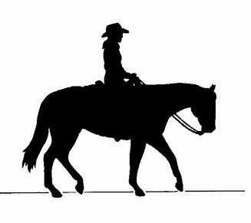
This Is Your Invitation To Join The

Alpena County Horsemen’s Club

Who We Are
Alpena county Horsemen’s Club is a group of people with a common yet diverse interest in horses and related activities. Member’s interest include showing (at local, state and national levels), Training, breeding, trail riding, horse camping and driving.
What We Do
The Alpena County Horsemen’s Club is all about enjoying and getting the most out of the time that we spend with our horses. We provide the opportunity to network with other horse owners with shared interests. We currently meet the second Tuesday of the month at the Aplex- in Alpena at 6:30 P.M. Once the days get longer and the weather nicer, we may meet at various members’ farms and ranches. We have sponsored local horse shows, Alpena Horse Development 4-H, Horse Science Short Course and many other educational opportunities. We get together for trail rides and equine camping. Other family events include cookouts and hayrides. We provide horse-related scholarships for local youth/adult or any equine trade schools as well. We wrap up the year’s activities with our famous Christmas party and gift exchange.

Membership
Membership is open to anyone with an interest in horses. You need not be a resident of Alpena County. Membership dues are $12.00 per individual or $20.00 per family per year and include a monthly newsletter preceding every meeting to keep you updated on club events, activities and items of interest.

How To Join
Fill out a membership form (found on web site) ahorseclub.com. Make your check payable to the Alpena County horsemen’s Club and mail to our treasurer:

Cindy Krentz
10811 Hubbard Lake Road
Hubbard lake, Michigan 49747

Or join us at our next meet and take care of your payment with Cindy at that time. We look forward to having you join us!

