<http://amazing-exercises.blogspot.com/2013/10/vestibular-exercises-and-rehabilitation.html>

### Vestibular Exercises and Rehabilitation To Help Improve Your Balance

[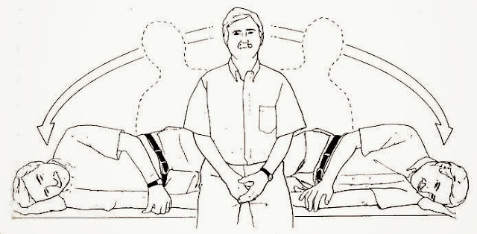](http://2.bp.blogspot.com/-9hTMkLSYnC4/Ump7IjMhfoI/AAAAAAAAAVU/JbUgaDTrWyI/s1600/vestibular+exercises.jpg)

    Falls are the leading cause of fatal and non-fatal for people over 70 injured. Most of these people report chronic problems with dizziness and imbalance. After consulting a doctor, a patient may be referred to a vestibular exercises rehabilitation therapist . VRT vestibular exercises will help the muscles , joints , eyes and inner ears learn to compensate for vestibular exercises imbalance and / or weakness. The vestibular exercises described in this article can do at home to complete physical therapy . Always get medical discharge by a physician before starting an vestibular exercises program .  
  
    The following vestibular exercises can cause dizziness . The first attempt should be made cautiously . Always be prepared to stop and rest if vestibular exercises causes dizziness or lightheadedness. For standing vestibular exercises , always standing near a solid support such as a chair very strong , leaving a movement, but enough standing to take if necessary .  
  
    Ankle Swings : Stand holding a stable support. Without locking your knees , but remains fairly simple, lean slightly forward from the ankles (not the waist or hips) . Hold for five seconds. Stand up straight . Do the same thing leans left , backward and right , holding for five seconds and straighten the middle.  
  
Repeat the pattern as follows :  
  
1. front left, rear right (as above ) ;  
2. front right, back left ;  
3. left rear , right front ;  
4. rear , right, left .  
  
    Rolls -toe heel: Stand holding onto a stable support . Without locking your knees , but remains fairly simple, throwing plugs (not on your hips or waist ), 360 degrees ( a full circle ) , one direction and then the other direction. Stand up straight . Repeat five times.  
  
    Alphabet Track : Stand holding onto a stable support . With the right foot , draw an imaginary letter A on the ground. Continue with the rest of the alphabet, and then do the same with the left foot . For a challenge, followed by lowercase letters of the alphabet on each side.  
  
    The following vestibular exercises can be done sitting, standing , supported , standing without support , or even on foot in some cases ( depending on the level of comfort ) .  
  
    Jerks (pronounced " suh - KAHDZ " ) Strip four targets ( pieces of paper or cards, for example) on a wall about 30 degrees out in a diamond (right , left , a top, low) . The arm length of the wall is approximately 20 inches. To be further from the wall, the objectives should be more widely spaced . Without moving your head , look back and forth between the goals of the left and right for about one second each, about 25 times . Repeat with the objectives of high and low.  
  
    V.O.R. ( vestibular exercises -ocular reflex ) years : VOR is a reflex eye normally move in equal and opposite way of the ears move . This keeps things clear vision while the head moves , as in walking . To stimulate this reflex , just watch a target face ( not too close or too far away ) and at the same time keep your eyes on the target, move the head to the right and the left in the second, with the lens focus article. Completing the cycle about 15 times , depending on the level of comfort. Repeat the cycle with head movements up and down , always trying to keep the target in focus. For challenge , treat with head movement diagonally ( as X lines ) . The goal is to keep your eyes on the target center at any time. The faster you move your head , the more difficult it will be to slow down or speed up when needed.  
  
vestibular exercises!  
Circles of the head : the head move as if drawing a circle on the wall with the nose. Maintain support if needed . Follow this pattern: clockwise (CW ) to open 5-10 times clockwise ( to the left ) with eyes open eyes 5-10 times, with closed eyes CW 5-10 times, and left with closed eyes 5-10 times.  
  
     Sinusoidal Tracking : Keep a card , a pen or a finger at arm's length . Keep your head still and move the right arm and the left 10 times, keeping his eyes on the object (only the eyes move to the left and right arm ) . Switch hands and repeat. Ask someone to help you if the arm fatigue vestibular exercises.  
  
    The movement of the head in a sitting or standing position , turn your head to look over your right shoulder , back to back to look ahead , he turned to look over his left shoulder, and then back to the earlier. Turn allows convenience only . Repeat the cycle of 10 hours. As you gain confidence , try looking up and down or diagonally , which increases the rate and / or make them to walk "vestibular exercises".  
  
    Recreational activities can also be excellent for vestibular rehabilitation . In general , activities should include the use of the eyes, while the head and / or body shake . Of course, many activities require : golf , bowling , tennis, racquetball , tennis , dance , martial arts , swimming, etc. The trick is finding one that is fun, safe and stimulating. Just walk around the block looking from side to side is a useful activity . Always be aware of the physical limitations , and be safe !