Cellular Music

Sonocytology Science has revealed that our cells “make music/sounds”:

<http://www.elitemv.com/2019/09/sonocytology-study-of-sounds-and.html>

<https://www.smithsonianmag.com/science-nature/signal-discovery-104663195/>

<https://youtu.be/x-_fUha592Q>

Below is a quote from the UCLA Art exhibit about the sounds of the cells:

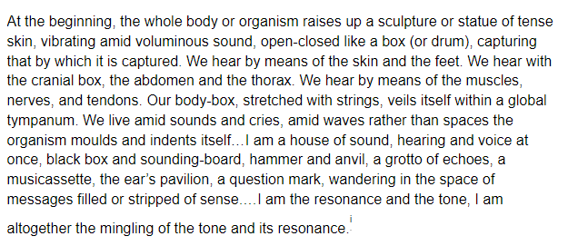

This science discovery is bring new meaning to the ancient humans’ belief that healing came from sound. The vibrations of sound are used now in energetic medicine. And the energy vibrations between people are the basis upon which we form our attachments, our family communities, and ultimately, our cultures.

<https://www.ncbi.nlm.nih.gov/pmc/articles/PMC4010966/>

This above article explains the vibrational rhythm of life. This quote comes from the article:

“The notion that one “hears” sounds not only through the ears but rather through the whole body is echoed in the words of the Sufi musician, healer and mystic, Hazrat Inayat Khan: A person does not hear sound only through the ears; he hears sound through every pore of his body. It permeates the entire being, and according to its particular influence either slows or quickens the rhythm of the blood circulation; it either wakens or soothes the nervous system. It arouses a person to greater passions or it calms him by bringing him peace. According to the sound and its influence a certain effect is produced. Sound becomes visible in the form of radiance. This shows that the same energy which goes into the form of sound before being visible is absorbed by the physical body. In that way the physical body recuperates and becomes charged with new magnetism.*”*