A Short Story (Part 3): The Evolutionary History behind “Pelvic Exercises for Throat Tension”

The Bioenergetic Field, Brain Neuro-plasticity, and “Juvenilization” of Adaptibility

You may be thinking: Why should I be concerned about all this “evolutionary” knowledge? What does this have to do with my psychological distress?

At the start of your IN SNYC psychotherapy, we discussed the vital importance of “psycho-education” as the basis of your treatment: that you must have a “cognitive structure” upon which to “store” all the new information you would be gaining. Now, we are beginning to implement techniques which will increase your “intuition,” which skill will seem like “magic” or “superstition” or “prophecy” without the underlying scientific knowledge.

You are the recipient of a human brain “design” which was completed over 100,000 years ago, perhaps even earlier. With recent theories of neuro-plasticity, Evolutionary Developmental Biology, and Neoteny (all science discussed in “A Short Story” Parts 1 and 2), you are now more aware of the vastness and power of your own ability to heal and self-determine your future with intuition.

What is “Intuition”? This concept refers to a “state of mind” which will arise as a result of combining your:

1. knowledge (i.e., how the brain functions with networks and systems; how bio-energy operates, how you can change your mental state with relaxation and breathing techniques, etc.);
2. sensory perception of your internal sensation, the external environment, the state of other humans with whom you interact (the outcome to you of the IN SYNC interventions);
3. mindfulness integrative connection between your knowledge and your sensory perceptions to enable you to problem-solve in a non-OCD manner, with deep insight and wisdom (a change in how your cognitive functions operate on the unconscious level).

I am providing you with education about the recent scientific knowledge of our human evolution because most prior education is comprised of “self-limiting” viewpoints and reflective of “biased” perceptions. This prior educational knowledge generally excluded a wholistic energetic framework of interpretation. You may find yourself recalling lessons from grade school, high school, or college which seem to be in contradiction with the information you are now learning. When a “knowledge conflict” occurs, you will need to bring these issues into your therapy, otherwise the prior “knowledge” may form a cognitive “blockage” just like the “body blockages” you have been resolving.

One area of evolution knowledge which is lacking in research is related to the female human. The majority of medical research, even ancestry research, has focused upon the male human. Therefore, in the next “short story” of evolution, I am taking a few liberties with interpretation of factual findings, in order to address this deficiency in female perspective. Also, in our “short story,” we are going to take an energetic perspective towards the evolution of the female pelvis and the birth channel created for handling the unique evolutionary changes to the human embryo.

Most theories of human evolution focus upon the “survival” needs--the strong muscles of arms, and fast movement of legs--in short, male dominant traits. Human evolutionary history is viewed through the perspective of “looking backwards” from the current human society to find “commonalities” between us and our Homo sapiens relatives. But this “commonalities” search excludes all knowledge of bio-energetic functions, excludes any consideration of a “human bio-field” which may have impacted that evolution. And the “theoretical” considerations of these “commonalities” excludes the female perspective.

This bias of exclusion began during World War I and World War II, possibly as a reaction to the German experiments on human infants. The West abandoned the whole field of fetal development and embryogenesis (a direction strong in Germany) in favor of population genetics. Population genetics is the study of the genetic composition of populations, including distributions and changes in genotype and phenotype frequency in response to the processes of natural selection, genetic drift, mutation, and gene flow. The West also rejected the evolutionary “theory” that female sexual selection of the male was a primary factor for reproduction. Instead, the focus was based solely on the concept of competition between males (the “war and competition” mentality of humans) for the “ownership” of the female.

Let’s look at how a female evolutionary viewpoint might impact how bipedalism may have evolved. The current theory is that the two-arm brachiation (swinging from trees) created the foot and bipedalism of the human-like primate (a “male” functional viewpoint). In the article “Safe Carrying of Heavy Infants Together with Hair Properties Explain Human Evolution,” written by Lia Queiroz do Amaral, it appears that we must focus on the role of females with infants, and that tripedal walk was an intermediate stage to bipedalism. This stage also lead to fur reduction and thermoregulation of the naked skin, with evolving of subcutaneous insulating fat layer. From here, she describes how hominin social structures evolved from “huddle formation” (to keep warm) and “hormonally defined rites of passage,” all of which are female viewpoints. (8)

Recall the prior “A Short Story: Part 2” in which I discussed the XY of the embryo’s sex: This article provides the research to support the above article, stating that the bipedalism would be carried forward on the mother’s genes, not being damaged by the Y chromosome of the male embryo. (9) This implies that female sexual selection choices are the cause of our current genetics, including the functions of brain neuro-plasticity, the neoteny of being able to develop new adaptation to current environmental challenges, and to “expand” the human bio-energy field for the purposes of developing “social systems of support” (this function will be discussed in later IN SYNC steps).

Let’s look at how an evolutionary viewpoint about the concept of “neoteny” (juvenilization) from female viewpoint may change this function. What if we view “juvenilization” not as a “slowing down” but rather as a function of “evolving towards” a longer maturation process as being necessary for “survival” in a changing environment which could no longer be dependable for a “rigid” infant structure? In other words, humans would not maintain a “rigid” infant structure like that still observed today in the other hominoid apes (gibbons, orangutans, gorillas, chimpanzees, etc.).

From a bio-energetic viewpoint, we will consider that the female pelvis and the embryo are interacting together in an energetic “dance of evolution” rather than a body “part” (the pelvis) being evolved solely to accommodate an embryo. The embryo evolves with the shared energetic interaction, not independently “developed” from a fertilized human ovum . This viewpoint could give a very different interpretation to the evolutionary “facts” of the past, including providing an energetic interpretation to the human infant’s neoteny function.

(I am presenting this above framing approach so that you will understand that not all of what I present has been proven by science. However, you will find ancient religions which address many of these topics, also without science evidence either. I will also discuss the prior science regarding the fascia network and how this energy field is connected to our “adaptability” for survival.)

Modern Human Pelvic Floor

So, how would the human mother’s pelvis change in shape in response to an energetic interaction with the embryo? And then a further psychotherapy question: Why should you do “pelvic exercises” for throat tension? And in preparation for your next IN SYNC step: What could possibly be the connection between the mother’s birth canal and the infant’s ability to talk as a human? Stay Tuned! We will eventually answer all these questions in the IN SYNC steps coming up!

As a result of evolutionary changes, there is a very big difference between the male and the female pelvic floor. In both sexes, the urethra (for urine) and anus (for feces) pass through the pelvic floor. In the female the uterus (center for the growth of new human life) also must pass through these firm and thick muscles. (1) (2) The male pelvis is narrow, the female pelvis is wide.

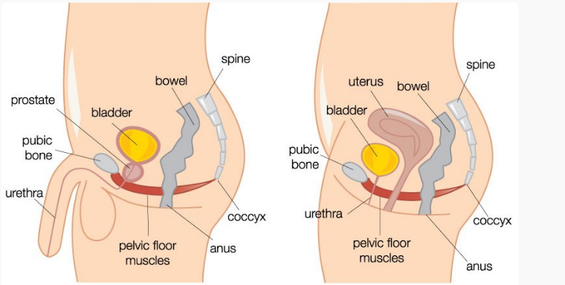

When and why did the pelvic floor evolve to these different male and female human characteristics? So here is a “little folk story”: “Adam” lost his baculum (the penis bone), not his rib to Eve. This is a main sexual difference between human males and apes. It has been argued that the "rib" (Hebrew [צֵלׇע](https://en.wiktionary.org/wiki/%D7%A6%D7%9C%D7%A2" \l "Etymology_1" \o "wikt:צלע) *ṣēlā'*) in the biblical story of actually a mistranslation of a Hebrew euphemism for baculum, and that its removal from Adam is a creation story to explain the absence of the “penis bone” (as well as the presence of the “scar” of the perineal raphe) in male humans. (10)

Without the ape’s baculum, the flexible human male penis requires the narrow pelvic with its muscle support to maintain a sexual erection. Tension in the fascia of the pelvic creates erectile dysfunction and other sexual issues. (11) An evolutionary approach based upon female selection explains this radical change in the male human as being a part of the female’s “choice” of a mate who will “socialize” more effectively and be more “sensorially-focused” than seen in the mating habits of male animals with baculum.

There are other differences between the male and female pelvis, but the primary one for continuation of the species with new life (infants) is that the female pelvis is larger and broader than the male pelvis, and that the angle is different. The change in the angle of the femoral head gives the female gait its characteristic swinging of hips. (3) However, this pelvis shape has been referred to as the “obstetrical dilemma” in that the favorite evolutionary idea is that humans developed a narrow pelvis (male viewpoint) as it was beneficial for locomotion when walking upright, but then females had to develop a wider pelvis to accommodate an infant which had such a large brain and big shoulders. (5)

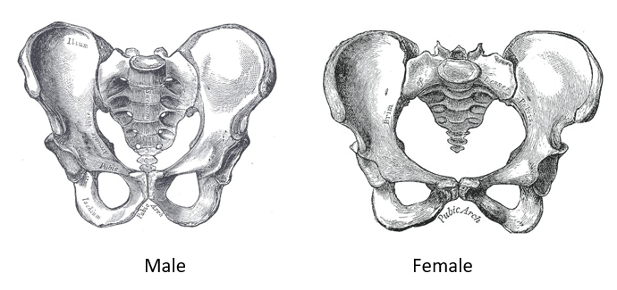(14)

The main outcome of this birth difficulty is that human females need a “social community” in order to give birth, whereas female primates do not as the primate infant has no difficulty in being born as mother primate pelvis accommodates perfectly to their infant. Due to birth difficulty, humans are born undeveloped and have long periods of growth (childhood through adolescence) whereas primates are off on their own fairly quickly. (4)

So I propose another evolutionary theory, based upon bio-energetics. The female human developed a unique pelvis which came about with the other changes which created a socialization aspect to birth. The unique shape of this pelvis requires an energetic dance composed of various movements of rotations for the human infant to be born. (12) This dance actually begins with impregnation (which we will discuss in next IN SYNC step).

The end result of this dance involves the activation of the fascia network throughout the infant’s body, beginning with the cranial fascia network. During birth, the action on the infant’s skull creates an expansion and contraction which pumps the cerebrospinal fluid out of the brain and into the body’s fascial network. It is during this process that injuries may occur which will impact the child’s life-long development. (13)

The female reproductive system (including the health of her pelvic floor) holds the key to human health and greater evolution to a very different social future. This future will not be based upon war and competition, but upon the same energetic processes which bring forth new life with each new individual’s birth.

So, why perform pelvic exercises for throat tension? A) Because the mouth and jaw are connected to the pelvic, beginning at day 15 as an embryo. During the gastrulation phase, two depressions form next to each other. One will form the opening for the mouth and the other will form the openings for the urethra, anus, and reproductive organs. These two depressions rest at the each end of the growing spine. B) Because the fascia line runs from the pelvic floor to the muscles in the jaw. Sounds formed by the jaw and mouth “vibrate” in the pelvic floor with contractions and relaxations. C) Because the pelvic floor musculature has an important role in respiration, in the intro-abdominal pressure as a primary expiratory (exhalation) muscle. You cannot vocalize correctly when the pelvic floor has dysfunction. (6) (7)

1. <https://www.continence.org.au/about-continence/continence-health/pelvic-floor>
2. <https://youtu.be/q0_JAoaM6pU> (Female pelvic floor muscle – 3D animation)
3. <https://med.libretexts.org/Bookshelves/Anatomy_and_Physiology/Book%3A_Anatomy_and_Physiology_(Boundless)/7%3A_Skeletal_System_-_Parts_of_the_Skeleton/7.7%3A_The_Hip/7.7E%3A_Comparison_of_Female_and_Male_Pelves>
4. <https://en.wikipedia.org/wiki/Obstetrical_dilemma>
5. <https://www.ncbi.nlm.nih.gov/pmc/articles/PMC9069416/> (Evolution of the human pelvis and obstructed labor: New explanations of an old obstetrical dilemma)
6. <https://pubmed.ncbi.nlm.nih.gov/30447797/> (The role of the pelvic floor in respiration)
7. <https://feminapt.com/blog/the-jaw-bone-s-connected-to-the-pelvic-bone-tmj-and-pelvic-pain>
8. <https://www.frontiersin.org/articles/10.3389/fpsyg.2022.854948/full> (Safe Carrying of Heavy Infants Together with Hair Properties Explain Human Evolution)
9. <https://www.ncbi.nlm.nih.gov/pmc/articles/PMC2270361/> (Mechanical analysis of infant carrying in hominoids)
10. The Domesticated Penis: How Womanhood Has Shaped Manhood, by Loretta A Cormier and Sharyn R. Jones
11. <https://www.smr.jsexmed.org/article/S2050-0521(15)00002-5/pdf> (The Role of Pelvic Floor Muscles in Male Sexual Dysfunction and Pelvic Pain)
12. <https://www.ajogmfm.org/article/S2589-9333(21)00131-2/fulltext> (There are 4, not 7, cardinal movements in labor)
13. <https://www.gillespieapproach.com/baby-brain-score-gillespie-approach-craniosacral-fascial-therapy-infant-driven-movement-model-infants/>
14. <https://www.ncbi.nlm.nih.gov/books/NBK551580/> (Anatomy, Bony Pelvis and Lower Limb, Pelvic Bones