A Short Story (Part 2):

(The Evolutionary History behind “Exercises for Throat Support Muscles”)

The Human Development Theories of Recapitulation and Neoteny

These two theories are the “chapters” of the human evolution story. The oldest theory is “recapitulation” (from 1790s) which has impacted all science for years, especially early developmental psychology in regards to cognitive and perceptual skills. It is based upon the visual inspection of the embryos of multiple life forms, wherein one could “see” that all embryos share features which appear to go through the same evolutionary stages (Darwin theory) until the organism reaches a species-distinct infant stage. However, there has been much research which suggests that this theory is incomplete, and possibly wrong. (1)

The current research is supporting a theory called “neoteny.” This theory has also been called “juvenilization” which means that the embryo, fetus, and infant of the early organism (and we will be focusing upon the human being) goes through a process of “slowing down” in which the development (physiological, somatic, cognitive, etc.) is delayed as a way of allowing the young human to “adapt” to all the external and internal challenges of the current earth environment in order to maximize its survival potential. At the same time, the sexual development is accelerated, for the same potential of species survival. (2)

The “recapitulation” theory stated that the brain was flexible only during a limited time period of early development. The “neoteny” theory explains neuronal neuroplasticity as the remarkable ability of the brain (and body sensory inputs via the fascia network) to reorganize itself in response to various experiences. We now know that there is few closures of the time-window for life changes and we continue to grow and adapt until physical death. The “limitations” of neuroplasticity are the current focus of health treatment. Research is studying all variabilities (such as trauma experiences) which impact and limit neuroplasticity and professionals are developing interventions which remove (heal) those limitations. Many interventions address the manipulations of the sensory inputs. (3)

Psychoeducation is an important part of your IN SNYC treatment. It is vital that you understand the self-directing aspect of the interventions. The “neoteny” theory places the action upon you to “change your brain” as you adapt to your environmental circumstances. The “neoteny” focus requires us to look further into the past than we have before: not only into the factors affecting your childhood traumas, but also your previous infant development, the formative gestation pregnancy period, and even your biological ancestors’ developmental traumas. These ancestors include grandparents and even further back, to the ancestors whose biological features we continue to observe in the embryo stage. That portion of the “recapitulation” theory is correct. The “juvenilization” features are seen in the human embryo, the emerging fetus, and the developing infant.

Below is a summary of the human (Homo sapiens) evolutionary journey. (4)

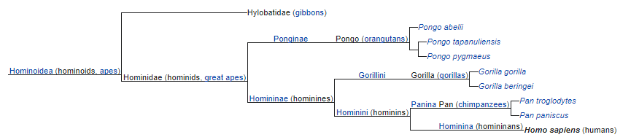

The apes that eventually gave rise to humans (Homo sapiens) first split from gibbons and and then from orangutans, Then the lineage split from gorillas and finally, from chimpanzees, which took place around 8–4 million years ago. This is the final split which created the human chromosome, leaving humans with only 23 pairs of chromosomes, compared to 24 for the other apes. This chromosome difference will be discussed a little later, as the human sexual DNA is very important to our current “juvenilization.” *Homo sapiens* are more neotenized than *Homo erectus*, *Homo erectus* were more neotenized than *Australopithecus* (“Lucy” mentioned in “A Short Story Part 1) and this first walking upright ancestor was more neotenized than any of the other prior lineages of apes.

The human embryo formation is a primary method by which researchers have determined our genetic history. Each human cell has two sets of 23 chromosomes, with 1 pair being sex chromosomes (called X,Y). The ova (female sex cell XX ) and the sperm (male sex cell XY) have only one set (23) of chromosomes. These two cells (ova and sperm) join during sexual reproduction in the female’s body with the male sperm cell of Y being the determiner of whether the new embryo will be a male. If Y, multiple changes for male features, including brain development, begin immediately in the embryo. (7) Current research has implicated the sperm cell as being responsible for multiple types of development dysfunctions, and being the cause of the female mother’s miscarriage due to severely damaged sperm. (5)

Every cell contains mitochrondrial DNA. When the sperm enters the female ova, its “tail’ of mitochrondrial DNA is cut off and does not enter the ova. The embryo will have only the mitochrondrial DNA of its mother. From this DNA, researchers have traced our ancestor to a female in Africa who lived around 90,000 to 200,000 years ago. (6) Thus, we will begin our discussion of the “neoteny” features of modern humans as a possible reflection of humans’ evolutionary development since that time period, from this “primal mother” of all humans.

Evolutionary Theories

The fascia network of cells include their “silent partners” of the mitochondria. Recall that it is through the unchanging maternal mitochondria that evolutionary researchers have linked humans to a path which began between 90,000 to 200,000 years ago. But that path actually began a long time before that split-off of the Homo sapiens.

Present-day cells evolved from a common prokaryotic ancestor along three lines of descent, giving rise to archaebacterial, eubacteria, and eukaryotes. This is thought to have occurred at least 2.7 billion years ago. Then mitochondria and chloroplasts originated from the endosymbiotic association of aerobic bacteria and cyanobacteria, respectively, with the ancestors of eukaryotes. All animal and plants species have mitochondria, but all plants also have chloroplasts. (10)

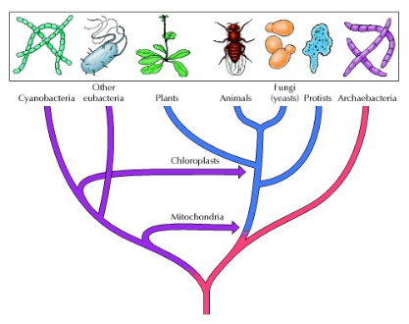

Most plants obtain all their energy from sunlight, which is captured in the chloroplasts and used to fuel, directly or indirectly, all other plant processes. However, in non-green plant parts or in darkness, the energy used by plant cells comes from plant respiration, which takes place in the mitochondria. Here photosynthetically fixed carbon is oxidized to CO2, (carbon dioxide) and the released energy is exported for use in the rest of the plant cell.

(A side note: as we face the current “climate crises,” it is proposed that we must grow more plants to “capture the carbon” being released by an “oil-based” world which is now threatening to destroy “oxygen-based” life forms, including humans.)

In the animal, the mitochondria create “bio-electrical” power (which light emission is visible by use of a luminometer) when the mitochondria transforms oxygen by a process called “oxidative phosphorylation.” This process uses the energy released during the oxidation of the food we eat. ATP is used in turn as the primary energy source for most biochemical and physiological processes, such as growth, movement and homeostasis. We turn over approximately our own body weight in ATP each day, and almost all of this is generated by mitochondria, primarily within muscle, brain, liver, heart and gastrointestinal tract. The pre-eminent role of eating is to provide the fuel for mitochondria, and the pre-eminent role of breathing is to provide the oxygen and to remove the carbon dioxide produced during oxidative phosphorylation by mitochondria. Similarly, a major role of the cardiovascular system is to deliver the substrates (glucose, fatty acids, oxygen) and remove the products (carbon dioxide) of mitochondrial activity. (11) (12)

Mitochondria are our cells' powerhouses and mitochondrial heath dictates our tissues' health. In fact, much of age-related decline is, in fact, related to diminished mitochondrial function: changes in cognition and memory, muscle strength, fatigue, even susceptibility to cancer. You can slow or even reverse these processes by being active and incorporating breath work into your life. (13) (14)

Next IN SYNC Step

In Part 3 of “A Short Story,” we will be discussing how your IN SYNC treatment will address the “juvenilization” features carrying forward to your life which may have been impacted by various traumas. We assume that the embryo of this ancient mother will show that the fascia network is in place, the sexual features have begun developing, and that the haptic system (sense of touch) is installing the sensoriomotor pathways to the brain. (9) We assume these facts as these features continue in the beginning stages of the modern embryo gestation, and in the modern human infant in his/her first month of life after birth. (8) The throat, shoulders, and chest continue development after birth. The current IN SYNC Step addresses any trauma in these areas.

1. <https://en.wikipedia.org/wiki/Recapitulation_theory>
2. <https://en.wikipedia.org/wiki/Neoteny_in_humans>
3. <https://www.frontiersin.org/articles/10.3389/fpsyg.2017.01657/full>
4. <https://en.wikipedia.org/wiki/Human>
5. <https://www.givelegacy.com/sperm-dna-fragmentation/#what-it-is>
6. <https://en.wikipedia.org/wiki/Mitochondrial_Eve>
7. <https://www.ncbi.nlm.nih.gov/books/NBK26940/>
8. <https://www.ncbi.nlm.nih.gov/pmc/articles/PMC5974044/>
9. <https://www.researchgate.net/publication/260836211_The_Bodywide_Fascial_Network_as_a_Sensory_Organ_for_Haptic_Perception>
10. <https://www.ncbi.nlm.nih.gov/books/NBK9841/> (The Origin and Evolution of Cells)
11. <https://onlinelibrary.wiley.com/doi/10.1111/tpj.15495> (Plant mitochondria--past,present and future)
12. <https://www.ncbi.nlm.nih.gov/pmc/articles/PMC3070485/> (Mitochondrial Metabolic Function In Vivo and In Vitro)
13. <https://www.loveyourbiology.com/post/2019/02/04/the-power-of-your-breath>
14. <https://www.ncbi.nlm.nih.gov/pmc/articles/PMC4321783/> (The role of mitochondrial function and cellular bioenergetics in ageing and disease)