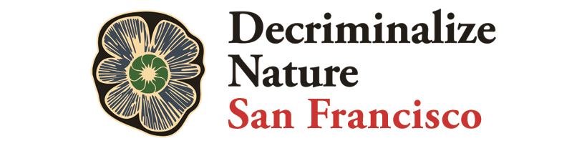
RESOLUTION SUPPORTING ENTHEOGENIC PLANT PRACTICES AND DECLARING THAT THE INVESTIGATION AND ARREST OF INDIVIDUALS INVOLVED WITH THE ADULT USE OF ENTHEOGENIC PLANTS ON THE FEDERAL SCHEDULE 1 LIST BE AMONGST THE LOWEST PRIORITY FOR THE CITY OF SAN FRANCISCO

WHEREAS, Entheogenic Plants, based on the term “entheogen”, originally conceived by Ott, Ruck, and other colleagues from a working group of anthropologists and ethnobotanists in 1979; and defined herein as the full spectrum of plants, fungi, and natural materials deserving reverence and respect from the perspective of the individual and the collective, that can inspire personal and spiritual well-being, can benefit psychological and physical wellness, and can reestablish human’s inalienable and direct relationship to nature, and

WHEREAS substance abuse, addiction, recidivism, trauma, post-traumatic stress symptoms, chronic depression, severe anxiety, end-of-life anxiety, grief, diabetes, cluster headaches, and other conditions are plaguing our community and that the use of Entheogenic Plants have been shown to be beneficial to the health and well-being of individuals and communities in addressing these afflictions via scientific and clinical studies and within continuing traditional practices, which can catalyze profound experiences of personal and spiritual growth; and

WHEREAS, practices with Entheogenic Plants have long existed and have been considered to be sacred to human cultures and human interrelationships with nature for thousands of years, and continue to be enhanced and improved to this day by religious and spiritual leaders, practicing professionals, mentors, and healers throughout the world, many of whom have been forced underground; and

WHEREAS, there is a lack of clarity as to whether such practices can be subject to law enforcement and therefore those seeking to improve their health and well-being through the use of Entheogenic Plants use them in fear of arrest and prosecution; and

WHEREAS, the Entheogenic Plant practices of certain groups are already explicitly protected in the U.S. under the doctrine of religious freedom -- for example the use of ayahuasca by two churches, a Santo Daime congregation and the União do Vegetal; and

WHEREAS, The United Nations considers Entheogenic Plant material used for ritual purposes as excluded from Schedule 1 substances; and

WHEREAS, Entheogenic plants containing ibogaine, for example, have been shown to alleviate treatment resistant cases of opiate and methamphetamine addiction at significantly higher rates than all other treatments for addiction. In addition, ibogaine is reported to be beneficial for addiction therapy related to specific work-related PTSD encountered by first responders such as EMT, police, and firefighters, as well as military veterans; and

WHEREAS, Entheogenic Plants or combinations of plants such as Ayahuasca that contain forms of DMT, a naturally occurring compound in the human body that is listed as a Schedule 1 substance, can lead to experiences that are reported as mystical or experientially similar to near death experiences and that are can be demonstrably beneficial in treating addiction, depression, PTSD, and in catalyzing profound experiences of personal and spiritual growth; and

WHEREAS, Entheogenic cacti that contain phenethylamine compounds such as mescaline can be beneficial in healing drug and alcohol addiction and for individual spiritual growth, and have been utilized in sacred initiation and community healing by diverse religious and cultural traditions for millennia and continuing use as religious sacraments in modern times; and

WHEREAS, psilocybin, naturally occurring in Entheogenic mushrooms, can alleviate end-of-life anxiety for hospice and terminal cancer patients, can reduce prison recidivism, and can effectively treats depression, cluster headaches, and trauma; and

WHEREAS, a Johns Hopkins University study on “healthy-normals” found that psilocybin can occasion mystical-type experiences, which were considered one of the top five most meaningful experiences in a subject’s life for over 75% of their subjects within the first year after the study, and also found continuing positive life-style changes after a 14-month follow-up; and

WHEREAS, the City of San Francisco wishes to declare its desire not to expend City resources in any investigation, detention, arrest, or prosecution arising out of alleged violations of state and federal law regarding the use of Entheogenic Plants; NOW THEREFORE BE IT

RESOLVED, That the Mayor and City Council hereby declare that it shall be the policy of the City of San Francisco that no department, agency, board, commission, officer or employee of the city, including without limitation, San Francisco Police Department personnel, shall use any city funds or resources to assist in the enforcement of laws imposing criminal penalties for the use and possession of Entheogenic Plants by adults; AND BE IT FURTHER

RESOLVED, That the San Francisco City Council directs the City Administrator to instruct the City’s state and federal lobbyists to work in support of decriminalizing all Entheogenic Plants and plant-based compounds that are listed on the Federal Controlled Substances Schedule 1; AND BE IT FURTHER

RESOLVED That the Mayor and City Council hereby declare that it shall be the policy of the City of San Francisco that the investigation and arrest of adult persons for planting, cultivating, purchasing, transporting, distributing, engaging in practices with, and/or possessing Entheogenic Plants or plant compounds on the Federal Schedule 1 list shall be amongst the lowest law enforcement priority for the City of San Francisco; AND BE IT FURTHER

RESOLVED That the Mayor and City Council call upon the San Francisco County District Attorney to cease prosecution of persons involved in the use of Entheogenic Plants or plant-based compounds on the Federal Schedule 1 List; AND BE IT FURTHER

RESOLVED That if any provision of this resolution is declared by a court of competent jurisdiction to be contrary to any statute regulation or judicial decision or its applicability to any agency person or circumstances is held invalid the validity of the remainder of this resolution and it applicability to any other agency person or circumstance shall not be affected

Refers to plants and natural sources (as defined herein), such as mushrooms, cacti, iboga containing plants and /or extracted combinations of plants similar to Ayahuasca; and limited to those containing the following types of compounds: indole amines, tryptamines, phenethylamines.

