Neat as a Pin
Textured Rolling Pins
Australian Native Flowers 2 – Hand drawn by Glenda Neaton
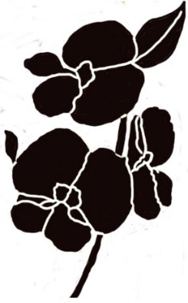 | 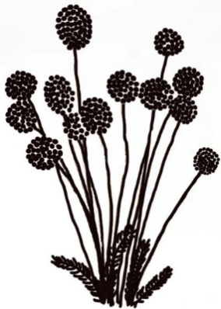 | 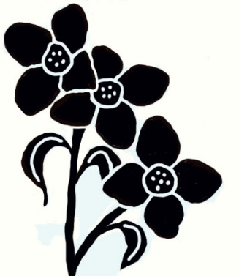 | 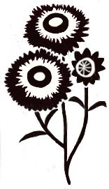
Ashburton’s Pea | Billy Buttons | Boronia | Everlasting daisy
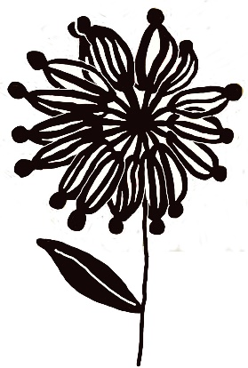 | 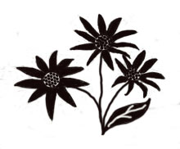 | 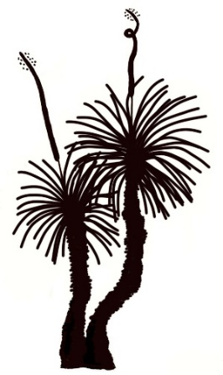 | 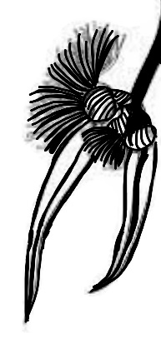
Firewheel | Flannel Flower | Grasstree | Gum (Eucalyptus) Blossom
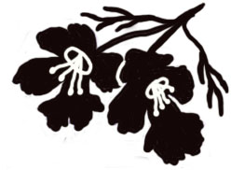 | 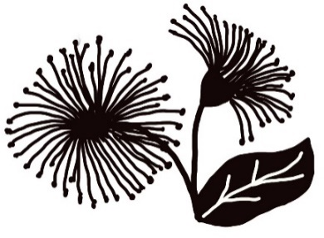 | 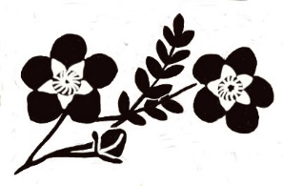 | 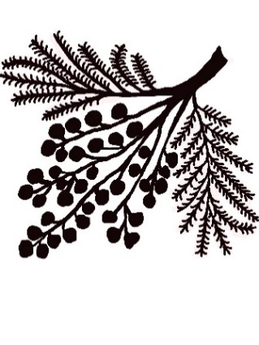
Hermiandra | Lilly Pilly blossom  (Syzygium) | Tea Tree | Wattle
Thank you for your purchase!
Your pin has been made from durable, sustainable rubber wood. The engravings were designed and made in Australia.
Please note your pin has been pre-treated with food-grade mineral oil, the same type used on wooden chopping boards. If your pin needs cleaning, please wipe with a damp cloth, or brush gently with a damp nail brush, and leave to air dry. Never leave your pin in a hot environment like a car in the sun, or put it in an oven.
Never put your pin in a dish washer, and don’t ‘dig’ any clay or debris out with a sharp, hard object.
neatasapin.com.au neatasapintexturedpins@gmail.com

Colours for Native Flowers 2:

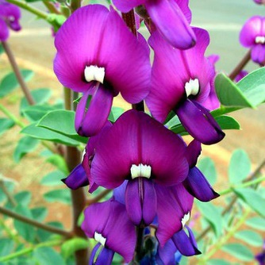 | 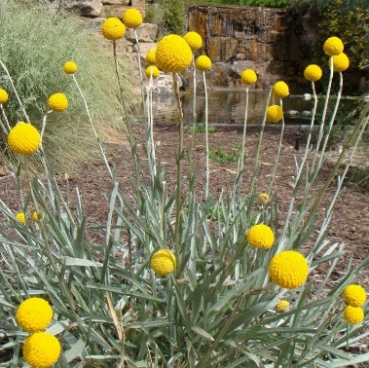 | 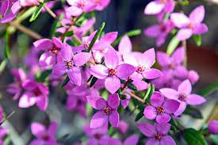 | 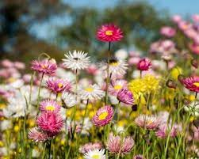
Ashburton’s Pea | Billy Buttons | Boronia | Everlasting daisy
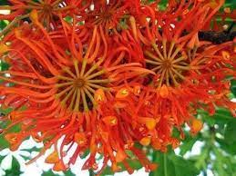 | 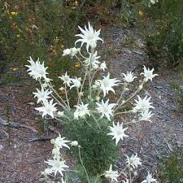 | 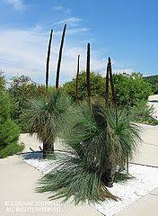 | 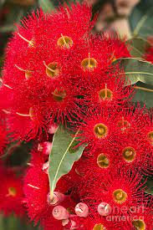
Firewheel | Flannel Flower | Grasstree | Gum (Eucalyptus) Blossom
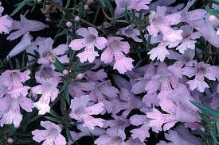 | 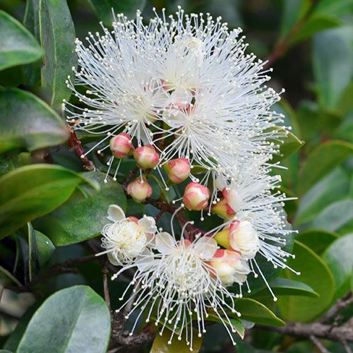 | 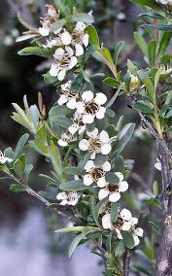 | 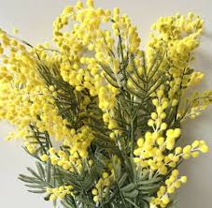
Hermiandra | Lilly Pilly blossom  (Syzygium) | Tea Tree (can also be light pink or dark pink) | Wattle

