***32nd Sunday in Ordinary Time**November 11, 2018***

***\*\*\*\*\*\*\*\****

***XXXII Domingo Ordinario ** Noviembre 11, 2018***

**Weekly Readings / Lecturas de la Semana**

**11/12/18 to 11/18**

Monday: Ti 1:1-9/Lk17:1-6

Tuesday: Ti 2:1-8,11-14/Lk17:7-10

Wednesday: Ti 3:1-7/Lk 17:11-19

Thursday: Phlm 7-20/Lk 17:20-25

Friday: 2 Jn 4-9/Lk 17:26-37

Saturday: 3 Jn 5-8/Lk 18:1-8

Sunday: Dn 12:1-3/Heb 10:11-14,18/Mk13:24-32

***Mass Intentions ** Intenciones de la misa***

**Sat. 11/10**

**5:00 p.m. Pro Populo**

**Sun. 11/11 For all living & deceased**

**8:00 a.m. Veterans**

**11:00 a.m. Birthday Blessings for**

**Stacy Gomez**

**This week’s flowers are donated by the Grimm & Rocha Family, in Honor of all the Veterans. If you would like to donate flowers for the Altar please contact the office at 831-8905**

**\*\*\*\*\*\*\*\*\***

**Esta semana las flores han sido donadas por La Familia Grimm y Rocha, en Honor a todos los Veteranos. Si gusta donar flores para el Altar favor de comunicarse a la oficina al 831-8905**



**1:00 pm † Luis Alberto Estrada**

**Mon. 11/12 No Service**

**Tue. 11/13 Communion Service**

**9:00 a.m.**

**Wed. 11/14 All Souls of Purgatory**

**9:00 a.m.**

**Thur. 11/15 All Souls of Purgatory**

**9:00 a.m.**

**Today’s second collection will be for the Improvement Fund.**

**\*\*\*\*\*\*\***

**La segunda colecta de hoy se para el edificio de Mejoría**

**Fri. 11/16 All Souls of Purgatory**

**9:00 a.m.**

**Prayer**

*Jesus my Lord, let me strengthen my courage by taking on the courage of all those people who have been "centurions" for me. Many have faced disasters and hard times with great constancy. The upper hand of*[*evil*](https://www.catholic.org/encyclopedia/view.php?id=4469)*never turned them against you. They kept going. Let me be like them, Lord. No*[*matter*](https://www.catholic.org/encyclopedia/view.php?id=7732)*what the cross, let me never stop declaring you to be "truly the Son of God, the source of my hope, the*[*reason*](https://www.catholic.org/encyclopedia/view.php?id=9875)*why I*[*will*](https://www.catholic.org/encyclopedia/view.php?id=12332)*never quit on life.*

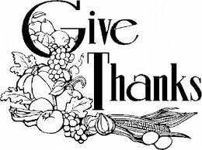

Thanksgiving mass, Thursday November 22nd. At 9:00 a.m.

There will be no mass Friday, November 23rd.

*****************

Misa De Acción de Gracias, el jueves 22 de noviembre a las 9:00 de la mañana. No habrá misa el viernes 23 de noviembre.

We could use your help in one of the English singing groups. Please contact the office for more information at 831-8905.

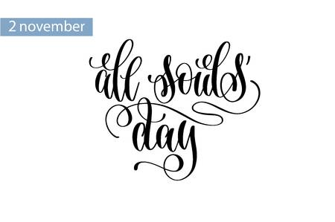November is All Souls month. All Souls envelopes are available at the back of the church. You will be welcome to write the name of our late loved ones and may include a suitable donation. For the month of November their names will be remembered at all regular masses.

*********

Noviembre es el mes de Todas las Almas. Es nuestra oportunidad para recordar las almas de todos nuestros seres queridos. Los sobres están disponibles al fondo de la iglesia. Ahí podrán escribir sus nombres e incluir una donación en memoria de ellos. Todos los sobres estarán junto al altar en todas mas misas en el mes de noviembre. Gracias

**Let us keep in our prayers the following who are sick ** Pongamos siempre en nuestras oraciones a los** **que están** **enfermo**s: Guadalupe Espain, Juanita Parnell, Maria Armendariz, Georgia Hinojos, Leon Shubin, Rick Haley, Nicholas, Kalya Riley Gina Cinquemani, Javier & Connie Ocampo, Mike Cervone ,Jeff Procell, Al Bell, Jose Samuel, Rosie Cinquemani, Rodrigo Vasquez, Jayden Lopez, Chuy Sanchez, Arnoldo Bonilla,Rene Canez, Hector Gerardo, May Borjon, Tiffany Cosby, Isabel Renee Martinez, Topete, Alex Padilla, Richard Uribe, Lidia, Angelica Trujillo, Sandro Ocampo, Hernandez, Maria Perez, Barbie Lopez, Manuel Hurtado, Jesus Herrera, Mariana Perez, Stephany Kelley & fam., Kristinna Peters & fam., Ernie Huerta & Fam., Eric Huerta & fam., David Whright, Patricia Martinez ,Efrain Ramos, Mellissa Gonzalez, Arturo Ruiz, Ella Flores, Elvia Ramirez, Colleen Forcey, Fernando Buenrostro, Maria Procell, Meagan Kapitza, Virginia Estrada Gabriela Vásquez, Gary Wheeler, Mari Aguirre, Agustina Guerrero, Vidal Torres, Daniela Barboza, Rose Valdez, Ed. Anchondo, Josie De Alba, Noe Ocampo, Norma Besoyan, Ma. Salud Zavala, Pablo Armendariz, Blake Anastacio Carreon, Danny Perez, David Perez, Julius Ericsson Marroquin, Jasmine Marroquin, Charles Borjon, , Meagan Kapitza, Juanita Reyes, Cynthia Umali, Carla Carrillo, Lou Morales, Edna La Fond Van La Fond, Cynthia Shrewsbury, Richard Telles, Liliana Prado, Nicholas Rodriguez, Delma, Jane Vandborg, Jessica Baca, Imelda Yanez, Christina Pacheco, Danny Kelly, Lorenzo Abundis, Teresa Wright, Georgia Hinojos, Manuel Olivera III, Lola King, Beatriz Salinas, Raquel Monroy, Marilyn Fanucchi, Teressa Howlett, Gary Davila, Francisco Roma, Milagros Guerrero, Agustina Aguilera, Emilia Soto, Marisol Estrada, and all others who need our Prayers.

 

***Sacred Heart Altar Society***

***Holiday Bazaar & Luncheon***

Saturday, December 1, 2018, Sacred Heart Hall – 9915 Ramos Ave. Bazaar Opens: 11:00 a.m. * Luncheon 12:00 noon

Menu: Baked ham, Scalloped Potatoes, Salad, Rolls Dessert and Beverage $8.00 - Adults * $4.00 – Children 12yrs and under

*********

***Sacred Heart Altar Society***

***Holiday Raffle***

December 1, 2018

1st Prize: Nativity Set

2nd Prize: Tree Skirt

3rd Prize: Cozy Blanket

$1.00 each ticket or 6 tickets for $5.00

**Need Not To Be Present To Win**

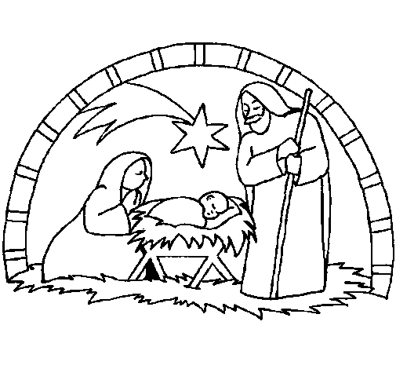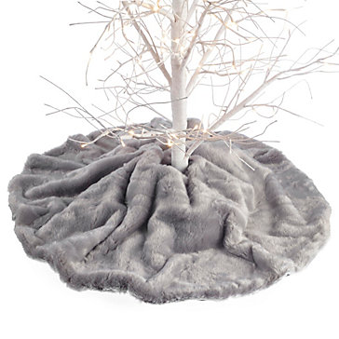

**2019 World Marriage Day Anniversary Mass with Bishop** **Armando X. Ochoa**, D.D. will be celebrated with Anniversary Couples on Sunday. February 10, 2019, 3:00 pm at Saint Anthony of Padua Parish in Fresno. Married Couples celebrating anniversaries of 25, 30,35,40,45,50 or more years are invited to register directly on the diocesan website home page [www.dioceseoffresno.org](http://www.dioceseoffresno.org) or call Rosie Mercado (559) 488-7474 ext. 103.

******************

**La Misa de Aniversario del Dia Mundial del Matrimonio 2019** **con el Obispo Armando Xavier Ochoa**, D.D. será celebrada con las parejas de Aniversarios el domingo, 10 de Febrero, 2019 a las 3:00 de la tarde en la Parroquia de San Antonio de Padua en Fresno. Las Parejas casadas celebrando aniversarios de 2, 30,35,40,45,50 o mas están invitadas a registrarse directamente a nuestro sitio web. [www.dioceseoffresno.org](http://www.dioceseoffresno.org) o llamar a Rosie Mercado al (559) 488-7474 ext. 103.

**Last week's collection** Colecta de la semana pasada**

**$4,450.40**

**Thank you for your generosity**

**Gracias por su generocidad.**

Office Hours

Tuesday-Friday

9:00 p.m. to 6:00 p.m.

Monday’s 3:00 p.m. to 6:00 p.m.

Lunch

1:00 p.m. to 2:00 p.m.