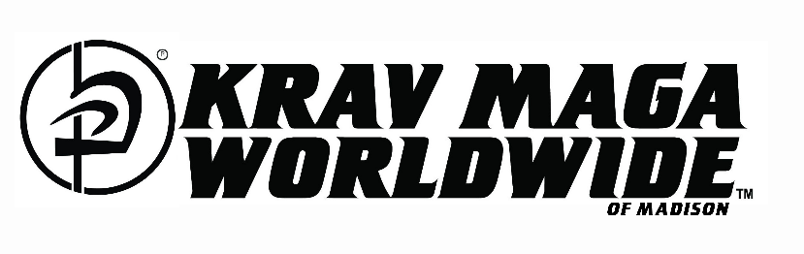
KM KIDS’ ENROLLMENT OPTIONS
(Ages 8 – 13 years)
Class Times: 4:30p – 5:30p
Tuesday and Thursday

8 Week Starter – Only $149.00 to Start!
1 Child – $45.00 per week.
2 Children – $80.00 per week.
3 – 4 Children – $95.00 per week.

14 Week Program – Only $149.00 to Start! (Up to 2-week Hold/Pause)
1 Child – $40.00 per week.
2 Children – $70.00 per week.
3 – 4 Children – $85.00 per week.

26 Week Plan – Only $149.00 to Start! (Up to 4-week Hold/Pause)
1 Child – $35.00 per week.
2 Children – $60.00 per week.
3 – 4 Children – $75.00 per week.

START UP INVESTMENT - $149 Covers Registration, Gear, Uniform Package, and 1st Week!
*For more than 1 child, uniforms with gear are sold separately at $120 per additional child.

Uniform Package – $120.00
Includes: School T-Shirt, School Pants, Boxing Gloves and Shin Guards

STRENGTH – CONFIDENCE - LEADERSHIP

www.madisonkravmaga.com
256-299-3700 | admin@madisonkravmaga.com

