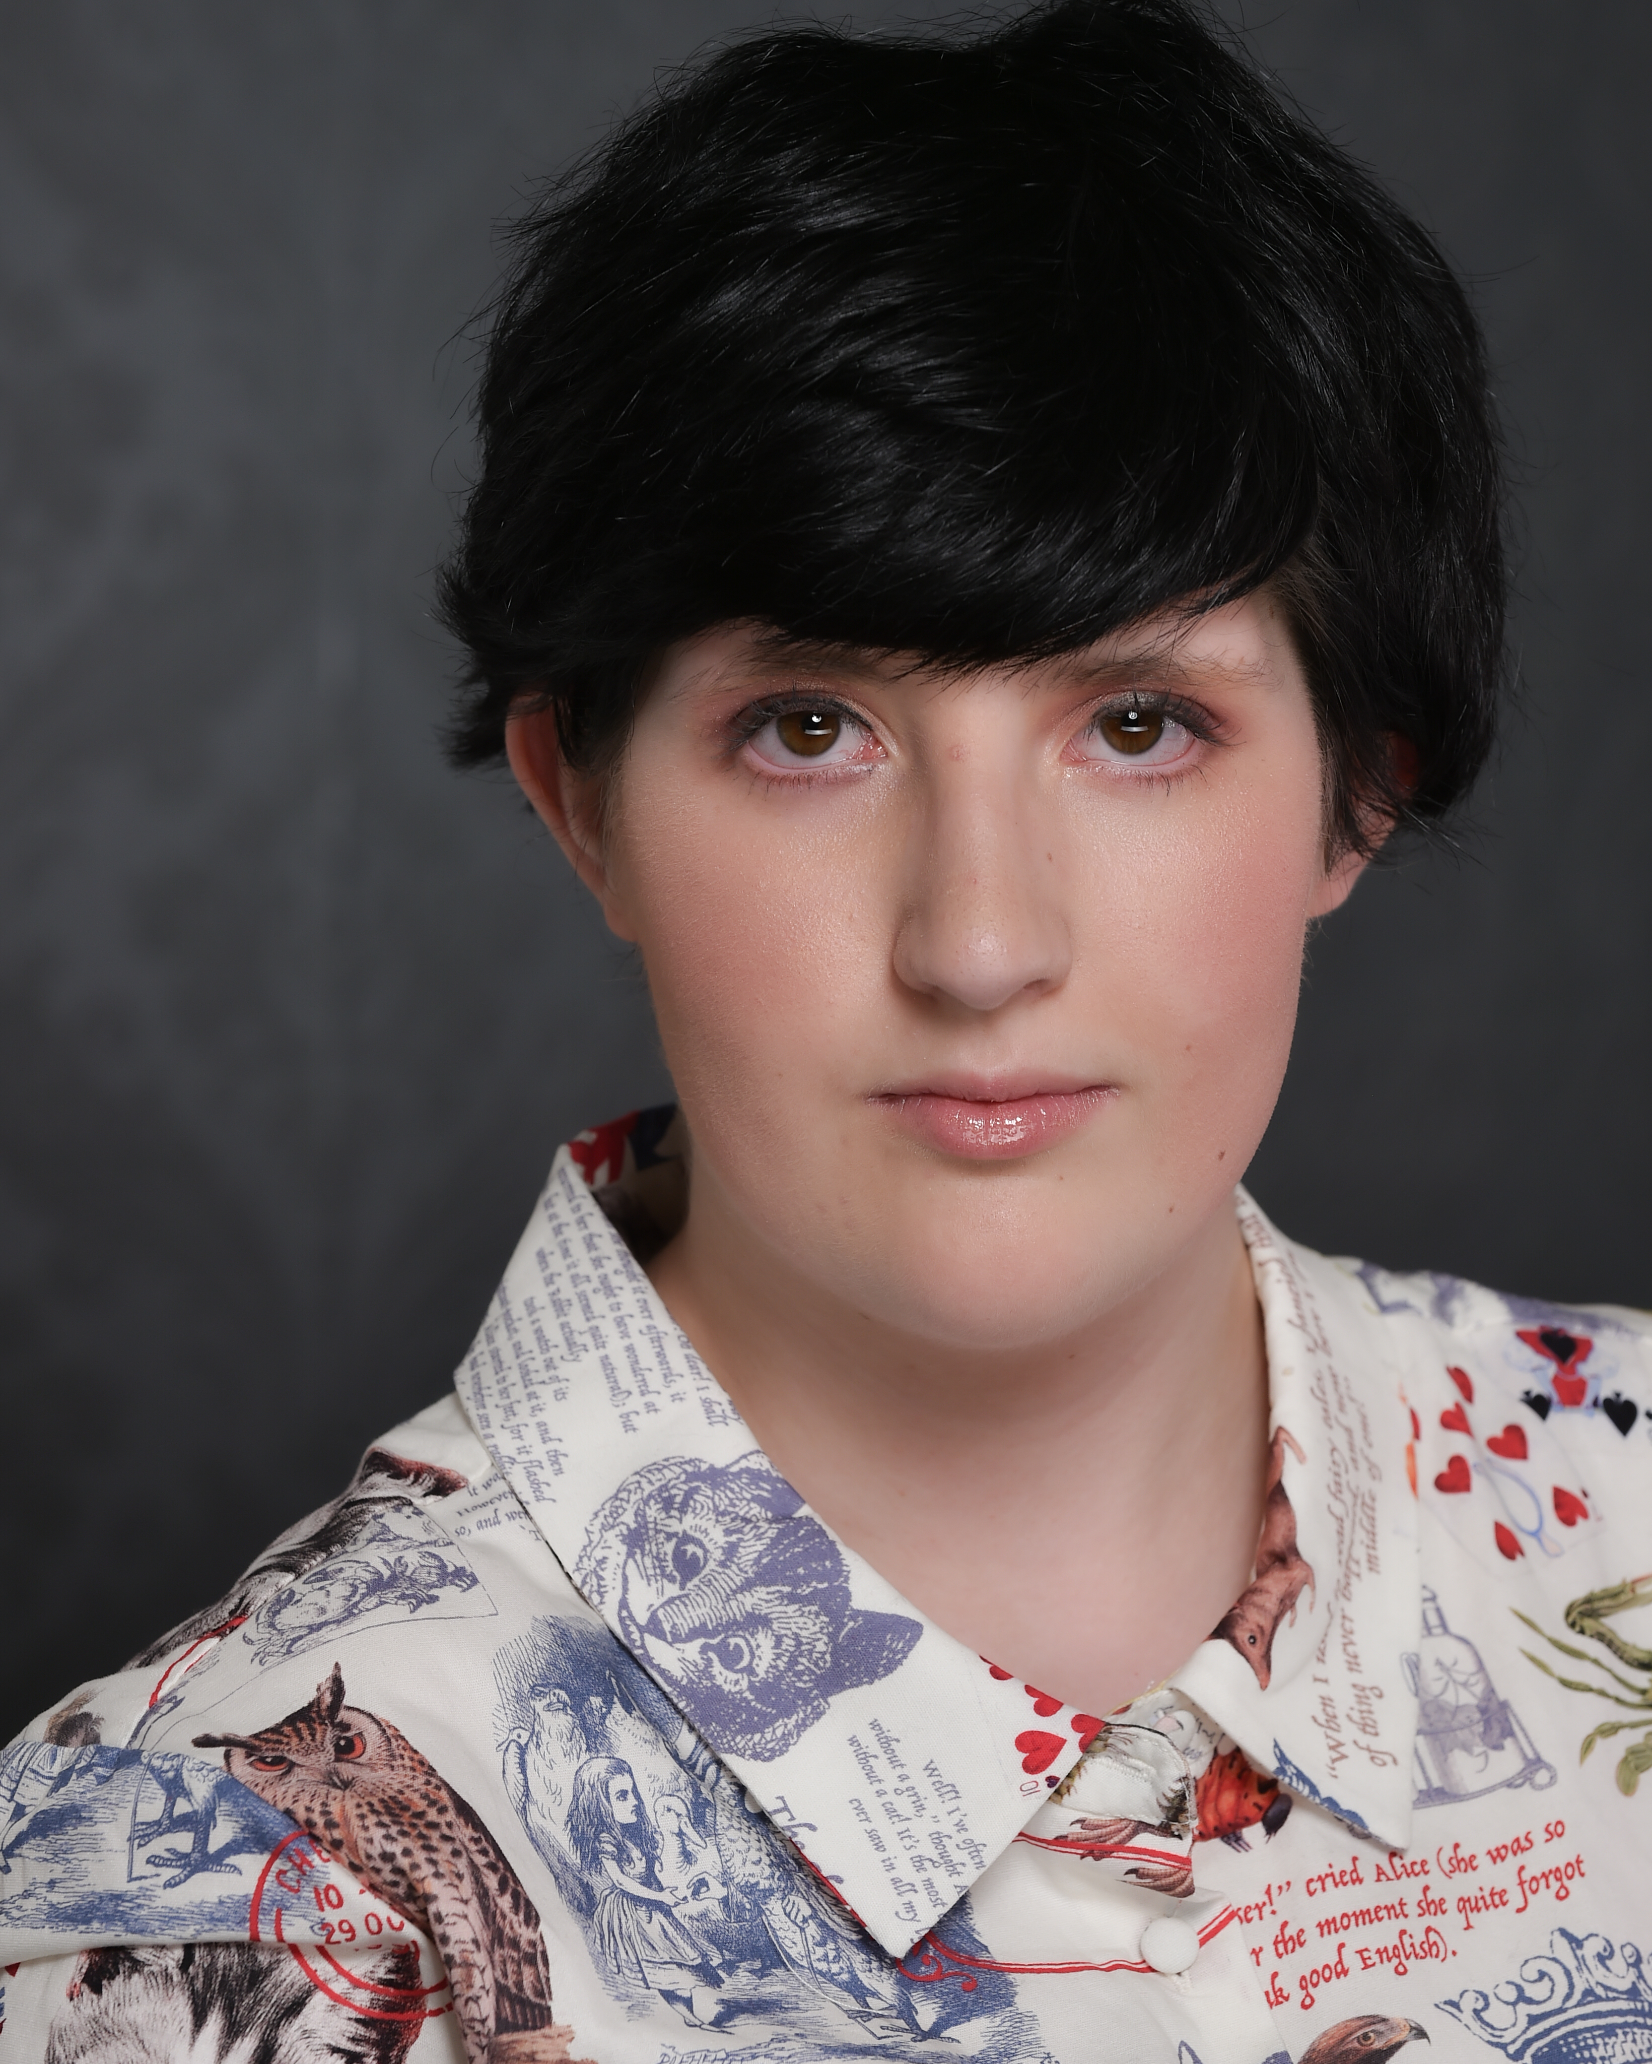 |  |  |  |  | Skye Porta
I am a talented, ambitious, and hardworking individual, with broad skills and experience in acting, singing, and dancing. I take every challenge as an opportunity to grow.
I am adept at handling multiple tasks on a daily basis competently and at working well under pressure.
My key strength is problem-solving.
I am a good team-player.

Experience

Online
Currently (since January 2023 every month)
Virtual Improv Comedy TV Shows (YouTube)
LA Connection Comedy Theatre – Kent Skov

Dec 2023
The Christmas Carol – virtual performance
Played Scrooge
With Jellybean Production

Nov 2023
The Monster Anonymous – virtual performance
Played the Witch
With Jellybean Production

Feb 2023
Peter Pan – virtual performance
Played John and the loyal Pirate Smithy
With Jellybean Production

Dec 2022
Merlin and the Dragons – virtual performance
Played Merlin
With Jellybean Production

Oct 2022
Alice in Wonderland – virtual performance
Played Queen of Hearts
With Jellybean Production

TV series and Movies

December 2023
Little Stars – Short Film
Played Extra.

June - October 2023
Neighbors – TV Series
Played extras in 3 episodes.

June 2023
Addition – Film Features (released 2024)
Played extras.

May 2023
High County – TV Series (released 2024)
Played extras.

TV series and Movies

November 2023
What the Dickens? – Stage School – Australia Youth Theatre
Played Fagin e Charlotte (Cockney Accent)

September 2023
R.I.P. – La Mama Theatre - Performance
Played Sebastian Flinsy (created the text and acted).
(Partly in British Accent)

April 2023
Frozen – Musical Performance
Played extras (guard – castle staff) and ensemble.
With Melbourne Kids Theatre

Nov 2022
Call of Guadalupe – musical
Played the Rebel

2017–2019
Stage School – YABC • Musicals •
- Goodies, Baddies & All That Jazz
- Take Off With Us
- The Greatest Shows

Singing

August 2023 to now - DHPC (Dan Hamil Performance Coaching)
Acting and Singing – all Year Long
Open Mic and Now Show Event every 6 weeks at
Newmarket Hotel
34 Inkerman St, St Kilda, VIC, 3182

2019 - Rainbow Rock – Minus 18 - Workshop
Cthulhu Cat Veins (Band) - Performance on live

2016 - Boite Schools Chorus Concert, Windrush at Melbourne Town Hall.
This is an extra-curricular activity. Students performed at one of Melbourne’s prestigious performance venues alongside acclaimed artists and 300 school students from across the state.

Education

August 2023 to now - DHPC (Dan Hamil Performance Coaching)
Acting and Singing – all Year Long

July 2023 to now - Stage School – Theatre (AYT) and Musicals (YABC)

2023 - Howard Fine Acting Studio
Year Long Youth Acting Program 2023

2023 - Melton Music – singing classes

Dec 2022 to Feb 2023 - Tanya Powell
TV Acting course – 12 weeks

July to Dec 2022 NIDA
Drama for Grades 7-10 – Term Three and Four

July 2022
Brave Studio – Winter workshop
Teen School Holiday Program

2017-2019
Stage School – YABC

2019
Mini-Mozart
Completed grade 2 of AMEB – singing exam.

Skills and Talents
Languages: Italian (fluent) and Spanish (fluent)
Writing: published my 1st book
Dancing and singing
Martial Arts - Taekwondo Yellow belt III
Archery
Canoeing

References
[Available upon request.]
2 Kingsford Ave
Melton South
VIC 3338
 |  |  | 0492850830
 |  |  | skye@skyeporta.com  www.skyeporta.com

