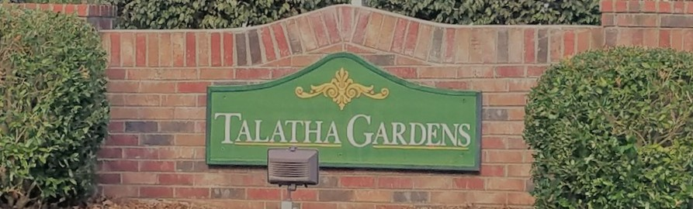

|  |  |  |
| --- | --- | --- |
| **HOA Update**C:\Users\ddewitt\AppData\Local\Microsoft\Windows\INetCache\Content.MSO\FC9A2919.tmp **– October 2020**  The Board has been updating paperwork and processes to make our Board more efficient. We look forward to updating you next month at our Annual Meeting.  SPEAKING OF BOARD UPDATES!  Shari Aberle-Dixon has volunteered her time and joined the HOA Board as a Member-At-Large. Please thank her when you see her and come out to the Annual HOA Meeting to officially welcome her to the Board!  If there is anything you would like the Board to discuss at our Monthly meeting, please email us.  Image result for hoa committee picture**HOA Board Openings!**  We always welcome more volunteers on the HOA Board. Below are current openings:  Secretary  If you are interested in being on the HOA Board, please email the HOA. | **Sign up for the Newsletter!**  To save money, all future newsletters will be digital and offered through the website, Facebook, or email. Please contact us to get on the list to make sure you receive it! If you already receive this newsletter, ask your neighbors if they have as well!  TalathaGardensHOA@gmail.com  www.facebook.com/TalathaGardens  TalathaGardens.com  **Neighborhood Speed Limit**  We would like to remind all residents that the neighborhood speed limit is 20 mph. Please keep our residents, especially our kids, safe and follow posted street signs.  **New Ellenton Water (Commission of Public Works)**  If you have any questions about New Ellenton CPW, please go to the below website: <https://www.newellentoncpw.myruralwater.com/>  **Halloween 2020**  The HOA will not be advertising or sponsoring any public trick or treating this year, HOWEVER, please see below local Trunk-or-Treats to bring your kids too, or your family to give out candy.  *Note: Walking through our neighborhood will be allowed.  Cedar Creek Church – Banks Mill  10/25 @ 4-6pm  City of Aiken: 10/26 @ 3-6pm Talatha Baptist: 10/31 @ 5-630pm | **Architectural Control Standards**  Please ensure you are using the ACC Request form online if you are doing external modifications to your property.  The HOA is finalizing the new Standards as well as receiving input from homeowners on items to review. If you have any suggestions to better the neighborhood using the ACC Standards, please feel free to contact us!  Finally, if you have questions on your property line, please Google “Aiken County Qpublic”, the first link will allow you to enter your property and check your line. Many people have more property than they know.    **Upcoming Events**  **Oct 24**, 6 pm – Roast on the River, 328 Riverfront Drive, Augusta, GA  **Nov 16 - Annual HOA Meeting**  **Location: Cedar Creek**  **Church, 3001 Banks Mill Rd**  **Social Distancing Enforced**  Dec 4 – Christmas Craft Show, Odell Weeks, Aiken |