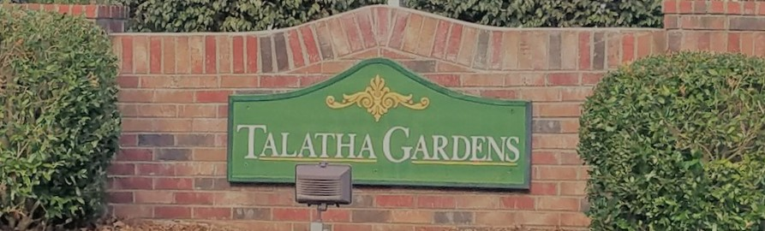

|  |  |  |
| --- | --- | --- |
| **HOA Update – December 2020**C:\Users\ddewitt\AppData\Local\Microsoft\Windows\INetCache\Content.MSO\FC9A2919.tmp  The Board is ready for the New Year and to make our neighborhood better! We will have our first meeting of the year in January where the new Committees will be confirmed.  At the Annual Meeting, we discussed our 2021 Budget, future planning, and the Architectural Standards changes.  If there is anything you would like the Board to discuss at our Monthly meeting, please email us.  **HOA Board Openings!**Image result for hoa committee picture  We always welcome more volunteers on the HOA Board. Our openings are:  Vice President Secretary  We also will be creating multiple committee’s in the New Year.  If you are interested in being on the HOA Board or a committee, please email the HOA. | **Sign up for the Newsletter!**  To save money, newsletters will be digital and offered through the website, Facebook, or email. Please contact us to get on the list to make sure you receive it! If you already receive the newsletter, ask your neighbors if they have!  TalathaGardensHOA@gmail.com  Facebook.com/TalathaGardens  TalathaGardens.com  **Neighborhood Speed Limit**  We would like to remind all residents that the neighborhood speed limit is 20 mph. Please keep our residents, especially our kids, safe and follow posted signs.  **New Ellenton Water (Commission of Public Works)**  If you have any questions about New Ellenton CPW, please go to the below website: <https://www.newellentoncpw.myruralwater.com/>    **Upcoming Events**  Jan 1 - New ACC Standards effective  Jan 1 - Jumperoo! - Urban Air Adventure Park, Augusta, GA  Jan 4/5 - Kids back to school!  Jan 10 - U10/U12 Baseball Tryouts - Harrison Caver Park, Clearwater, SC  Feb 1 - ACC Standards are inspected | **Architectural Control Standards Update**  Please ensure you are using the **ACC Request Form** online if you are doing external changes to your property.  Please see below changes to the ACC Standards. These changes become effective on 1 January 2021 with inspections starting on 1 February. These new Standards have been uploaded to the website.   * Fine Structure: Warning, $10, $20, $25 each successive month * ACC will review all applications within 30 days. * Fences: White PVC fencing is authorized, however, MUST be approved by the ACC as a new construction. * Garbage Cans: screened from road AND neighbors * at the road on pickup day and from noon the day before until noon day after * Shutters: Neutral Colors only * Doors: Accent Color authorized * Golf Carts: Authorized if following South Carolina law * Must have: Drivers License, registration, and insurance |
|  | **Aiken Atomics, LLC**  **Premier USATF Registered Club in Aiken, SC**  Aiken Atomics Track Club is a USA Track & Field (USATF) registered Junior Olympic club in Aiken, SC. Practices start Feb 2. Please visit our website or email us if you’re interested!  AikenAtomics.com AikenAtomics@gmail.com |  |