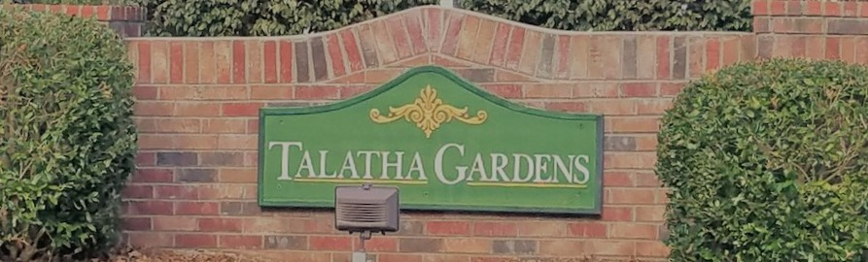

|  |  |  |
| --- | --- | --- |
| **C:\Users\ddewitt\AppData\Local\Microsoft\Windows\INetCache\Content.MSO\FC9A2919.tmpHOA Update**  We had our Annual HOA meeting in November. The Board is very happy with the attendance and the feedback we received from our Members. Thank you to everyone who came out!  The Board will be meeting in the New Year to discuss our strategy for meeting our Members priorities.  If there is anything you would like the Board to discuss at our Monthly meeting, please email us.  **Committee and Board Involvement**  The HOA Board will be creating some committees to help the Board more effectively manage the neighborhood, starting with the Architectural Control Committee. This Committee is responsible for ensuring our residents are following the Standards that have been approved by the Board with the input of the Members.  Image result for hoa committee pictureThe Board is looking for a new Secretary as Chelsea has expressed a desire to resign her position. If you are interested in being on the HOA Board, please email the HOA. | **Sign up for the Newsletter!**  To save money, all future newsletters will be digital and offered through the website, Facebook, or email. Please contact us to get on the list to make sure you receive it!  TalathaGardensHOA@gmail.com  www.facebook.com/TalathaGardens  TalathaGardens.com  **New Ellenton Water Update**  save water save money Stock Vector - 51373367The Board has heard rumours that New Ellenton Public Works Commission will begin charging water usage by usage instead of flat rate starting Jan 1.  Please be aware that your water bills will be changing. Make sure to conserve water when able.  **Live Christmas Tree Disposal**  How To Dispose Of Your Christmas Tree In The Limerick AreaLast year, Camp Gravatt received donated live Christmas trees to have them decompose naturally. When disposing of your live Christmas Tree this year, please try and find a safe environmentally friendly way instead of sending out to the dump. | **Neighborhood Speed Limit**  We would like to remind all residents that the speed limit in the neighborhood is 20 mph. Please keep our residents, especially our kids, safe and follow the posted street signs.  **Winter Home Checklist**  The colder temperatures will be coming in the New Year. Make sure to keep your house and property safe during this time!  1. Switch your ceiling fans: During the colder months, if you flip the switch on the fan unit, it will pull the colder air up and force the hot air back down, saving energy.  2. Exterior water faucets: Make sure to shut off water or cover the exterior faucets to stop the seal from breaking. If it breaks, leaks will begin.  3. Water Heaters: Think about lowering the temperature of your water heaters. This will not only save heating energy but could also save wear and tear on your water pipes.  **Upcoming Events**  Jan 14, 3:30 pm – Aiken Library: Teen Lego Club  Feb 6, 6 pm – Aiken Library: Harry Potter Book Night  Feb 8, 8 pm – Palmetto Golf Club: Adult Prom 2020 |