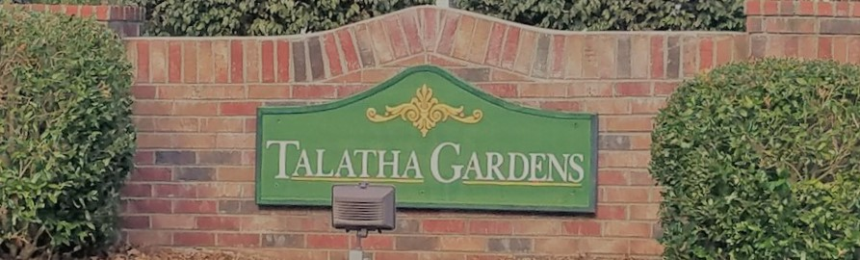

|  |  |  |
| --- | --- | --- |
| **HOA Update**C:\Users\ddewitt\AppData\Local\Microsoft\Windows\INetCache\Content.MSO\FC9A2919.tmp  The Board has been very busy trying to plan the year in the current environment. We hope that everyone is staying safe and following all guidelines from our Government officials.  Most of the HOA Dues have been paid for this year as well, if you haven’t paid, PLEASE contact us as soon as possible.  If there is anything you would like the Board to discuss at our Monthly meeting, please email us.  **HOA Board Openings**  If you are interested in being on the HOA Board, please email the HOA. Image result for hoa committee pictureWe have an open Secretary position as well as an At-Large member if you anyone is interested.  **Neighborhood Speed Limit**  We would like to remind all residents that the neighborhood speed limit is 20 mph. Please keep our residents, especially our kids, safe and follow posted street signs. | **Sign up for the Newsletter!**  To save money, all future newsletters will be digital and offered through the website, Facebook, or email. Please contact us to get on the list to make sure you receive it! If you already receive this newsletter, ask your neighbors if they have as well!  TalathaGardensHOA@gmail.com  www.facebook.com/TalathaGardens  TalathaGardens.com  **Spring Home Checklist**  Springtime is almost over and the Summer heat is quickly coming. Make sure you’re ready for the heat by checking the below priorities:  1. Clean up leaves in gardens  2. Test outdoor faucets for leaks  3. Reseed/Fertilize lawns  Sunny weather will hit Leeds this week4. Tune-up your lawnmower  **Summer Home Checklist**  Summertime means hurricane season starts. Also, it’s very very hot. Please check the below points in your house and on your property to stay safe, and maybe save money:  1. Examine roof shingles and flashes, check flashes from the attic. Any light coming in from outside should be investigated.  2. Service your Air Conditioners!  3. Examine your fence and replace rotted boards and/or support beams. | **Architectural Control Standards**  The Architectural Control Standards keep our neighborhood looking beautiful and keep our collective property values high. If you have any questions, please email the HOA or go to our Website.  The main issues that our current inspectors have noted are Trash Can locations and Damaged Fences.  Please ensure you are using the ACC Request form online if you are doing external modifications to your property.  Finally, if you have questions on your property line, please Google “Aiken County Qpublic”, the first link will allow you to enter your property and check your line. Many people have more property than they know.  **Upcoming Events**  **May 2 - Community Yard Sale!!! - POSTPONED**  **May 18 - Semi-Annual HOA Meeting, Location: TBD – POSTPONED**  Please follow all social distancing guidelines. We want all of our homeowners and residents being safe and healthy! |