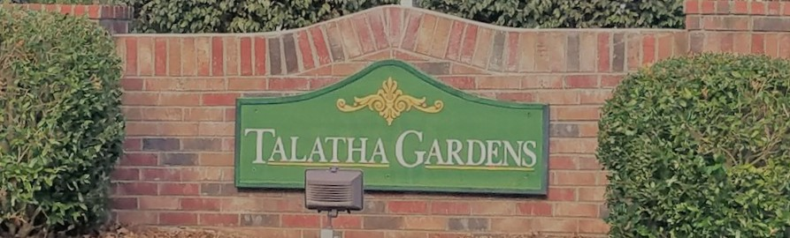

|  |  |  |
| --- | --- | --- |
| **HOA Update**C:\Users\ddewitt\AppData\Local\Microsoft\Windows\INetCache\Content.MSO\FC9A2919.tmp **– Labor Day 2020**  The Board has been hard at work during this quarantine. It has been a busy 6 months for us and we hope everyone is staying safe and healthy.  Our current priorities are finalizing updated Architectural Standards and preparing for the Annual Meeting in November.  If there is anything you would like the Board to discuss at our Monthly meeting, please email us.  Image result for hoa committee picture  **HOA Board Openings!**  We always welcome more volunteers on the HOA Board. Below are current openings:  Secretary  Member-at-Large  If you are interested in being on the HOA Board, please email the HOA. | **Sign up for the Newsletter!**  To save money, all future newsletters will be digital and offered through the website, Facebook, or email. Please contact us to get on the list to make sure you receive it! If you already receive this newsletter, ask your neighbors if they have as well!  TalathaGardensHOA@gmail.com  www.facebook.com/TalathaGardens  TalathaGardens.com  **Neighborhood Speed Limit**  We would like to remind all residents that the neighborhood speed limit is 20 mph. Please keep our residents, especially our kids, safe and follow posted street signs.  **New Ellenton Water (Commission of Public Works)**  The Board knows how difficult the water billing change has been. CPW has been contacted and they have supplied all their information online.  If you have any questions about New Ellenton CPW, please go to the below website: <https://www.newellentoncpw.myruralwater.com/>  **Is Your Hot Water Heater Clean?**  Your hot water heather can be clogged with minerals. To clean:  1. Turn off water supply  2. Drain hot water inside house  3. Drain Heater with a hose  4. Refill Water Tank  5. Test Tank Pressure Release Valve | **Architectural Control Standards**  Please ensure you are using the ACC Request form online if you are doing external modifications to your property.  The HOA is finalizing the new Standards as well as receiving input from homeowners on items to review. If you have any suggestions to better the neighborhood using the ACC Standards, please feel free to contact us!  Finally, if you have questions on your property line, please Google “Aiken County Qpublic”, the first link will allow you to enter your property and check your line. Many people have more property than they know.  **Upcoming Events**  **Sept 12**, 5 pm – Aiken Music Fest, 118 Gaston Street, Aiken  **Sept 25-26 –** Hot Air Balloon Festival, Augusta, GA  **Oct 24**, 6 pm – Roast on the River, 328 Riverfront Drive, Augusta, GA  **Nov 16 - Annual HOA Meeting, Location: TBD**  **Social Distancing Enforced**  Dec 4 – Christmas Craft Show, Odell Weeks, Aiken |