SCENIC HILLS NEIGHBORHOOD ASSOCIATION
UPDATE
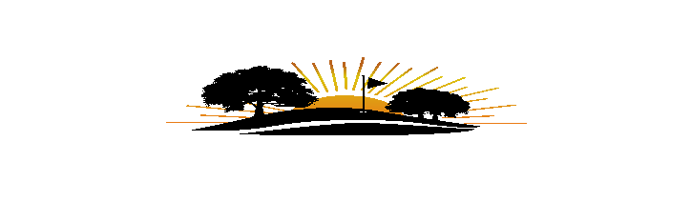
March xx, 2024

Hello Scenic Hills Neighbors,
Re: Board Update
We had a very successful annual meeting in February. We had a great turnout and many of you shared suggestions for new ideas and projects for 2024 – see the list included in this newsletter. Thank you for your support. We appreciate your input and look forward to hearing more.
If you are not a member of the SHNA, we encourage you to join. Last year’s membership was 62, less than half of the homes in the neighborhood.
Our goal is to make this a safe, clean, well-kept neighborhood so that our property values are preserved. We want to be able to renew the contracts for security of the neighborhood and lawn maintenance of the common areas but in order to do that we need your support in the form of joining the SHNA and paying the very reasonable annual membership dues. Please reach out to me or any board member at any time if you have any questions, comments or concerns about the neighborhood. Please encourage your neighbors to join the association. We want to create a community of friendship through periodic meetings and newsletters to share news and ideas.
Sincerely,
Jo Moore, President
Scenic Hills Neighborhood Association (SHNA)
jo@eaasite.com
850-698-4152

Your Scenic Hills Neighborhood Association board members:
Lori Nunley, Vice President lorinunleybrown@yahoo.com 850-261-5384
Melissa Klotzbach, Secretary melissadesiree2014@gmail.com 850-977-3445
Dena Faessel, Treasurer denafaessel@gmail.com 850-324-8003

Members at Large
John Boyd jboydpcola@aol.com 850-494-2606
Claudette Fisher clauzilla@icloud.com 407-535-9334
Jack Klotzbach jackklotzbach@gmail.com 850-377-7229
Deric Morris dmorris829@gmail.com 850-426-2843
Rebekah Morris becca1024@yahoo.com 850-292-9224
Chet Yort cyort@bellsouth.net 850-484-9335

Website: www.shna32514.com
Email: shna@shna32514.com

Suggested Projects and Improvements
(Number shown indicates how many times this was suggested)

FROM 2/13/2024 Annual MEETING

- Repaint home address numbers on curb. (7)
- Even though we have Escambia County Sheriff patrolling the neighborhood & entrances for security and speeding, we need to share any additional concerns. (2)
- Review potential for a Neighborhood security plan. Escambia County can supply training for Neighborhood Watch if we have volunteers. (2)
- Better communication, (i.e., emails) to members about things that are happening in the neighborhood including: (2)
  - Home sales
  - Life changes
  - Club updates
  - Club sign status on 9 Mile Rd (2)
- Update on zoning law changes including County request for Control Burns in area. (2)
- Remind neighbors that walking or letting dogs roam on the fairways is not allowed. (2)
- Contact Code Enforcement for houses that have poor property maintenance. (1)
- Planting at entrance on 9 Mile, the island and other grassy areas throughout to improve aesthetics to our neighborhood. (1)
- Request Escambia County to resurface all roads in Scenic Hills. (1)
- Ring Camera discounts offered to neighborhood for personal installation. (1)
- Periodic publication of county ordinances that affect property, ROW, Trash/Recycle Can placement, etc. (1)
- Host miscellaneous small block parties throughout the neighborhood to meet the Board and your neighbors. (1)

**Let us know what you think about the list. Please vote on your top three choices. Send your selection and comments to: shna@shna32514.com

Our Mission: We are dedicated to providing a common basis for preserving, maintaining, and enhancing the homes and property of this community; to protect property values; and to promote a neighborly, attractive and safe community. We want our neighbors to share ideas and work cooperatively to make this Scenic Hills neighborhood a better place to live.

