Los Amigos Del Sol
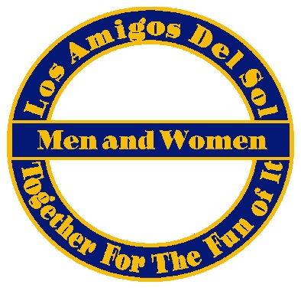
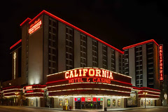
Las Vegas Registration Form
January 4-6, 2019
California Hotel & Casino
(Downtown Las Vegas)

One Registration form per person
Includes:
- Two Nights stay (Fri. & Sat.) at California Hotel & Casino
- Transportation to & from California Hotel & Casino
  - Bus leaves OZ Bar Friday, Jan. 4th at 8:00am (meet by 7:30am)
  - Bus leaves California Hotel & Casino Sunday, Jan. 6th at 11:00am (meet by 10:30am)
- Bus will make one 45-minute stop each way
- Select beverage’s (Beer, Liquor & Non-alcoholic) and snacks will be provided both ways

Payment due at time of sign-up. Must be paid in full by December 2, 2018.
Payment options: cash, check or credit/debit card. Credit/debit card will incur a service charge.

Sign-up Options:
- Mail form and check to Los Amigos Del Sol, PO Box 27335, Phoenix, AZ 85061
- Give form and payment to Jeff Granberg, Carl Perkins or Brian Alexander
- Pay online at www.ladsaz.org (bring form with you or mail to address above)

I hereby waive, release and discharge Los Amigos Del Sol and its legal representatives and executives for all liability for or by any reason of damage, loss or injury to me or my property which may be sustained as a result in my participation in this activity.

Print Name: _______________________________ Signature: __________________________

Email Address: _______________________________________ Phone: __________________

Amount Paid: $__________ Date Paid: ____________ Received by: ____________________

Roommate Name (if double occupancy): ____________________________________________
Circle ONE beverage of choice: Budweiser – Bud Light – Miller Light – Vodka – Rum – Bourbon – Gin – Scotch
Smoking Room Wanted Yes _____ No _____

Cancellation Policy: No Refunds after December 2, 2018
Note: NO Glass allowed on the bus

