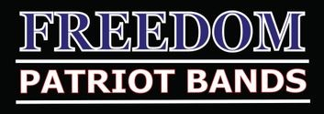 511 Independence Blvd Morganton NC 28655
Hello Parents and Families!
Several people have asked how they may sponsor a trophy for their student so we wanted to make this available online for you to be able to sponsor the trophies for the classic.

Each trophy is as follows:
1st place …………………………… $35
2nd place …………………………….$30
3rd place………………………………$25
A rating trophy…………………….$15

Please fill out this form if you would like to sponsor a trophy and send your payment with it. There will be time at the meeting and reveal show on 9-29-17 to fill out these forms and submit payment should you need to do so at that time.
This would be a great way to help support the band and honor your child at the same time! Here is an example of the form filled out

Name__Jennifer Forney__________________________________
Trophy Amount____1st place $35 ____________________________
Paid by ____check # 2584__________________________________
Message/Announcement _In honor of Kaylen Forney

Name_______________________________________
Trophy Amount________________________________
Paid by ______________________________________
Message/Announement_________________________________________________________________
_____________________________________________________________________________________

