- ABLE TO SELL? Can you sell potential customers?
Launching a New Venture

Ninth Edition

Module 4
Business Planning

Content and Style

Entrepreneurship Foundation, Inc.

Launching a New Venture Edition 9.0

Module 4 - Business Planning

ISBN-13: 979-8-9998903-1-3

ALL MODULES IN THE SERIES

Module 1 - Entrepreneurship
Startup Checklist, Business Modeling, Problem-Solution Fit, MVP, Product-Market Fit, Competition, Lean BMC, Pricing, Landing Page, Company Name, Protecting IP, Legal Structure, Regulatory Matters, Raising Startup Capital

Module 2 – Small Business Marketing
Branding, Website, the Message, Collateral Material, Traditional Mass Media, Digital Mass Media, Targeted Media, Direct sales

Module 3 – Entrepreneurial Finance
Production and Distribution, HR, Space Requirements, Risk Management, Budgeting, Accounting, Buying a business, Banking, Raising Growth Capital, Pitching business plans

Module 4 - Business Planning
Content, Style

Editor@EntrepreneurshipFoundation.org
© Academy Publishing, 2012, 2014, 2016, 2020, 2023, 2024, 2025 All rights reserved.
DISCLAIMER: The contents of this work are for general informational purposes only and do not constitute legal advice. You should not act or refrain from acting on the basis of any content without seeking professional legal advice. This site contains links to other web sites. We are not responsible for the privacy practices or the content of such web sites, and we do not endorse such sites.

Table of Contents

4.1 – Business Plan Outline 4
4.1.1 Executive Summary 5
4.1.2 Product or Service 6
4.1.3 Market size (sales Potential) 6
4.1.4 MARKETING AND SALES STRATEGY 8
4.1.5 COMPETITION 12
4.1.6 BARRIERS TO ENTRY (Protecting your market niche) 13
4.1.7 RISK ANALYSIS 14
4.1.8 PRODUCTION (OPERATIONS) 15
4.1.9 MANAGEMENT 16
4.1.10 HUMAN RESOURCES 17
4.1.11 FINANCE 18
4.1.12 RESOURCES NEEDED TO LAUNCH BUSINESS 21
4.1.13 CAPITAL REQUIREMENT 22
4.1.14 APPENDICES 23
4.2 – Bullet-Proofing The Plan 24
4.2.1 Content Mistakes 25
4.2.2 Financial Model Mistakes. 28
4.2.3 Stylistic Mistakes 29
4.2.4 Execution Mistakes 29
4.3 – Professional Writing Style 30

Module 4 - Business Planning Chapter 1 – Business Plan Outline

4.1 – Business Plan Outline

After you have discovered a sustainable business model and battle-tested it with the lean launch of a Minimum Viable Product (MVP), you will need to prepare a thorough Business Plan to convince lenders and investors that their funds will be returned, and with the expected ROI.

4.1.1 Executive Summary

4.1.2 Product or Service

4.1.3 Market Size (Sales Potential)

4.1.4 Marketing and Sales Strategy

4.1.5 Competition

4.1.6 Barriers to Entry (Protecting Your Market Niche)

4.1.7 Risk Analysis

4.1.8 Production (Operations)

4.1.9 Management

4.1.10 Human Resources

4.1.11 Finance

4.1.12 Resources Needed to Launch Business

4.1.13 Capital Requirement

4.1.14 Appendices

Module 4 - Business Planning Chapter 1 – Business Plan Outline

4.1.1 Executive Summary

TABLE OF CONTENTS (1 page). Number pages to make it easy to find information.

EXECUTIVE SUMMARY (2-5 pages). Investors are looking for clear, compelling and credible information to have confidence in you and your idea. Write this section last. Be concise but cover all the bases. (Lengthy explanations and examples should be left to the body of the full plan or the appendices.) Cover the same information as you would in a three-to-eight-minute oral presentation.

- Business Description.
- Indicate whether the plan is for a start-up, purchase of an existing business, or expansion of a business you own. If the business is a franchise, so indicate and include a copy of the Franchise Agreement in the appendices to your business plan.
- Legal form of ownership: sole proprietor, LLC, partnership, corporation, etc.
- Brief description of product or service.
- Development stage of the product or service
- How you will make money (The business model)
- If expanding an established business, also include the following:
  - years in business,
  - number of employees,
  - growth rate, and
  - current sales volume
- Market opportunity. Define the potential customers in your market niche and the pain they are experiencing without your product.
  - Your solution to this customer problem; and the amount of money, aggravation, and time your product will save the customer.
  - Market growth trend
  - Sales potential within five years (number of customers and annual dollar volume)
  - Competitive advantage
  - Marketing and sales strategy
- Management team credentials (relevant training and successful experience)
- Amount of funding requested and intended use of the capital
Module 4 - Business Planning Chapter 1 – Business Plan Outline

4.1.2 Product or Service
(2-4 pages)

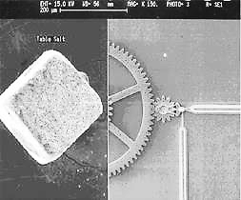
Describe your product or service and its important features. Include a photo or drawing if helpful to understand product and its unique characteristics.

What are the benefits your product provides to the customers in your target market? And more to the point, what urgent need or desire does your product fulfill?
Microelectromechanical Biopump.
Grain of table salt shown for size comparison.

4.1.3 Market size (sales Potential)
(1-2 pages)

Market Niche. It is difficult to take on the whole world. When planning your company, look for a market niche to target, a portion of the market in which you have a unique advantage; or a small corner of the market largely overlooked or underexploited by the competition. Some submarkets are just too small for a Microsoft or General Electric to bother with; but might provide adequate income for a young lean enterprise.

The book publishing industry, for example, has many niches. There is a worldwide market for books; but sports books would be a niche, albeit a large niche, and still tough to break into. Books on fishing would be a narrower niche and one in which it would be easier to establish a beachhead, fly fishing narrower still.
Describe your market niche, your target customers, their characteristics and geography (i.e. - their demographics).

FOR CONSUMER PRODUCTS OR SERVICES, demographics often include:
- Age
- Gender
- Location
- Income level
- Occupation
- Education
- Other (specific to your industry)

FOR BUSINESS CUSTOMERS, demographic factors include:
- Industry
- Location
- Size of firm
- Other (specific to your industry)

Module 4 - Business Planning Chapter 1 – Business Plan Outline

Size of Market Niche (Initial Sales Potential). Define the size of your target market and provide evidence that the market is as large as you claim. Your market research data will be the basis of the sales projection and therefore the income projection of the company. Be specific: give numbers and sources. (Potential investors will want to double-check your information. This is called Due Diligence, the process of making sure everything in your plan is accurate.)
- Number of customers and the amount they spend annually.
- Percentage of the market you have now and that you realistically expect to capture within 3-5 years.
- Obstacles you must surmount to achieve a) break even, and b) full potential. Examples might include:
        - Consumer acceptance and brand recognition. (There are hundreds of superior mousetraps in the annals of the patent office, but no one is beating a path to the doorways of the inventors. Humans are creatures of habit. They buy the familiar, not the new and untested, in spite of marketing claims.)
        - Unique technologies and patents of competitors
        - Union restrictions
        - Shipping costs (The Internet pet supply company, Pets.com, failed because the cost of shipping dog food made them more expensive than the local pet store. Glib sock puppets will not compensate for a defective strategy.)
        - Tariffs and quotas
- How you will overcome the barriers

Sources For Substantiating Data
- Amazon Sales of Similar Products. Amazon typically lists the number of products sold in the prior month. Ideally, track the sales over time. Is it seasonal?
- Trade journals. Every industry has one or more periodicals. Check the business reference department of your local library or the web. The trade publications will often include information about market conditions in the industry. How many subscribers does the magazine have?
- Professional Societies. Research the associations your customers might join. How many members do they have? How many in your area? Is the organization growing?
- Trade shows. Attending a trade show for your industry will provide useful information and insights into trends. How many people were at the event? Were the aisles packed with buyers? Which booths were attracting the most attention? Why do you think that was and what does this suggest for the potential for your chosen market niche?
- Census data will provide demographic profiles in your area. See https://www.census.gov/data.html.
- Mail List Companies know the number of people by title within any geographic area or group of zip codes. (There will not be a charge for the list providers to tell you how many companies or consumers are in a particular demographic.)
- Traffic Monitoring. Who will be your main competitors and how many cars/pedestrians flow past their establishments in an average day?
Module 4 - Business Planning Chapter 1 – Business Plan Outline

4.1.4 MARKETING AND SALES STRATEGY

How will you capture the market share necessary to meet sales projections?

Advertising and Promotion. How will customers find out about your product, its features and benefits? This is especially critical if you are relying on intermediaries (e.g. - retail stores, wholesale distributors, or contractors) to sell your product. Advertising channels might include some or all of the following:
- Print advertising (magazines and newspapers)
- Radio and TV advertising
- Web advertising
- Guerrilla marketing (spreading the word through word-of-mouth). This works in a tight-knit community of buyers
- Direct mail (Indicate where you will obtain lists of prospects)
- Trade shows

Indicate how much you plan to spend on each marketing channel …
- At startup to establish the brand
- Annually thereafter
Corporate Identity Program. Do you have graphic design standards to project the necessary image consistently? Components of a design program that impact a company’s image include:
- Logo,
- Website,
- Print material (business cards, brochures, etc.)
- Signage,

Distribution Channels. (How will you sell your products or services?)
- Directly to consumers (mail order, Web, catalog)?
- Through retail stores?
- Through wholesalers?
- Through your own sales force?
- Through manufacturers’ reps?
- By bidding on contracts?

Credit Policies.
- Will you need to extend credit to customers?
- If so, what policies will you have about how much credit to extend and for how long?
- How will you check the creditworthiness of new applicants?
- How will you collect from slow-paying customers?

Module 4 - Business Planning Chapter 1 – Business Plan Outline

Sales Forecast

Now that you have described your products, services, customers, markets, and marketing plans in detail, you’re ready to attach some numbers to your plan. Entrepreneurs Magazine has extensive information on annual sales as well as startup costs for various franchises at www.Entrepreneur.com.

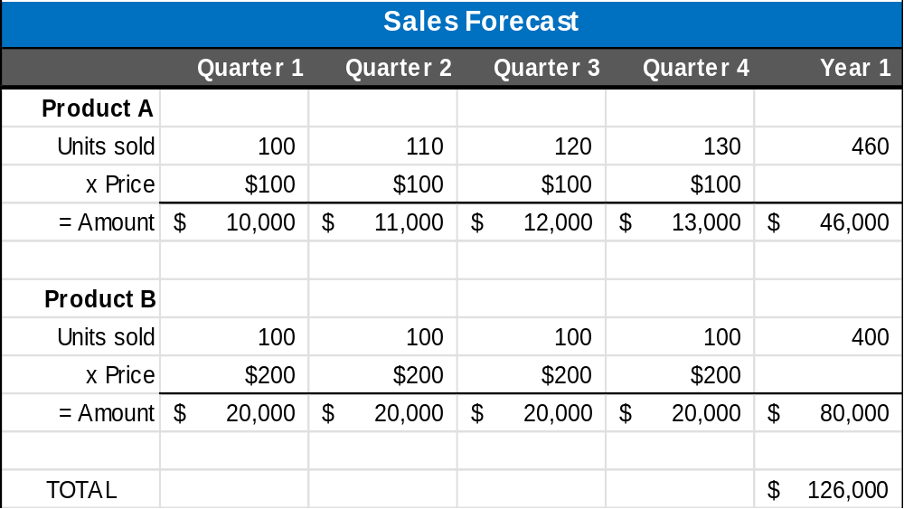

You may want to prepare two forecasts:
- Best guess – what you really expect, and
- Worst case – low estimate that you are confident you can reach no matter what happens.
Keep notes on your research and your assumptions as you build this sales forecast. Investors will grill you on your assumptions.

Obviously, it helps to have some hard data based on market testing, an analysis of the sales of similar companies. The comparative sales should be based on other startups or early-stage companies. Basing your sales forecast on the sales experience of Microsoft or GE is not realistic.

Here are two empirical methods of forecasting sales that are based on more than wishing and hoping, and therefore more believable to investors or lenders:

- RELATIONSHIP BETWEEN SALES AND ADVERTISING DOLLARS. If, for example, you can show that an $8000 two-week radio campaign in one market resulted in sales of $100,000, it is reasonable to presume equal results from the same advertising budget in a city of similar size. However, check to make sure the station listener demographics (especially family income) are the same as for the test campaign, and that the ads will run at the same time on the same days of the week.
- Similarly, if you show $100,000 in sales worldwide from a purchase of $10,000 of Google ad words, you may correctly project sales of $1 million dollars with an investment of $100,000 for an identical marketing effort, assuming no seasonal variation in the marketplace. Be aware that investors will want proof that you have the resources to produce, deliver, and service 10x the number of goods or services as in the trial, while maintaining the same level of quality, service and customer satisfaction.

Module 4 - Business Planning Chapter 1 – Business Plan Outline

Excel Sales Trend Function. Excel can project future sales based on a mathematical analysis of prior sales, using the “least squares” method.

a) START BY PREPARING A SIMPLE TWO-COLUMN FILE OF PAST SALES. You can record unit or dollar sales. In this example, we have used unit sales. In the left column, indicate the time interval you wish to use: (week, month, quarter, or year). An established company might use yearly sales, whereas a recent startup might only have weeks or months of actual data.

b) HIGHLIGHT THE CHART DATA,
INCLUDING HEADINGS.

c) CLICK ON THE “INSERT” TAB,

RIGHT CLICK ON THE “SCATTER CHART.”

SELECT THE PLOT POINTS ONLY VERSION
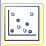

Excel will create the chart at left.

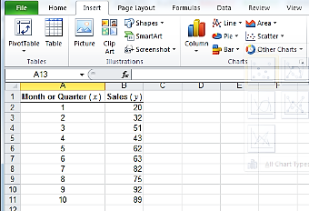

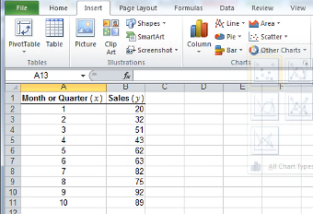
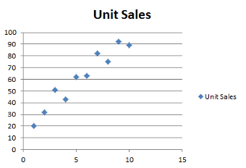

Module 4 - Business Planning Chapter 1 – Business Plan Outline

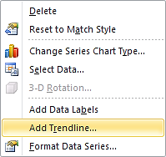
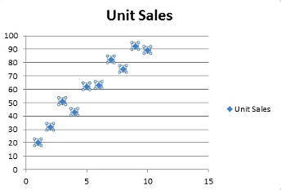
d) RIGHT-CLICK ON ONE OF THE DATA POINTS in your chart.

SCROLL DOWN ON POP-UP WINDOW AND CLICK ON “ADD TRENDLINE.”

e) A “Trendline Options” window will appear.

SELECT THE “LINEAR” LINE OPTION

NAME THE CHART

SELECT THE NUMBER OF TIME PERIODS YOU WOULD LIKE TO FORECAST. In the example we selected 6 [months].

We also suggest you check the “Display Equation on chart” option so that you can estimate unit sales based on the derived formula; and check the “Display R-squared value on chart” as this will indicate to your readers the validity of the forecast.

An R-value near .99 is considered reliable.
Of course that is in the predictable world of mathematicians. You’re an entrepreneur embarking on the seas of uncertainty, so do not assume the fates will cooperate.

Your final chart should look something like the one at left. Using the displayed formula, the unit sales (y) for the example company can be computed for a future month by multiplying the month number (x) by 7.7515 and adding 18.267 (which is called the “y-intercept,” the value where the line intercepts the y or vertical axis).
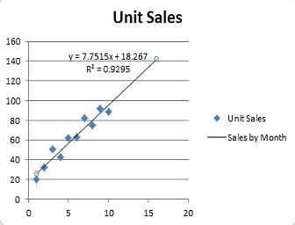
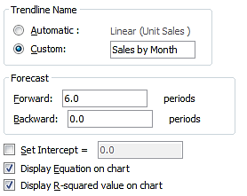
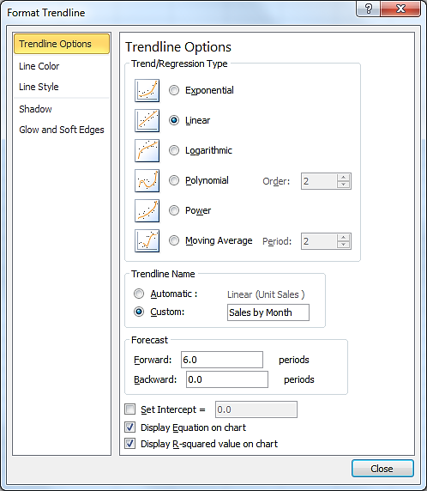
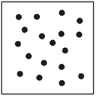
To verify the validity of your forecast, check the R value. The lower the number (.99 is high), the less reliable the results. You can also tell pretty quickly just by reviewing your scatter chart. If it looks like the one at right, the R value will be close to zero, and the data meaningless for
predicting future sales.
Module 4 - Business Planning Chapter 1 – Business Plan Outline

4.1.5 COMPETITION

(2 pages)

List the significant competitors in your niche, with their locations.

Also show alternatives to your product. If there is a way customers can solve their problem or satisfy their need without your type of product, this should be noted. For example, if you run a live music venue, you would probably compare your operation to other clubs. However, movie theaters that show movies of live shows and streaming services are also competition. Even other non-music entertainment venues will impact your sales.

What are the Market Drivers? Determine what product differentiators drive customer decisions. Criteria might include some of the following variables.
- Price
- Quality
- Range of choices
- Service and Support
- Reliability
- Expertise and Reputation
- Location
- Credit Policies
- Advertising budget

Analyze each competitor, summarizing its strengths and weaknesses, especially as regards the above critical customer decision-making factors.

Competitor | Strengths | Weaknesses
A

B

C

D

Module 4 - Business Planning Chapter 1 – Business Plan Outline

4.1.6 BARRIERS TO ENTRY (Protecting your market niche)

(1 page)

How will you keep competitors from entering your market with similar products? Barriers can include:

- Patents
- Exclusive contracts with sole suppliers of critical components
- Long-term contracts with customers
- A long product development cycle. For example, a complicated software program that would take someone else at least two years to reverse-engineer, test and deploy. This would provide two years for you to build brand loyalty.
- Significant first-mover advantage. For example, anyone can offer to sell books online, but Amazon has had such a long head start that it would be difficult to entice many of its customers to switch to a new online supplier.

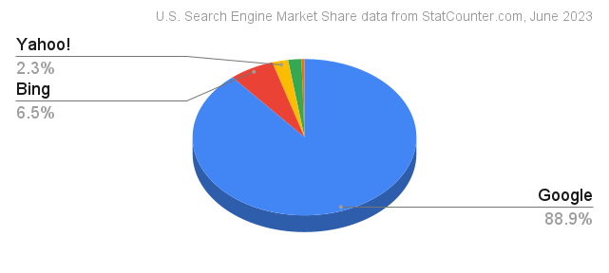
You may have invented a search engine that is preferred 2-to-1 over Google in focus-group testing, you’ll still have a daunting battle to attract users now using Google. Humans are creatures of habit. Even Microsoft, with its huge war chest and marketing resources, has barely chipped away at Google’s lead. In fact, Bing has even slipped since this 2023 study. According to gs.statcounter.com, as of April 2025, Bing has slipped to under 4% of search-engine market share and Google had climbed above 90%. All other search engines worldwide made up the remaining 6% of usage. Moral: pick a competition battle you have a chance of winning.

Module 4 - Business Planning Chapter 1 – Business Plan Outline

4.1.7 RISK ANALYSIS

(2-4 pages)

Potential Risks (“Anything that can go wrong will” – Murphy).
- Human resources risks. Is there an adequate supply of labor available with the skills you require at a wage you can afford to pay?
- Will new employees require training? How long will the training take and what will it cost?
- Technology risks. What theoretical technologies could overtake you if they become practical realities?
- Economic risks. What happens to your company in a recession or inflationary cycle? Do you need to borrow money regularly because your business is cyclical, like the fashion industry or toy sales? If so, what would happen to your bottom line if interest rates doubled in a year?
- Society risks. Do you have a strategy to mask your forecasts from effects of the next pandemic?
- Political risks. What happens to your power plant in Bali if there is a coup?
- Competitive risks. What happens if you really are wildly successful and Bigco decides your niche is valuable after all.

Adversity Preparedness
Just as the weather bureau needs to monitor new developments that might turn into natural disasters, you need to keep an eye out for the winds of change in your key technologies, consumer behavior, and the economic climate in general. An effective early warning system can help you minimize any negative impact.
Imagine the worst thing that could happen to your company or your customers or the country, then figure out what you could do to survive that catastrophe. Is there a prudent change you might make to your business plan to reduce your susceptibility to this contingency? Perhaps plan to raise more equity capital so that you are not overly dependent upon the debt market to perpetuate your company. The lack of emergency preparedness has sunk many a venture.
Include in your plan the steps you would take to respond to changes in ...
- Consumer preferences
- Technology. Can AI perform the same function as your service business cheaper and faster?
- Government regulations
- The economy (How would you retrench if you only achieve half the sales you forecast for year one?)
Module 4 - Business Planning Chapter 1 – Business Plan Outline

4.1.8 PRODUCTION (OPERATIONS)
(2-4 pages)

- How and by whom is your product or service to be produced? What portions of the product or service will you produce “in house”; what components will be produced by subcontractors?
- How reliable is the supply chain?
  - What is the source of each critical component and raw material?
  - How reliable are the subcontractors?
  - Are they in economically and politically stable countries?
- Are supply costs steady or fluctuating? If fluctuating, how would you deal with changing costs?
- Production capacity of your space and equipment
  - Planned production level
  - Break-even production level
- Quality control
  - What procedures will you use to establish and monitor quality standards?
  - Who will provide customer service? (Not every customer will understand your written instructions for how to assemble their mini home nuclear reactor. Expect calls.)
- What R&D processes will need to be continued and for how long?
- What type and level of inventory will you need to maintain? (raw materials, supplies, finished goods).
  - Average monthly value (your inventory investment)?
  - Annual turnover rate and how it compares to the industry averages?
  - Seasonal buildups?
  - Lead-time for ordering?

Module 4 - Business Planning Chapter 1 – Business Plan Outline

4.1.9 MANAGEMENT

(1-2- pages)

Management Team
New businesses are usually dependent upon the enthusiasm, dedication, special expertise and contacts of their founders. List the key management positions and the qualifications and relevant education and experiences of the individuals that are filling these critical roles (or who will fill the positions once the company is funded.) Bases that need to be covered, at a minimum, are:
- CEO (Chief Executive Officer). As the top manager, the CEO is typically responsible for the entire operations. Indicate prior successful management experience in growing a similar company.
- CMO (Chief Marketing Officer). Indicate prior sales experience with similar products and key contacts the CMO has with buyers in the industry.
- CTO (Chief Technology Officer). What evidence is there that this individual has the expert knowledge of how to produce the product or deliver the service.
- CFO (Chief Financial Officer). the CFO is responsible for analyzing and reviewing financial data, reporting financial performance, preparing budgets and monitoring costs. Business failure is often related to mismanaging cash flow, failing to monitor accounts receivable adequately, inaccurate budgeting, poor purchasing practices, or failure to meet government reporting and compliance regulations. Indicate education and relevant experience of the CFO.
What measures will be taken to ensure the survival of the business if it loses one of the key managers? For example, will you have key person insurance to at least refund investor money if you lose someone critical to the success of the venture. You have a restaurant named for your celebrity chef and he dies from food poisoning …

Professional and Advisory Support.
List any of the following that you have or plan to retain:

- Corporate Attorney (who advises you on contracts, investor deals, and legal structure)
- Intellectual Property Attorney (who makes sure your important patents and trademarks are bullet proof)
- Accountant
- Insurance agent
- Banker
- Board of directors (Indicate members with relevant experience, expertise or valuable contacts)
- Advisory board (Indicate members with relevant experience, expertise or valuable contacts)
- Mentor
- Consultants
Module 4 - Business Planning Chapter 1 – Business Plan Outline

4.1.10 HUMAN RESOURCES
(1-2 pages)

At least half the operating cost of most businesses is personnel.

- Ultimately, how many people will you need and what skills must they have for you to…
  - Get started?
  - Reach break-even?
  - Meet your five-year projection?
  - Meet ultimate sales potential?
- How do you know these human resources are available?
- Where/how will you recruit the workers you will need?
- What is the cost per hour and per year for each type of worker?
- Will you have to provide benefits in order to compete for these workers?
  - What benefits will you provide?
    - Health Insurance?
    - Dental?
    - Paid vacations?
    - Retirement plan?
  - What will this cost?
- Will they need training?
  - Who will provide necessary training?
  - What will this cost?
Determine how much you will need to live on. Your living expenses will need to be included in your start-up capital (unless you plan to keep your day job). We recommend that you do obtain alternate means of paid employment until your business is self-sustaining. Not only is it unlikely that you will be able to withdraw money in salary or dividends for some time, but you will probably need to periodically pump new funds into the business until it can sustain itself. See https://entrepreneurshipfoundation.org/spreadsheets for a downloadable personal budget worksheet
Note that investors and lenders will scrutinize your salary budget and may turn you down if they feel you are expecting a lifestyle too luxurious at their expense. They expect you to tighten your belt.

Human Resources Requirements Worksheet
EMPLOYEE CATEGORY | Number Needed | Annual Wage  per Employee | Taxes and benefits ** | Total Annual Cost  per Employee
** As a rough rule of thumb, add 10% for payroll taxes; 30% if you also provide health insurance.
Module 4 - Business Planning Chapter 1 – Business Plan Outline

4.1.11 FINANCE
(5 pages)

The finance section consists of a 5-year Profit and Loss Projection, Cash Flow Forecast, and Capitalization Table. These documents are necessary for investors to evaluate the reasonableness of your plan.
A Profit and Loss projection should be accompanied by a narrative explaining the major assumptions used to estimate company income and expenses. Keep careful notes on your research and assumptions, so that you can explain them during interviews with skeptical investors. A free Budget Worksheet in the form of an Excel document is downloadable from https://entrepreneurshipfoundation.org/spreadsheets

EMPLOYER TAX RATES (as of 2025). You’ll need to factor these taxes into your management and labor costs.

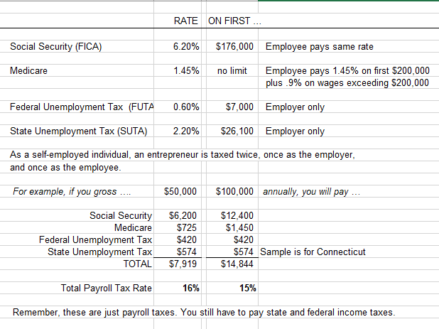

The above SUTA rate is an example. To find SUTA for your state, see
https://www.paycom.com/resources/blog/suta-taxes-heres-what-you-need-to-know/

Module 4 - Business Planning Chapter 1 – Business Plan Outline

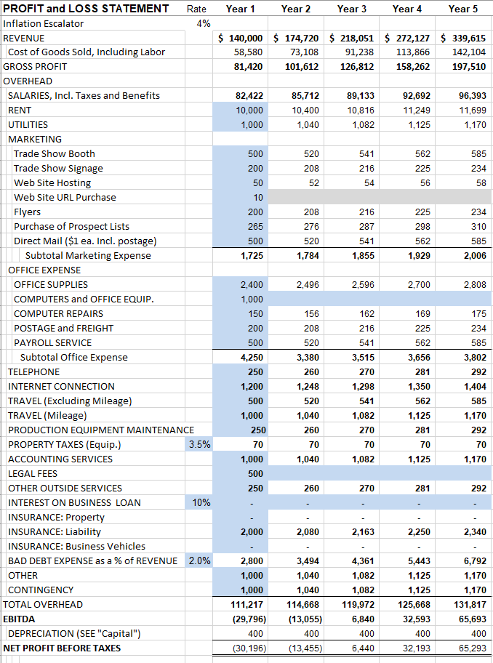
Sample of P&L spreadsheet available at https://entrepreneurshipfoundation.org/spreadsheets
Module 4 - Business Planning Chapter 1 – Business Plan Outline

A Cash Flow FORECAST will tell you how much capital you will need to start the business. Explain your major assumptions, especially where the cash flow differs from the Profit and Loss Projection. For example, if you make a sale in month one, when do you collect the cash? Probably the same month if a retail store; but perhaps month two or three if a service business. Depreciation should not appear on a Cash Flow Forecast. (You will not write a check for depreciation.) However, the full purchase price of capital equipment should appear in the Forecast. A Cash Flow spreadsheet may be downloaded from https://entrepreneurshipfoundation.org/spreadsheets

CAPITALIZATION TABLE (Cap Table). The amount of new capital you expect you will need at each stage of development, and the share of ownership of the founders and outside investors upon founding and after each round of financing. As new capital is invested the percentage ownership of prior investors is reduced, or “diluted” by the new investment. A Cap Table may be downloaded from https://entrepreneurshipfoundation.org/spreadsheets
THE BREAK-EVEN ANALYSIS shows the sales volume, at a given price, required to cover total costs. In other words, it is the sales level that is the dividing line between operating at a loss and at a profit:
Unit Sales to Break Even = Fixed Overhead Costs / (Selling price - Cost per unit)

For example, if your product sells for $100, and the variable cost to produce each unit is $40, and your overhead costs are $100,000, the BREAK-EVENT POINT is …

Unit Sales to Break Even = $100,000 / ($100-$40) or 100,000 / $60 = 1667 Units

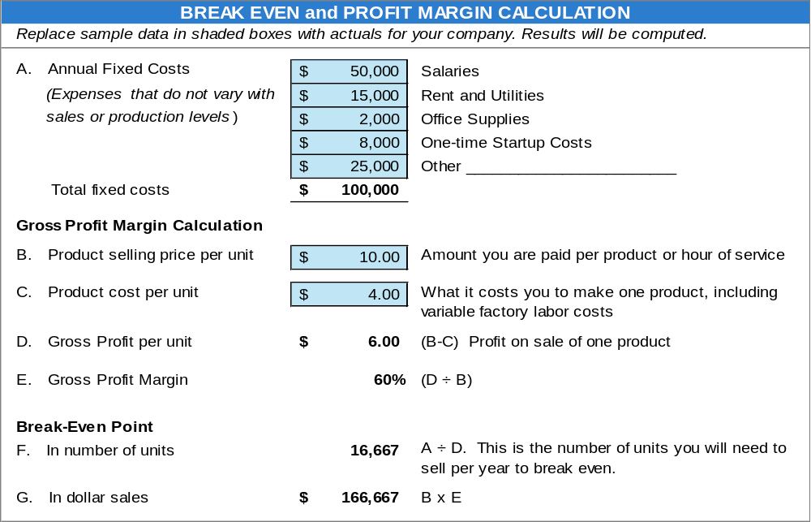

This Break-Even Calculator may be downloaded from https://entrepreneurshipfoundation.org/spreadsheets

Module 4 - Business Planning Chapter 1 – Business Plan Outline

4.1.12 RESOURCES NEEDED TO LAUNCH BUSINESS
(1-2 pages)

Space

BUSINESS-TO-Consumer (B-C) VENTURES. Location is particularly important for retail, restaurant or consumer services since customers must come to you. The location must obviously be convenient and project the proper image for your target clientele. Indicate your intended place of business:
- Physical address. Include a map with the location marked.
- Access (Is it convenient to transportation arteries?)
- Number of parking spaces
- Size (square footage)
- Amenities
- Type of heat and air conditioning
- Does it conform to government requirements for your industry?
  - Zoning laws
  - Building codes
  - Health department regulations
  - Handicap access
  - Fire codes
- Interior design. (Does space need extensive remodeling?)
Business-to-Business (B-B) Enterprises. A factory or warehouse might not need to meet high standards for ambience, but there are efficiency and cost considerations. Is it all on one floor, or will you have to move goods up and down elevators? Is it accessible to tractor-trailers? How close is the turnpike entrance? Indicate the physical characteristics of the intended space:
- Amount of space (square footage)
- Type of construction and age
- Zoning restrictions
- Power supply
- Heating system

Equipment
- What equipment will you need?
- Will you lease or buy? Why?
- What will the equipment cost?

Intangibles
- Licenses
- Bonding, if required
- Insurance
- Trademarks and copyrights
- Patents

Personnel (See “Human Resources” section.)

Module 4 - Business Planning Chapter 1 – Business Plan Outline

4.1.13 CAPITAL REQUIREMENT

(1 page)
Break the capital requirement into periodic tranches. Investors prefer to mete out cash when (and if) interim goals are met. The tranches may be annual, semi-annual, or based on important milestones, such as receiving a patent, demonstrating a working prototype, or concluding the first sale.
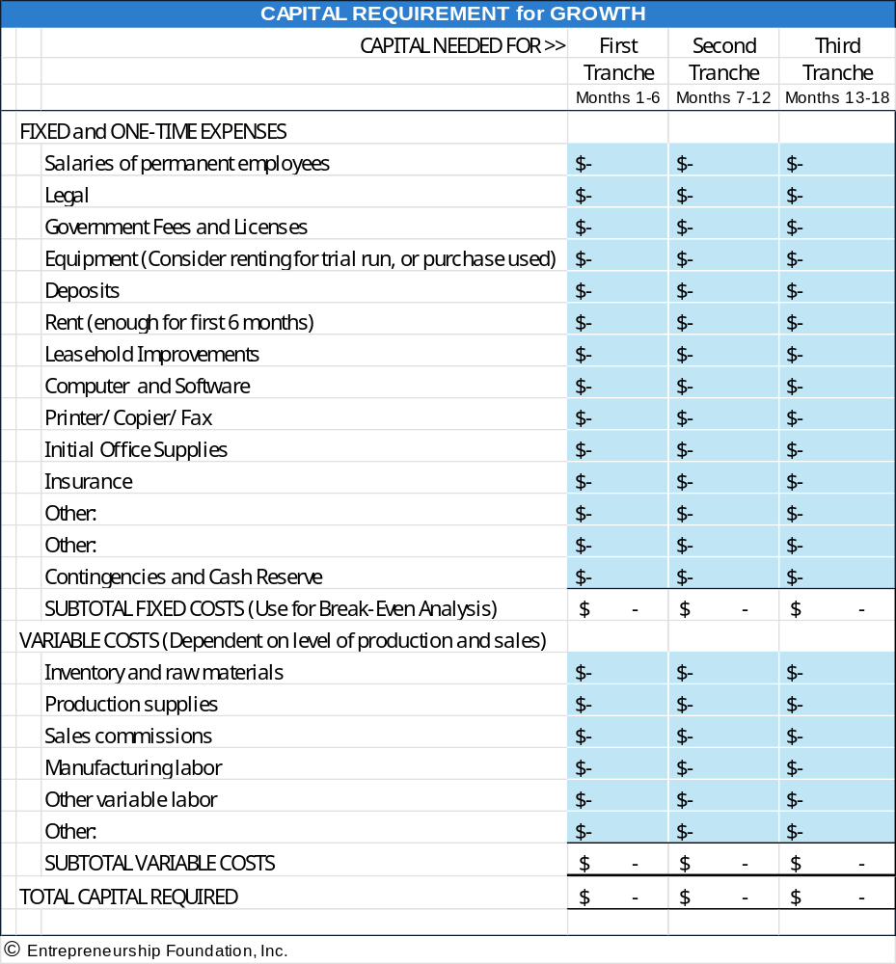

Module 4 - Business Planning Chapter 1 – Business Plan Outline

4.1.14 APPENDICES

- Brochures and advertising materials
- Industry studies or articles that support growth predictions
- Letters of endorsement from potential customers
- Any other materials needed to support assertions in the plan

Modify the business plan outline as needed to include the unique factors determining success or failure in your industry. For example, if you are planning a brick-and-mortar retail establishment, a discussion of the planned location and traffic flow would be appropriate to include.

Module 4 - Business Planning Chapter 2 – Bullet-Proofing the Plan

4.2 – Bullet-Proofing The Plan

INVESTORS see thousands of business plans each year. With so many opportunities, most investors focus on finding reasons to say no. Following are the most common errors found in business plans. (© copyright, Cayenne Consulting. www.caycon.com.)

4.2.1 Content Mistakes

4.2.2 Financial Model Mistakes.

4.2.3 Stylistic Mistakes

4.2.4 Execution Mistakes

Module 4 - Business Planning Chapter 2 – Bullet-Proofing the Plan

4.2.1 Content Mistakes

Failing to relate to a true pain. Pain comes in many flavors: my computer network keeps crashing; my accounts receivable cycle is too long; existing treatments for a medical condition are ineffective; my tax returns are too hard to prepare. Businesses and consumers pay good money to make pain go away.
You are in business to get paid for making pain go away.
Pain, in this setting, is synonymous with market opportunity. The greater the pain, the more widespread the pain, and the better your product is at alleviating the pain, the greater your market potential.
A well-written business plan places the solution firmly in the context of the problem being solved.

Value inflation. Phrases like "unparalleled in the industry;" "unique and limited opportunity;" or "superb returns with limited capital investment" - taken from actual documents - are nothing but assertions and hype.
Investors will judge these factors for themselves. Lay out the facts - the problem, your solution, the market size, how you will sell it, and how you will stay ahead of competitors - and tone down the hype.

Trying to be all things to all people. Many early-stage companies believe that more is better. They explain how their product can be applied to multiple, very different markets, or they devise a complex suite of products to bring to market.
Most investors prefer to see a more focused strategy, especially for very early-stage companies: a single, superior product that solves a troublesome problem in a single, large market that will be sold through a single, proven distribution strategy.
That is not to say that additional products, applications, markets, and distribution channels should be discarded - instead, they should be used to enrich and support the highly focused core strategy.
You need to hold the story together with a strong, compelling core thread. Identify that and let the rest be supporting characters.

No go-to-market strategy. Business plans that fail to explain the sales, marketing, and distribution strategy are doomed. The key questions that must be answered are: who will buy it, why, and most importantly, how will you get it to them?
You must explain how you have already generated customer interest, obtained pre-orders, or better yet, made actual sales - and describe how you will leverage this experience through a cost-effective go-to-market strategy.
"We have no competition". No matter what you may think, you have competitors. Maybe not a direct competitor - in the sense of a company offering an identical solution - but at least a substitute. Fingers are a substitute for a spoon. First class mail is a substitute for e-mail. A coronary bypass is a substitute for an angioplasty. Competitors, simply stated, consist of everybody pursuing the same customer dollars.

To say that you have no competition is one of the fastest ways you can get your plan tossed - investors will conclude that you do not have a full understanding of your market.
The "Competition" section of your business plan is your opportunity to showcase your relative strengths against direct competitors, indirect competitors, and substitutes. Besides, having competitors is a good thing. It shows investors that a real market exists.

Module 4 - Business Planning Chapter 2 – Bullet-Proofing the Plan

Too LONG. Investors are very busy, and do not have the time to read long business plans. They also favor entrepreneurs who demonstrate the ability to convey the most important elements of a complex idea with an economy of words.
An ideal executive summary is no more than 1-3 pages. An ideal business plan is 20-30 pages (and most investors prefer the lower end of this range).
Remember, the primary purpose of a fund-raising business plan is to motivate the investor to pick up the phone and invite you to an in-person meeting. It is not intended to describe every detail.
Document the details elsewhere: in your operating plan, R&D plan, marketing plan, white papers, etc.

Too technical. Business plans - especially those authored by people with scientific backgrounds - are often packed with too many technical details and scientific jargon.
Initially, investors are interested in your technology only in terms of how it:
- solves a big problem that people will pay for.
- is significantly better than competing solutions.
- can be protected through patents or other means; and
- can be implemented on a reasonable budget.
All these questions can be answered without a highly technical discussion of how your product works. The details will be reviewed by experts during the due diligence process. Keep the business plan simple. Document the technical details in separate white papers.

No risk analysis. Investors are in the business of balancing risks versus rewards. Some of the first things they want to know are what are the risks inherent in your business, and what has been done to mitigate risk. Key risks of entrepreneurial ventures include:

- Market risks: Will people buy what you have to sell? Will you need to create a major change in consumer behavior?
- Technology risks: Can you deliver what you say you can? On budget and on time?
- Operational risks: What can go wrong with the day-to-day operations of the company? What can go wrong with manufacturing and customer support?
- Management risks: Can you attract and retain the right team? Can your team pull this off? Are you prepared to step aside and let somebody else take over if necessary?
- Legal risks: Is your intellectual property truly protected? Are you infringing on another company's patents? If your solution does not work, can you limit your liability?
This is, of course, just a partial list of risks.
Even if you feel that the risks are negligible, potential investors may feel otherwise, unless you demonstrate that you have given a lot of thought to what can go wrong and have taken steps to mitigate the risks.

Module 4 - Business Planning Chapter 2 – Bullet-Proofing the Plan

Poorly organized. Your idea should flow in a nice, organized fashion. Each section should build logically on the previous section, without requiring the reader to know something that is presented later in the plan.
Although there is no single "correct" business plan structure, one successful structure is as follows:

- Executive Summary: This is a brief, 1-to-3-page summary of everything that follows in the plan. It should be a stand-alone document, as many readers will make their initial decision based on the executive summary alone. This should usually be written last; otherwise, you have nothing to summarize!
- Background: If you are in a highly specialized field, you should provide some background in lay terms since most investors will not have advanced degrees in your field.
- Market Opportunity: Describe how businesses and consumers are suffering, and how much they are willing to pay for a solution.
- Products or Services: Describe what you do, and how your solution fits into the market opportunity.
- Market Traction: Describe how you have succeeded in attracting customers, marketing and distribution partnerships, and other alliances that demonstrate that experts in your market are betting on your solution.
- Competitive Analysis: Identify your direct and indirect competitors and describe how your solution is better.
- Distribution and Marketing Strategy: Describe how you will go to market, how you will price your products, etc.
- Risk Analysis: Identify major sources of risks and describe how you are mitigating them.
- Milestones: Showcase a strong past track record and describe key checkpoints for the future.
- Company and Management: Provide the basic facts about your company - where and when you incorporated, where you are located, and brief biographies of your core team.
- Financials: Provide summaries of your P&L and cash flows, and the assumptions used to come up with these. Also describe your funding needs, how you will use the proceeds, and possible exit strategies for investors.

Module 4 - Business Planning Chapter 2 – Bullet-Proofing the Plan

4.2.2 Financial Model Mistakes.
Forgetting Cash. Revenues are not cash. Gross margins are not cash. Profits are not cash. Only cash is cash.
For example, suppose you sell something this month for $100, and it cost you $60 to make it. But you have to pay your suppliers within 30 days, while the buyer probably won't pay you for at least 60 days.
In this case, your revenue for the month was $100, your profit for the month was $40, and your cash flow for the month was zero. Your cash flow for the transaction will be negative $60 next month when you pay your suppliers.
Although this example may seem trivial, very slight changes in the timing difference between cash receipt and disbursement - just a couple of weeks - can bankrupt your business.
Make sure that your assumptions are realistic so that you raise sufficient capital.

Lack of Detail. Your financials should be constructed from the bottom-up and then validated top-down.
A bottom-up model starts with details such as when you expect to make certain sales, or when you expect to hire specific employees.
Top-down validation means that you examine your overall market potential and compare that to the bottom-up revenue projections.
Round numbers - like one million in R&D expenses in Year 2, and two million in Year 3 - are a sure sign that you do not have a bottom-up model.

Unrealistic financials. Only a very small handful of companies achieve $100 million or more in sales only five years after founding.
Projecting much more than that will not be credible and will get your business plan canned faster than almost anything else.
On the other hand, a business with only $25 million in revenues after five years will be too small to interest serious investors.
Financial forecasts are a litmus test of your understanding of how venture capitalists think.
If you have a realistic basis for projecting $50-100 million in Year 5, you are probably a good candidate for venture financing. Otherwise, you should probably look elsewhere.

Insufficient financial projections. Basic financial projections consist of three fundamental elements: Income Statements, Balance Sheets, and Cash Flow Statements. All of these must conform to Generally Accepted Accounting Principles, or GAAP.
Investors generally expect to see five years of projections. Of course, nobody can see five years into the future. Investors primarily want to see the thought process you employ to create long-term projections.
A good financial model will also include sensitivity analyses, showing how your projected results will change if your assumptions turn out to be incorrect. This allows both you and the investor to identify the assumptions that can have a material effect on your future performance, so that you can focus your energies on validating those assumptions.
They should also include benchmark comparisons to other companies in your industry - things like revenues per employee, gross margin per employee, gross margin as a percentage of revenues, and various expense ratios (general and administrative, sales and marketing, research and development, and operations as a percentage of total operating expenses).

Module 4 - Business Planning Chapter 2 – Bullet-Proofing the Plan

Conservative assumptions. Nobody ever believes that assumptions are conservative, even if true.
Develop realistic assumptions that you can support, refrain from using the words "conservative" or "aggressive" in your plan and leave it at that.
Offering a valuation. Many business plans err by stating that their company is worth a certain amount.
If you name a price, one of two things can happen: (a) your price is too high, and investors will toss your plan; or (b) your price is too low, and investors will take advantage of you. Both are bad.
The purpose of the business plan is to tell your story in the most compelling manner possible so that investors will want to go to the next step. You can always negotiate the price later.

4.2.3 Stylistic Mistakes
Poor spelling and grammar. If you make silly mistakes in your business plan, what does that say about how you run your business? Use your spelling and grammar checkers, get other people to edit the plan, do whatever it takes to purge embarrassing errors.

Too repetitive. All too often, a plan covers the same points repeatedly. A well-written plan should cover key points only twice: once, briefly, in the executive summary, and again, in greater detail, in the body of the plan.

Appearance matters. At any point in time, an investor has dozens if not hundreds of plans waiting to be read. Get to the top of the pile by making sure that the cover is attractive, the binding is professional, the pages are well laid out, and the fonts are large enough to be easily read. On the other hand, do not go too far - you do not want to give the impression that you are all style and no substance.

4.2.4 Execution Mistakes
Waiting until too late. The capital formation process takes a long time. In general, count on 6 months to a year from the time you start writing the plan until the time the money is in the bank.

Failing to seek outside review. Make sure that you have a few people review your plan before you send it out - preferably people who understand your market, sales and distribution strategies, the VC market, etc.
Your plan may look perfect to you and your team, but that's probably because you have been staring at it for months. Good, objective reviews from outsiders with a fresh perspective can save you from myopia.

Over-tweaking. You could spend countless hours tweaking your plan in the pursuit of perfection. A lot of this time would be better spent working on your product, company, and customers. At some point, you need to pull the trigger and get the plan out in front of a few investors. If the reaction is positive, and they want to move forward, great. If the reaction is negative (assuming that the investor was a good fit to begin with), then you may have been heading down the wrong path. Get feedback from a couple of investors, and if a general consensus emerges, go back and refine your plan.

Conclusion. It's a tough investment climate, but good ideas backed by good teams and good business plans are still getting funded. Give yourself the best possible chance by avoiding these simple mistakes.
Module 4 - Business Planning Chapter 3 – Professional Writing Style

4.3 – Professional Writing Style

Packaging sells. Writing an easy-to-read proposal is almost as important as the substance of your plan.

Headings -- use headings and subheadings to separate and identify sections. Headings show the organization of the content.

Vocabulary. Do not be sesquipedalian. Use short paragraphs, simple sentences, and short words for readability.

Use active verbs. “Jane saw the disaster,” and not “The disaster was seen by Jane

Use the Grammar Checker in Word.”

Break up monotonous text blocks with simple charts, graphs, tables and photographs to break up the text.

Use Consistent Page Layout

Absolutely, positively no typos.

Avoid orphans. A single word at the end of a paragraph. Rewrite the sentence or if it’s a short word, try kerning. The previous sentence had one word left over “kerning.”

Here is the sentence again but foreshortened by .01 point of letterspacing (the spacing between letters).
Avoid orphans. A single word at the end of a paragraph. Rewrite the sentence or if it’s a short word, try kerning.
To kern, highlight the line you want to shorten, go to the “Font” menu, select “spacing” and then hit the down arrow once in the “By” window. You can kern the letter spacing by up to .03 points without it being noticeable.

Start each new page with a new section or at least a new paragraph. A paragraph that slops over from one page to the next is a “widow”.

Do not mix fonts. Stick with one type font, Times Roman, Arial, or another business-like typestyle. You can use different sizes of the same font, but do not use less than a 12-point font size for Times Roman, or less than 10 points for Arial. You are reading Arial 10-point text.

Justification. You can align your text with left justification. This will leave a ragged edge on the right side (like the preceding paragraph). Or you can fully justify the text. Full justification (like this paragraph) looks more professional to most people. But full justification is a bit harder to read than left justification.

Alternatively, use Semi-Justification to combine a professional look with easy-to-read text, rewrite your text so it is almost at full justification.

Avoid breaking words (hyphenating) at the end of lines. Rewrite the line or use kerning to remove the hyphen.

Highlighting. Use CAPS, color, font size, Italics and boldfacing. Avoid underlining except to point out negatives. (Sarah is not familiar with models, except for Simplex.)

Use bullet points to present ideas in a list.

Module 4 - Business Planning Final Thoughts

Final Thoughts
Lessons from Successful Investors and Serial Entrepreneurs

1. THREE HEADS ARE BETTER THAN ONE. Based on the experience of business accelerators, teams with diverse skills are more successful than solopreneurs. Empower your staff. Require action but provide coaching. Give your team members ownership of their ideas, and diplomatic immunity from failure.

2. MANAGE YOUR TIME LIKE MONEY. Your business will make demands, but you can still do other things: school, day job, family, and just unwinding.
The trick is budgeting your time. When you were a student you probably did this for homework. Decide how many hours per day or week you want to devote to the needs of the business. Get into a routhine by setting aside a consistent time of day, and place, to work on the business. This makes it easier for others who have a claim to your time and attention. “Kids, when mom is sitting at her desk, she is at work.”

Harvard Professor Kyle Westway advises:
- Prioritize your to-do list. What is really important?
- Put goals and their deadlines on your calendar.
- Then backdate from those deadlines: what has to be done, by what date, to meet ultimate goals?
Check the calendar every night and morning, and adjust as necessary—but meet the deadlines.
- Avoid distractions. Stay focused.
- Work on the most important goal or problem until you cannot progress further until something else happens. Then make that happen.
3. MONITOR THE COMPETITION within your product and service area. Be prepared to zig if they zag.
4. GET HELP. Find a mentor or form an advisory board. Attract and keep the best and the brightest employees. Teams are much more successful than solopreneurs.

"If you want to go fast, go alone. If you want to go far, go together"
- African proverb
“I'm convinced that about half of what separates successful entrepreneurs from the non-successful ones is pure perseverance”

- Steve Jobs

5. LEARN FROM FAILURE through honest introspection. Create an imaginary out of body experience to observe the company and your decisions. Pretend you are a customer or investor.

“The only real mistake is the one from which we learn nothing.”
-- Henry Ford
“Fail fast; Succeed sooner” – Peter Drucker
“Success is survival.” -- Leonard Cohen
6. LEAD BY EXAMPLE: be the top salesperson. Employees, investors and customers will see your confidence and passion; and follow.
7. BELIEVE IN YOURSELF. Nurture the passion that led you to launch the venture.
8. STAY FOCUSED ON THE MOST IMPORTANT GOALS.
9. REMEMBER: HONESTY IS THE BEST POLICY. Your most valuable asset is your reputation.

