Launching a New Venture

Ninth Edition

Module 1
Entrepreneurship
Problem, Solution, MVP, Competition, BMC, Pricing, Company name, Website, IP, Legal Structure, Regulatory matters

Entrepreneurship Foundation, Inc.

Launching a New Venture Edition 9.0

Module 1 - Entrepreneurship

ISBN-13: 979-8-9998903-1-3

ALL MODULES IN THE SERIES

Module 1 - Entrepreneurship
Startup Checklist, Business Modeling, Problem-Solution Fit, MVP, Product-Market Fit, Competition, Lean BMC, Pricing, Landing Page, Company Name, Protecting IP, Legal Structure, Regulatory Matters, Raising Startup Capital

Module 2 – Small Business Marketing
Branding, Website, the Message, Collateral Material, Traditional Mass Media, Digital Mass Media, Targeted Media, Direct sales

Module 3 – Entrepreneurial Finance
Production and Distribution, HR, Space Requirements, Risk Management, Budgeting, Accounting, Buying a business, Banking, Raising Growth Capital, Pitching business plans

Module 4 - Business Planning
Content, Style

Editor@EntrepreneurshipFoundation.org
© Academy Publishing, 2012, 2014, 2016, 2020, 2023, 2024, 2025 All rights reserved.
DISCLAIMER: The contents of this work are for general informational purposes only and do not constitute legal advice. You should not act or refrain from acting on the basis of any content without seeking professional legal advice. This site contains links to other web sites. We are not responsible for the privacy practices or the content of such web sites, and we do not endorse such sites.

Table of Contents

1.1 – Introduction 4
1.1.1 Checklist 5
1.1.2 Business Modeling 6
1.1.3 INCREMENTAL Launch STRATEGY 7
1.1.4 EntrepreneurSHIP aPTITUDE Self-Assessment 8
1.2 – Problem-Solution Fit: Identifying a Problem and the Best Solution 11
1.2.1 Identify a Real Problem 12
1.2.2 Survey to See if There is a Market for a Solution 13
1.2.3 Ideate: Brainstorm POSSIBLE SOLUTIONS 14
1.2.4 SHORT LIST OF POSSIBLE SOLUTIONs 15
1.2.5 Filter SOLUTIONS BASED oN PATENTABILITY 16
1.2.6 FILTER SOLUTIONS Based on market POTENTIAL 17
1.2.7 FILTER SOLUTIONS Based on Feasibility of Success 18
1.2.8 Validated problem-soLution fit 22
1.3 – Building an MVP for Market Testing 23
1.3.1 Designing a Minimum Viable Product or Service 24
1.3.2 Building a Physical Prototype 25
1.3.3 Software and Mobile App Prototyping 26
1.3.4 Market TESTING THE PRODUCT OR SERVICE 28
1.4 – Product-Market Fit: Perfecting the Solution 29
1.4.1 How to Measure Product–Market Fit 30
1.4.2 FINDING PRODUCT-MARKET FIT 31
1.4.3 Customer Survey to discover buyIng preferences 32
1.5 – Competitive Positioning 33
1.5.1 Researching COMPETITIon 34
1.5.2 Selecting a Target Market Niche 35
1.5.3 dETERMINing Size of Target Market 36
1.5.4 Developing a COMPETITIVE STRATEGY 37
1.5.5 CoMparing Features to Competitor Products 38
1.5.6 Strategizing Barriers to Entry To DETER Competition 39
1.6 – Lean Business Model Canvas 40
1.7 – Pricing the Product or Service 44
1.7.1 PRoduct COMPONENT CostS 45
1.7.2 Shipping AND HANDLING COSTS 46
1.7.3 ESTIMATING TOTAL COST OF PRODUCTION 48
1.7.4 Pricing ProductS 49
1.7.5 Pricing SERVICES 50
1.7.6 TESTING PRICEs WITH A SOFT LAUNCH (The Landing page) 52
1.8 – Naming the Company 54
1.9 – Protecting Intellectual Property 59
1.9.1 Trademarks 60
1.9.2 Patents 62
1.9.3 Trade Secrets 65
1.9.4 CopyrightS 65
1.10 – Structure and Regulatory Matters 66
1.10.1 Finding Your NAICS CODE 67
1.10.2 Federal EIN Number (Employer Identification Number) 67
1.10.3 SETTING UP AN LLC 68
1.10.4 Business Licenses 69
1.11 – Raising Startup Capital 70
1.11.1 Determining Startup capital requirements 71
1.11.2 Sources of Startup Capital 72
1.11.3 Pitching Business Concepts 74

1.1 – Introduction

1.1.1 Checklist

1.1.2 Business Modeling

1.1.3 Incremental Launch Strategy

1.1.4 Entrepreneurship Aptitude Self-Assessment

Entrepreneurship is the art of solving a problem with a new product or service, and building a business to produce, market and deliver that solution.

Launching a new venture is rewarding, creative, and allows true freedom. It also involves risk and uncertainty. Those who want a predictable income through traditional employment will still benefit from an understanding of entrepreneurship. The skills you acquire will help you advance in any company. Entrepreneurship inside a firm is called intrapreneurship.

What is the life you want? What are your personal goals? Where do you want to be in five years? Ten Years? Then decide whether starting a new venture as an entrepreneur, or working for someone else as an intrapreneur, is the best way to achieve them. To help you choose the right path, see the Entrepreneurship Aptitude Assessment at the end of this chapter.

IF YOU DO WANT TO START YOUR OWN BUSINESS, do you think you would be happier running a personal business or high-growth enterprise?

ASPECT OF BUSINESS | PERSONAL BUSINESS | HIGH GROWTH ENTERPRISE
Time and Attention Required | You can still have a life | Business will be your life until you can hire others to help
Scalable (average product cost declines as volume increases) | No (e.g. – If it takes 3 people to roof one house, it takes 6 to roof 2 houses) | Yes (e.g.– software or music. The orignal may cost $100,000 to create; but the second is only $.50)
Annual Sales Potential | $100,000 to $500,000 | $50,000,000 (amount necessary to attract investors)
Geographic Range of Market | Neighborhood or Town | State, country or world
Capital needed to launch | $5000 to $500,000 | $50,000 to $250,000
Typical Sources of Startup Capital | Savings, credit cards, family | Savings, credit cards, family

Module 1 - Entrepreneurship Chapter 1 - Introduction

1.1.1 Checklist

Click on a topic to go to that secion in the book.

BUSINESS MODELING - Conceive and validate a winning concept
- □ Indentify a Real Problem to Address
- □ Determine If There Is a Market for a Solution (Interview people with problem)
- □ Brainstorm Possible Solutions
- □ Filter Solutions: Patentability
- □ Filter Solutions: Market Potential
- □ Filter Solutions: Feasibility
- □ Achieve Problem-Solution Fit
- □ Design a Minimum Viable Product or Service (MVP)
- □ Build and Test an MVP Prototype
- □ Achieve Product–Market Fit: Solution is repeatable, profitable, and sustainable
- □ Research Competition
- □ Select A Market Niche
- □ Determine Size of Target Market Niche
- □ Strategize Barriers to Entry – To hold Competitors at Bay
- □ Draft a Business Model Canvas
PRODUCT OR SERVICE
- □ Determine Price for Product or Service
- □ Test Price Acceptability with a Landing Page
MARKETING
- □ Select Best Name for Company
LEGAL
- □ Decide Which Intellectual Property Protections to Pursue
- □ Determine NAICS code
- □ Obtain Federal Employer Identification Number (EIN)
- □ Set up LLC (if appropriate)
- □ Determine Business Licenses and Permits Needed
CAPITAL
- □ Determine Startup Capital Requirements
- □ Write a 60-Second Elevator Pitch

Module 1 - Entrepreneurship Chapter 1 - Introduction

1.1.2 Business Modeling

ITERATIVE BUSINESS MODELING VERSUS TRADITIONAL BUSINESS PLANNING. Business Modeling is based on the premise that a traditional business plan is not suited to a new venture. Formal business plans and proforma financials presume the new venture must immediately support the founder on a full-time permanent basis (a legacy from large-company planning). But for a startup ...

- ​​Long-range forecasts are largely discounted by investors. According to John Seiffer, former president of the Angel Investor Forum, "It is not an efficient use of time and energy to prepare elaborate 20-page pro formas on untested concepts."
- A new business concept is really a set of unproven hypotheses. These include: demand per price point, production costs, feasible distribution channels, cost for post-purchase customer service, production lead times, repeat sales rates, and preferred features.

Champions of business modeling, Eisenmann (Harvard), Bob Dorf (Columbia), and Steve Blank (Stanford) assert that startups need a plan to FIND a sustainable business model. Nathan Furr, a contributing writer to Forbes, differentiates the two approaches this way:

“In a business plan, you are trying to plan, inside the building, the optimal solution that you can execute. In a business model process, you recognize that everything is a guess that has to be tested, outside the building, with the goal of learning” what will work.

“Startups are more likely to succeed when they rapidly and iteratively test assumptions about a new venture’s business model based on customer feedback, then quickly refine promising concepts and ruthlessly cull the flops. New ventures that follow this approach are lean startups.”

Bear in mind that formulating a business model is a non-linear process. As each aspect of the business is refined, an entrepreneur may have to revise budgets, production plans, distribution channels, or even the product itself.

TRADITIONAL BUSINESS PLANNING. But once you do arrive at a sustainable business model, you will need a comprehensive business plan to to secure growth financing. Still, as serial investor David Rose warns: “A real business plan is never done.” Tim Perry refers to the continuing updating process as PRRR: Plan, Run the plan, Review the plan based on results and customer feedback, and Revise.

Module 1 - Entrepreneurship Chapter 1 - Introduction

1.1.3 INCREMENTAL Launch STRATEGY

The strategy recommended in this text is to establish a new business in stages, with each milestone confirming the assumptions necessary to advance to the next.
DISCOVER A VIABLE BUSINESS CONCEPT using the Lean Startup Method: market testing iterative versions of a product or service, with a limited number of customers. A venture starts with a a Minimum Viable Product (MVP), a prototype with the fewest number of features to test customer acceptance, then refines and iterates based on feedback until it discover a profitable and sustainable model.

START SMALL. Bootstrap the business with what you can save or borrow comfortably. If your dream is a restaurant, start with a food cart, second-hand.
VIDE Lean Startup Method. https://www.youtube.com/watch?v=QaoVWtLX038
GROW ORGANICALLY. Use the proceeds from your first sales to buy the materials for your second round of production. You may be able to gradually increase the volume of purchasing and production to grow organically without ever having to raise outside capital.

MINIMIZE RISK. If you do need outside investment, raise only the amount of capital required at each stage, rather than raising in advance the entire amount necessary to take an idea to profitability. Successfully mastering each stage before raising funds for the next will also allow you to negotiate more favorable financing terms.

This incremental approach reduces risk. The process of launching a startup is divided into capitalization tranches, corresponding to the stages of development of the business. The incremental approach allows the entrepreneur or investor the opportunity to withdraw from the venture at an interim stage if expected results are not attained. For example, an investor might agree to provide a total of $250,000 to bring a new idea to the market, provided interim milestones are achieved. Initially, the investor might provide $25,000 to apply for a patent, but if the patent is not received, the investor would then not be obligated to provide the balance of the capital.

TYPICAL LAUNCH STAGES

Stage 1: Advance the idea on paper—without financing—to the furthest extent possible.
Stage 2: Save your own money in a business savings account to build, bench test, and market test a minimum viable product, performing as much of the work yourself to conserve capital.
Stage 3: Raise seed capital from crowd sources to launch business on a part-time basis. (Do not quit the day job just yet.)
Stage 4: Raise growth capital from an angel, VC or bank once the business proves itself as a long-term source of increasing revenue.

“The goal of an entrepreneur is to find a repeatable and scalable business model.”
– Steve Blank
Module 1 - Entrepreneurship Chapter 1 - Introduction

1.1.4 EntrepreneurSHIP aPTITUDE Self-Assessment

By: Ken Kollmeyer, Small Business Development Specialist

IS ENTREPRENEURSHIP RIGHT FOR YOU? An entrepreneur should think about how they will feel about the loss of 1) steady income, 2) paid holidays and vacations, 3) regular working hours, 4) reduced family time, 5) peace of mind and 6) financial security. Some not too far-fetched scenarios for consideration might include:
a) it’s 2:00 am; your phone rings and it’s your alarm company advising you that a door alarm at your building has been activated. They ask you if you will be driving to the facility to meet the police. What do you do?
b) you have a small boutique across from a mall and you have decided that you will open on the July 4th holiday to take advantage of the traffic from a sale at the mall. Sally, your lone employee has agreed to cover the day but has become ill and contacts you during the early morning hours on the Holiday. You have committed to spending the day at the beach with your family; all family members have been looking forward to this day. What will you do? Will you open the shop and abandon your family plans, or will you keep the shop closed? What if you had already bought a newspaper ad saying that you would be open?

Small Business-a Roller Coaster Ride: Starting and running a small business can truly be a ‘double-edged sword’. There can be exhilarating highs and there can be harsh lows. Think about the following possibilities:
- You are the focal point and carry the prestige that owning a business can bring; you are the proverbial point at which the buck stops.
- You have independence and can come and go as you wish; you will need to accept 60- to 84-hour workweeks as a fact of entrepreneurial life, and you cannot quit.
- Running a successful small business can be gratifying and uplifting; But if your business is underperforming and you are struggling to pay your bills, your ego may suffer.
- Attaining your dream of financial security can bring a lifestyle filled with many creature comforts; But owning a business can also result in fluctuating levels of income and the loss of your investment.
- Since your business is your dream, it is your ‘labor of love’; in some instances, however, the pressures and stresses of running a business may turn your vocation into drudgery.

Insightful Questions: To come to grips with whether you have what it takes to be a successful entrepreneur, here are some insightful questions to answer before taking the leap:
 | PREPAREDNESS | YES = 5 | 4 | 3 | 2 | NO = 1
1 | Do I have the skills to start and operate a business?
2 | Do I have substantial experience in the type of business I want to start?
3 | What is motivating me to act, and can these motivators be sustained?
4 | Do risk taking and I get along?
5 | Can I afford to lose the money I need to invest?
6 | Have I allowed my family or significant others to voice their true feelings about this significant commitment of time and finances?

Module 1 - Entrepreneurship Chapter 1 - Introduction

Inventory Your Skills: Have you taken an inventory of your skills? Do you possess a reasonable level of proficiency across the various business disciplines (e.g., sales, marketing, finance, operations, etc.)?
- Basic math skills are unavoidable. You will need to be reasonably comfortable working with numbers (e.g., addition, subtraction, multiplication, division, ratios). Can you analyze revenue and expense figures to determine what products or services are profitable, and which are unprofitable? Can you determine what level of sales and profit increases might justify a 20% increase in advertising?
- People skills are indispensable. Running a business will require you to interact with other people. After all, your customers, employees, suppliers, lenders and advisors are people.
- Solid written and verbal communication skills are critically important to your success. Observe almost any ‘help wanted’ classified advertisement. How many positions of leadership do not require ‘strong written and verbal’ communication skills?
- A solid grounding in technology is also a logical prerequisite for a successful small business.
- Possessing a ‘Passion to Learn’ will serve you well. You will need to look at all facets of your business for an understanding of why it is working or not working.
- Are you grounded in reality? Can you be honest and face your strengths and weaknesses?

Compare your skill set proficiency against these requirements and should you arrive at the conclusion that you are indeed deficient in one or more competencies, do not despair. Help is available. Individual and multiple session seminars, workshops, and courses are available through SCORE and the Small Business Development Centers.
 | SELF-CRITIQUING SKILLS | YES = 5 | 4 | 3 | 2 | NO = 1
7 | Do I seek advice and feedback?
8 | Do I listen to my critics?
9 | Do I take the criticism to heart?
10 | Do I apply what I learn?

Common Characteristics of Successful Entrepreneurs.

Experience. Therefore, take the necessary time to learn as much as you can about your business. If you have never performed your intended business’s work, take a job(s) that will provide you with the necessary insights and feel for its unique rhythm and challenges.

Personality. Personality is a component of the ‘art form’ of management. In many respects, it is part of your DNA. Answer these questions honestly:
 | IS THIS REALLY WHAT I WANT | YES = 5 | 4 | 3 | 2 | NO = 1
11 | Do I like to sell?
12 | Can I persevere and stay focused?
13 | Can I interact effectively with others?
14 | Can I inspire and motivate others?
15 | Am I an effective listener?
16 | Am I competitive?
17 | Am I a self-starter?
18 | Am I comfortable with ambiguity?

Module 1 - Entrepreneurship Chapter 1 - Introduction

If you did not answer yes to most of these questions, you probably will find the road to small business ownership success to be very bumpy and possibly distressful.

Managerial Ability. In the business world, achieving positive results through other people is an ever-present challenge. Are you skilled and able to do the following?
 | MANAGERIAL ABILITY | YES = 5 | 4 | 3 | 2 | NO = 1
19 | Manage people?
20 | Deliver results?
21 | Maintain a tight control over the money?
22 | Keep accurate records?
23 | Understand the relationships between resources, assets and financial results?

Courage. Starting and running a business will require you to deal with various issues. Avoidance will usually translate into costs and will reduce profit. Therefore, can and will you:

 | COURAGE | YES = 5 | 4 | 3 | 2 | NO = 1
24 | Deal with adversity ‘head on’?
25 | Make bold and difficult business decisions in a timely fashion?
26 | Not become easily discouraged or intimidated?

IN CONCLUSION: The preceding thoughts and information are meant to provide a ‘reality check’ and ‘food for thought’ for all would-be entrepreneurs. In many instances, deciding not to take this plunge will be the correct decision. Entrepreneurship and business ownership is not for everyone. Eight of ten businesses will fail within the initial five years of operation. Finding out the hard way can lead to the loss of your home, financial security, health and even your family.

However, let us not lose sight of the fact that many storied entrepreneurs have indeed forged ahead starting and owning small businesses that have grown into significant companies. It can be done. Examples include Intel; Jet Blue, Subway Restaurants, Microsoft, and Walmart to name but a few. All started with an entrepreneur’s dream and that dream was nurtured with hard work, capital and passion.

The key is to be informed and to be true to yourself; then make the big decision.

Module 1 - Entrepreneurship Chapter 2 - Problem-Solution Fit

1.2 – Problem-Solution Fit:
Identifying a Problem and
the Best Solution

Using insights from market research, in-person interviews, and surveys, problem-Solution Fit focuses on on identifying an intense problem, explores whether there is a viable market for a solution, and formulates the ideal solution to the problem. The process also helps define a target market and competitive positioning.

1.2.1 Identify a Real Problem
1.2.2 Survey to See if There is a Market for a Solution
1.2.3 Ideate: Brainstorm Possible Solutions
1.2.4 Short List of Possible Solutions
1.2.5 Filter Solutions Based on Patentability
1.2.6 Filter Solutions Based on Market Potential
1.2.7 Filter Solutions Based on Feasibility of Success
1.2-8 Validated Problem-Solution Fit

Module 1 - Entrepreneurship Chapter 2 - Problem-Solution Fit

1.2.1 Identify a Real Problem

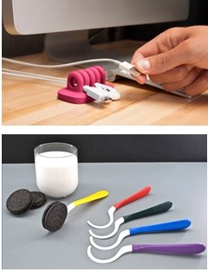
According to Thomas Eisenmann, “Most startups fail—usually due to lack of customer demand—not product development problems. These new ventures burn through their capital, wasting money on engineering and marketing before discovering they have built a product no one wants. These new ventures fail not because the innovation did not work; but because the founders did not guage the market’s ability or willingness to adopt it.”
What problem (customer pain) does each of these products solve?

All successful companies start with identifying a problem, and then brainstorming and testing possible solutions until they discover a sustainable business model

Investigate a market in which you have an interest. What are you passionate about? What would you be happy doing the rest of your life? It might be a hobby, a social need, or a sport you follow. One innovator developed a product to filter out carbon monoxide from the air race drivers breathe. He discovered the problem by talking to drivers.

Jane Porter, writing in Entrepreneur magazine, asks, “What bugs you?” Then suggests, “Do something about it!”

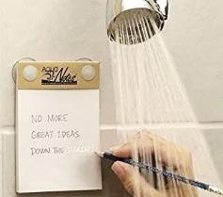
WHERE TO LOOK FOR PROBLEMS
- Amazon.com: what are the top nonfiction books (what problems are people trying to solve?)
- Google trending searches: http://www.google.com/trends/hottrends
- Needs Identifier https://www.kolenda.io/tools/needs-generator employs AI to uncover customer needs by industry. (Confirm results with customer interviews.)

ADDRESS AN OLD PROBLEM NOT ADEQUATELY SOLVED. What problems persist? Ask people who likely deal with the issue.


FIND A MARKET NICHE NOT CURRENTLY SERVED. Is there a need for a left-handed version? Foreign-language version? Organic model? Disposable (e.g. - Pampers)? Major corporations target a new product or service to the largest buying demographic. However, one size does not always fit all consumers.

RESPOND TO AN EMERGING PROBLEM. Covid caused the demand for disposable face masks to spike.
LOOK FOR PROBLEMS CAUSED BY NEW SOLUTIONS. The mobile phone made calling possible anywhere anytime. But it created a new problem: the cost of repairing the phone if dropped. (Users seldom dropped a wall phone or desk set.) What solution did entrepreneurs create? What opportunities are being created by new technologies? Peruse Wired magazine (a publication that monitors the future).

Module 1 - Entrepreneurship Chapter 2 - Problem-Solution Fit

1.2.2 Survey to See if There is a Market for a Solution

Once you identify a problem you would like to address, interview potential customers. Is it a real problem? How strong is the desire to be rid of it? Would anyone pay for any solution? Probe for details by asking follow-up questions: “Why is that important?” Your first objective is to validate the pain, not to validate a solution. Do not discuss solutions yet; keep an open mind.

Prepare an 8-second preview to place your questions in context. Describe the problem you want to solve: “Hi, I’m Tyler Swift, and I’m talking to people about paparazzi.”
Respondent Demographics Estimated age >> | 1  M – F  Age~____ | 2  M – F  Age~____ | 3  M – F  Age~____ | 4  M – F  Age~____ | 5  M – F  Age~____
A. [Qualifying question]  Are you hounded by paparazzi? | Y / N | Y / N | Y / N | Y / N | Y / N
B How often?
5 = Constantly
4 = Once a day
3 = Once a week
2 = Once a month
1 = Once or twice a year
C. How much of an annoyance are they?
5 = Dangerously so, pushing and shoving
4 = They stalk my family
3 = I cannot have a life.
3 = They get in the way
2 = They can be rude
1 = Not really a problem
D. Any suggestions for a solution?
[Do not approach problem investigation with a pre-conceived solution; keep an open mind]
E. How much would it be worth, per month, to solve this problem?
5 = $ 500
4 = $ 200
3 = $ 100
2 = $ 10
1 = $ 0

Module 1 - Entrepreneurship Chapter 2 - Problem-Solution Fit

1.2.3 Ideate: Brainstorm POSSIBLE SOLUTIONS

Now that you have verified that the problem is real and those who experience it will gladly pay for an effective solution, time can now be invested productively conceptualizing products or services to reduce or eliminate the problem.

But keep it real: Place-based businesses (restaurants, retail stores, gyms) may require $150,000 or more to set up; and raising that kind of money from a bank or investors for a startup is not realistic. Pick something that you can fund now or open a bank account in the name of the business and set aside $50 a week, $500 per month, or whatever you can afford. And do not touch this money. It is for your future.

To maximize your chance of success, Sam Altman, of Open AI and Y Combinator, suggests that you Explore opportunities at the intersection of your skills, excitement and needs of the world.
- Greenlighting. Jot down ideas as quickly as they come to you. Then go back over the list and narrow to a manageable number to research. Think about innovation during down time: while driving, in the shower.

- Improve an existing solution by making it...
  - Cheaper (Model T Ford),
  - Faster (McDonalds hamburgers, Amazon delivery),
  - Better (Starbucks coffee, Google search),
  - Customized or personalized (American Girl dolls)
  - Less worrisome, with superior customer service (State Farm Insurance: “"Like a good neighbor…."
What successful businesses can you think of that did not invent a solution, but rather improved upon one?
Talk to consumers about what they feel is missing or needs improvement in current solutions.
- Seek insights from suppliers and service providers in your industry. If you are planning a restaurant, talk to the food and beverage distributors. They know what sells in your area.
- Outsighting. Talk to people outside your industry or area of expertise to gain fresh insight into solutions.
- Peruse Trend-Monitoring Websites
  - https://www.trendhunter.com/
  - https://cassandra.co/ For insights on Millennial, Gen Z, and Gen Alpha
- Surf media. Look for ideas, trends, events, anything that is not in your daily line of sight.
- TechCrunch Media, an online tech news platform https://techcrunch.com.
- Entrepreneur Magazine, information and inspiration for starting or growing a business. https://entrepreneur.com. While you are there, check out the database on franchises.
- Quirky, an online platform that pairs inventors with product designers and companies that can bring ideas to market. https://quirky.com
- Consult an idea generating site: http://www.entrepreneur.com/businessideas
- Check new-product launch sites http://www.Kickstarter.com and http://www.IndieGoGo.com. What is getting attention?
- Consider combining two products to make something new. Steve Wozniak wired a TV screen to a digital computer to invent the PC. Now anyone can run (or even write) software in their home or office.
Module 1 - Entrepreneurship Chapter 2 - Problem-Solution Fit

1.2.4 SHORT LIST OF POSSIBLE SOLUTIONs

But catch the start of the wave. If you wait too long you will have to compete with dozens of others fighting over the scraps left by the first movers. Don’t get wiped out.

There is a tide in the affairs of men
Which taken at the flood, leads on to fortune -- William Shakespeare

A. Product or Service _______________________________________________________________________________________

_______________________________________________________________________________________
Problem it solves:
_______________________________________________________________________________________

_______________________________________________________________________________________

B. Product or Service _________________________________________________________________________

_________________________________________________________________________
Problem it solves:
_________________________________________________________________________

_________________________________________________________________________

C. Product or Service _________________________________________________________________________

_________________________________________________________________________
Problem it solves:
_________________________________________________________________________

_________________________________________________________________________

D. Product or Service _________________________________________________________________________

_________________________________________________________________________
Problem it solves:
_________________________________________________________________________

_________________________________________________________________________
Module 1 - Entrepreneurship Chapter 2 - Problem-Solution Fit

1.2.5 Filter SOLUTIONS BASED oN PATENTABILITY

If your idea is a product or process, make sure it is not already patented, and therefore you have the right to make it. The legal termfor this is Freedom to Operate (FTO). You can conduct a patent search at patents.Google.com or www.USPTO.gov. For guidance see https://ppubs.uspto.gov/pubwebapp/static/pages/quick-reference-guides.html

Whether or not you should seek a patent is a very different question that you can postpone until you have verified that your idea is feasible and that there is adequate demand. For more information see section on “Patenting”.

Give some thought to your search words and phrases. For example, if you have an idea for a better mousetrap, you will want to search for mouse, mousetrap, mouse capture, mouse eradicator, rodent trap, pest control, etc.
Enter below the terms you used to search for patents related to your ideas.
PRODUCT IDEA A __________________________________________________________________________
PRODUCT IDEA B __________________________________________________________________________

If you do not find a patent for your idea, it could be because...
- YOUR IDEA HAS NOT BEEN PATENTED
- THE PRODUCT CANNOT BE PATENTED BECAUSE IT IS “OBVIOUS.” The non-obvious requirement is defined by the Patent Office as an invention or improvement that would not have been obvious "to a person having ordinary skill in the art to which the claimed invention pertains.”
- THE IDEA HAS BEEN PATENTED, BUT YOU DID NOT USE A SEARCH TERM WOULD FIND IT.

HOW TO LOOK FOR SOMETHING YOU HOPE NOT TO FIND. This is probably the hardest thing for an innovator to do. Several ways to reduce the chances of missing something in your patent search are:
- Have a disinterested party do the search. A patent attorney might charge $500 or more for this service.
- Try every conceivable search term for your product or service, and their synonyms. For example, for a tic-tac-toe game for mobile phones, try mobile game, phone game, electronic games, tic-tac-toe, tic tac toe, and “noughts and crosses” (an early name for the game).
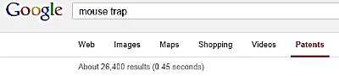
IF YOU DO FIND A PRIOR PATENT, Share the first page of your search results with a patent attorney. Your product may still be—or with some modification, could be—different enough from the original to not violate the existing patent. For example, if you search for “mousetrap”, you will find thousands of patents. So just because a mousetrap has been patented does not mean there isn’t room for one more.

26,400 hits for “Mouse trap”

NUMBER OF HITS FOR YOUR IDEAS: Idea A ( ) Idea A ( )
IF YOU DO NOT FIND A PRIOR PATENT that might prohibit you from producing a product, you can file a patent application. For a list of filing fees see section in this text on “Patenting” The Patent Office will check for any conflicts before issuing you a patent. In some cases, however, a prior patent holder might still sue you, claiming the patent office made a mistake and should not have issued you a patent. So best to work with an experienced patent attorney. Alternatively, you can request a Freedom to Operate opinion from an attorney. This is expensive and could cost $25,000 or more. However, an investor may require you to obtain an FTO opinion.

Module 1 - Entrepreneurship Chapter 2 - Problem-Solution Fit

1.2.6 FILTER SOLUTIONS Based on market POTENTIAL

Now that you have identified a real problem and devised some possible solutions, you’re ready to validate the potential market demand.

AI MARKET RESEARCH: PROMPT: Bill Schloth of www.USBizStrong.org offers this as a quick way to obtain a quick market everview:
“Conduct a comprehensive market analysis for [specific industry/product in geographic area], identifying key trends, customer preferences, and competitive landscape.”

SECONDARY RESEARCH. Visit sites where similar products might be offered for sale such as:
- www.Amazon.com
- www.Etsy.com
- www.Shopify.com
- www.eBay.com (It’s not just collectibles; many companies us eBay to sell new products.)
Even www.Pinterest.com can be a useful market research source as it may indicate how passionate consumers may be about a particular item.

DEMAND VERSUS PRICE RESEARCH (How much will the market bear?) Assume you want to introduce a new board game. A search for “Board Games” on Amazon delivered 80,000 results! Okay, you’re going to have lots of competition, but you knew that. What else can you learn?

Below is a screenshot from 2025 of “board games” for sale on Amazon. Selecting “Board Games Under $30” produced 50,000 results. Only 10,000 games were sold in the $30-$60 range; and an equal number above $60. This reveals that most board game competitors sell their products for under $30.

Note also that Amazon shows how many of each item sold in the past month. Look for products similar to the one you want to launch. How many were sold? At each price point? If only 50 were sold nationally last month, this would suggest a small market; but if 5000 were sold, perhaps the marketplace could tolerate another entry. For even more insight, click on the ratings. What do customers like/not like about the current offerings? This will help you decide which features to offer and how to beat the competition at their own game.

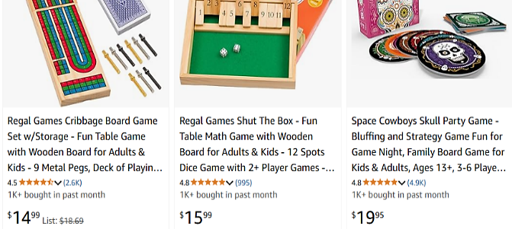
Module 1 - Entrepreneurship Chapter 2 - Problem-Solution Fit

1.2.7 FILTER SOLUTIONS Based on Feasibility of Success

Evaluating your ideas to identify the one most likely to succeed.

Complete a feasibility analysis for each idea. Verify assumptions through interviews, market research and discussion with advisers. Total the scores and enter on the “Summary” page at end of this section.

A. Industry and Competition (Variables affecting potential success of concept)
 |  | +1 | 0 | -1
1 | Growth rate of market:  companies in industry are typically...  The Risk Management Association publishes financial data on over 700 industries.  Ask if your library has the RMA Annual Statement Studies. | ...New and adding employees (check help wanted ads). | Stable or growing slowly. Busy, but no lines at registers. | Mature or declining. Advertising copy reveals desperation.
2 | Dependency on suppliers | Many alternative suppliers | Few suppliers, but prices have been stable for years. | Only a few suppliers. They set prices (e.g.- DeBeers diamonds)
3 | Competition in market niche | No direct competitors. | A few small competitors, and most are new | Market crowded and some competitors have deep pockets
4 | Industry profitability  PERSONAL BUSINESSES  See www.bizbuysell.com for offering prices for businesses like the one you want to start.  The site indicates the annual “cash flow” (amount owner earns before taxes). | Adequate to live on and repay a loan for startup costs. | Profits adequate to live on | Many similar businesses available for purchase.
4 | VENTURE ENTERPRISES | Net profit at least 10% and adequate to repay investors 10 times in 5 years | Industry profit percentages are a few points above prime rate | Industry profit percentages are at or near Consumer Price Index

B. Market Niche
1 | Annual sales potential  PERSONAL BUSINESSES  VENTURE ENTERPRISES | $ 1,000,000  $ 1,000,000,000 | $ 500,000  $ 50,000,000 | $ 250,000  $10,000,000
2 | Market trend (Total industry sales growth, year over year) | A hot new trend | Demand has settled down, but market is still growing by 5% annually | Stagnant. Item is passé; or anyone  who wanted one has one
3 | Purchase frequency. Do customers tend to make repeat purchases (as in banking, gyms, food products)? | You sell blades that fit only your razor. Customers buy monthly. | Customers buy quarterly but not necessarily from you | Your product lasts a year or longer. (When was last time you bought a hammer?).
4 | Customer pain intensity | Solution is a must-have: Eating out occasionally | Customers need your product but are not enthusiast. Groceries | Customers are ambivalent.  Squash
Module 1 - Entrepreneurship Chapter 2 - Problem-Solution Fit

C. Customers (Liklihood they’ll adopt new idea)
 |  | +1 | 0 | -1
1 | Customer Inertia. IF A NEW SOLUTION, to what degree will customers have to change practices or habits to adopt? | Little or no change in habits necessary. | Moderate change necessary for adoption. | Substantial change in habits necessary, plus retraining or one-time cost to switch over.
1 | IF AN IMPROVED VERSION OF EXISTING PRODUCT, how willing are users in target market to  adopt new ideas and solutions? | Customers are early adopters, tech savvy, fearless. eager to try new ideas. | Neither averse to nor eager to try new things. | Customers tend to show brand loyalty, are risk averse, or tied to old ways.
2 | Customer satisfaction with current solutions and alternatives | Desperate for a better solution. | Ambivalent. | Customers like current solutions.
4 | Customer budget for product category | High. | Medium. | Low
4 | Customer bargaining power  relative to yours | Enough potential customers that you will only have to sell less than1% to reach goal. | You will have to sell 1-2% of customer base to reach goal. | You will have to sell  more than 2% of customer base to reach goal.

D. Comparative Advantage of Concept
1 | Degree of improvement of new  idea over existing products or services | Market disruptor; earth shaking improvement. | Somewhat better than alternatives. | Equal to, but different from current solutions.
2 | Your can erect “barriers to entry” to keep other companies from copying your concept | Patentable or you have an exclusive  Contract. | Secret sauce (process difficult to reverse engineer); or you have first-mover advantage. | No way to protect your idea.
3 | Scale advantage. Is each successive product or service cheaper to produce and deliver? | Cost of each additional product is lower than first (e.g.- software). | There is some gain in efficiency from experience and volume production. | No. Each product costs as much as the one before (e.g.-kitchen remodeling).
4 | Complexity | Opportunity is easy to launch and grow. You control all the necessary resources | Will involve other people or companies, but you have proof they are on board. | Requires cooperation from other people or companies. Many moving parts that must come together. Investors will avoid as too risky.
Module 1 - Entrepreneurship Chapter 2 - Problem-Solution Fit

E. Costs
 |  | +1 | 0 | -1
1 | Startup cost: the amount of capital required to launch business  FOR PERSONAL BUSINESS | Well within your personal budget. No need to raise capital. | Significant amount, but loan payments manageable – even  if business fails | You risk losing home if business fails.
1 | FOR VENTURE ENTERPRISE  Initial capital for proof of concept >  Additional to reach break-even > | $ 10,000 or less  $ 250,000 | $ 25,000  $ 500,000 | $ 100,000  $ 1,000,000
2 | Space costs | You can work from home. | Only need small office or shared space. | Would need to sign a  five-year lease for necessary space.
3 | Labor cost | Plentiful low-cost talent available. | Moderate cost (e.g.-salespeople). | High-cost (e.g. – MBAs,  proven marketers, programmers)
4 | Advertising cost  (Customer acquisition cost) | Free. Only need social media | Affordable; only local advertising needed. | Expensive. Slick ads, broadcast media, or national exposure required.

F. Team (Relevant Skills and Experiences of Founders)
1 | Team passion for industry | It’s why you get  up in the morning. Nothing is more important. | This is a deal breaker. If you would not crawl through a desert to make this business a success, pick something else or do not be an entrepreneur.
2 | Skills | Highly skilled in technology or service. | Average skill level. | None or almost none.
3 | Experience | Successful management and marketing experience. | Some management or marketing experience. | Little or no experience.
4 | Industry connections | Well known in industry; strong connections with suppliers and resellers. | Connections with a critical supplier or marketing outlet. | None or minimal.

Module 1 - Entrepreneurship Chapter 2 - Problem-Solution Fit

Summary (Overall Potential of the Idea.) Add up scores from preceding pages. Then brainstorm ways to raise low scores. How might you modify the concept so that it becomes realistically doable? If the idea is just not viable, no problem, look for a more promising problem and solution. You have not spent a lot of time or money on the idea.

 | CATEGORY | SCORE | WAYS SCORE MIGHT BE IMPROVED
A | Industry and Competition | 4 max
B | Market Niche | 4 max
C | Customers | 4 max
D | Comparative Advantage of  Concept | 4 max
E | Costs | 4 max
F | Team | 4 max
 | TOTAL (24 max)

Module 1 - Entrepreneurship Chapter 2 - Problem-Solution Fit

1.2.8 Validated problem-soLution fit

If you have identified a problem, determined that a market exists for a solution, and have devised a solution that you can deliver, congratulations! You have achieved Problem-Solution Fit. Summarize your conclusions here:

PROBLEM (Customer pain or desire)

SOLUTION: product or service (the painkiller)

PRODUCT OR SERVICE FEATURES, especially innovations that make it unique and competitive.
This is usually a zero-sum game; that is, to make a sale, you will have to take a customer away from a competitor. To do this you must offer either: a) lower price, b) better performance, c) greater variety, d) faster delivery,
e) more liberal return privileges, f) better customer service, or g) serve a new market niche.

BENEFITS. What are the benefits your product/service provides to the customers in your target market?
(Benefits are the answer to “So what?” for every feature you listed above.)

Module 1 - Entrepreneurship Chapter 3 - MVP

1.3 – Building an MVP for Market Testing

DESIGN > PROTOTYPE > ALPHA TEST by entrepreneur > BETA TEST by customers

1.3.1 Designing a Minimum Viable Product or Service

1.3.2 Building an MVP Prototype

1.3.3 Software and Mobile App Prototyping

1.3.4 Market Testing the Product or Service

Module 1 - Entrepreneurship Chapter 3 - MVP

1.3.1 Designing a Minimum Viable Product or Service

A MINIMUM VIABLE PRODUCT [or SERVICE] (MVP) is one with the fewest set of features necessary to test basic functionality and measure customer acceptance. MVPs can be counter-intuitive since full-featured products are considered easier to sell as they have something for everyone. However, building more features than necessary risks wasting time and money on functionality no one wants. It can also be difficult to determine why a customer rejected an offering if it incorporated many new features or changes.
Also, the more features you add to a product, the more expensive it will be to build and service, driving up the price. You may wind up with a product that is priced out of the market because it includes extra features no one wants.
In the R&D phase, founders rapidly evolve an MVP based on customer feedback through interviews, focus groups, and user tests.

USING AI TO CREATE A VISUAL MOCKUP. Physical prototypes can be time-consuming and costly. Before investing in actual products samples, consider employing AI to generate one or more virtual concepts. The cost is zero and takes only a minute or two. The digital image can also be used for …
- Trying out different designs or features. For example, what might a backpack look like with a pocket for a phone? (See AI-generated concepts below.)
- Customer validation. An easy way to show potential users alternative designs or colors.
- Providing judges or potential investors with a clear explanation of your vision.
- Clearly communicating to fabricators exactly what you want when you are convinced you have the optimal design and are ready to create physical prototypes for user testing.
The following images were created with Microsoft Copilot. The prompt given was “Create an image of a backpack with a built-in phone charger.” The version with the gray background was the first iteration. The AI program probably “thought” it needed a dark background to show the white power cord for the phone. I, on the other hand, felt it more important that the product pop.

The second gray version was created using a follow-up prompt “Remove the gray background.” The third version with the prompt “Please shows a version of the backpack in medium blue.”
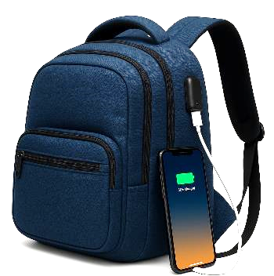
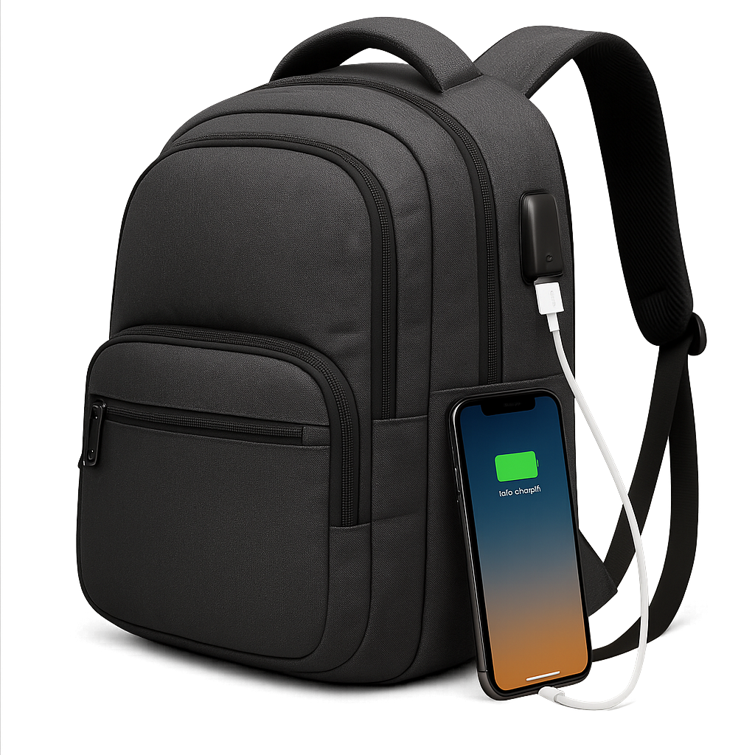
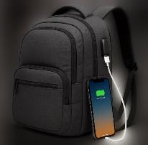

Virtual product prototypes generated by MS Copilot in two minutes at no cost.
Module 1 - Entrepreneurship Chapter 3 - MVP

1.3.2 Building a Physical Prototype

Develop the product in stages to conserve capital and reduce risk.

- First-Stage Prototype. A prototype that demonstrates proof of principle: that your idea will work. It does not have to be pretty, and it may not even be fully functional.
- Second-Stage Prototype. A product iteration that can be produced in small quantities and with a level of quality adequate to assess market reaction. The manufacturing method at this stage does not need to be the optimum method for later volume production.
A common mistake at this stage is to attempt to produce a test supply at the eventual projected cost. It is better to buy 10 samples at $20 each—that you offer for $20 for market testing; than to produce 100 units at $10 each that you wind up scrapping because of a technical flaw or the market rejects the design.

You may lose money on every production run until you derive the perfect design and set of features. Then research methods and quantities of production that will allow the product to be sold at a competitive price and still earn a gross margin of 75% to 80%.

  - DESIGN AND ENGINEERING ASSISTANCE. If, as is usually the case, you need engineering and design help before approaching a manufacturer, you may wish to work with a component maker, industrial design house, or product engineering firm with the ability to design products for efficient fabrication at varying volumes.

  - BUILD OR BUY. If you are willing and able to serve as general contractor and perform the final assembly, you can utilize multiple component manufacturers to reduce costs.
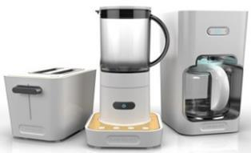
A second-stage prototype will likely require some trial and error before you arrive at a functional, aesthetic and economically viable product.

Products designed by
Big Bang for Cuisinart.

- Third-Stage Prototype. After you have perfected the second-stage prototype in the market, the next step is to prepare the Full-Production Prototype. The production prototype should be designed in such a way as to be able to be manufactured in volume.
Reward-based crowdfunding (e.g., Kickstarter.com or Indiegogo.com) is a great way to underwrite the cost of tools and dies and your initial production run. To arrive at a realistic fundraising goal for this stage, prepare a comprehensive cost accounting of all the component parts and labor.
RESOURCES FOR PROTOTYPING AND MANUFACTURING. Many colleges and universities have 3-D printers that are excellent for prototyping. There are also maker and hacker clubs in most cities that may offer help.

Module 1 - Entrepreneurship Chapter 3 - MVP

1.3.3 Software and Mobile App Prototyping

If you or a co-founder is skilled at coding, great, you will save time and money doing the development yourselves. To ensure that the CEO, CMO and CTO are all on the same page, it will be helpful to create a mock-up showing how the software is to work, especially the user experience (UX), with screen shots and working links to navigate between screens.

If you plan to outsource the development, the demo model will help to explain what you are expecting in the finished product; which will save developer’s time and you money; and prevent rework due to misunderstandings.

A demo version also allows you to show competition judges, investors and potential customers (for market research) exactly how your software or mobile app will function.

There are free and low-cost tools available that anyone can use to create remarkably convincing prototypes: (no coding required):

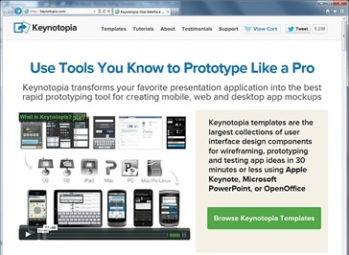
- MICROSOFT PowerPoint and Apple Keynote both support embedded video, slide transitions to simulate animation, and clickable links to jump to other slides (posing as web pages). For Apple Keynote see https://support.apple.com/keynote

- ADOBE XD. For website wireframing and interactive click-through prototypes for mobile apps. For macOS, Windows, iOS, Android. Freemium adobe.com/products/xd.html

3. PROTO. iPhone and Android app development www.Proto.io. Free for 15 days, then $24/mo. (2025). Discounts for schools.

4. FLINTO.COM. Free for 30 days, then $99 per year (2025). For iPhone or Android. http://www.Flinto.com

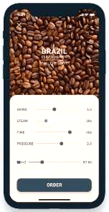
5. Balsamiq. For quick software mockups. Web-based. $144/ year (2025). www.balsamiq.com
6. ForeUI. Mockup and simulate an app in a browser. PC/Mac. $150 for permanent license (2025). http://www.foreui.com

Mockup of Coffee-ordering app developed by Shingo Suzuki on Adobe XD

Module 1 - Entrepreneurship Chapter 3 - MVP

SOFTWARE AND MOBILE APP FINAL DEVELOPMENT

When you have created a prototype and shown it to prospective users to:

a) Verify that it solves a real problem and people are willing to pay for it; and

b) Confirm that users intuitively know how to use the software or app and do not get frustrated because it does not work the way they expect it to…

… then you are ready to develop the final version to sell—although on a limited basis until you are certain you have worked out all the bugs.

WHERE TO FIND DEVELOPERS. If you want to find those near you, just search online for “developers” (or “programmers” or “coders”) near [your city]. The advantage of buying local is you can interview the person face-to-face; or if a company, visit the office to meet the people who will be working on your account.

You can also access developers through freelancing sites like www.freelancer.com and www.upwork.com where you can review samples of work. Many of the freelancers work in countries where wage rates are lower, but communications may not be as good unless you speak the same language and are awake at 5 am when they are. Someone working for $10 per hour, but who takes longer (because of misunderstandings) can be more expensive than someone nearby who charges $30 an hour.

It may be wise to work through a multilingual local company who in turn works with employees in other countries, as they can translate your needs accurately.

The freelance sites usually allow you to set a budget limit, which protects you from cost overruns, but may not be fair to the freelancer if they have to redo work because your instructions were vague, or they just did not understand correctly because of language differences. The best solution is a written set of very detailed specifications from you, so the freelancer can make an informed estimate of the time required and therefore give you a firm quote you can both live with. This is an ETHICAL question for all employers of contract employees

FREE TEMPLATES TO SPEC SOFTWARE AND APP PROJECTS:

Software Requirements Documents (SRD)
https://krazytech.com/projects/sample-software-requirements-specificationsrs-report-airline-database
App Requirements Documents (ARD) http://www.creativesparksolutions.com/blog/how-to-create-a-requirements-document-for-your-mobile-app-steps-and-tips/

WHAT TO BUDGET FOR DEVELOPMENT
- APP -- $5,000 to $50,000 depending on complexity of software and credentials of developer
- SOFTWARE -- $20,000 to $150,000

DIY APP MAKERS. There are programs that allow you to create actual finished products, even if you are not a coder. If you do know how to code, these aids can save you time on simple routines, and you can still add your own HTML.. For example platforms, see
- https://appery.io/pricing $25 per month (2025).
- https://www.appypie.com/ $16 per month (2025).

Module 1 - Entrepreneurship Chapter 3 - MVP

1.3.4 Market TESTING THE PRODUCT OR SERVICE

All new products and services must go through two testing periods before release for sale:
- ALPHA TESTING. This is testing in the lab. Does product work as intended? How well does it hold up with normal handling? What if it gets wet, cold or hot? For software, use it extensively to catch as many bugs as possible before allowing customers to try it. For services, practice on friends and family.



Auto test track

- BETA TESTING. Seek out Early adopters, customers willing to try new things, to perform this testing. Ethically, you should tell customers that the product has not been fully vetted. Typically, beta testers are allowed to use the product free of charge.

HOW TO KNOW WHEN YOUR PRODUCT IS CONSUMER-READY: THE NET PROMOTER SCORE (NPS).
This simple test, developed by Satmetrix, has a lot of research behind it. It consists of asking only one question: “How likely is it that you would recommend our company to a friend or colleague?” Users choose an answer along a scale from zero to ten, with zero meaning “not likely at all”, and ten “Extremely likely”.

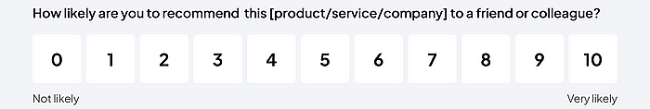

Research shows that responses of
- 9 or 10 are “Promoters”, people who will repurchase and refer others
- 7-8 are “”Passives” who are satisfied but easily drawn away by competitors
- 0-6 are “Detractors” who are unhappy and may damage you brand through negative word-of-mouth
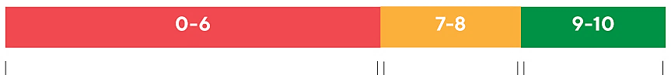
DETRACTORS PASSIVES PROMOTERS

Subtract the percentage of Detractor responses from the percentage of Promoter responses to arrive at your NPS.
NUMBER OF PEOPLE YOU SURVEYED _____
PROMOTORS #_____ (_____%) DETRACTORS #_____ (_____%) YOUR NPS = _________

Highly successful companies operate in the 50-80 NPS range.

Module 1 - Entrepreneurship Chapter 4 – Product-Market Fit

1.4 – Product-Market Fit: Perfecting the Solution

Whereas Product-Solution Fit is critical during the ideation stage to verify that the problem is real and there is a strong desire for a solution; Product-Market fit is a tool for validating a specific solution to determine if is a repeatable, profitable and sustainable.

Attaining Product-Market Fit describes the point where a product meets the needs of a specific group of customers, who actively buy, use, and recommend it.

The process of finding Problem-Market Fit can only commence once Problem-Solution Fit has been confirmed: That is, the company’s solution serves a real problem, an adequate market exists for a solution, and the company has drafted a Minimum Viable Product (MVP) to obtain customer feedback for its solution.

Refining the solution to the point of true Product-Market Fit will reduce the risk for you and your capital providers. Achieving Product-Market Fit is also necessary for the company to reach its full potential: if the company scales up production and marketing prematurely, the company may never grow beyond first-time buyers.

1.4.1 How to Measure Product–Market Fit
1.4.2 Finding Product–Market Fit
1.4.3 Customer Survey to Discover Buying Preferences

Module 1 - Entrepreneurship Chapter 4 – Product-Market Fit

1.4.1 How to Measure Product–Market Fit

1. QUANTITATIVE MEASUREMENTS
- Net Promoter Score (NPS): A measure of customer satisfaction and loyalty, which indicates the likelihood of customers recommending your product to others.
- Conversion Rate: The percentage of users who continue using your product or service after the beta test
- Growth rate. Each month, are you onboarding more customers than in the previous month?
- Churn Rate. The percentage of users who stop using your product or service. If you obtain a new customer every week, but lose 10% of current customers every month you will not achieve traction.
- Engagement Metrics: Time spent using the product, frequency of use, and feature adoption.

2. QUALITATIVE MEASUREMENTS:
- When surveying potential customers or allowing them to test your product, does some segment indicate they will switch to your product?
- Do users demonstrate an understanding of your product’s differentiators?
- Word of mouth. Are customers talking about your product? Postively? Search for your brand on social media for comments, Pinterest, and Yelp. What is the ratio of positive to negative posts?


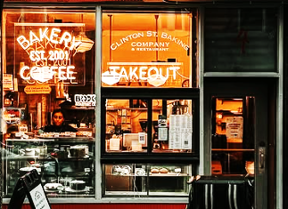

New York Coffee Shops on Instagram. Number of likes range from 200 to 2000.
Module 1 - Entrepreneurship Chapter 4 – Product-Market Fit

1.4.2 FINDING PRODUCT-MARKET FIT

VIDELINK Surveying customers to validate business concept: https://hitenism.com/business-ideas/

The process of refining your solution until you are certain people will buy it at a price that allows an adequate gross profit margin (typically 75-80%), plus a competitive profit is called Product-Market Fit.

Start with face-to-face surveys. People will be more likely to volunteer additional information in person, or ask you questions that may give clues to possible concerns. Bur before jumping into Q&A, give the survey subject your 8-second elevator pitch to put your questions in context. Find strangers; If we only talk to friends, discussions will likely proceed along familiar lines. And friends will tell you what they think you want to hear.

Once you have surveyed at least 30 people live to determine whether the solution will meet with an enthusiastic market, drill down on the issues with a survey of at least 100 people via email or through social media followers that match your customer demographics. (Capital providers will want to know how many people you have surveyed.)

FREE SURVEY SERVICE. www.QuestionPro.com offers free surveying with up to 10 questions to 200 respondents that you supply. (2025). www.SurveyMonkey.com allows up to 10 questions and 25 respondents for free.

FEE-BASED SURVEY SERVICES. Google and Amazon will provide survey-takers for you, for a fee. Both services have a base rate for randomly selected respondents; but you can request specific demographics for additional fees. (This is recommended to give your results credibility. Surveying non-homeowners for roof shingles with solar panels would have zero value.)
Google allows users to specify respondents by the first 3 Zip code digits of (not all 5 digits). But with Zip code targeting, you will not be able to drill down by age or gender as there are not enough registered survey takers for that level of granularity. See https://support.google.com/surveys/answer/2447244. Rates (2025) per respondent:
Random Population Age, gender, or location targeted Postal code targeted
1 Question | 2-10 questions | 1 Question | 2-10 questions | 1 Question | 2-10 questions
$.10 | $1.00 | $.15 | $1.50 | $.60 | $6.00

Amazon’s www.MTurk.com is also fee-based, but you can set the amount you are willing to pay per survey. MTurk then adds 25% for “Masters” (respondents with verified demographics and high ratings from prior surveyors). Choose this option; otherwise, you will wind up paying Nepalese Sherpas for opinions on your new hip-hop release. With MTurk you can specify location of respondents. (Contact MTurk for pricing.)
MAXIMIZING THE LIKELIHOOD PEOPLE WILL TAKE THE TIME TO RESPOND.
- Start with simple, non-threatening questions to qualify the respondent: are they a potential customer?
- Put the demographic identifiers you might need (gender, age, occupation, etc.) at end of survey. Survey takers may be less reluctant to provide personal data if they have already answered other questions
- Keep questions short and to no more than five. If you need more feedback, do a second survey.
INSURING RELIABILITY OF RESULTS.
- Use multiple-choice questions with no more than five options, or yes/no questions. Keep it simple.
- Avoid absolutes like “Always” and “Never” as answer options. If question is how much time a person spends in the car, use specific ranges like “Less than 10 minutes a day, 10-30 minutes, 31-60 minutes, 61-120 minutes, over 120 minutes.” This way, every possible situation is covered, and answers do not overlap. Vague answer choices like “A lot of time” may mean 30 minutes to one person and 2 hours to another.
- Use simple wording, not subject to more than one interpretation. To make sure the questions and answer choices mean to others what they mean to you, ask your friends the questions and answer choices and then ask them to explain to you what they mean. You may be surprised at the answers you receive.
- For additional surveying tips see https://support.google.com/consumersurveys.
Module 1 - Entrepreneurship Chapter 4 – Product-Market Fit

1.4.3 Customer Survey to discover buyIng preferences

Use surveys to answer the following questions to achieve product-market fit:
- Where customers would want to purchase (in stores, online, other)
- How customers expect to find out about new products or services
- Opinion of your offering versus alternatives
- Most valued and least valued of possible features
- Amount customers would be willing to pay
Respondent Demographics Estimated age >> | 1  M – F  Age~____ | 2  M – F  Age~____ | 3  M – F  Age~____ | 4  M – F  Age~____ | 5  M – F  Age~____
A. What would most affect your buying decision?
Price, convenience, fast delivery, choice of styles/colors/sizes, or other: _______________
B. How would you improve
upon the product?
C. How much would you
be willing to pay?

D. Would you use product?
5 = definitely,
4 = probably
3 = maybe
2 = probably not
1 = definitely not
E. If you are not likely to use product, why not?
If potential customers are not as enthusiastic as you hoped, probe to find out why; how would they solve the problem?
Module 1 - Entrepreneurship Chapter 5 – Competitive Positioning

1.5 – Competitive Positioning

1.5.1 Researching Competition

1.5.2 Selecting a Target Market Niche

1.5.3 Determining Size of Target Market

1.5.4 Developing a Competitive Strategy

1.5.5 Comparing Features to Competitor Products

1.5.6 Erecting Barriers to Entry

Module 1 - Entrepreneurship Chapter 5 – Competitive Positioning

1.5.1 Researching COMPETITIon

In the space below, list the companies in your market area with similar products that have features or prices that pose a potential threat to your company. According to Cliff Ennico, “Competitors are all companies going after the same customers, even if the product (solution to the problem) is different. For example, if you are planning to open a pizza parlor, other pizza restaurants in your market radius are clearly competitors, but so are all other restaurants, as they also offer a solution to problem you solve: hunger.

A. ______________________________________________ URL______________________________

City _________________________ Their competitive strategy ______________________________
__________________________________________________________________________________

B. ______________________________________________ URL______________________________

City _________________________ Their competitive strategy ______________________________
__________________________________________________________________________________

C. ______________________________________________ URL______________________________

City _________________________ Their competitive strategy ______________________________
__________________________________________________________________________________

TO IDENTIFY LOCAL COMPETITORS, Google the name of the industry you want to research and add “near me” (e.g. - “pizza parlors near me”.) Here are some other ways to gather intelligence about competition:
- If a store, count the number of cars in the parking lot or count the number of people who walk in during different days of the week and times of the day. (Do they walk out with packages?)
- Talk to suppliers of your industry. They will know who is doing well, and who is not.
- Talk to buyers in your industry. Ask them what criteria they use to make decisions.
- Google the competition. Have they been in the news? What are people saying about them on their website, Yelp and local search directories?
TO SEARCH FOR NATIONAL COMPETITORS …
Hoovers maintains a database of companies that includes industry, location, sales, employees and other variables. You can access Hoovers at most universities and the main branch of city libraries. Search for “Hoovers” under the “research” or “online resources” tab of the library website. Within Hoovers, click on “Company Dossier.” You will see a search form that will allow you to generate a list of potential competitors in your industry and service area.
Bizminer.com. Market and financial research on thousands of small businesses. Reports cost $100 or more, so check to see if your local public library or university has a subscription.
Crunchbase.com is a free site where you can search for companies in hot industries. www.crunchbase.com


If you do not find any competitors in your search, this is not necessarily a good thing. It may mean that there is not adequate demand in the marketplace to support the product or service.

Module 1 - Entrepreneurship Chapter 5 – Competitive Positioning

1.5.2 Selecting a Target Market Niche

Positioning your company within competitive landscape.

Market Niche. Who needs your product, and why? How can you fit into the competitive landscape to carve out a beachhead in the marketplace?

Your Market Niche

Demographics of Target Customers
- Age _________
- Gender _________
- Where they live, work ___________________________________
- Educational level ___________________________________
- Income level $ ___________ to $ ________________
- Any other pertinent descriptors (e.g. -- home ownership) ___________________________________
_________________________________________________________________________________

Target Customer Buying Habits.

Who do they buy from now? ________________________________________________________________

_______________________________________________________________________________________

How often do they buy? ___________________________________________________________________

In what quantities? _______________________________________________________________________

How much are they accustomerd to spending? ___________________________________________________

Module 1 - Entrepreneurship Chapter 5 – Competitive Positioning

1.5.3 dETERMINing Size of Target Market

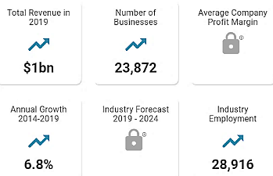
It is important to know the size of the market for your industry (the number of buyers and the amount they spend annually) as this is one indication of the potential success of your business. Investors and lenders will ask for this.
Market size data on every imaginable industry is available at www.IbisWorld.com. Although a full industry report is approximately $1000, enough data is available free to glean some useful information. For example, a search on “Food trucks” provided the following:
From the public data on the IbisWorld site, the average food truck is a one-person business grossing $42,000 per year.

For local demographics, consult www.census.gov/

Calculating TAM SAM SOM. These are short-hand measures of your market size.

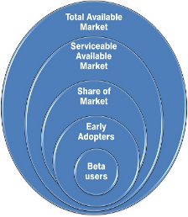
TAM = TOTAL AVAILABLE MARKET. Everyone in the world with the problem. (If product is left-handed scissors, how many left-handed people are in the world?)

SAM = SERVICEABLE AVAILABLE MARKET. The market segment served by
your solution. (If your scissors are designed primarily for cutting cloth, how
many left-handed tailors, clothes designers, crafters, and people who
make their own cloths from patterns are there?)

SOM = SHARE OF MARKET that you can acquire, realistically, based on your:
- Technology
- Geography
- Features
- Price
- Capacity
If your scissors are priced at $100, but have ball bearings to prevent fatigue
by employees in the clothing industry, you will probably have to eliminate
DIYers. Also, as a startup, you may not be able to reach all markets.

Your TAM SAM SOM

TAM Units per year _______________ $_______________

SAM Units per year _______________ $_______________

SOM Units per year _______________ $_______________

Goal for number of beta testers _______

Be prepared to explain to competition judges and capital providers how you arrived at your market size. What are your sources of information?

Module 1 - Entrepreneurship Chapter 5 – Competitive Positioning

1.5.4 Developing a COMPETITIVE STRATEGY

HOW WILL YOU DIFFERENTIATE YOUR PRODUCT OR SERVICE? Your options are:
- Lower price. To maintain this competitive advantage, you will need to purge every excess cost from the supply chain. (Examples: Walmart, Bob’s Discount Furniture.) This is a risky strategy: too many entrepreneurs simply offer their product for less than competitor pricing, usually resulting in an unsustainable business model and insolvency.

- Superior product. Better quality materials, more pleasing design, better performance, or more features. (Apple).

- Superior service. On-site repairs, longer warrantee, 24-hour phone support, returns accepted for full credit with no questions asked. Some online apparel sellers ship in cartons that can be used to return unwanted merchandise.

- Unique Market Niche. A sub-group of customers not adequately served.

YOUR COMPETITIVE STRATEGY:

________________________________________________________________________________________

________________________________________________________________________________________

________________________________________________________________________________________

________________________________________________________________________________________

________________________________________________________________________________________

________________________________________________________________________________________

________________________________________________________________________________________

________________________________________________________________________________________

________________________________________________________________________________________

________________________________________________________________________________________
Before settling on your Competitive Strategy, you might want to read some advice from other entrepreneurs who have been down the same path. Entrepreneur Magazine has published guides (at under $20 each) for starting businesses in more than 60 different industries. For titles, see https://www.entrepreneur.com/bookstore/category/starting-a-business
Module 1 - Entrepreneurship Chapter 5 – Competitive Positioning

1.5.5 CoMparing Features to Competitor Products

Look for an opportunity for an “ONLY STATEMENT: “We are the only company that______________” For example, “We are the only pizza parlor that keeps your pie heated and drinks chilled during delivery.”

 | Point of comparison | Your product ** | Competitor A  ______________ | Competitor B  ______________ | Competitor C  ______________
 | FEATURES
1 | Price | $ | $ | $ | $
2 | Quantity Discount
3 | Shipping and Handling
4 | Delivery Time
5 | Product Options
6
7
 | STRENGTHS
8
9
10
 | WEAKNESSES
11
12
13

** See Pricing the Product or Service. If you have not yet priced your product, researching competitor pricing will help determine where you need to be to capture a share of the market.

Module 1 - Entrepreneurship Chapter 5 – Competitive Positioning

1.5.6 Strategizing Barriers to Entry To DETER Competition

(How you will prevent—or impede--competitors copying your idea)

□ Patents – Received or pending in US and abroad. Note: a pending patent or provisional patent is not a guarantee of market protection. (In the decade ending in 2020 only 53% of applications were approved https://yjolt.org/what-probability-receiving-us-patent.
□ Technology will be difficult to reverse engineer.
□ Lead time advantage. It will take competitors ____ months to reproduce solution.
□ Major Customers locked in with exclusive long-term agreements: _________________________
_____________________________________________________________________________
□ Critical suppliers locked in: _______________________________________________________
□ Other _______________________________________________________________________
_____________________________________________________________________________
_____________________________________________________________________________
_____________________________________________________________________________
_____________________________________________________________________________
_____________________________________________________________________________
_____________________________________________________________________________

Module 1 - Entrepreneurship Chapter 6 – Lean Business Model Canvas

1.6 – Lean Business Model Canvas

A Business Model Canvas (BMC) is a shorthand approach to business planning, whereby the entrepreneur lays out assumptions about the market and tentative plans all on one page; and then validates those assumptions through surveys and prototype testing with potential customers. The premise is that you will find some false hypotheses, some customer reactions you did not expect; and it is a lot better to discover flaws in the business concept before you create detailed plans and invest in the concept.

Shown above is the original Canvas, developed by Alexander Osterwalder in 2008 to help established businesses bring new products to market quickly and economically. In this text, we use the Lean Canvas, designed for startups. If you prefer the Osterwalder BMC, a copy may be found at https://www.strategyzer.com/library/the-business-model-canvas

Module 1 - Entrepreneurship Chapter 6 – Lean Business Model Canvas

The Lean Business Model Canvas (LBMC) is a process for thinking through the business model for a new enterprise. The LBMC helps you

- Quickly explain your idea to others
- Identify who has the problem that you are trying to solve
- Get to Product Market Fit quickly (the degree to which a product serves a strong market demand) by Asking, Listening and Learning.

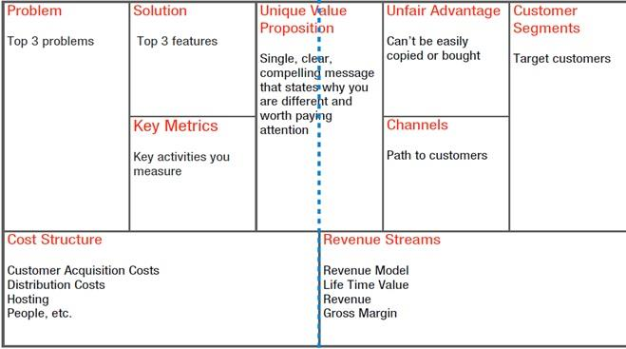
FINANCE
Gross Margin
Existing Alternative Sound bite: Early Adopters
Solutions
PRODUCT
MARKET

Click here to access a fillable Lean BMC on Google Docs:
https://docs.google.com/drawings/d/16uOd158UzJM9oqGWgJOtbppzGNPmZ4fWMSV6_xBz3Z8/edit
As you pivot (modify your plan), go back online and update your BMC, and print out the new iteration.

See https://canvanizer.com/new/lean-canvas for a free fillable online lean canvass. The canvas may be shared with four other team members for collaboration for $25/ year (as of 2025).

VIDELINK Eight-minute overview on how to fill out a Lean BMC, using Uber as an example.
https://www.youtube.com/watch?v=pvIN9STpzCQ

Here is a 16-minute video if you want more details
https://www.youtube.com/watch?v=uE34HsmT6E0

Module 1 - Entrepreneurship Chapter 6 – Lean Business Model Canvas

THE NINE SEGMENTS OF THE LEAN CANVAS

Problem. Most startups fail, not because they fail to build what they set out to build, but because they waste time, money, and effort building the wrong product. I attribute a significant contributor to this failure to a lack of proper “problem understanding” from the start. “A problem well stated is a problem half-solved.” - Charles Kettering

Solution. Once you understand the problem, you are then in the best position to define a possible solution.

Value Proposition. The measurable benefits prospective customers can expect versus how much they pay in return, including any indirect expenses, like having to retrain employees onto a new system, having to pay to park, or other inconvenience. From the customer’s standpoint the perceived value should exceed the costs: Value = Benefits – Cost. The right Value Prop serves as a differentiator to motivate customers to choose your product or service over others in the marketplace. The Value Prop should be reflected in the Branding Strategy, and clearly and continuously communicated. If an investor asks you only one question, it will be “What is your Value Proposition?”

Key Metrics. Startups often drown in a sea of numbers in an attempt to bring order to the chaos of uncertainty. At any given point in time though, there are only a few key actions (or macro metrics) that matter. “A startup can only focus on only one metric. So, decide what that is and ignore everything else.” - Noah Kagan.

Unfair Advantage. What feature, expertise, supply source, or market connection do you have that few competitors have? “A true unfair advantage is something that cannot be easily copied or bought.”- Jason Cohen

Customer Segments. The users of Cocoa Puffs are children, but they are not the Customers, the people who make the buying decision.

a) For your product, who is the ultimate user? Who are the decision makers in the buying process?
b) Demographics of Market Niche (potential customers you will appeal to).
- Age
- Gender
- Where they live, work
- Educational level
- Income level
- Any other pertinent descriptors (e.g. -- home ownership)
What are their Buying Habits?
From whom do they buy now? Why?

EARLY ADOPTERS are a segment of a market niche that is most likely to adopt the product or service in its early stage. They tend not to be risk averse and are willing to try new things. Or they may just be the most desperate sub-set of a market to solve the problem.

Channels.
- How will you deliver the product or service to the customer?
- How will the user become aware of the product?
- How will you support customers after purchasing and delivery?

Cost Structure.
a) How much it will cost you to provide product/ service.
b) Pricing Model (e.g. – low-volume, high margin)

Revenue Streams.
a) Who will pay you (distributor, wholesaler, end user)?
b) How will you collect the money?

Lean Business Model Canvas Product ________________________

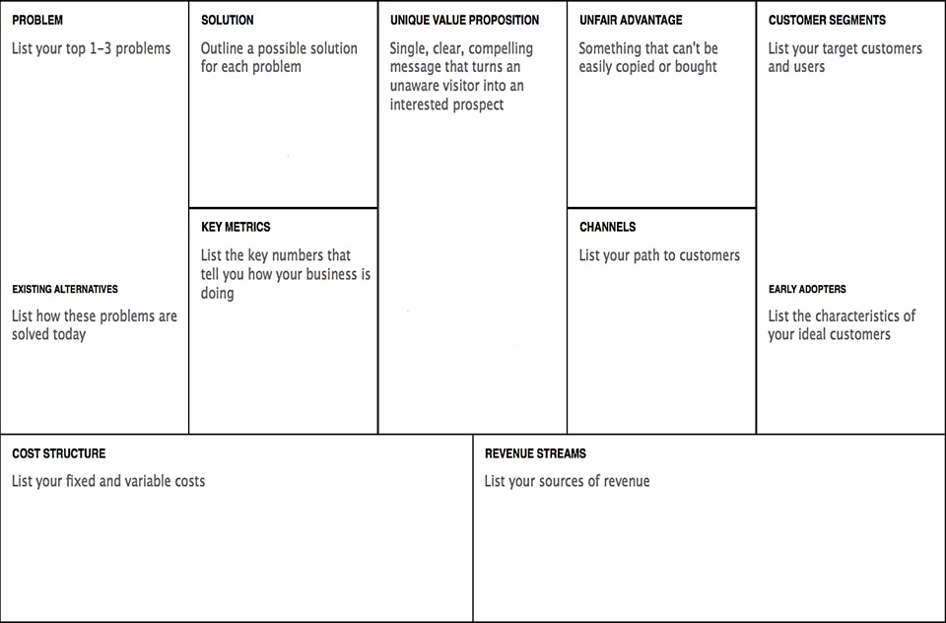

Click on a colored section to add text. Slide color block to side to see explanation for section.

Module 1 - Entrepreneurship Chapter 7 – Pricing

1.7 – Pricing the
Product or Service

1.7.1 Product Component Costs

1.7.2 Shipping and Handling Costs

1.7.3 Estimating Total Cost of Production

1.7.4 Pricing Products

1.7.5 Pricing Services

1.7.6 Testing Price with a Soft Launch (The Landing Page)

Novices price products and services to get the sale.
Pros price to make a profit.

Module 1 - Entrepreneurship Chapter 7 – Pricing

1.7.1 PRoduct COMPONENT CostS

This is an interactive spreadsheet. To open, right-click on spreadsheet, click “Worksheet Object” and then "Open.” You need to enter data in shaded fields only; the totals will be computed for you. You can download a copy of this form at thttp://www.EntrepreneurshipFoundation.org/spreadsheets
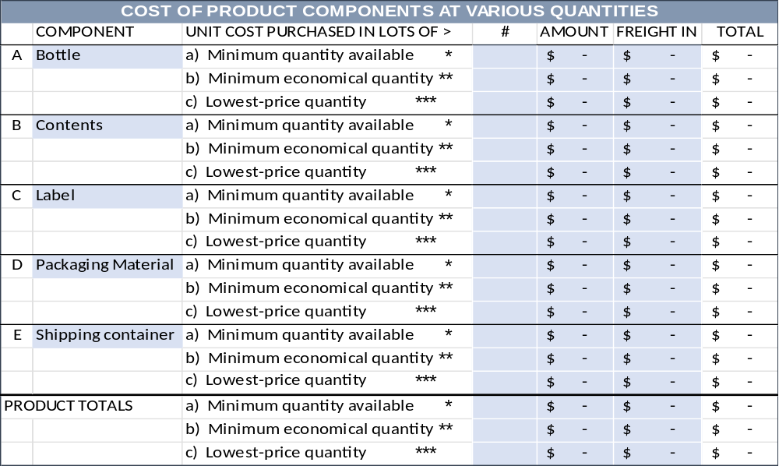
* Minimum Quantity you can purchase, at any price. Typically, manufacturers and wholesalers will not “break carton lots.” However, most suppliers will provide free samples for testing.
** Minimum Economical Quantity. A balance between the minimum quantities you can purchase (to conserve cash), and the lowest-price quantity (requiring the largest commitment). Most suppliers publish a price list showing the price breaks. You will quickly notice that there is a diminishing return. Buying 10 instead of just one might save 50% per unit, 100 versus 10 another 20%; but the next price break at 1000 might only save 2%. The MEQ in this case is 100.
*** Lowest-Price Quantity. The quantity that will allow you to purchase the component at the lowest possible price. Knowing this quantity price break enables you to predict the profit potential of the business if it really takes off. Hint: you may be able to negotiate a commitment to purchase the lowest-price quantity over time. Not having to take delivery of all the material at one time will allow you to recycle your capital and minimize the cost of storing materials.
----------------------------------------------------------------------------------------------------------------------------------------------------------

COMPONENT SOURCES. Consult Thomas Register, a directory of 700,000 manufacturers www.thomasnet.com. Companies that are known to work with small companies include:

METAL COMPONENTS. Metals Depot will ship “any size, any quantity, anywhere”: metalsdepot.com. The company will also fabricate parts.

FASTENERS AND OTHER STOCK PARTS. www.McMaster.com is a source of a wide variety (550,000 items in stock) for prototyping and initial short runs for market testing. Stock parts include nuts and bolts, shims, spacers, threaded inserts, metal stock for machining, tubing, bearings, motors, belts, gears, etc.

PLASTIC COMPONENTS. Modern Plastics sells small quantities and will also fabricate modernplastics.com.

Module 1 - Entrepreneurship Chapter 7 – Pricing

1.7.2 Shipping AND HANDLING COSTS

1. Shipping

FREIGHT OUT AND HANDLING ON SALES TO RESELLERS. Retailers typically pay the actual freight costs on products shipped to their stores. However, be sure to make this clear in your sales literature. The term used is F.O.B. [location], shorthand for free on board, meaning shipping is free to the place designated. F.O.B. Destination means the seller will pay for all freight charges from the factory to the buyer’s location. F.O.B. Factory means that the buyer must pay for all freight charges.
If your terms state “FOB customer’s warehouse,” then you are saying you will pay the freight. If your terms state “FOB factory” or “FOB [city where products are made or warehoused]” then you are advising the customer that they will be billed freight costs from that point to their store or warehouse. It is not customary to charge retailers for handling and packaging. That is on you – so do not forget to include packaging and handling when figuring your product cost.

FREIGHT OUT AND HANDLING ON DIRECT SALES TO CONSUMERS. Decide if you want to absorb the freight costs (for simplicity and to better compete with retail stores) or pass these expenses along to the buyer. In either event, you will want to know what they are, as these expenses can be a large part of the total.

2. Computing Your Handling labor (The “H” in “S&H”)
A. Number of shipments that one person can process per hour # _______
(Assume there will be down time: sick days, holidays, and times
when no work can be done because you are out of boxes or goods.)
b. Wage per hour (including payroll taxes of approximately 10%) $ _______
c. Cost per order (b / a) .......................................................... $ _______

3. Cost of Shipping Materials (See following page for hints on what to order)
OUTER CARTON for bulk shipments
Cost each $_______ in quantities of ______________ Best source: _____________________________
INNER CARTON for bulk shipments
Cost each $_______ in quantities of ______________ Best source: _____________________________
CARTON TO SHIP ONE ITEM (Corrugated mailer or padded bag)
Cost each $_______ in quantities of ______________ Best source: _____________________________
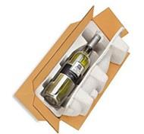

Whatever you are planning to ship directly to customers, rest assured there is a container designed for it.

Module 1 - Entrepreneurship Chapter 7 – Pricing

SHIPPING CARTONS FOR BULK SHIPMENTS TO BRICK AND MORTAR STORES

To save money on freight charges most companies ship products in outer cartons that hold an economical quantity for shipping, but still a reasonable number to expect a store to purchase. However, an outer carton for shampoo (as an example) that could hold 48 bottles would probably result in complaints from stores, as the bottles would jostle about loose in a large carton. The answer is to add smaller inner cartons that hold fewer products each. The two carton sizes also allow you to sell a smaller quantity to a store (or even to an online purchaser who wants to save money by buying in quantity).

An outer carton with eight inner cartons, each containing 6 bottles of shampoo. Allowing sales in quantities of 48, 6, or even 12 (two sub-cartons taped together).

Obviously, you have a better chance of a store carrying your product if the buyer has a range of quantity/price options. By knowing preferred quantities (and designing cartons for them) you will keep your handing costs low. Broken carton shipments require more work to open a carton, take out a non-standard quantity, and then custom package the shipment. Moreover, this leaves you with an odd quantity that will be difficult to sell.

SHIPPING CARTONS FOR SAMPLES AND DIRECT SHIPMENTS TO ONLINE CUSTOMERS.
Regardless of who ships the small individual orders directly to online customers, order a supply of individual mailers that can serve as shipping cartons, so the shipper just has to add a label and mail.
Standard mailers are available in a variety of stock sizes, and as such may be purchased in small quantities as needed. These sturdy shipping boxes will arrive flat and can be easily set up without tape or glue.
When ordering these single-product cartons, do not forget to allow room for instructions or bubble wrap, if needed. Ask for free samples (vendors will be happy to provide them) so you can make sure everything fits.


Sample mailer from Uline uline.com/Cls_04/Boxes-Corrugated
Prices current as of 2025.

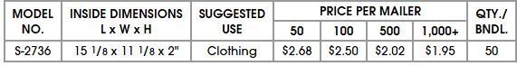

The shipping terms are FOB factory (so you pay the freight), but this supplier has eight warehouses in the U.S. Still, boxes are heavy and bulky, so figure at least 20% additional for delivery.

Another company, Packaging Price also sells fold-up boxes in small quantities https://www.packagingprice.com/mailers-1

Module 1 - Entrepreneurship Chapter 7 – Pricing

1.7.3 ESTIMATING TOTAL COST OF PRODUCTION

ESTIMATING COST OF PRODUCTION. Double click to open spreadsheet. This data is for a sample company. To use form for your company, delete data in shaded fields. (Do not delete data in white boxes as these contain formulas.) You can download a copy of this form at http://www.EntrepreneurshipFoundation.org/spreadsheets

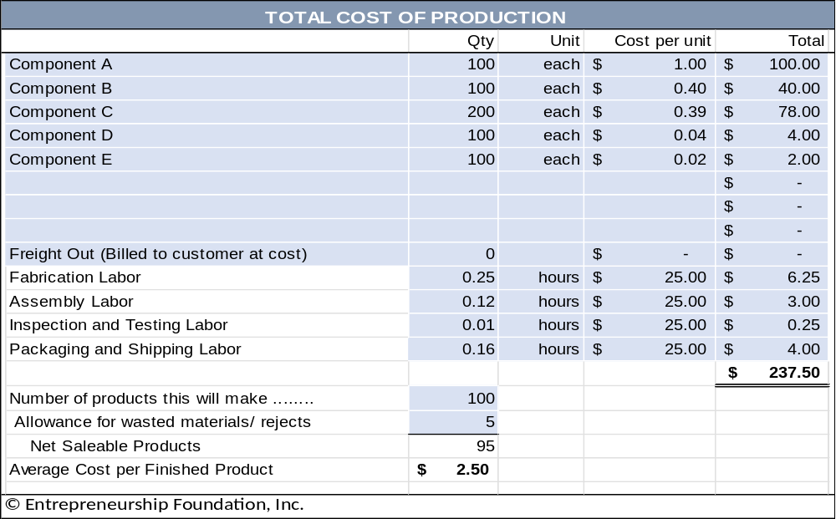

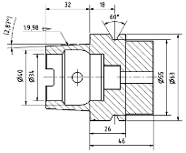
MEETING WITH MANUFACTURERS. Express your expectations clearly. Keep in mind that most manufacturers are wary of startups. They do not want to waste their time working with entrepreneurs that have a poor understanding of their industry. They will expect you to have market research to support your eventual production needs.

You will need to provide a professional drawing or sketch for manufacturers.

Module 1 - Entrepreneurship Chapter 7 – Pricing

1.7.4 Pricing ProductS

MARKUP VERSUS MARGIN. Products sold on TV generally have a 5x markup (retail price divided by the cost of production). A 5 times markup for a product that costs $2 to make = $10. The margin of profit on the $10 sale would be $8 or 80% of retail (Retail-Cost)/Retail). A high margin is necessary to cover the cost of the infomercial. Another rule of thumb in the industry is to price products at “impulse” amounts like $9.99, and with a max of $19.95.

When using traditional distribution channels: MANUFACTURER > DISTRIBUTOR (WHOLESALER) > RETAILER, a safe margin to cover salaries, marketing and other fixed costs is a retail of 4 times the cost to produce.

TRY UP TO FIVE ALTERNATIVE RETAIL PRICES for your product using the spreadsheet below (downloadable from http://www.EntrepreneurshipFoundation.org/spreadsheets. Assume material and production labor is based on your Minimum Economical Quantity ) Enter amounts in shaded boxes; the spreadsheet will calculate the other amounts.

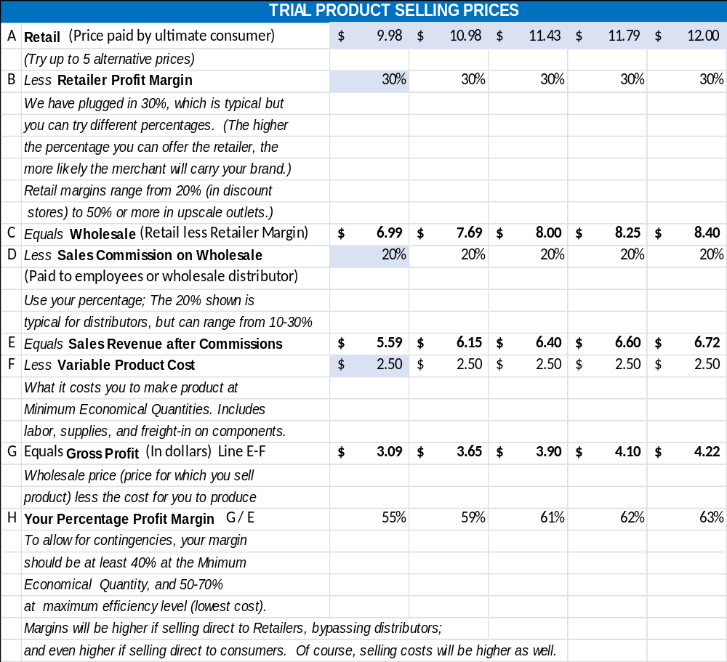

Module 1 - Entrepreneurship Chapter 7 – Pricing

1.7.5 Pricing SERVICES

If you provide a service as an individual, without employees or an office, then the total of the fees you collect will be your personal annual income.

1. Take-Home Income Goals. How much do you need to earn from your business each year? According to the Washington Examiner, it now takes a $32 hourly wage (in 2024) to afford a typical modest two-bedroom rental, assuming you spend 30% of your income on housing. Of course, rates will vary with locale. However, as a rough rule of thumb, this would equate to $40,000 to $50,000 per year.
EXAMPLE YOU
A. Full-time to live solely off the business ….................................... $ 50,000 per year $_________

B. As a part-time endeavor ………………………………………….… $ 10,000 per year $_________
Therefore, how much do you need to earn (gross) to take home these amounts? You will need to earn more than the target numbers above to allow for Payroll and Income Taxes.

2. Allowance for Taxes.

PAYROLL TAXES. As a self-employed individual, you have to pay the employer and employee shares of all payroll taxes. As a rule of thumb, assume you will pay the government approximately 16% of your earnings for Payroll Taxes: Social Security, Medicare, and Federal and State Unemployment Insurance (FUTA and SUTA). Do not forget to report the income and pay the taxes. When you are self-employed, no one will be doing this for you.

PERSONAL INCOME TAXES. H&R Block has a tax calculator at hrblock.com/free-tax-tips-calculators/index.html

- FEDERAL INCOME TAX. For a quick estimate of the FIT, use 10%.

- STATE INCOME TAX. Look up your state’s personal income tax rate at http://www.tax-brackets.org.
For quick budgeting, assume your total personal taxes (payroll taxes and Income taxes) will amount to approximately 30% of your gross earnings.
3. Calculating Your Tax Multiplier. To arrive at the business revenue necessary for you to net your personal income goal, you will need to multiply the goal by (1 minus the tax rate) or
Business Revenue Target = Personal Net Income Goal (1-tax rate)

Therefore, if your goal is $50,000 per year take-home, and the total personal taxes are 30% of your business revenue, the calculation would be …
Revenue = 50,000 (1x –.3x) or .7 Revenue = 50,000 or Revenue = $50,000 / .7 = $71,429

To prove the formula, multiply the Revenue target $71,429 x 30% tax rate = $42,857 in taxes. Subtract the tax bill from the Revenue target ($142,857 - $42,857) = $100,000 which is the take-home goal.

Incidentally, you can use 143% instead of the more cumbersome 142.857% and still be close enough for government work, which this is.

Module 1 - Entrepreneurship Chapter 7 – Pricing

The correct MULTIPLIER for your TAKE-HOME PAY GOAL to arrive at your BUSINESS REVENUE TARGET will not always be 143%. That works for a combined tax rate of 30%. To find your MULTIPLIER, divide 100 by (100% - your combined federal and state tax rate %).

4. Calculating Service-Business Revenue Goals EXAMPLE YOU
A. ULTIMATELY, to live on the business revenue alone ……. $ 71,429 per year $_________

B. INITIALLY, as a part-time endeavor to test the concept …. $ 14,286 per year $_________

5. Calculating Amount to Charge Clients per Hour. First, determine the number of hours you will work in a typical year. Full-time, you may want to assume 40 hours per week x 50 weeks, allowing 2 weeks for vacation (and to make the math easier) = 2000 hours per year. For the initial part-time launch, estimate how many hours you will be able to devote to the business, after allowing for school, work, family, etc. For the example below, we assumed 8 hours each Saturday plus one evening per week for 4 hours, for a total of 12 hours per week. Times 50 weeks = 600 hours part-time.
A. ULTIMATELY, to live on the business revenue alone ……40 hours / week x 50 weeks #______hours
= 2000 hours /year

B. INITIALLY, as a part-time endeavor to test the concept …12 hours / week x 50 weeks #______hours
= 600 hours /year

Divide the Business Revenue Goals (step #4 above) by the number of hours per year to arrive at AVERAGE HOURLY INCOME.
A. ULTIMATELY, to live on the business revenue alone ……. $ 35.71 per hour $_______ hr.

B. INITIALLY, as a part-time endeavor to test the concept .… $ 23.81 per hour $_______ hr.

6. Allowance for Uncollectables. Some unscrupulous buyers, knowing you are a small startup without a battery of lawyers, and knowing you cannot take back the service once you deliver it, will take advantage of that situation and simply not pay unless you take them to court. So, before you know which clients are honorable and which are not, assume that 10% of sales will be uncollectible.

7. Allowance for Non-Billable Hours and Office Supplies. The above hourly customer rates assume a perfect world where you always have work, and the kids do not get sick. You also need to budget non-earning time for bookkeeping, filing tax returns, and marketing. In addition, you will have some modest expense for office supplies.

8. Adjusting Your Hourly Fee to Cover Uncollectables, Non-Billable Hours, and Office Supplies. To arrive at a realistic fee to charge clients per hour, multiply the amount you need to earn per hour (as calculated in step 5 above) by three. The example business then would need to charge $107 per hour to meet the entrepreneur’s personal full-time income goal. You may be able to start out with only a 2x multiplier, but when you begin to grow and hire associates, you will need 3x or 4x to cover office space and other overhead.

Failing to add multipliers to allow for taxes and non-billable hours is the single most common reasons service businesses fail.

Module 1 - Entrepreneurship Chapter 7 – Pricing

1.7.6 TESTING PRICEs WITH A SOFT LAUNCH (The Landing page)

Now that you know how much you need to charge for your product or service (and this is the correct place to start), you need to determine if customers are willing to pay that amount, The VALUE PROPOSITION, what you provide the customer versus how much the customer pays you in return, must be in equilibrium. And the only way to be certain that customers will pay the advertised price is to ask them to take out their credit cards. You may find that even your friends will vanish into a fog of non-commitment.

To obtain honest feedback, set up a Landing Page, a temporary website to accept pre-orders or to obtain emails of potential clients who want to be notified when you launch. According to Unbounce.com a landing page is a one-page website created specifically for the purposes of test marketing. It’s where a visitor lands when they click on a social media ad or a link in an email.

CALL TO ACTION. Landing pages require a Call to Action (CTA) to measure customer receptiveness to your Value Proposition. As such, they do not have additional pages, as do traditional web sites, as these would be a potential distraction from the laser-focus of the CTA. Typical Calls to Action are:
- Pre-order product not yet manufactured. Reward-based crowdfunding sites like Kickstarter and Indiegogo are landing pages. Of course, you have to share the platform with other companies (potential distractions to your customers) and pay about 8% to the platform provider as a commission and to cover payment-processing fees). Pre-selling your product or service may give you—and your investors—the confidence you need to press forward with your plans. Moreover, it helps with the cash flow if you collect all or part of the purchase price in advance. Just make sure you can deliver when you promise.
- Sign up to be notified when a product or service will be available. You might be able to gauge whether there is enough potential demand to invest funds in inventory and marketing; and you can survey prospects as to which features are most important. You can also add this notification form to your main web site to capture contact information of anyone who discovers you from a web search.
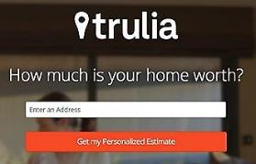
- Provide contact information in exchange for a free report, webinar or free trial. The offer shown here by Trulia, an online real estate agency, is an example of a lead-generation landing page.
Get a free estimate
Enter an address


Flea Markets and local fairs are also an easy and low-cost ($40 to $150) way to test market a product or service, or to obtain feedback on a prototype. People love to give their opinion. Take along some printed surveys and product samples and find out what consumers do and do not like. Think of it as a brick-and-mortar landing page

To find flea markets near you, go to...
http://www.keysfleamarket.com/fleamarket/state/

Module 1 - Entrepreneurship Chapter 7 – Pricing

A/B TESTING. You can create multiple landing pages to try different …
- Marketing copy,
- Product names,
- Package designs
- Alternative Prices. Try different price points to find the sweet spot for maximum GROSS PROFIT. For example, if a $9.95 price generates adequate sales volume and a 70% gross profit margin, what effect would an $8.95 offer have on demand? Might it double the demand, allowing you to reduce production costs and thereby achieve a higher gross profit? For more see chapter on “Pricing the Product”.
- Price discounts (does two for $1.97 outperform $.99 each?)
- Customer preference for feature A versus feature B
- Keywords for ad purchases
The A/B tests will allow you to see which options convert more ad readers to ad clickers, and more website or landing-page visitors to buyers.

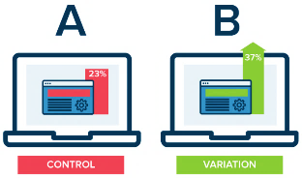
At the right is A hypothetical example by Optimizely.com comparing conversions between landing pages, one with a red color scheme, the other green.

A seemingly trivial change can sometimes produce very different results. In a test of 2000 visitors, a red “get started now” button brought 21% more visitors to a landing page.

LANDING PAGE PLATFORMS. Most provide a free basic service. Analytics are sometimes extra.

LaunchRock.com Helps new companies acquire beta testers and customers. (LaunchRock practices what they preach; the Call-to-Action [right] is from their website.) $249/ year (2025).

Mailchimp.com Free basic landing page, plus free email marketing platform.

Wix.com. They are a traditional web hosting service, inexpensive and easy to use, and you can create a one-page landing page (www.Wix.com/YourCompanyName).

Unbounce.com Expensive but great how-to articles. Perhaps a good fit after you reach your first million in sales.

Module 1 - Entrepreneurship Chapter 8 – Naming the Company

1.8 – Naming the Company

“The action that follows deliberation should be
quick, but deliberation should be slow.”
— Aristotle

Module 1 - Entrepreneurship Chapter 8 – Naming the Company

DO NOT rush this decision.
It has far-reaching effects on the business and is difficult to change after the company launches because of all the places a company name appears:
- Letterhead and business cards
- Signage
- URL and email address
- Legal documents
- Bank accounts and checks
The personality of the words in your company name will color public opinion. Your company or product name will be a potential customer’s first impression. Entrepreneur Magazine suggests, “Your name should convey the expertise, value and uniqueness of the product or service you have developed.” If you were starting a bakery, which of these company names is more likely to arouse positive emotions: “Anderson’s Bread Shop” or “Open Hearth Breads”?

CRITERIA FOR THE PERFECT NAME INCLUDE...
- Short and easy to remember (easy to type into a web browser).
  - Of the 100 most visited websites, 72% have six or fewer letters; only 3% have more than 15.
No one wants to type www.TheWorldsMostWonderfulWidget.com. As evidence that shorter is better, consider that United Parcel Service goes by UPS, International Business Machines as IBM, Hewlett-Packard legally changed its name to HP Inc., and International House of Pancakes changed its name to Ihop.
  - Single words. All things being equal, a one-word name is better than two or three words, so “Panera” for a bakery trumps mouthfuls like “Open Hearth Breads”, which is also a long string to type into a browser. Short, simple words are also easier to remember (Apple, Google, Skype, Madonna).
  - Conjoined words are the next best (Netflix, Microsoft, StubHub, FedEx, Hotmail). They become unique new words and therefore are relatively easy to trademark.
- Describes what service you provide or the type of products you sell. Most people now use search engines to find products or services online or that are available locally. Does the name allow you to be found by search engines? Which is better for a bookstore, “Jane’s Place” or “Academy Books”?

But the name is not too specific. Diversifying might become awkward. Which is better: Acme Garage Doors or Acme Manufacturing? Consider a made-up name like Exxon, Xerox, or Google. An advantage of a word you make up is that it is easy to trademark (it is not likely anyone else will have registered it.)
- Name conveys the sense of a stable, reliable company. Some words suggest quality and inspire confidence. Some do not. Jennifer Fitzgerald, founder of Policygenius (an insurance advisory service) suggests asking yourself if you can imagine saying your company name to a Wall Street Journal reporter.
- Spelling is easy and unambiguous. Do not get clever with words like “Muunglow”. Select a name that people will spell correctly the first time, so they find you in a search, and not your competitor.

Module 1 - Entrepreneurship Chapter 8 – Naming the Company

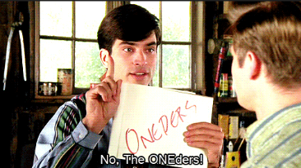
- Pronunciation is obvious. The movie, That Thing You Do, was built around a disastrous homonymous name for a musical group called the Oneders. Band members thought fans would pronounce it as the “Wonders,” but they were always introduced as the “Oh-Needers”.

- It is not geographically limiting. An exception is if you want to evoke a regional culture or food (e.g. - Kentucky Fried Chicken).
- Does not have a negative meaning in another language. Examples of unfortunate translations include:
  - Chevy Nova. “No va” means “No go” in Spanish.
  - Nature’s Gift aromatherapy products. “Gift” means “poison” in German.
- It conforms to legal requirements and restrictions.
  - You cannot use LLC, Corp, Corporation, Ltd, Inc. or Incorporated unless your company is organized under that legal structure.
  - On the other hand, if the business is an LLC, then the company must disclose this fact by placing "LLC" or "Limited Liability Company" at the end of its name. The purpose is to advise the public about the type of business organization. You cannot use Corp, Corporation, Ltd, Inc. or Incorporated in the name of an LLC as those adjectives designate and are restricted to full corporations.
  - The name cannot include words prohibited by state law (e.g., "Bank" or “Insurance” in some states). The prohibited words vary from state to state.

- The Domain name is available. A .com is usually the best choice for a commercial enterprise (com is short for commercial). If buyers know your company name, they will probably assume you are a .com and type that ending. When the top-level domain is not typed in, the default is .com. That is, if someone types in just a company name without a suffix, search engines will deliver the searcher to the .com version. Do not adopt a name if you cannot secure the domain name. If someone else owns it, all your marketing will just benefit them. For more information see Choosing a Domain Name.

- Name is Easy to Trademark: Of the following different types of names, the higher it is on the list, the easier it will be to trademark.
  - Your personal name (This is usually safe unless your name is J. C. Penney, and do not even think about using McDonalds for the name of a restaurant, even if your name really is Ronald McDonald. Examples of companies based on the names of their founders include Ford Motor Company, Smuckers, Firestone, and Ben and Jerry’s.
  - Fanciful (made up) words like “Google” and “eBay” were chosen because no one anywhere in the world was using them.
  - Combinations (Linking two words to make a new word): Kickstarter, LinkedIn.
  - Arbitrary (using a common word out of context): Apple computer, Twitter.
  - Suggestive (These can help establish your brand): Coppertone suntan lotion
  - Descriptive (The name explains what you do): Freightliner, International Business Machines.
Trademark Horror Stories
Two young entrepreneurs were sued for $1 million by a company who claimed their use of the name “HypeWipes” (for their mobile phone cleaning pad) conflicted with its long-standing trademark “Hype-Wipe” for a hospital disinfecting wipe. Lesson: check hyphenated and plural spellings when conducting a trademark search.
Facebook sued a company for using the name DesignBook. Lesson: Do not kick big dogs.

Module 1 - Entrepreneurship Chapter 8 – Naming the Company

BRAINSTORMING NAME IDEAS.

- For insights into the psychology of words see: kolenda.io/guides/brand-names.
- Consider ancient Greek or Latin words (Nike, Volvo). The right word may be evocative of what you do or the customers you want to attract.
- Use a Name-Generator Site. Free name-generator sites, useful for getting the creative process going. Note: you do not have to purchase your URL through these sites. See ”Where to Buy Domain”.
  - www.123Finder.com,
  - http://www.shopify.com/tools/business-name-generator
  - http://www.NameStation.com
CLEARING THE NAME. Make sure the name is not used by a competitor in your current or future market area. (For web-based companies, remember your market is the universe.) Do not worry if another company has a similar name if they are in another industry, as it would be unlikely that your use of the name will create confusion. For example, there are over 30 companies with the word “Sterling” in their name. However, before you buy that $20,000 sign for your building, check with an attorney. Confirm availability of each potential company name against the checklist on the following page.
- □ Google search (may uncover an unregistered trademark or competitor already using the name.)
Search name as two words (Whole Foods) and as one word (Wholefoods). .
- □ Check Secretary of State for your state (Has a company reserved or currently using the name?)
- □ Check social media. Is another company using the name on FB, IG, YouTube, X, TikTok?
- □ Domain name is available
These free AI services can suggest names as well as check for domain and trademark availability
  - www.Namify.tech Checks to see if domain, social media username and trademark are available
  - https://namelix.com/ Checks for domain availability
  - http://www.godaddy.com/offers/airo Checks for domain availability

PROTECTING THE NAME
- Buy the URL. Many registrars charge only $11 or $12 to purchase a domain name (but read the fine print, some services charge $35 or more for renewals). For low-cost sources, see “Selecting a Domain Name”
- Purchase the URL for your product name as well if it is different from the company name.
- Use TM (if a product) or SM if a service when you use your trade name. This puts others on notice that you claim the name as your trademark. For more information, see the “Trademarks” section of this text.

SUMMARY: Picking the perfect name is probably the most important decision you will make. Don’t get clever – pick a straightforward name anyone can understand, pronounce, spell, and find on a search engine.
- Brainstorm Names that evoke the right impression among your target demographic
- Test your short list on potential customers
- Verify that the name is not already being used
- Protect the name

Module 1 - Entrepreneurship Chapter 8 – Naming the Company

CHOOSING A DOMAIN NAME

Of the top 100 most visited sites in the United States, all are dotcoms. Some newer endings are growing in popularity, especially .co, but this should be a distant second choice. If you type in the name of a company in your browser, as the default, you will be taken to the company with the .com suffix.

Protecting Your Brand. Pirates have been known to register a name similar to a popular site and then clone the content. To protect yourself, consider registering...

- Alternative spellings: If you have drjones.com, you might want to buy doctorjones.com, as well.

- Additional extensions: if you own the .net or .co, consider registering the .com as a defensive measure.
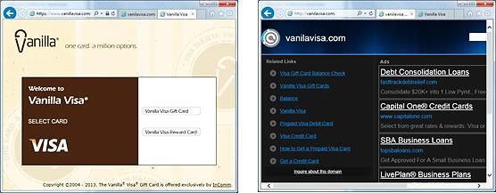

InComm launched a pre-paid Visa card called Vanilla Visa. They registered VanillaVisa.com but did not purchase VanilaVisa.com (a common misspelling), or VisaVanilla. As a result, another company registered those URLs to take advantage of InComm’s advertising and siphon off clients who had not won spelling bees. Wise entrepreneurs register likely mistypings as well as possible misspellings. If you type “Goddady.com” into a browser, you will arrive at “Godaddy.com”. Smart daddy.

Where to Buy Domain. NameCheap.com $11 first year/ $17 on renewal. GoDaddy.com charges $.01 first year/ $22 on renewal. Wix.com Free first year with hosting/ $19.35 on renewal. (All prices are for .COM domains (2025).

Subdomains. Some web hosting services offer free hosting if you use a subdomain of their domain name. A domain would be www.YourCompanyName.com. A subdomain might be www.YourCompanyName.Wix.com.

Module 1 - Entrepreneurship Chapter 9 – Protecting Intellectual Property

1.9 – Protecting Intellectual Property

1.9.1 Trademarks

1.9.2 Patents

1.9.3 Trade Secrets

1.9.4 Copyrights

Module 1 - Entrepreneurship Chapter 9 – Protecting Intellectual Property
The law provides three means for you to protect your intellectual property:

A Trademark protects a brand name, product logo or other feature that distinguishes one company’s products from its competitors. The intent of the law is to protect consumers from buying a look-alike, assuming it to be the real McCoy. A trademark of a service is referred to as a Service mark.

A Patent is an intellectual property right granted by the government to an inventor to exclude others from making, using, selling or importing the invention for a specified time, in exchange for public disclosure of the invention. See www.USPTO.gov.

A Copyright protects original works of authorship including books, scripts, music, art and design, and computer software.

DISCLAIMER. Government regulations and fees subject to change. The information provided is not legal advice. If you are contemplating pursuing protection for intellectual property consult with an attorney who practices trademark and patent law.

. Contact them at iplawclinic@law.uconn.edu.

1.9.1 Trademarks
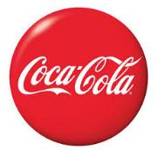

Product names and logos may be protected with a trademark, and in some cases, you can register a color, or even a sound connected to your product or service.
The Coca-Cola Company has trademarked not only “Coca-Cola” and “Coke”, but also the typestyle, the swash below the name, and the shade of red. Even the distinctive hourglass bottle shape is trademarked.

NBC’s distinctive three-note musical theme G-E-C (for General Electric Corporation) is trademarked.

Where to start. Before adopting a trade name for your product or company, make sure it is not already registered for your class of product or service. If you search “Hilton”, you will of course find that it is registered as the name for a chain of hotels. However, this would not prevent you from using or even registering the name Hilton as a brand name for a hockey stick. The Hilton Company could not claim that you are confusing customers shopping for a hotel.

Steve Jobs named his company Apple because he admired the Beatles. (The Beatles record label was Apple.) The Beatles did not object—until Apple Computers entered the music business with iTunes. The Beatles sued for trademark infringement, which resulted in a $500 million payment to the musicians.
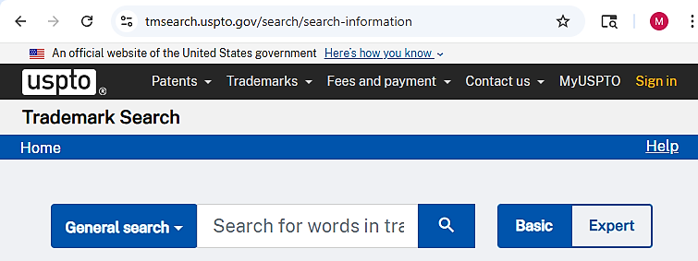

To access the trademark search page at the U.S. Patent and Trademark Office website (shown above) see...
http://www.uspto.gov/trademark
Trade Dress. There are ways to identify your product other than through a name (tradename) or logo (trademark). It could be the general design of a chain of restaurants, like Hard Rock cafes, or the layout of a magazine cover, or the brown trucks used by UPS. The intent of the law is to prevent consumers from being fooled into buying a product thinking it was something else. For example, if you saw a bracelet in a powder blue box, you would probably assume it from Tiffany’s, or a soda in an hourglass bottle was “The Real Thing.” Protection of trade dress may be registered in the same manner as a trademark.

Module 1 - Entrepreneurship Chapter 9 – Protecting Intellectual Property

Do you have to register a mark before using it? No. You can assert your claim to a tradename (the name of your company or product) or trademark (logo) by placing a TM (trademark) or SM (Service mark) designation next to the name or symbol. This is a common-law convention and does not require registration with the U.S. Patent and Trademark Office. However, you need to continually assert that you claim the name as a trademark by using the ^{tm} consistently. Otherwise, someone could say they did not know it was a trademark, adopted it innocently, and argue that you took no steps to protect it. Use the ^{tm} or ^{sm} (for a service) on all sales literature, business card, letterhead, invoices, and where it appears at least once on each page of your website and social media platforms.
Under the law, you even have some protection for an unregistered mark or trade dress, although a registered mark does provide greater protection and clearer title of ownership. Priority ownership goes to the first person to use the mark not the first to file (as with patents). Therefore, you need to be able to prove when you began using the trademark in business. Evidence might include a combination of a dated invoice to a customer, a dated receipt showing your company name for the purchase of products or services, or an ad in a newspaper or magazine (since they are dated). In any case, consult an attorney for professional advice.

While it is not necessary that you register a mark, there are several advantages of doing so:
- Official public notice that your claim of ownership has been registered
- The ability to sue for infringement
- An official registration may be used as the basis to obtain registration in other countries
- The ability to record the registration with the U.S. Customs and Border Protection Service to prevent importation of infringing foreign goods.
- The right to use the federal registration symbol ®; and
- Listing in the United States Patent and Trademark Office’s online database, where other entrepreneurs will see that you have registered the mark.
Trademark Protection Overseas. The Madrid Protocol allows a holder of a U.S. registration to file for protection of a mark in multiple countries with a single application, in English, and for only one set of fees. The World Intellectual Property Organization's International Bureau administers the Madrid System.
For details, see http://www.uspto.gov/trademarks/law/madrid/index.jsp
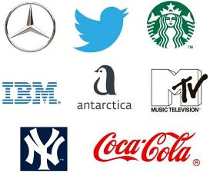
Trademark Filing Fees. The application filing fee for the TEAS (Trademark/Service mark Electronic Application System) is $350 (as of 2025) per class of goods and/or services. For example, if you intend to use the mark on computer hardware and T-Shirts, then you will have to pay a filing fee for each of the two classes. You will also need to pay $150 when you begin to use the mark in commerce (selling items displaying the mark); and a renewal fee of $525 every 10 years. Budget an additional $700 for attorney fees. For details, see http://www.uspto.gov/trademarks/index.jsp

Trademarks.
Note that the Starbucks mark is not registered.

Module 1 - Entrepreneurship Chapter 9 – Protecting Intellectual Property

1.9.2 Patents

First to File Versus First to Invent. As of March 16, 2013, the law was changed in the U.S. to award patents based on who was the first to file for a patent, as opposed to the previous method of granting a patent to the original inventor. Unfortunately, it is now easier to “steal” an idea. The “poor man’s patent”—mailing plans to yourself to prove when you developed an invention—is now immaterial.

How Can an Inventor Protect an Idea Before It Is Patented?
- DO NOT DIVULGE THE Formula for your SECRET SAUCE when selling your idea to supporters. Just reveal the benefits of the innovation: “Our new beverage beats Coke and Pepsi in taste tests and has zero calories.”
- LIMIT EXPOSURE. Pick out one or two people you feel you can trust: an attorney, potential investor, or beta tester (early customer you allow to use the product for free to determine if the idea needs more development), or a mentor to discuss how best to move the project forward.
- USE A non-disclosure agreement (NDA) when possible. If someone does need to see enough of a product to be convinced, and this would allow the viewer to replicate the product, ask the person to sign an NDA. That said, prospective investors will not sign NDAs just to evaluate an idea. With potential financial backers, you need to trust your instincts as to their character. You can ask for references; that is, names of other innovators or entrepreneurs that the investor has worked with. Then call these individuals and ask about their experiences.
- FILE A Temporary PROVISIONAL PATENT. This requires less paperwork than a full patent and will buy you 12 months to refine the final product and still establishes your precedence as the first to file. You will be able to use the term patent pending in conjunction with the product during the 12-month pending period. You must file for a full (non-provisional) patent within 12 months or risk losing the right to patent.
The cost to file a Provisional Patent is $325 (as of 2025). You will then incur the regular filing expenses when you file for the full patent. (See Patent Office Fees in this text. )

For more on provisional patents, see https://www.uspto.gov/patents/basics/apply/provisional-application

There are two types of full or long-term patents:

DESIGN PATENTS that protect how something looks, not how it works. To obtain patent protection an “Ornamental Design” must be new, original, and non-functional. A design patent is good for 15 years.

Design patent filing fees are about 10% less on average than utility fees. The rounded corners on an iPhone is a design patent. When Samsung introduced its smartphone, with rounded corners, Apple sued for violation of its design patent.

UTILITY PATENTS are full non-provisional protections for inventions, processes, materials, machines and manufactured items that provide utility (they are useful). Good for 20 Years.

For an invention to receive a utility patent it must …
- BE NOVEL. Cannot already be in use in U.S. or patented anywhere in world more than a year before filing.
- HAVE UTILITY. Must have a useful purpose.
- NOT BE OBVIOUS to a person with ordinary skill in the field of the invention

Module 1 - Entrepreneurship Chapter 9 – Protecting Intellectual Property

To Patent or Not to Patent

REASONS TO PATENT:

- To Build Investor Confidence. Investors do not value abstract ideas. They need to see tangible evidence of value: patents, working prototypes, proof of profit potential, satisfied beta testers. A patent also provides some business life insurance for the investors; if the business fails, but the product is still marketable, the investors may be able to salvage some of their investment by selling the patent.

- TO DISCOURAGE KNOCK-OFFS.

- To prevent someone else from PATENTING THE IDEA. It does not matter that you were the inventor. If someone patents the idea before you do, then that person will own it and can prevent you from marketing the product.

REASONS NOT TO PATENT:

- TheRE ARE OTHER FASTER AND LESS EXPENSIVE STRATEGIES TO CREATE A BARRIER TO COMPETITORS. The opposite strategy to patenting and then enforcing your rights in the courts is called the First to Market or First Mover strategy; that is, to establish your platform or methods as the standard. This strategy may be the most feasible even if your intellectual property is not obscured within a secret sauce. Many companies, without patents, have been successful with a first-to-market strategy. Indeed, most new businesses are based on ideas that are not patentable in any event. For example, McDonalds Restaurants (fast, cheap, limited menus, no ambience), Starbucks (good quality coffee), or FedEx shipping services (overnight delivery) are not patentable concepts, but those companies were the first to market nationally and they set new standards.

The Secret Sauce Approach. If you really do have a secret sauce, like Coca-Cola, and it is unlikely anyone will figure it out, then the value of the patent might be more than offset by the fact that to obtain a patent you would have to divulge the formula, thereby aiding the unscrupulous who will not honor your patent rights anyway. Coca-Cola has not been patented for just this reason. Other secret sauces whose very secrecy can sometimes be more valuable than patents (which are online for all to see), include many software products. For example, only Google knows exactly what algorithms it uses to determine which web pages to return during a search.
For more on the just-keep-it-secret strategy versus patenting, see “Trade Secrets” in this text.

The Case Where a PRODUCTS MARKET LIFE IS LESS THAN THE TIME NEEDED TO OBTAIN A Patent. For some software or electronic products, the useful life may be shorter than the time it takes the U.S. patent office to approve it. In this case, you would be better off going to market immediately. Otherwise, the invention may become obsolete or go out of style before a patent is granted.

Time and Expense to File and Defend a Patent. Attorney fees can run to $10,000 or more. A full patent requires typically three or more years to obtain; and applicants are not always successful.

Module 1 - Entrepreneurship Chapter 9 – Protecting Intellectual Property

Patent Office Fees. There are four types of fees, assuming electronic filing versus paper. (Amounts as of 2025.)
- Basic Filing Fee, $ 350 (+$600 for each claim in excess of 3)
- Patent Search Fee, $ 770
- Patent Examination Fee, and $ 880
- Patent Issue Fee (if application is approved) $ 1290
$ 3290
DISCOUNTS FOR SMALL AND MICRO ENTITIES.
Small Business Entity: Independent inventor, a for-profit with fewer than 500 employees, or non-profit organization as long as the filer has not assigned, granted, conveyed, or licensed (and is under no obligation to do so) any rights in the invention to a for-profit company with over 500 employees.
60% Discount on most fees = ……………………... $ 1316 approximate total
Micro Entity: Meets the Small Business Entity requirement and has income below $241,830 (as of June 2025). Note, the threshold amount for a micro entity changes every year during or shortly after September. For more information on micro entity status see https://www.uspto.gov/patents/laws/micro-entity-status
80% Discount on most fees = ……………………..… $ 658 approximate total

Patent Maintenance Fees. However, to maintain the patent, a Small Entity must pay additional fees of $860 after 3.5 years, $1616 after 7.5 years, and $3312 after 11.5 years. (A Micro Entity will pay half of these amounts.)
If the product is not successful, the filer may avoid paying the maintenance fees by abandoning the patent.
For a full schedule of filing fees see https://www.uspto.gov/learning-and-resources/fees-and-payment

Where To Start
- CONDUCT A PATENT SEARCH to confirm that no one else has patented the product, process or design. You can conduct a search at the www.USPTO.gov website. Google also has an easy-to-use patent search function at https://www.google.com/?tbm=pts

If you do not find anything, before committing funds to developing your product idea, you may still want to have a patent attorney conduct a professional search for you. Just to be sure.
- DECIDE WHEN AND IF TO FILE. Seek professional advice, as this is a complex decision.
- DECIDE ON WHICH TYPE OF PATENT TO FILE: Design, Provisional, or Utility.

A Note on Software: Copyright versus Patent. While software may be copyrighted, patenting is becoming a more popular choice of protection. With a copyright, it is difficult to prove plagiarism of specific “expression.” Moreover, the courts may not understand the code. Check with an Intellectual Property attorney.

Module 1 - Entrepreneurship Chapter 9 – Protecting Intellectual Property

1.9.3 Trade Secrets

An alternative to patenting is the Trade Secret. Information about the product or process is not filed with the government, as then it would be available to the public and, well, no longer a secret. The common law behind the concept is that if you literally had a secret sauce, you could take legal action against someone who sells the identical sauce if you can prove they would have had to obtain the information illegally.
To prove the information could have only been obtained surreptitiously, you would have to document that you had a formal procedure to prevent disclosure of the trade secret. The percentage of each ingredient or the process you use to mix and prepare them cannot appear in any sales literature, website or even relayed in a conversation to a customer. It must be kept secret. Proof of your safeguarding procedures might include:
- Security of business office and manufacturing location
- Procedures to keep vital information under lock and key
- Non-disclosure agreements with employees and suppliers

A patent is more expensive, but as a government document it is easier to defend in court than a Trade Secret.

1.9.4 CopyrightS
A copyright protects works of authorship, such as writings, music, and works of art.
Before 1989, US copyright law required creators to publish works with a copyright notice, and before 1978, creators had to file for a copyright renewal after the initial 28-year term. However, obtaining and retaining copyright is now an automatic practice. Under the current US statute (US Code Title 17), you own a copyright on your work from the moment you create it, and the copyright lasts for the life of the author plus 70 years.
Although you do not have to register works to protect them, if you wish to bring a lawsuit for infringement of your work, you will have to produce a registration certificate.
Registration Fee. If you choose to register your work, the fee to do so online is $45 (as of 2025). See https://www.copyright.gov/
Protection in Other Countries. The U.S. has reciprocal copyright agreements with most countries. For a list see http://www.copyright.gov/circs/circ38a.pdf, International Copyright Relations of the United States. For More on Copyrights, see www.copyright.gov.
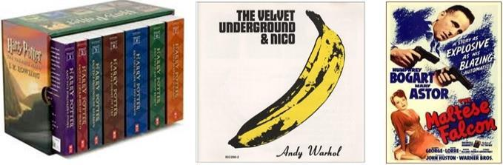

Examples of copyrightable works. The Velvet Underground album embodies three types of copyright examples: 1) the banana cover design by Andy Warhol, 2) the liner notes on the back of the album, and 3) the music itself.
Module 1 - Entrepreneurship Chapter 10 – Structure and Regulatory Matters

1.10 – Structure and Regulatory Matters

1.10.1 Finding Your NAICS Code

1.10.2 Federal EIN Number

1.10.3 Steps to Setting up an LLC

1.10.4 Business Licenses

A wide variety of legal templates can be downloaded for free at

https://law4startups.com

Module 1 - Entrepreneurship Chapter 10 – Structure and Regulatory Matters

1.10.1 Finding Your NAICS CODE

NAICS (North American Industry Classification System). To find the NAICS (rhymes with rakes) code for your business, go to www.naics.com. You will need this code number for many government documents and on trade association membership applications. If you are having difficulty finding your industry, try typing into a Google search “What is the NAICS Code for [describe your business]?”

Terms you used in the search for your NAICS code: ________________________________________
NAICS Code(s) and official definition. Note: a company may have more than one code.

1.10.2 Federal EIN Number (Employer Identification Number)

You will need to complete an EIN Application (federal form SS-4) to establish an LLC or corporation, hire employees, or open a business bank account. You can apply online at sa.www4.irs.gov/modiein/individual/legal-structure.jsp and receive your number within 24 hours.

However, we suggest you first draft a copy of the one-page application to review with an advisor or attorney and to discuss any questions you are not sure how to answer. To access a fillable pdf see www.irs.gov/pub/irs-pdf/fss4.pdf. Here are some explanations of the more ambiguous questions on the Federal EIN application:

No. | QUESTION | BRIEF EXPLANATION
3 | Executor, Administrator, trustee etc. | Leave blank unless you are working through one of these agents
4-5 | Location of business | Use your home address if you do not have a business location, or if it is likely the business will move.
8a | Is this application for an LLC? | If you are intending to organize as an LLC, but have not yet filed the papers, that’s OK, answer YES.
8b | Number of members in the LLC | You may not know how many co-founders you will have. Make as good a guess as you can. If you plan to go it alone, enter “1”.
8c | Was the LLC organized in the U.S.? | If not organized yet, but you do plan to establish in the U.S., answer “Yes.”
9a | Type of Entity | If you will be organizing as an LLC, check the “Other” box and write in “Disregarded entity.”
11 | Date business started. | Businesses are like people. When they are young they want to appear older. So, give your business the earliest possible birthdate. If you have not yet started, enter today’s date.
12 | Closing month of accounting year | Enter “December” so your fiscal year will match the calendar year. This is not like tattoos. You do not want to be different. If you enter a month other than December, you will regret it when you have to issue financial reports to investors or tax returns for Uncle Sam.
14 | Federal Payroll Taxes | Check the box if you do not have employees now and do not expect to hire anyone before the end of the calendar year.
15 | First date wages were paid | If correct, just write “Do not yet have employees”
18 | Third Party Designedd | Leave this section blank unless you want someone else—like your attorney—to receive government notices instead of you.

For detailed instuction for form SS-4 see https://www.irs.gov/pub/irs-pdf/iss4.pdf
Module 1 - Entrepreneurship Chapter 10– Structure and Regulatory Matters

1.10.3 SETTING UP AN LLC

The most common florms are the Sole Proprietorship, LLC (Limited Liability Company), and Corporation (C-Corp). By default, you are a Sole Proprietorship (you and the business are one and the same). Setting up an LLC will provide some protection of your personal assets in case of lawsuits, but requires annual filing fees and in many states a minimum annual tax. If you want to raise outside funding from angel investors or venture capitalists, you will need to organize as a Corporation. However, you can start as an LLC and then convert to a C-Corp when you are ready for equity financing.

LLC State Filing Fees. The one-time fee to register an LLC ranges from $50 to $500 per state, with most in the $100 to $200 range. To find the filing fee for your state see www.upcounsel.com/annual-llc-fees-by-state.

Minimum State Business Income Taxes. Almost all states levy taxes on business income, ranging from 4% to 12%, but what a startup needs to know for budgeting purposes and deciding what legal structure to use, is whether their lurks in the tax code of his or her state a minimum Business Entity Tax, Franchise Tax, Annual Filing Fee, or other term for a minimum tax. Although LLCs allow business income to pass through to the owner(s), so that the owner or owners are not taxed twice, some states still expect the business entity to pay a minimum tax--even if it didn’t have any income. For information on state corporate tax rates, see taxfoundation.org/center/state-tax-policy/

The federal government does not levy a minimum tax on companies that break even or lose money.

STEPS TO SET UP AN LLC

1. Check with your Secretary of State to see if another business has registered the name. Also check the U/S. Patent and Trademark Office https://www.uspto.gov/trademarks/search to see if the tradename is available.

2. Arrive at an agreement among the founders as to what percentage each of you will own. (You can also form an LLC as the sole member.)

3. Prepare an Operating Agreement. This agreement governs the operation of the LLC and defines the rights and obligations of the Members to each other and to the LLC. (The Operating Agreement is not the document you file with the state to set up an LLC. That document is the Articles of Organization.) A boilerplate LLC Operating Agreement may be downloaded from www.LawDepot.com or www.RocketLawyer.com at no charge with a limited=time free trial. We recommend that you review the document with a business attorney.

4. File Articles of Organization with your Secretary of State We recommend you register in the state where your company is located. While some states have very favorable laws for companies, there are additional fees to register in another state. Once you reach $10,000,000 in sales, then consider registering in Delaware.

5. Register your company with the Town Clerk’s office of each municipality in which you will operate. For most companies this will be your headquarters location. However, a consumer service business such as a roofing company will need to register in every town that it has customers. A Google search of “[city] Town Clerk” should connect you to the appropriate web site where you will most likely find a simple one-page form.

6. Obtain a Sales Tax License through your state department of revenue services. (Search “Sales taxes” and the name of your state.) Some municipalities, like New York City, also require you to collect sales taxes on their behalf, so also check with the city administration in the town where your business is headquartered.

Since you will be obligated to submit periodic reports after you register for a sales tax permit, you may want to wait until you have actual sales before doing so.

Module 1 - Entrepreneurship Chapter 10 – Structure and Regulatory Matters

1.10.4 Business Licenses

If you are involved with any of these industries, you may require one or more business licenses from LOCAL, STATE and/or FEDERAL AGENCIES”
- Agriculture
- Alcohol
- Auctions
- Aviation
- Broadcasting (Radio and TV)
- Construction
- Day care
- Dry cleaning
- Energy
- Firearms and ammunition, explosives
- Fish and wildlife
- Food service
- Gambling
- Manufacturing
- Maritime
- Mining and Drilling
- Plumbing
- Recycling
- Restaurants
- Retail
- Spas and beauty parlors
- Tobacco
- Transportation
- Vending machines
LOCAL LICENSES and PERMITS. Check with your town and county clerks to ascertain what may be required. For most businesses, local governments will require only that you register. The cost usually ranges from $25 to $50.
It is also wise to check with the local fire department to make sure your intended business location can be occupied.

ZONING RESTRICTIONS. When you visit your town clerk to register your business, check to see if your business location is zoned to permit your type of business; and what limitations there might be on signage, noise, use of hazardous materials, minimum parking spaces required; and if a food service business, the health department codes.

STATE LICENSING DEPARTMENTS. See https://www.constantcontact.com/blog/state-business-licenses/
If you need help, consult with your nearest Small Business Development Center (SBDC).
https://www.sba.gov/local-assistance/resource-partners/small-business-development-centers-sbdc

FEDERAL LICENSES AND PERMITS.
See www.sba.gov/business-guide/launch-your-business/apply-licenses-permits#federal-licenses-and-permits

Module 1 - Entrepreneurship Chapter 11 – Raising Startup Capital

1.11 – Raising Startup Capital

1.11.1 Determining Startup Capital Requirements

1.11.2 Sources of Startup Capital

1.11.3 Pitching Business Concepts

ANGEL AND BANK FINANCING ARE NOT REALISTIC FOR PURE STARTUPS.
- Investors will not risk money on ventures without a proven revenue and profit model. The time to pitch investors is after a business model has been successfully proven and demonstrated.

- More realistically, the initial capital to test your concept will probably come from personal savings, family, and crowdfunding.
- In any event—with or without startup capital—entrepreneurs should avoid large commitments to marketing and infrastructure until all business model hypotheses are validated.

A WORD ABOUT NDAS (NON-DISCLOSURE AGREEMENTS). An NDA is basically a written promise not to divulge the unique aspects of your business model to potential competitors. If your product is not patented, you may want to ask for an NDA before discussing details with a prospective employee, supplier, or financier. However, it is a rare investor who will sign an NDA. Their concern is that they may already have invested in a similar product that is about to be released.
One work-around is simply not to divulge your secret sauce. For example:
- If you have a new beverage, just say “It outperforms Brand X in blind taste tests” (but do not divulge the formula).
- If you have developed enterprise software for financial institutions, say “It will save banks 20% on their compliance costs” (but do not show the source code).
You can still ask for an NDA when you begin serious investment discussions.

The culture of most collaborative forums (Startup Weekends and entrepreneurship classes, to name two) is to ask everyone to honor each other’s confidential information. As BUSINESS MODEL guru Steve Blank points out, discussing an idea openly in his Stanford University class risks intellectual property theft, but the upside is lots of feedback. He does not use NDAs in his class.

Module 1 - Entrepreneurship Chapter 11 – Raising Startup Capital

1.11.1 Determining Startup capital requirements

THE CAPITAL REQUIREMENT is the amount of cash you will need to cover startup expenses and operating expenses until the company is cash-flow positive. Do not overlook general liability and product insurance. Even if you are selling products made by other companies, you still may be liable if a customer is injured by the product.

MINIMIZING CAPITAL NEEDS. The lower the capital requirement, the easier it will be to attract investment. To reduce investor risk, break down capital requirement into tranches for each plateau of development (e.g. – R&D, prototyping, lab testing, patenting, beta testing with customers, full market launch, and runway to break even). Investors prefer to mete out cash when (and if) interim goals are met. (Investors adhere to Cheops law: Nothing ever gets built on schedule or within budget.)

You may be able to reduce your total capital needs with tight cash-management techniques:
    - REQUIRE PREPAYMENT at time of order, at least enough to cover the cost of the raw materials you will need. This is a customary practice in the home remodeling industry.
    - LEASE VERSUS PURCHASE. Leasing a car or truck for a business instead of purchasing it conserves cash. There are also leasing agents and finance companies that will purchase manufacturing equipment and then lease it back to you.

This is an interactive spreadsheet. To open, right-click on spreadsheet, click “Worksheet Object” and then "Open.”
You need to enter data in shaded fields only; the totals will be computed for you. You can download a copy of this form at http://www.EntrepreneurshipFoundation.org/spreadsheets

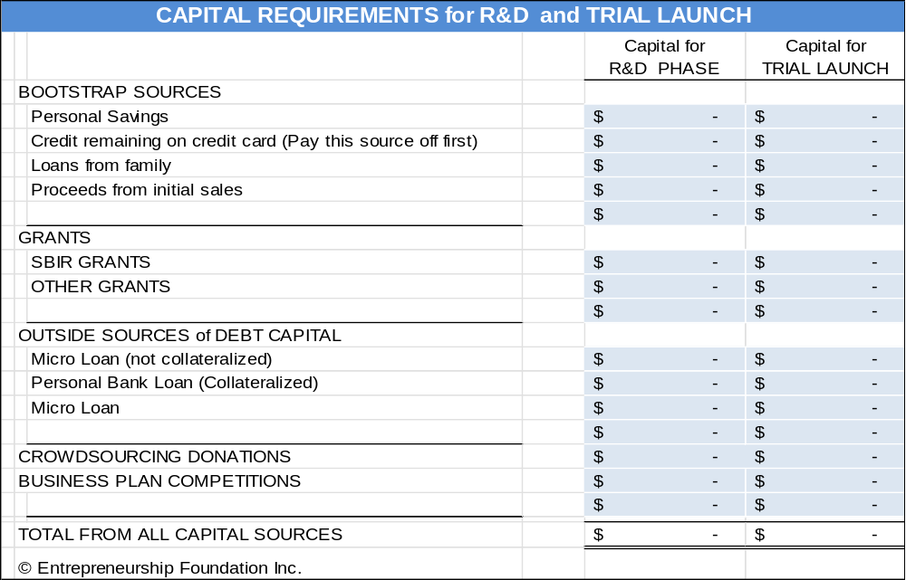

Module 1 - Entrepreneurship Chapter 11 – Raising Startup Capital

1.11.2 Sources of Startup Capital

- Personal Savings. The more money you personally invest in your business, the easier it will be to attract outside financing. Capital providers feel more confident you will stick with the venture if you have “skin in the game.” Investors will only consider cash contributions on your part, not the value of your time. Determine how much capital you need to start the business and set that amount (plus a reserve for contingencies) as your savings goal. If you do not have outside employment, include twelve months of living expenses in your capital needs. You probably will not be able to draw money out of the business for at least that long.
- Family and Friends. Along with personal savings, this is the most common source of capital for new businesses. Family members may not require personal guarantees and therefore will not foreclose on your home but be careful not to risk more family and friends than you can afford to lose. Those Thanksgiving get-togethers can get rather frosty if you lose your sister’s college fund.
- Government Lenders. The SBA offers a Microloan Program (amounts up to $50,000). For details See www.sba.gov/loans-grants/see-what-sba-offers/sba-loan-programs/microloan-program
- Small Business Innovation Research (SBIR) Grant Program. SBIR awards grants to small tech businesses. See www.sba.gov/loans-grants/see-what-sba-offers/sba-loan-programs/microloan-program
Phase I awards range up to 314,363 and Phase II awards $2,095,748 (2025). This R&D funding does not have to be repaid.

The Small Business Technology Transfer program (STTR) is a sister program that awards federal funds to small businesses that subcontract R&D to universities or research institutions.

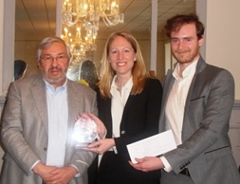
Business Competitions. Search online for “Business plan competitions” and “business model competitions” to find opportunities that you might qualify to enter. If you are a student, search your school’s website to see if it holds an annual competition. Popular competitions include:
Two Yale students accept a check and trophy from angel investor Joseph Demartino at an Entrepreneurship Foundation business plan competition.
  - GLOBAL STUDENT ENTREPRENEUR AWARDS, for students who are already in business, sponsored by the Entrepreneurs Organization https://eonetwork.org/gsea
  - RICE BUSINESS PLAN COMPETITION, with $1 million in awards. https://rbpc.rice.edu/
  - VENTUREWELL. Grants for social, health, or environmental solutions. https://venturewell.org/

- Reward-Based Crowdfunding. RECOMMENDED GOAL: $5000 to $50,000. The funds in this instance come from customers paying for the product in advance of it being manufactured. The buyers need to be told in advance how long it will be (usually months) before the product will be delivered.

The “reward” is typically one or more of the products. However, for amounts less than the value of the product, the reward might be a token of appreciation, such as a mention on the company website.

Module 1 - Entrepreneurship Chapter 11 – Raising Startup Capital

THERE ARE TWO TYPES OF REWARD-BASED CROWDFUNDING:
- All-or-nothing (AON) where the entrepreneur receives nothing unless the goal is met. A study by Inc. Magazine concluded that all-or-nothing fundraising campaigns “were much more likely to be successful at achieving their goals… and potential investors are more inclined to support ‘all-or-nothing’ initiatives.” This is the Kickstarter model. Set your official “goal” as the number you need to produce to meet the Minimum Economical Quantity (MEQ) to produce the products. You can go over the minimum.
- Keep-it-All: the entrepreneur publishes a goal on the crowdfunding website and keeps whatever is raised regardless of whether the goal is met. Indiegogo offers both Keep-it-all and All-or-nothing.

For a free how-to guide see https://entrepreneur.indiegogo.com/how-it-works/

Platform | KIA or aon | COMMISSION FEE | PAYMENT PROCESSING | COMMON  PRODUCTS
Kickstarter.com | AON | 5% | 3.0% + $ .20 | Creative arts
Indiegogo.com | KIA | 5% | 2.9% + $ .30 | Innovation / creative arts

TIPS FOR REWARD-BASED CAMPAIGNS
- Make sure you know the cost and source of every product component and process before launching campaign: (Manufacturing 1000 widgets is a lot more complicated than making one prototype.)
- Factor in the additional cost to ship overseas and price for U.S. and foreign buyers separately. If you have a heavy or bulky product, you may want to limit buyers to the U.S. For international postage rates (and weight and size limits) see https://www.usps.com/international/. Note, for Kickstarter, you must set one price for all foreign buyers, including freight, so estimate high.
- Keep accurate cost-accounting records to make sure you will make money at each level after factoring in the cost of the reward. The following is a link to a free Google Awards Pricing Template: https://docs.google.com/spreadsheets/d/1_nNBz-TheExh8rxeQCffu3U2fJJBkRDBdnUgpKDrmk0/edit#gid=0.
Include a 20% cushion for unforeseen expenses and contingencies: e.g., Tariff hikes between date of sale and when order is shipped. Preferably, look for a domestic supplier. Cost may be a little higher, but you should be able to lock it in.
- Offer donor levels at $5 and $10. (with a thank-you only). Some people may give you money because they like the idea, especially if it is a social enterprise. Check similar products to see which prices and prizes were most popular.
- Start promoting via email and social media starting a month before launch. Maintain momentum with weekly updates on the platform, social media, and emails to backers and media.
- The reward-based-campaign can also serve as a Trial Launch to test pricing and quantity discounts.

FULFILLMENT: Some fulfillment houses specialize in distributing rewards to backers. Contact the services for pricing, which depends on the difficulty of storing and shipping your physical rewards

SHIPBOB https://www.shipbob.com/crowdfunding-fulfillment-services/
SHIPMONK https://www.shipmonk.com/fulfillment-services/crowdfunding-fulfillment
FULFILLRITE https://fulfillrite.com/crowdfunding

Module 1 - Entrepreneurship Chapter 11 – Raising Startup Capital

1.11.3 Pitching Business Concepts

Competition judges and capital providers, by nature, are risk averse and skeptical. Be Clear, Concise and Convincing.

EIGHT-SECOND SOUND BITE. This is a statement about your investment opportunity that you can get out in one breath. The place to use this is at a business-networking event where someone asks, “What do you do?” You never know who you might meet, so assume everyone you talk to is a potential investor or knows someone who is. A brief but engaging introduction about what you do is also valuable when recruiting employees or clients.
No one writes a check in an elevator. The sole purpose of the elevator pitch is to pique the interest of the investor, so they want more information. Success is these brief encounters is an exchange of business cards and an offer for you to call and set up an appointment for an in-depth interview.

The elevator pitch forces you to achieve clarity. At a minimum, the pitch should include YOUR NAME, COMPANY NAME, PROBLEM, and YOUR SOLUTION.

The elevator pitch should be memorized and rehearsed enough so that you can give it without it sounding rehearsed. You never know where you might meet a potential investor: at a cocktail reception, football game, even in an elevator. An 8-second elevator pitch might sound like this:
“Sugarcoate Systems reduces the time to bring new drugs to market by 20%.”
“We make flameproof fabrics for aircraft interiors.”
“We make cupcake decorating kits for children’s birthday parties.”

You need to convey all the essential information in a clear, concise, credible, and convincing manner that is also natural but passionate.

For more on mastering the elevator pitch see...
http://www.inc.com/guides/2010/05/mastering-business-elevator-pitch.html.

30-to-60-SECOND ELEVATOR PITCH (without audiovisuals). You will probably be one of many presenters, so be memorable. State your name and company name slowly and distinctly at the beginning and end of your talk. Consider opening with a dramatic statement to capture the attention of the audience. Address the following points:

        - Big idea (customer problem and your solution) (1 or 2 sentences)
        - Status of the idea or business (1 brief sentence)
        - Revenue model (e-commerce, wholesale, etc.) (1 sentence)
        - Sales potential (justify expectations) (1 sentence)
        - Competition and why do you believe you have an advantage (2 sentences)
        - Rock stars are on the team who will ensure success (2 sentences)
        - Personal goal (1 sentence). To create a …
1) Part-Time Business (side hustle),
2) Full-time Personal Business,
3) Venture Enterprise with a substantial market and requiring venture capital to reach full potential.
        - Total funding required to launch the business full-time, and how much you need initially to develop the Minimum Viable Product and test it in the marketplace? (1 brief sentence)

Module 1 - Entrepreneurship Chapter 11 – Raising Startup Capital

SAMPLE ELEVATOR SCRIPT. "Our company, WorkBoots.com, is an e-commerce website that sells brand-name construction boots. There are currently no companies serving this niche exclusively. We will drive traffic to our site by linking to other websites catering to the construction industry as well as through word-of-mouth. In industry surveys, over 90% of construction workers have three traits: 1) they have a favorite brand of boots, 2) they know their size, and 3) they hate shopping at stores. In our own polling of 30 construction workers, over 70% indicated that they would prefer to buy their boots online and have them delivered. We need $500,000 in funding to reach break-even, which we can reach in 18 months. I am the CEO. I have operational experience and contacts with boot manufacturers. Our Marketing Director was instrumental in the growth and recent sale of a successful e-commerce clothing company. Our goal is to sell WorkBoots.com to a 'brick and mortar' retailer in 3 years."
VIDELINKS Sample elevator pitches: MIT Pitch competition https://youtu.be/n0BKBcSZaA0

YOUR 8-SECOND PITCH:

YOUR 60-SECOND PITCH:

Module 1 - Entrepreneurship Chapter 11 – Raising Startup Capital

 |  | ELEVATOR PITCH RATING SHEET FOR COMPETITIONS
 |  |  | S c o r e
 |  |  | NO | < -- > |  |  | YES
 | 1. PRODUCT or SERVICE: Do you know what it is and what it will do? |  | 1 | 2 | 3 | 4 | 5
 | Compelling value proposition or solution to customer problem?
 | 2. COMPETITION: Is product unique, or superior to alternatives? |  | 1 | 2 | 3 | 4 | 5
 | 3. TARGET MARKET: Clearly defined? Adequate to support business? |  | 1 | 2 | 3 | 4 | 5
 | 4. MANAGEMENT: Was presenter knowledgeable, polished, confident? |  | 1 | 2 | 3 | 4 | 5
 | 5. FINANCE: Do you know how the company will make money? |  | 1 | 2 | 3 | 4 | 5
 | 6. FUNDING: Do you know how much company needs to launch? |  | 1 | 2 | 3 | 4 | 5
 | TOTAL (Maximum 30) ………………………………………………………..
FEEDBACK _____________________________________________________________________________

_____________________________________________________________________________

_____________________________________________________________________________

_____________________________________________________________________________

 | Presentation Style: Speak louder Speak slower

Nathan Furr, Forbes, February 2, 2012, “Practical Insights on the Management Science of Entrepreneurship”
The Startup Checklist, David Rose, p. 33
Kouzes and Posner, The Leadership Challenge, 5th Ed., p. 172.
The Lean Startup, Crown Publishing Group, 2011
Michael Porter, Competitive Strategy, 1980, p. 35.
https://nlihc.org/oor/about
https://unbounce.com/landing-page-articles
https://www.optimizely.com/optimization-glossary/ab-testing/
Joshua Porter, https://blog.hubspot.com/blog/tabid/6307/bid/20566/the-button-color-a-b-test-red-beats-green.aspx 2017
Entrepreneur.com/article/21774
https://www.entrepreneur.com/article/21774
Jason Calacanis. http://blog.launch.co/blog/how-to-name-your-startup-and-land-the-perfect-domain.html)
Jason Feifer (May 2018). “Did You Pick the Right Name?” Entrepreneur.com (print), p. 28.
www.quantcast.com/top-sites-1
https://www.justia.com/intellectual-property/trademarks/unregistered-trademarks/

